**LAB # 2 :-**

**OBJECT : To learn creation of stream sockets.**

**Task 1 : Compile and run the above code. Start the acceptor first and then the requestor with appropriate command line arguments. Describe and explain the output.**

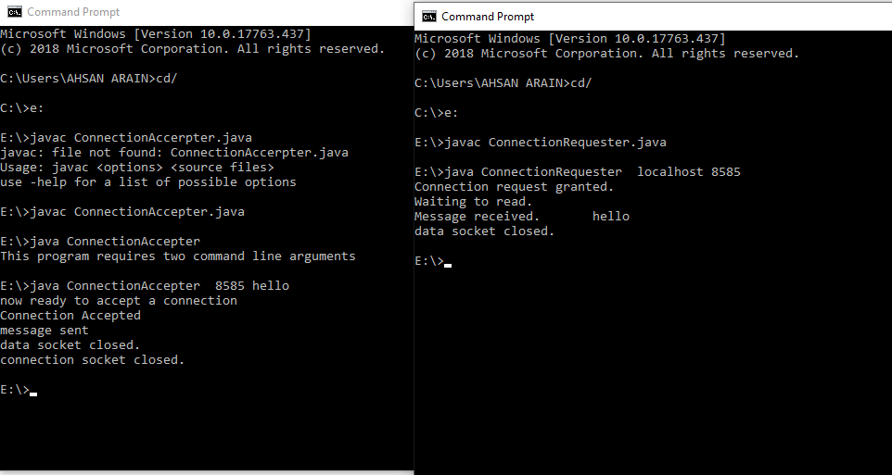

**TASK 2 : Now run the code again, but reverse the order of program’s execution. Start the requestor first and then the acceptor. Describe and explain the outcome.**

ConnectionAcceptor.java

import java.net.*;

import java.io.*;

public class ConnectionAcceptor {

public static void main(String[] args){

if(args.length!=2){

System.out.println("This program requires two command line arguments");

}else{

try{

int portNo=Integer.parseInt(args[0]);

String message=args[1];

ServerSocket connectionSocket=new ServerSocket(portNo);

System.out.println("now ready to accept a connection");

Socket dataSocket=connectionSocket.accept();

System.out.println("Connection Accepted");

OutputStream outStream=dataSocket.getOutputStream();

PrintWriter socketOutput=new PrintWriter(new OutputStreamWriter(outStream));

socketOutput.println(message);

socketOutput.flush();

System.out.println("message sent");

dataSocket.close();

System.out.println("data socket closed.");

connectionSocket.close();

System.out.println("connection socket closed.");

Thread.sleep(10000);

}catch(Exception ex){ ex.printStackTrace();

} } } }

ConnectionRequestor.java

import java.net.*;

import java.io.*;

public class ConnectionRequestor {

public static void main(String[] args){

if(args.length!=2){

System.out.println("This program requires two command line arguments");

}

else{

try{

InetAddress acceptorHost=InetAddress.getByName(args[0]);

int acceptorPort=Integer.parseInt(args[1]);

Socket mySocket=new Socket(acceptorHost,acceptorPort);

System.out.println("Connection request granted.");

InputStream inStream=mySocket.getInputStream();

//create buffered reader object for character mode output

BufferedReader socketInput=new BufferedReader(new InputStreamReader(inStream));

System.out.println("Waiting to read.");

String message=socketInput.readLine();

System.out.println("Message received."+"\t"+message);

mySocket.close();

System.out.println("data socket closed.");

Thread.sleep(10000);

}catch(Exception ex){

ex.printStackTrace();}

}

}

}

**OUTPUT :**

**In order make connection, Connection Request needs a port no that is not pre occupied. Connection Acceptor allocates the port no to Connection Acceptor. Hence Connection Acceptor is not running so Connection Request can’t make connection and “Connection refused” exception has occurred.**

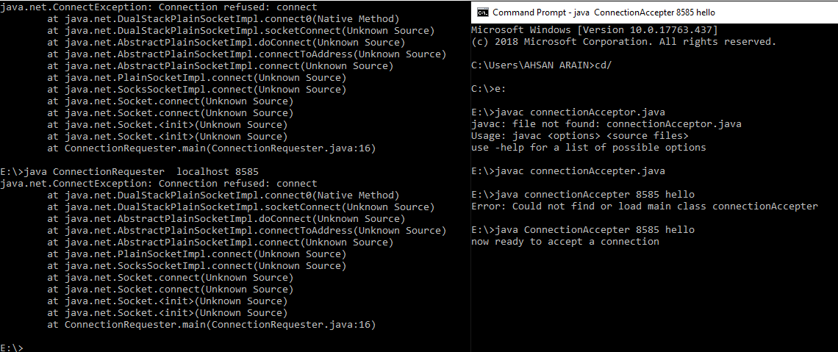

**TASK 3 : Add a time delay of 5 seconds in the ConnectionAcceptor process just before the message is written to the socket, then run the program. This will show you the blocking at the receiver. Show a trace of the output of the processes.**

TASK2Acceptor.java

import java.net.*;

import java.io.*;

public class TASK2Acceptor {

public static void main(String[] args){

if(args.length!=2){

System.out.println("This program requires two command line arguments");

}else{

try{

int portNo=Integer.parseInt(args[0]);

String message=args[1];

ServerSocket connectionSocket=new ServerSocket(portNo);

System.out.println("now ready to accept a connection");

Socket dataSocket=connectionSocket.accept();

System.out.println("Connection Accepted");

OutputStream outStream=dataSocket.getOutputStream();

PrintWriter socketOutput=new PrintWriter(new OutputStreamWriter(outStream));

Thread.sleep(5000);

socketOutput.println(message);

socketOutput.flush();

System.out.println("message sent");

dataSocket.close();

System.out.println("data socket closed.");

connectionSocket.close();

System.out.println("connection socket closed.");

Thread.sleep(5000);

}catch(Exception ex){ ex.printStackTrace();

} } } }

TASK2 Requestor.java

import java.net.*;

import java.io.*;

public class TASK2Requestor {

public static void main(String[] args){

if(args.length!=2){

System.out.println("This program requires two command line arguments");

}

else{

try{

InetAddress acceptorHost=InetAddress.getByName(args[0]);

int acceptorPort=Integer.parseInt(args[1]);

Socket mySocket=new Socket(acceptorHost,acceptorPort);

System.out.println("Connection request granted.");

InputStream inStream=mySocket.getInputStream();

//create buffered reader object for character mode output

BufferedReader socketInput=new BufferedReader(new InputStreamReader(inStream));

System.out.println("Waiting to read.");

String message=socketInput.readLine();

System.out.println("Message received."+"\t"+message);

mySocket.close();

System.out.println("data socket closed.");

Thread.sleep(5000);

}catch(Exception ex){

ex.printStackTrace();}

}

}

}

**OUTPUT :**

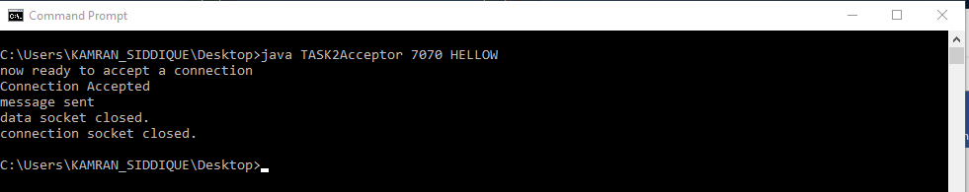

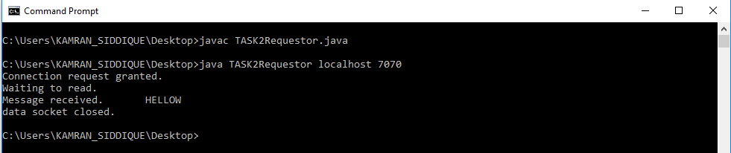

**Task#04: Modify the sample code to include two way communication between the client and the server.**

**TASK3Acceptor.java**

import java.net.*;

import java.io.*;

import java.util.Scanner;

public class TASK3Acceptor {

public static InputStream inStream = null;

public static Scanner input = new Scanner(System.in);

public static PrintWriter socketOutput = null;

public static void main(String[] args){

if(args.length!=2){

System.out.println("This program requires two command line arguments");

}else{

try{

int portNo=Integer.parseInt(args[0]);

ServerSocket connectionSocket=new ServerSocket(portNo);

System.out.println("now ready to accept a connection");

Socket dataSocket=connectionSocket.accept();

System.out.println("Connection Accepted");

OutputStream outStream=dataSocket.getOutputStream();

socketOutput=new PrintWriter(new OutputStreamWriter(outStream));

InetAddress acceptorHost=InetAddress.getByName("localhost");

int acceptorPort=Integer.parseInt("7071");

Socket mySocket=new Socket(acceptorHost,acceptorPort);

inStream=mySocket.getInputStream();

while(true)

{

TASK3Acceptor.sendMsg();

TASK3Acceptor.receiveMsg();

}

}catch(Exception ex){ ex.printStackTrace();}

}

}

public static void sendMsg()

{

try{

System.out.print(">>");

String message=input.nextLine();

socketOutput.println(message);

socketOutput.flush();

}catch(Exception ex){ ex.printStackTrace();}

}

public static void receiveMsg()

{

try{

BufferedReader socketInput=new BufferedReader(new InputStreamReader(inStream));

String message=socketInput.readLine();

System.out.println("%%"+message);

}catch(Exception ex){

ex.printStackTrace();}

}

}

TASK3 Requestor.java

Import java.net.*;

import java.io.*;

import java.util.Scanner;

public class TASK3Requestor {

public static PrintWriter socketOutput = null;

public static InputStream inStream = null;

public static Scanner input = new Scanner(System.in);

public static void main(String[] args){

if(args.length!=2){

System.out.println("This program requires two command line arguments");

}

else{

try{

InetAddress acceptorHost=InetAddress.getByName(args[0]);

int acceptorPort=Integer.parseInt(args[1]);

Socket mySocket=new Socket(acceptorHost,acceptorPort);

System.out.println("Connection request granted.");

inStream=mySocket.getInputStream();

//create buffered reader object for character mode output

int portNo=Integer.parseInt("7071");

ServerSocket connectionSocket=new ServerSocket(portNo);

Socket dataSocket=connectionSocket.accept();

OutputStream outStream=dataSocket.getOutputStream();

socketOutput=new PrintWriter(new OutputStreamWriter(outStream));

while(true)

{

TASK3Requestor.receiveMsg();

TASK3Requestor.sendMsg();

}

}catch(Exception ex){

ex.printStackTrace();}

//mySocket.close();

//dataSocket.close();

//connectionSocket.close();

}

}

public static void receiveMsg()

{

try{

BufferedReader socketInput=new BufferedReader(new InputStreamReader(inStream));

String message=socketInput.readLine();

System.out.println("%%"+message);

//System.out.println("data socket closed.");

}catch(Exception ex){

ex.printStackTrace();}

}

public static void sendMsg()

{

try{

System.out.print(">>");

String message=input.nextLine();

socketOutput.println(message);

socketOutput.flush();

}catch(Exception ex){

ex.printStackTrace();}

}

}

**OUTPUT :**

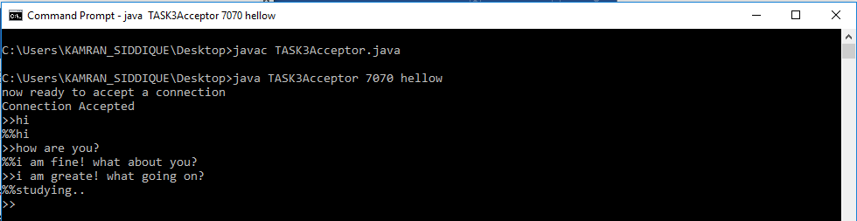

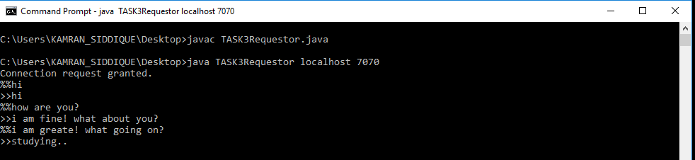

**Task#05: Modify the sample code to send complete files between the client to the server.**

**SimpleFileClient.java**

import java.io.BufferedOutputStream;

import java.io.FileOutputStream;

import java.io.IOException;

import java.io.InputStream;

import java.net.Socket;

public class SimpleFileClient {

public final static int SOCKET_PORT = 13267;

public final static String SERVER = "127.0.0.1";

public final static String

FILE_TO_RECEIVED = "EdxA.docx";

public final static int FILE_SIZE = 6022386;

public static void main (String [] args ) throws IOException {

int bytesRead;

int current = 0;

FileOutputStream fos = null;

BufferedOutputStream bos = null;

Socket sock = null;

try {

sock = new Socket(SERVER, SOCKET_PORT);

System.out.println("Connecting...");

byte [] mybytearray = new byte [FILE_SIZE];

InputStream is = sock.getInputStream();

fos = new FileOutputStream(FILE_TO_RECEIVED);

bos = new BufferedOutputStream(fos);

bytesRead = is.read(mybytearray,0,mybytearray.length);

current = bytesRead;

do {

bytesRead =

is.read(mybytearray, current, (mybytearray.length-current));

if(bytesRead >= 0) current += bytesRead;

} while(bytesRead > -1);

bos.write(mybytearray, 0 , current);

bos.flush();

System.out.println("File " + FILE_TO_RECEIVED

+ " downloaded (" + current + " bytes read)");

}

finally {

if (fos != null) fos.close();

if (bos != null) bos.close();

if (sock != null) sock.close();

}

}

}

SimpleFileServer.java

import java.io.BufferedInputStream;

import java.io.File;

import java.io.FileInputStream;

import java.io.IOException;

import java.io.OutputStream;

import java.net.ServerSocket;

import java.net.Socket;

public class SimpleFileServer {

public final static int SOCKET_PORT = 13267;

public final static String FILE_TO_SEND = "Edx.docx";

public static void main (String [] args ) throws IOException {

FileInputStream fis = null;

BufferedInputStream bis = null;

OutputStream os = null;

ServerSocket servsock = null;

Socket sock = null;

try {

servsock = new ServerSocket(SOCKET_PORT);

while (true) {

System.out.println("Waiting...");

try {

sock = servsock.accept();

System.out.println("Accepted connection : " + sock);

File myFile = new File (FILE_TO_SEND);

byte [] mybytearray = new byte [(int)myFile.length()];

fis = new FileInputStream(myFile);

bis = new BufferedInputStream(fis);

bis.read(mybytearray,0,mybytearray.length);

os = sock.getOutputStream();

System.out.println("Sending " + FILE_TO_SEND + "(" + mybytearray.length + " bytes)");

os.write(mybytearray,0,mybytearray.length);

os.flush();

System.out.println("Done.");

}

finally {

if (bis != null) bis.close();

if (os != null) os.close();

if (sock!=null) sock.close();

}

}

}

finally {

if (servsock != null) servsock.close();

}

}

}

**OUTPUT :**

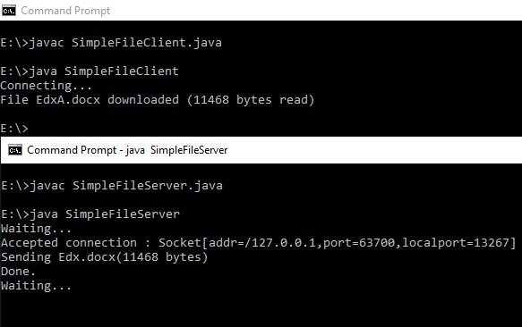

**Task#06: Explore the non-blocking java socket API in the nio package and implement a sample program.**

Starting [JDK 1.4](https://crunchify.com/where-is-java-installed-on-my-mac-osx-system/), NIO was created to allow all [Java programmers](https://crunchify.com/category/java-tutorials/) to implement very high-speed input/output without having to deal with custom native code. NIO uses java.nio.buffer library compare to [simple I/O](https://crunchify.com/java-file-copy-example-simple-way-to-copy-file-in-java/) which drains and fills back buffer internally any operating system.

In this tutorial we will go over java.nio.channels and java.nio.channels.Selectorlibraries.

* channels represent connections to entities that are capable of performing I/O operations, such as files and sockets; defines selectors, for multiplexed, non-blocking I/O operations.
* selector may be created by invoking the open method of this class, which will use the system’s default selector provider to create a new selector.

How it works:

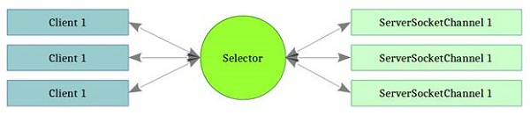

**Code:**

**SocketServerExample.java**

import java.io.IOException;

import java.net.InetSocketAddress;

import java.net.Socket;

import java.net.SocketAddress;

import java.nio.ByteBuffer;

import java.nio.channels.SelectionKey;

import java.nio.channels.Selector;

import java.nio.channels.ServerSocketChannel;

import java.nio.channels.SocketChannel;

import java.util.*;

public class SocketServerExample {

private Selector selector;

private Map<SocketChannel,List<byte[]>> dataMapper;

private InetSocketAddress listenAddress;

public static void main(String[] args) throws Exception {

Runnable server = new Runnable() {

@Override

public void run() {

try {

new SocketServerExample("localhost", 8090).startServer();

} catch (IOException e) {

e.printStackTrace();

}

}

};

Runnable client = new Runnable() {

@Override

public void run() {

try {

new SocketClientExample().startClient();

} catch (IOException e) {

e.printStackTrace();

} catch (InterruptedException e) {

e.printStackTrace();

}

}

};

new Thread(server).start();

new Thread(client, "client-A").start();

new Thread(client, "client-B").start();

}

public SocketServerExample(String address, int port) throws IOException {

listenAddress = new InetSocketAddress(address, port);

dataMapper = new HashMap<SocketChannel,List<byte[]>>();

}

private void startServer() throws IOException {

this.selector = Selector.open();

ServerSocketChannel serverChannel = ServerSocketChannel.open();

serverChannel.configureBlocking(false);

serverChannel.socket().bind(listenAddress);

serverChannel.register(this.selector, SelectionKey.OP_ACCEPT);

System.out.println("Server started...");

while (true) {

// wait for events

this.selector.select();

Iterator<SelectionKey> keys = this.selector.selectedKeys().iterator();

while (keys.hasNext()) {

SelectionKey key = (SelectionKey) keys.next();

keys.remove();

if (!key.isValid()) {

continue;

}

if (key.isAcceptable()) {

this.accept(key);

}

else if (key.isReadable()) {

this.read(key);

}

}

}

}

private void accept(SelectionKey key) throws IOException {

ServerSocketChannel serverChannel = (ServerSocketChannel) key.channel();

SocketChannel channel = serverChannel.accept();

channel.configureBlocking(false);

Socket socket = channel.socket();

SocketAddress remoteAddr = socket.getRemoteSocketAddress();

System.out.println("Connected to: " + remoteAddr);

dataMapper.put(channel, new ArrayList<byte[]>());

channel.register(this.selector, SelectionKey.OP_READ);

}

private void read(SelectionKey key) throws IOException {

SocketChannel channel = (SocketChannel) key.channel();

ByteBuffer buffer = ByteBuffer.allocate(1024);

int numRead = -1;

numRead = channel.read(buffer);

if (numRead == -1) {

this.dataMapper.remove(channel);

Socket socket = channel.socket();

SocketAddress remoteAddr = socket.getRemoteSocketAddress();

System.out.println("Connection closed by client: " + remoteAddr);

channel.close();

key.cancel();

return;

}

byte[] data = new byte[numRead];

System.arraycopy(buffer.array(), 0, data, 0, numRead);

System.out.println("Got: " + new String(data));

}

}

SocketClientExample.java

import java.io.IOException;

import java.net.InetSocketAddress;

import java.nio.ByteBuffer;

import java.nio.channels.SocketChannel;

public class SocketClientExample {

public void startClient()

throws IOException, InterruptedException {

InetSocketAddress hostAddress = new InetSocketAddress("localhost", 8090);

SocketChannel client = SocketChannel.open(hostAddress);

System.out.println("Client... started");

String threadName = Thread.currentThread().getName();

String [] messages = new String []

{threadName + ": test1",threadName + ": test2",threadName + ": test3"};

for (int i = 0; i < messages.length; i++) {

byte [] message = new String(messages [i]).getBytes();

ByteBuffer buffer = ByteBuffer.wrap(message);

client.write(buffer);

System.out.println(messages [i]);

buffer.clear();

Thread.sleep(5000);

}

client.close();

}

}

**OUTPUT :**

