**LAB # 2:**

**Object:** **To become familiar with conversion from ERD into real-time database.**

**TASK # 1: convert the ERD into database, which was given in the previous lab.**

**Entity Relationship Diagram :-**

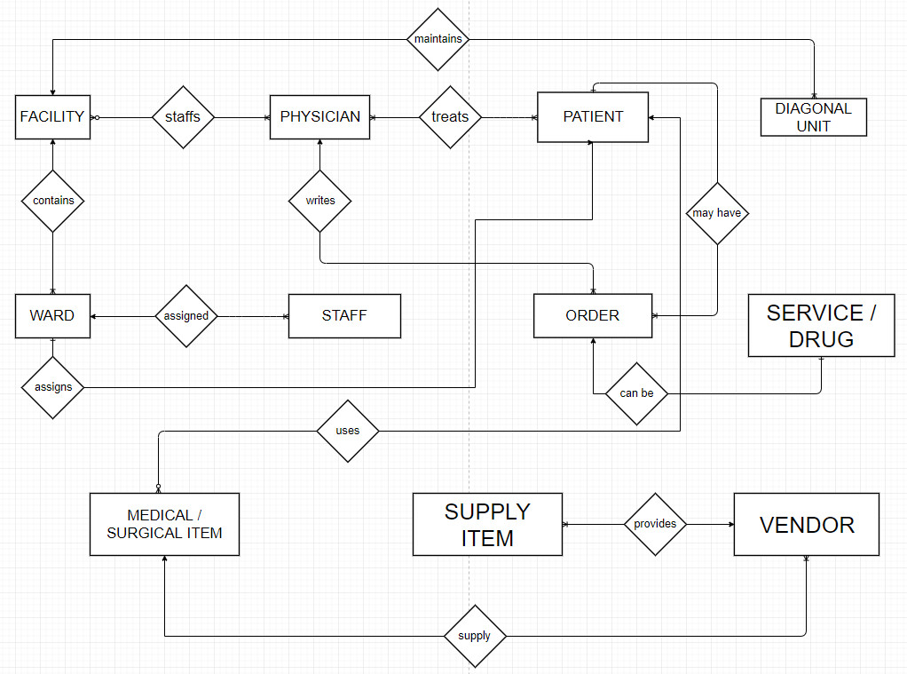

**Logical Diagram:-**

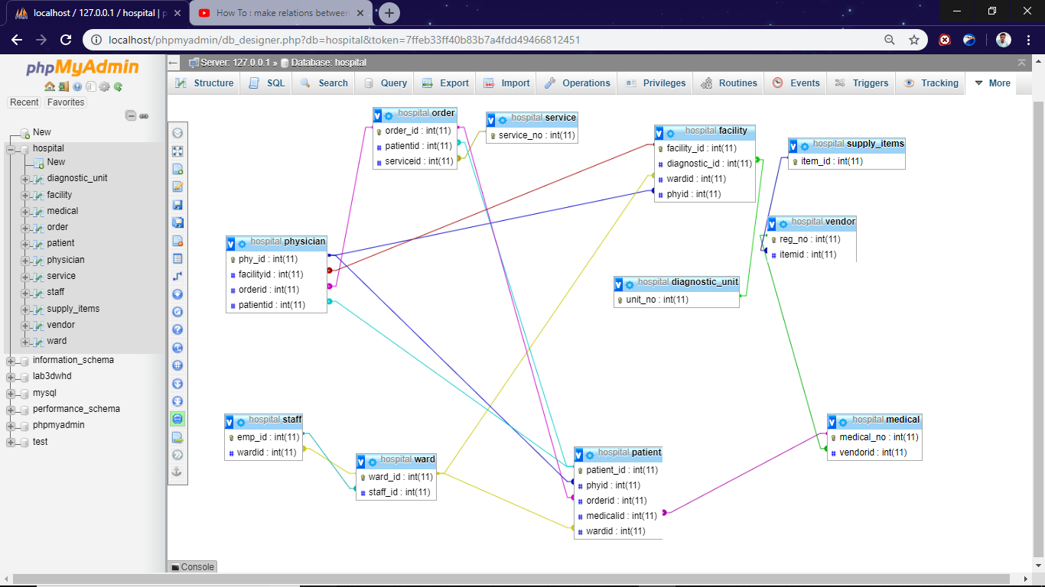

**Database:-**

