|  |
| --- |
| Department of Software Engineering  Mehran University of Engineering and Technology, Jamshoro |

|  |  |  |  |
| --- | --- | --- | --- |
| Course: SWE324 - Data Warehousing and Data Mining | | | |
| Instructor | Rabeea Jaffari | **Practical/Lab No.** | 05 |
| Date | 30 April 2019 | **CLOs** | CLO-4: P3 & P4 |
| Signature |  | **Assessment Score** | 1 Marks |

|  |  |
| --- | --- |
| Topic | To become familiar with DW Design |
| Objectives | * To learn conceptual and logical DW Design |

|  |
| --- |
| Lab Discussion: Theoretical concepts and Procedural steps |

|  |
| --- |
| Lab Tasks |
| Submission Date: |

1. **Draw M/ERDs for the following scenarios represented by ERDs and business rules to ease your task.**
2. **Scenario 1: Advertising**



**Business Rules**

1. Advertisements are placed by Agencies.

2. Advertisements are placed by Channels, such as TV or Print.

3. Advertisements can be part of a Marketing Campaign.

4. Invoices are produced and result in Payments.

5. Advertisements result in Responses.

6. Responses can be analysed by Demographics.

1. **M/ERD for advertisement scenario(Cube Diagram):**

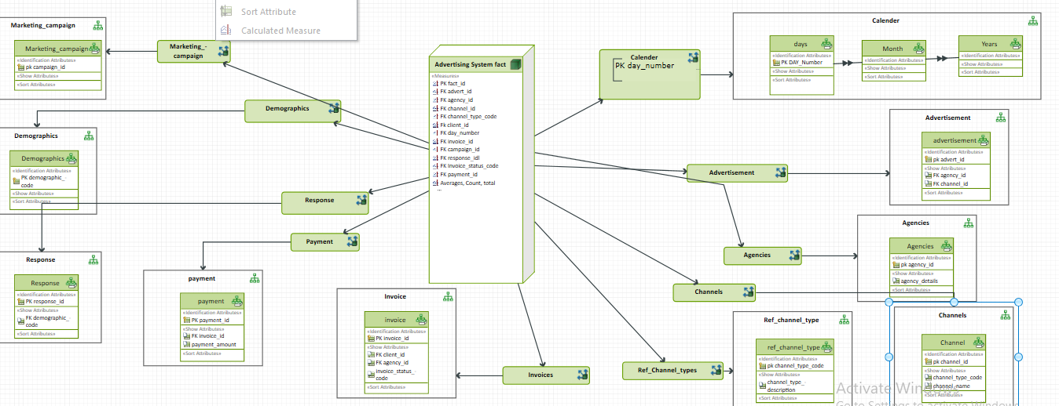

1. **M/ERD for advertisement scenario(Measure Dimension Diagram):**

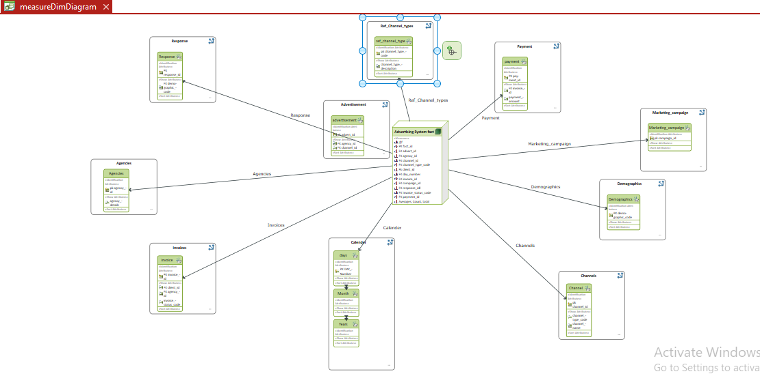

1. **Scenario 2: Amusement Parks**



**Business Rules**

1. Rides are available.

2. Customers use Credit or Debit Cards to buy Tickets to Ride.

3. Staff operate the Rides.

4. Staff also work on Maintenance Schedules for the Rides.

1. **M/ERD FOR AMUNSEMENT PARK SCENARIO:**

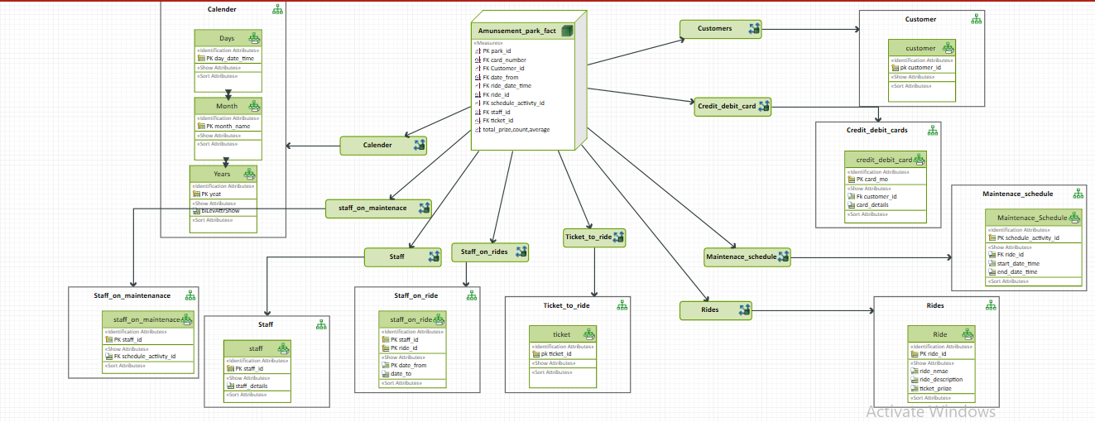

1. **Scenario 3: Clown registry**

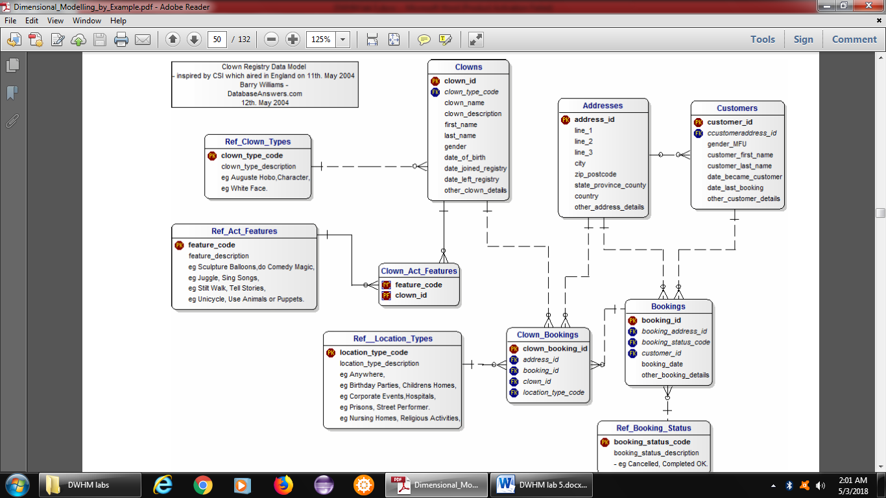

**Business Rules**

1. People registered as Clowns are stored in the Clowns Table.

2. A Clown can have Acts with specific Features.

3. Clowns accept Bookings to perform at specific Locations for specific Customers.

1. **M/ERD for clown registry scenario:**

