**Async in Rust:**

Async program is a form of parallel programming, its allows the atomic work to run separately from the primary (main) application thread. When the atomic work is complete, it notifies the main thread with failed or success status. Moreover, Asynchronous code allows us to run multiple tasks concurrently on the same OS thread.

**Concept:**

Async program basically is a concept which allows not blocking the program workflow when waiting for the results of certain actions.

**Code Example:**

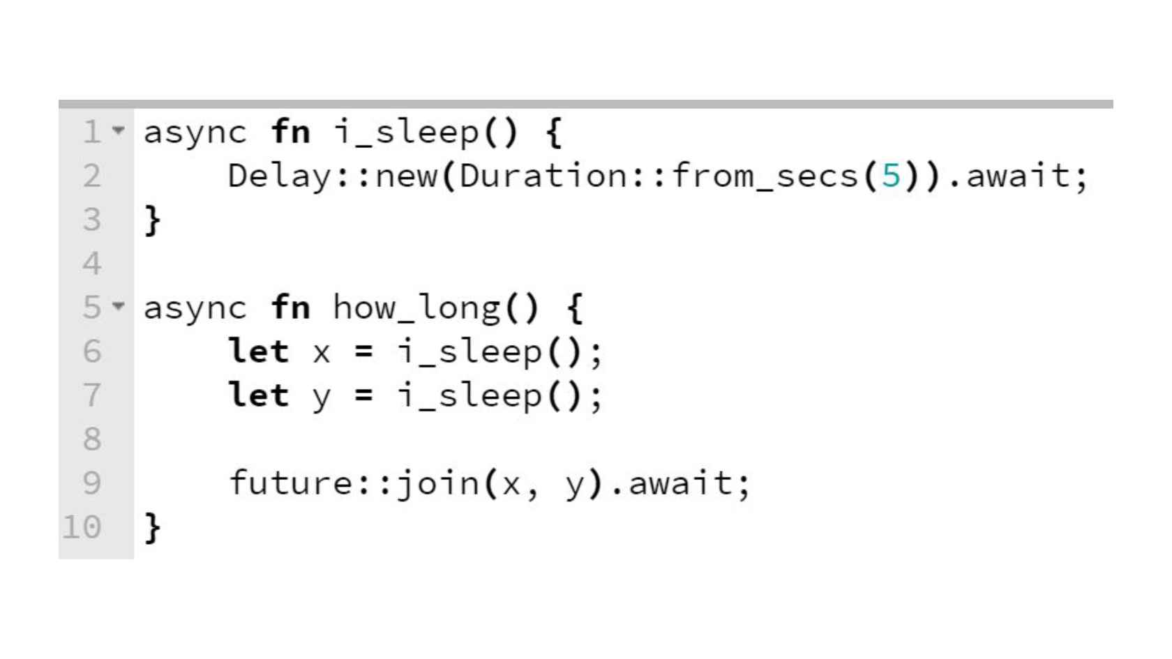

**Visual Representation of Async State Machine Basic:**

Below diagram explains how Async works and how Async code differs from traditional Rust programs.

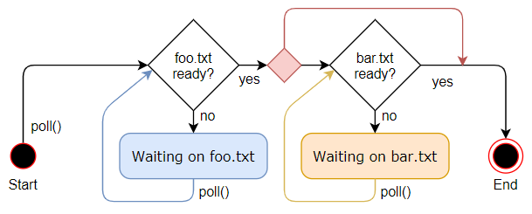

**Conclusion:**

Overall, asynchronous applications have the potential to be much faster and use fewer resources than a corresponding threaded implementation but it has some cost. As we know that