**Oracle SQL Foundations 1-4**

Project Questions

**Name**: Kamran Butt

**Date**: September 4, 2024

**DFo_1_4_Project**

**Question**:

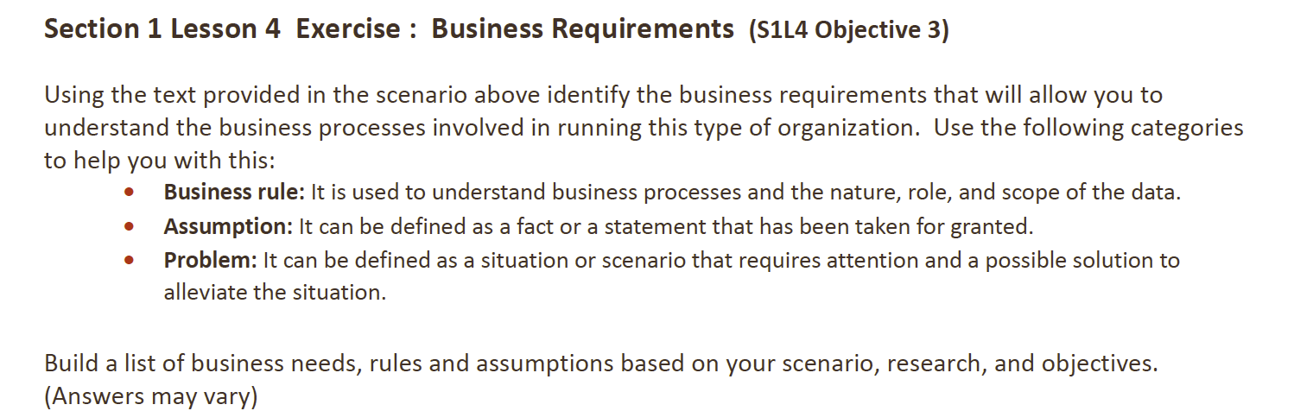

**Answer**:

**Business Rules**:

1. Customer Types and Discounts:
   1. There are two kinds of customers: individual buyers and teams. Teams get a special discount depending on how many players they have. This needs to be managed in the system, where team orders include the number of players to calculate the discount.
2. Sales Representatives:
   1. Three sales representatives mainly work with teams but also deal with individual complaints. The system should allow representatives to be flexible in handling both teams and individuals.
3. Order Management:
   1. Every order should be recorded with the details of all items purchased. There should be a table that links each order to the products, ensuring no data is repeated and every aspect is correctly tracked.

**Assumptions**:

1. No Purchase Limits:
   1. Both individual customers and teams can buy any product from the store, with no restrictions on what they can choose.
2. Handling Complaints:
   1. Sales representatives deal with complaints from both individual customers and teams. The system should allow for this flexibility.

**Problems**:

1. Applying Discounts:
   1. The system must calculate team discounts correctly, based on the number of players – this needs to be reflected in the database.
2. Sales Representative Responsibilities:
   1. Since sales representatives handle both team orders and individual complaints, the system should track who is responsible for which tasks to avoid confusion.
3. Inventory Management:
   1. It is important to keep track of what is sold to ensure the inventory is accurate and there are no issues with stock. The system should support tracking all sales without repeating data.

**DFo_2_3_1_Project**

**Question**:

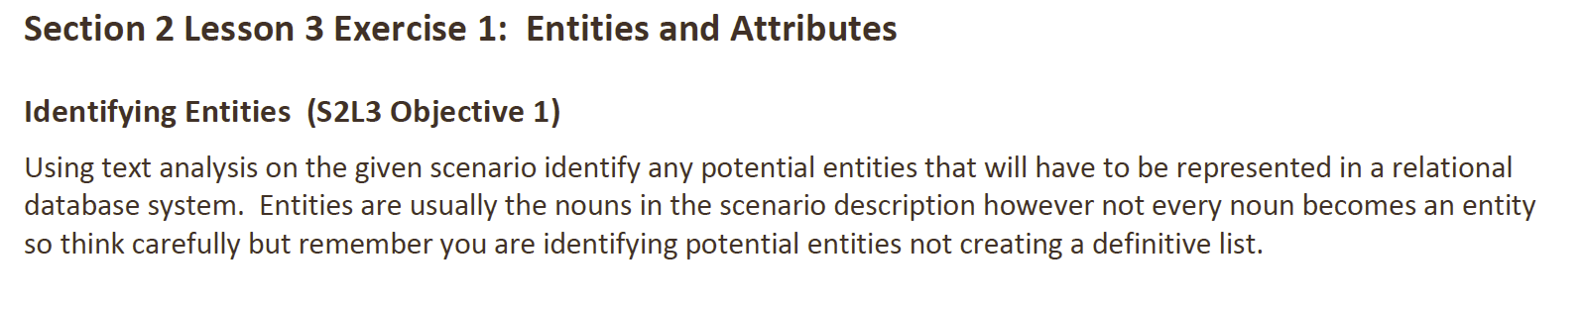

**Answer**:

Potential Entities:

|  |  |  |
| --- | --- | --- |
| **Entity** | **Description** | **Potential Attributes** |
| Customer | Represents both individual customers and team representatives | Customer ID, Customer Name, Customer Type (individual or team), Contact Information |
| Team | Teams purchasing on behalf of players | Team ID, Team Name, Number of Players, Discount Eligibility |
| Sales Representative | Sales reps managing team orders and handling individual complaints | Sales Rep ID, Name, Assigned Team(s), Individual Complaint Handling |
| Order | Captures each purchase made by a customer | Order ID, Customer ID (foreign key), Order Date, Total Amount |
| Order Items | Tracks individual items within an order | Order Item ID, Order ID (foreign key), Product ID, Quantity, Item Price |
| Product | Represents items available for sale at the OBL store | Product ID, Product Name, Category (balls, gloves, shirts, etc.), Price, Stock Quantity |
| Inventory | Tracks available stock for each product | Inventory ID, Product ID (foreign key), Quantity on Hand |
| Complaint | Logs customer complaints managed by sales reps | Complaint ID, Customer ID (foreign key), Sales Rep ID (foreign key), Complaint Description, Resolution Date |

**DFo_2_3_2_Project**

**Question**:

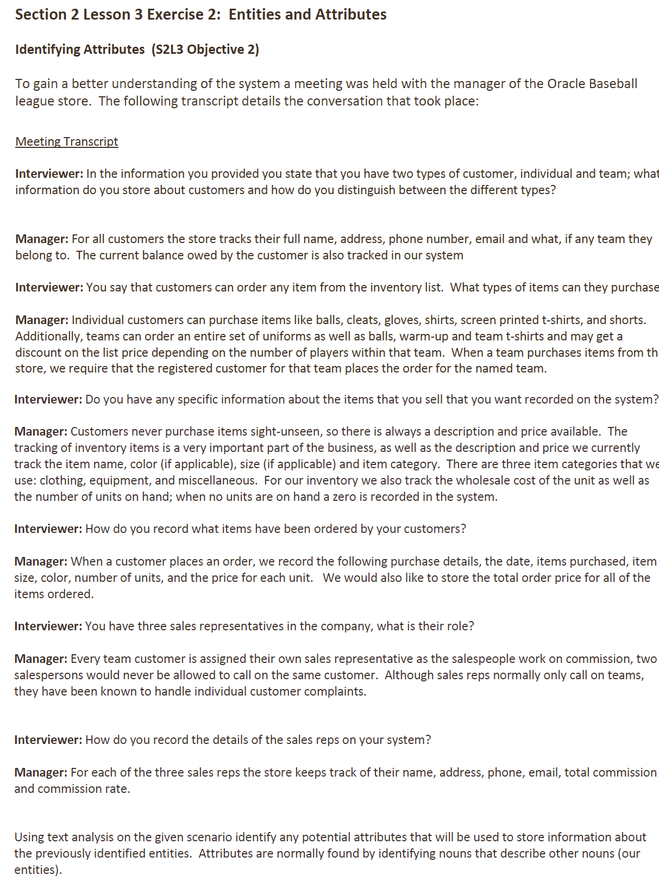

**Answer**:

Potential entities and their respective attributes:

|  |  |
| --- | --- |
| **Entity** | **Attributes** |
| **Customer** | Full Name, Address, Phone Number, Email, Team Affiliation (if any), Current Balance Owed |
| **Team** | Team Name, Number of Players, Discount Eligibility, Registered Customer (Team Representative) |
| **Sales Representative** | Name, Address, Phone Number, Email, Total Commission, Commission Rate |
| **Order** | Order Date, Items Purchased, Item Size, Item Color, Number of Units Purchased, Price per Unit, Total Order Price |
| **Item** | Item Name, Description, Price, Color (if applicable), Size (if applicable), Item Category (Clothing, Equipment, Miscellaneous) |
| **Inventory List** | Wholesale Cost, Units on Hand, Item Name (foreign key to Item), Zero Units Flag (when no units are available) |

**DFo_2_3_3_Project**

**Question**:

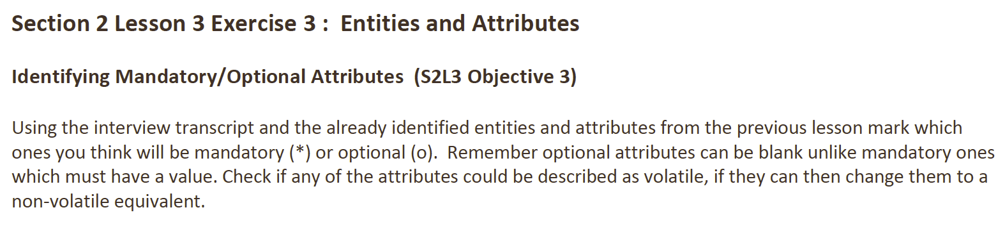

**Answer**:

### Customer (Volatile attributes: Phone Number, Email)

+----------------------------+

| CUSTOMER |

+----------------------------+

| # Customer_ID |

| * Name |

| * Address |

| o Contact Method | (Instead of volatile Phone or Email)

| * Current Balance Owed |

| o Team Affiliation (if any) |

+----------------------------+

### Team

+----------------------------+

| TEAM |

+----------------------------+

| # Team_ID |

| * Name |

| * Number of Players |

| o Discount |

+----------------------------+

### Sales Representative (Volatile attributes: Phone Number, Email)

+----------------------------+

| SALES REPRESENTATIVE |

+----------------------------+

| # Sales_Rep_ID |

| * Name |

| * Address |

| o Contact Method | (Instead of volatile Phone or Email)

| * Commission Rate |

+----------------------------+

### Order (No volatile attributes)

+----------------------------+

| ORDER |

+----------------------------+

| # Order_ID |

| * Date |

| * Items Purchased |

| o Item Size |

| o Color |

| * Price |

| * Number of Units |

| * Total Order Price |

+----------------------------+

### Item (No volatile attributes)

+----------------------------+

| ITEM |

+----------------------------+

| # Item_ID |

| * Name |

| * Description |

| * Price |

| * Category |

| o Color |

| o Size |

+----------------------------+

### Inventory List (No volatile attributes)

+----------------------------+

| INVENTORY LIST |

+----------------------------+

| # Inventory_ID |

| * Cost of the Unit |

| * Units on Hand |

+----------------------------+

**DFo_2_3_4_Project**

**Question**:

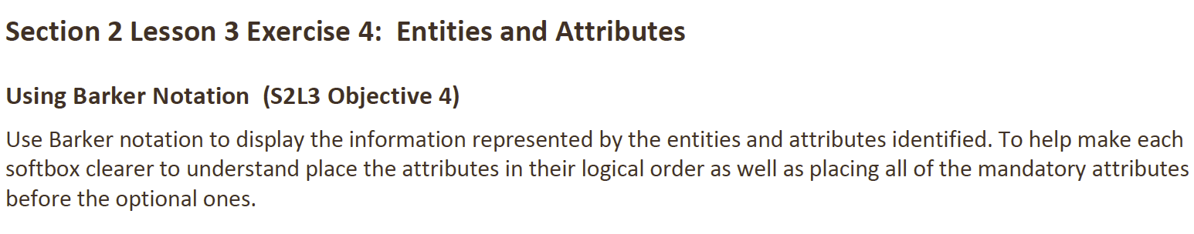

**Answer**:

### Customer (Volatile attributes: Phone Number, Email)

+----------------------------+

| CUSTOMER |

+----------------------------+

| # Customer_ID |

| * Name |

| * Address |

| * Current Balance Owed |

| o Contact Method | (Instead of volatile Phone or Email)

| o Team Affiliation (if any) |

+----------------------------+

### Team

+----------------------------+

| TEAM |

+----------------------------+

| # Team_ID |

| * Name |

| * Number of Players |

| o Discount |

+----------------------------+

### Sales Representative (Volatile attributes: Phone Number, Email)

+----------------------------+

| SALES REPRESENTATIVE |

+----------------------------+

| # Sales_Rep_ID |

| * Name |

| * Address |

| * Commission Rate |

| o Contact Method | (Instead of volatile Phone or Email)

+----------------------------+

### Order (No volatile attributes)

+----------------------------+

| ORDER |

+----------------------------+

| # Order_ID |

| * Date |

| * Items Purchased |

| * Price |

| * Number of Units |

| * Total Order Price |

| o Item Size |

| o Color |

+----------------------------+

### Item (No volatile attributes)

+----------------------------+

| ITEM |

+----------------------------+

| # Item_ID |

| * Name |

| * Description |

| * Price |

| * Category |

| o Color |

| o Size |

+----------------------------+

### Inventory List (No volatile attributes)

+----------------------------+

| INVENTORY LIST |

+----------------------------+

| # Inventory_ID |

| * Cost of the Unit |

| * Units on Hand |

+----------------------------+

**DFo_2_4_1_Project**

**Question**:

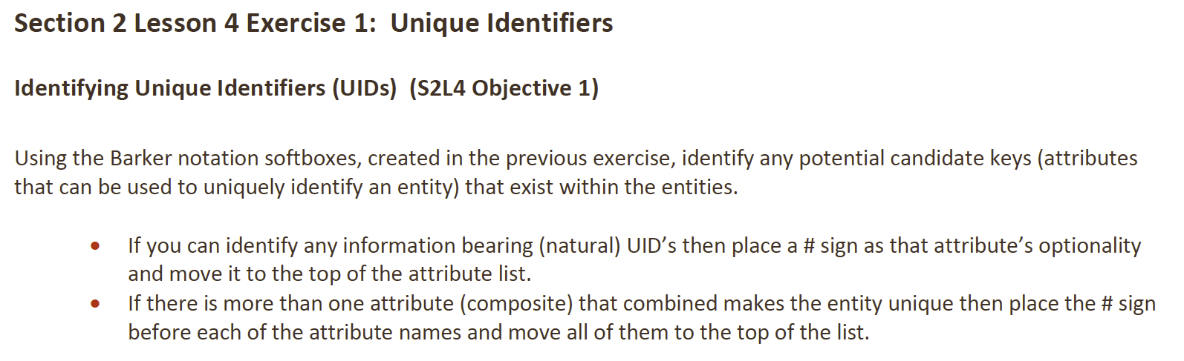

**Answer**:

### Customer

+----------------------------+

| CUSTOMER |

+----------------------------+

| # Email | -- Natural UID

| * Name |

| * Address |

| * Phone Number |

| * Current Balance Owed |

| o Team Affiliation (if any) |

+----------------------------+

### Team

+----------------------------+

| TEAM |

+----------------------------+

| # Name | -- Natural UID

| * Number of Players |

| o Discount |

+----------------------------+

### Sales Representative

+----------------------------+

| SALES REPRESENTATIVE |

+----------------------------+

| # Email | -- Natural UID

| * Name |

| * Address |

| * Phone Number |

| * Commission Rate |

+----------------------------+

### Order

+----------------------------+

| ORDER |

+----------------------------+

| # Date | -- Composite UID (part of the natural UID)

| # Items Purchased | -- Composite UID (part of the natural UID)

| * Price |

| * Number of Units |

| * Total Order Price |

| o Item Size |

| o Color |

+----------------------------+

### Item

+----------------------------+

| ITEM |

+----------------------------+

| # Name | -- Natural UID

| * Description |

| * Price |

| * Category |

| o Color |

| o Size |

+----------------------------+

### Inventory List

+----------------------------+

| INVENTORY LIST |

+----------------------------+

| # Cost of the Unit | -- Natural UID

| * Units on Hand |

+----------------------------+

**DFo_2_4_2_Project**

**Question**:

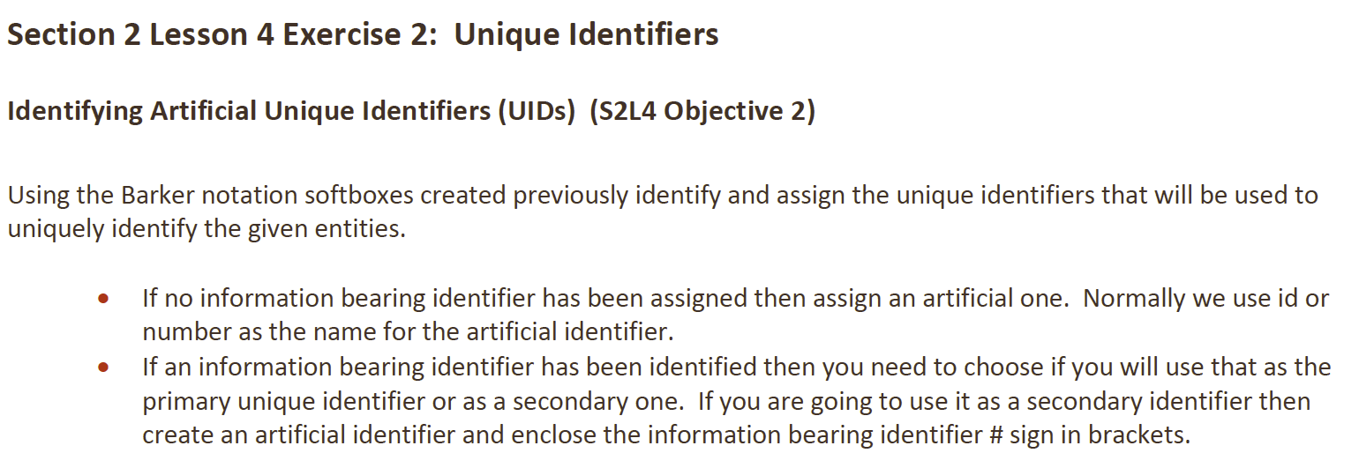

**Answer**:

### Customer

+----------------------------+

| CUSTOMER |

+----------------------------+

| # Customer_ID | -- Artificial UID

| (# Email) | -- Secondary natural UID

| * Name |

| * Address |

| * Phone Number |

| * Current Balance Owed |

| o Team Affiliation (if any) |

+----------------------------+

### Team

+----------------------------+

| TEAM |

+----------------------------+

| # Team_ID | -- Artificial UID

| (# Name) | -- Secondary natural UID

| * Number of Players |

| o Discount |

+----------------------------+

### Sales Representative

+----------------------------+

| SALES REPRESENTATIVE |

+----------------------------+

| # Sales_Rep_ID | -- Artificial UID

| (# Email) | -- Secondary natural UID

| * Name |

| * Address |

| * Phone Number |

| * Commission Rate |

+----------------------------+

### Order

+----------------------------+

| ORDER |

+----------------------------+

| # Order_ID | -- Artificial UID

| * Date |

| * Items Purchased |

| * Price |

| * Number of Units |

| * Total Order Price |

| o Item Size |

| o Color |

+----------------------------+

### Item

+----------------------------+

| ITEM |

+----------------------------+

| # Item_ID | -- Artificial UID

| * Name |

| * Description |

| * Price |

| * Category |

| o Color |

| o Size |

+----------------------------+

### Inventory List

+----------------------------+

| INVENTORY LIST |

+----------------------------+

| # Inventory_ID | -- Artificial UID

| * Cost of the Unit |

| * Units on Hand |

+----------------------------+

**DFo_2_5_1_Project**

**Question**:

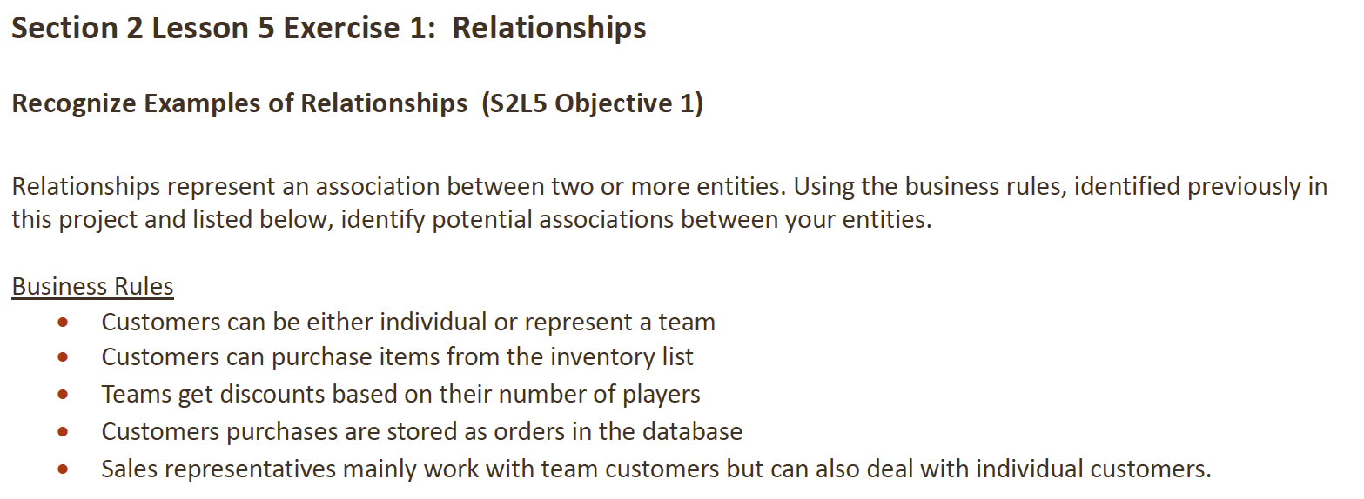

**Answer**:

### Customer and Team Relationship

+----------------------------+ +----------------------------+

| CUSTOMER | | TEAM |

+----------------------------+ +----------------------------+

| # Number |<---------M | # Id |

| (# Email) | | * Name |

| * Name | | * Number of Players |

| * Address | | o Discount |

| * Phone Number | | |

| * Current Balance Owed | | |

| o Team Affiliation (if any) | | |

+----------------------------+ +----------------------------+

M (Each customer must belong to one team)

O (Not all customers are team representatives)

### Customer and Order Relationship

+----------------------------+ +----------------------------+

| CUSTOMER | | ORDER |

+----------------------------+ +----------------------------+

| # Number |------------| # Id |

| (# Email) | 1:M | * Date |

| * Name | | * Items Purchased |

| * Address | | * Price |

| * Phone Number | | * Number of Units |

| * Current Balance Owed | | * Total Order Price |

| o Team Affiliation (if any) | | o Item Size |

+----------------------------+ | o Color |

+----------------------------+

1:M (One customer can place many orders)

### Order and Item Relationship

+----------------------------+ +----------------------------+

| ORDER | | ITEM |

+----------------------------+ +----------------------------+

| # Id |------------| # Number |

| * Date | M:M | * Name |

| * Items Purchased | | * Description |

| * Price | | * Price |

| * Number of Units | | * Category |

| * Total Order Price | | o Color |

| o Item Size | | o Size |

| o Color | +----------------------------+

+----------------------------+

M:M (Each order can contain many items, and an item can appear in many orders)

### Sales Representative and Customer Relationship

+----------------------------+ +----------------------------+

| SALES REPRESENTATIVE | | CUSTOMER |

+----------------------------+ +----------------------------+

| # Id |------------| # Number |

| (# Email) | 1:M | (# Email) |

| * Name | | * Name |

| * Address | | * Address |

| * Phone Number | | * Phone Number |

| * Commission Rate | | * Current Balance Owed |

+----------------------------+ | o Team Affiliation (if any) |

+----------------------------+

1:M (One sales representative may serve many customers)

### Inventory List and Item Relationship

+----------------------------+ +----------------------------+

| INVENTORY LIST | | ITEM |

+----------------------------+ +----------------------------+

| # Id |------------| # Number |

| * Cost of the Unit | 1:M | * Name |

| * Units on Hand | | * Description |

+----------------------------+ | * Price |

| * Category |

| o Color |

| o Size |

+----------------------------+

1:M (One item can be linked to many records in the inventory list)

**DFo_2_5_2_Project**

**Question**:

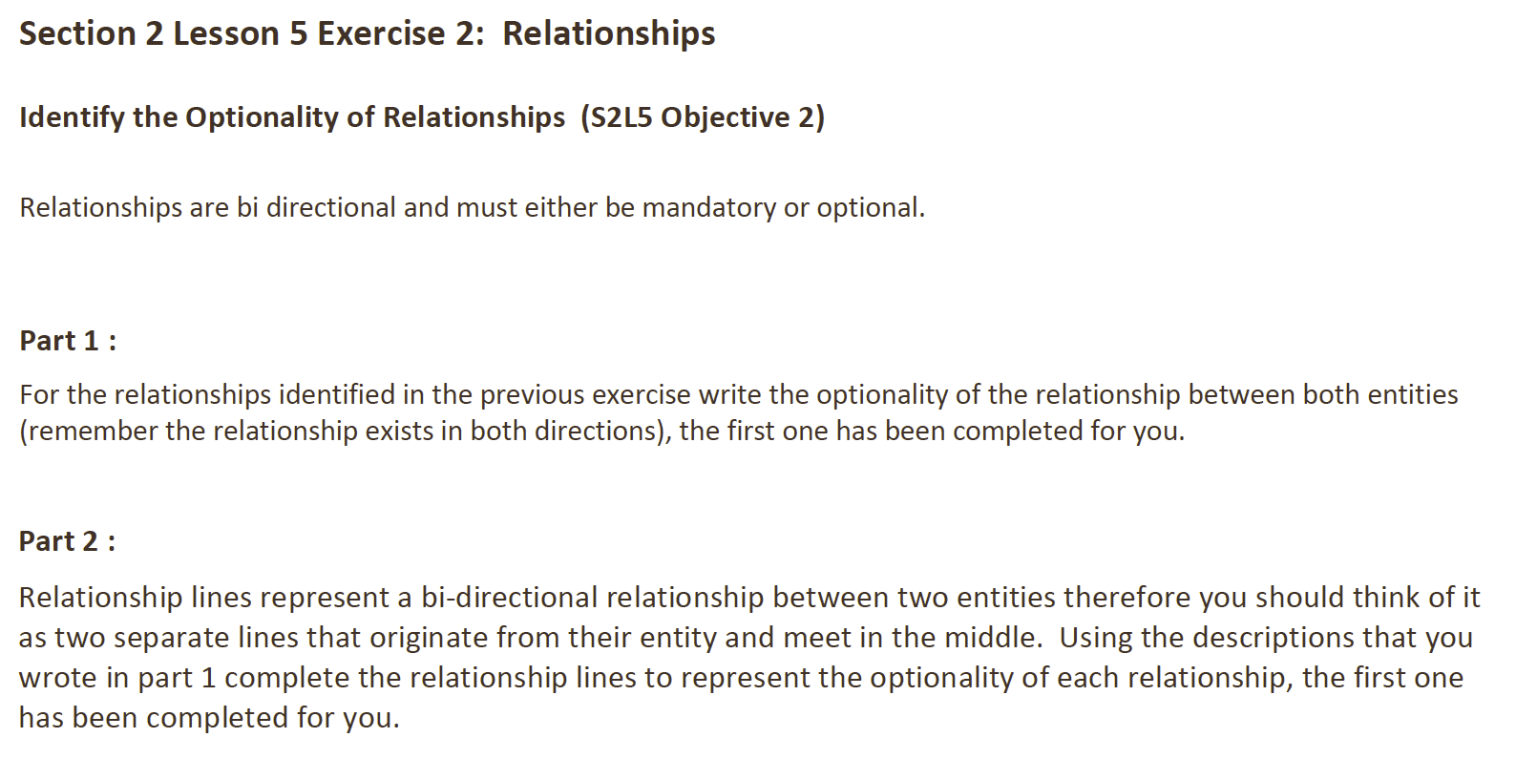

**Answer**:

*Part 1 – Optionality of Relationships*

### Customer and Team Relationship

Left to Right:

• Each CUSTOMER may represent a TEAM (Optional)

Right to Left:

• Each TEAM must be represented by a CUSTOMER (Mandatory)

### Customer and Sales Representative Relationship

Left to Right:

• Each CUSTOMER must be assigned to one SALES REPRESENTATIVE (Mandatory)

Right to Left:

• Each SALES REPRESENTATIVE may serve one or more CUSTOMERS (Optional)

### Customer and Order Relationship

Left to Right:

• Each CUSTOMER may place one or more ORDERS (Optional)

Right to Left:

• Each ORDER must be placed by one CUSTOMER (Mandatory)

### Order and Item Relationship

Left to Right:

• Each ORDER may contain one or more ITEMS (Optional)

Right to Left:

• Each ITEM must appear in at least one ORDER (Mandatory)

### Item and Inventory List Relationship

Left to Right:

• Each ITEM must be linked to at least one INVENTORY record (Mandatory)

Right to Left:

• Each INVENTORY LIST may contain one or more ITEMS (Optional)

*Part 2 – Relationship Lines*

### Customer and Team Relationship

+----------------------------+ +----------------------------+

| CUSTOMER | | TEAM |

+----------------------------+ +----------------------------+

| # Number |<---------M | # Id |

| (# Email) | | * Name |

| * Name | | * Number of Players |

| * Address | | o Discount |

| * Phone Number | | |

| * Current Balance Owed | | |

| o Team Affiliation (if any) | | |

+----------------------------+ +----------------------------+

Left to Right: Optional

Right to Left: Mandatory

---

### Customer and Sales Representative Relationship

+----------------------------+ +----------------------------+

| CUSTOMER | | SALES REPRESENTATIVE |

+----------------------------+ +----------------------------+

| # Number |------------| # Id |

| (# Email) | M | (# Email) |

| * Name | | * Name |

| * Address | | * Address |

| * Phone Number | | * Phone Number |

| * Current Balance Owed | | * Commission Rate |

+----------------------------+ +----------------------------+

Left to Right: Mandatory

Right to Left: Optional

---

### Customer and Order Relationship

+----------------------------+ +----------------------------+

| CUSTOMER | | ORDER |

+----------------------------+ +----------------------------+

| # Number |------------| # Id |

| (# Email) | M | * Date |

| * Name | | * Items Purchased |

| * Address | | * Price |

| * Phone Number | | * Number of Units |

| * Current Balance Owed | | * Total Order Price |

| o Team Affiliation (if any) | | o Item Size |

+----------------------------+ | o Color |

+----------------------------+

Left to Right: Optional

Right to Left: Mandatory

---

### Order and Item Relationship

+----------------------------+ +----------------------------+

| ORDER | | ITEM |

+----------------------------+ +----------------------------+

| # Id |------------| # Number |

| * Date | M:M | * Name |

| * Items Purchased | | * Description |

| * Price | | * Price |

| * Number of Units | | * Category |

| * Total Order Price | | o Color |

| o Item Size | | o Size |

| o Color | +----------------------------+

+----------------------------+

Left to Right: Optional

Right to Left: Mandatory

---

### Item and Inventory List Relationship

+----------------------------+ +----------------------------+

| ITEM | | INVENTORY LIST |

+----------------------------+ +----------------------------+

| # Number |------------| # Id |

| * Name | M | * Cost of the Unit |

| * Description | | * Units on Hand |

| * Price | +----------------------------+

| * Category |

| o Color |

| o Size |

+----------------------------+

Left to Right: Mandatory

Right to Left: Optional

**DFo_2_5_3_Project**

**Question**:

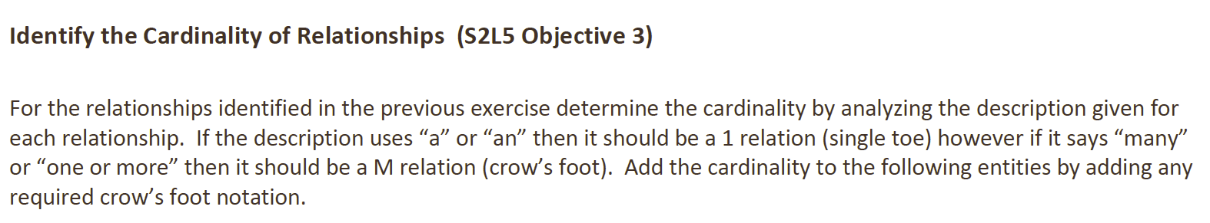

**Answer**:

### Customer and Team Relationship

+----------------------------+ +----------------------------+

| CUSTOMER | | TEAM |

+----------------------------+ +----------------------------+

| # Number |<---------1 | # Id |

| (# Email) | | * Name |

| * Name | | * Number of players |

| * Address | | o Discount |

| * Phone number | | |

| * Current balance | | |

| o Team they belong to | | |

+----------------------------+ +----------------------------+

• Each CUSTOMER may represent a TEAM

• Each TEAM must be represented by a CUSTOMER

---

### Customer and Sales Representative Relationship

+----------------------------+ +----------------------------+

| CUSTOMER | | SALES REPRESENTATIVE |

+----------------------------+ +----------------------------+

| # Number |----------- | # Id |

| (# Email) | 1:M | (# Email) |

| * Name | | * Name |

| * Address | | * Address |

| * Phone number | | * Phone number |

| * Current balance | | * Commission rate |

| o Team they belong to | | |

+----------------------------+ +----------------------------+

• Each CUSTOMER may be assigned a SALES REPRESENTATIVE

• Each SALES REPRESENTATIVE must be assigned to one or more CUSTOMERS

---

### Customer and Order Relationship

+----------------------------+ +----------------------------+

| CUSTOMER | | ORDER |

+----------------------------+ +----------------------------+

| # Number |----------- | # Id |

| (# Email) | 1:M | * Date |

| * Name | | * Items purchased |

| * Address | | * Item size |

| * Phone number | | * Color |

| * Current balance | | * Price |

| o Team they belong to | | * Number of units |

+----------------------------+ | * Total Order Price |

+----------------------------+

• Each CUSTOMER may place one or more ORDERS

• Each ORDER must be placed by a CUSTOMER

---

### Order and Item Relationship

+----------------------------+ +----------------------------+

| ORDER | | ITEM |

+----------------------------+ +----------------------------+

| # Id |----------- | # Number |

| * Date | M:M | * Name |

| * Items purchased | | * Description |

| * Item size | | * Price |

| * Color | | * Category |

| * Price | | o Color |

| * Number of units | | o Size |

| * Total Order Price | +----------------------------+

+----------------------------+

• Each ORDER must include one or more ITEMs

• Each ITEM may be part of one or more ORDERs

---

### Item and Inventory List Relationship

+----------------------------+ +----------------------------+

| ITEM | | INVENTORY LIST |

+----------------------------+ +----------------------------+

| # Number |----------- | # Id |

| * Name | M:M | * Cost of the unit |

| * Description | | * Units on hand |

| * Price | +----------------------------+

| * Category |

| o Color |

| o Size |

+----------------------------+

• Each ITEM must be on an INVENTORY LIST

• Each INVENTORY LIST may include one or more ITEMs

**DFo_2_5_4_Project**

**Question**:

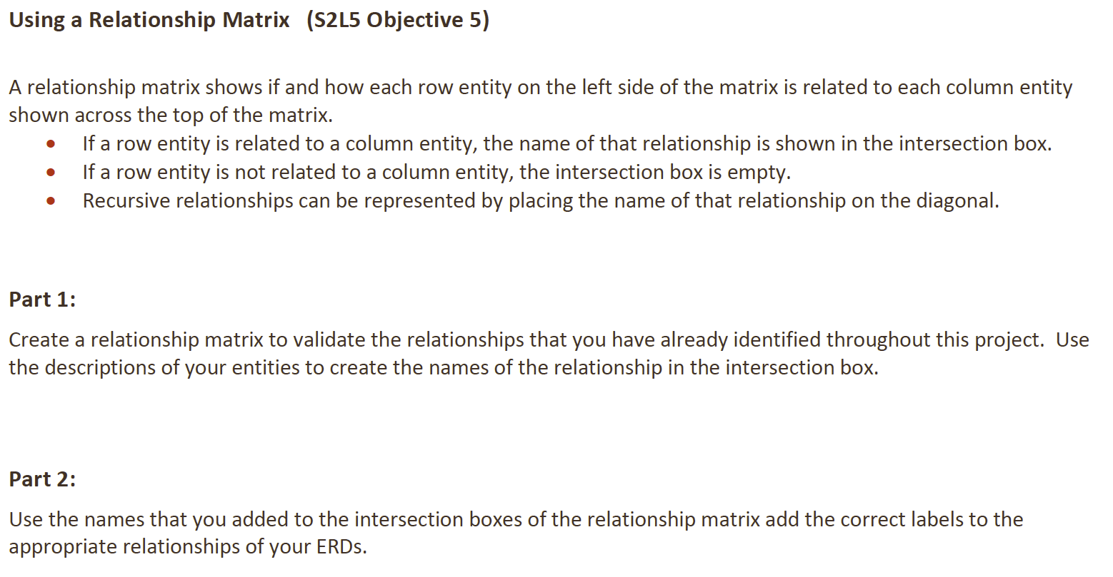

**Answer**:

*Part 1 – Relationship Matrix*

|  |  |  |  |  |  |  |
| --- | --- | --- | --- | --- | --- | --- |
| Entity | Customer | Team | Sales Representative | Order | Item | Inventory List |
| Customer | - (self) | Represents | Assigned to | Places | Purchases | (N/A) |
| Team | Represented by | - (self) | Assigned to | Places through | Purchases for | (N/A) |
| Sales Representative | Assigned to | Assigned to | - (self) | (N/A) | (N/A) | (N/A) |
| Order | Placed by | Placed through | (N/A) | - (self) | Includes | (N/A) |
| Item | Purchased by | Purchased for | (N/A) | Included in | - (self) | Listed in |
| Inventory List | (N/A) | (N/A) | (N/A) | (N/A) | Listed for | - (self) |

* Customer and Team: A customer can represent a team, and each team must be represented by a customer.
* Customer and Sales Representative: Each customer may be assigned to a sales representative who handles their purchases or complaints.
* Customer and Order: A customer places one or more orders.
* Customer and Item: A customer purchases items.
* Team and Sales Representative: A sales representative is assigned to a team to manage their orders.
* Team and Order: A team can place an order through a representative.
* Order and Item: An order includes one or more items.
* Item and Inventory List: Items are listed in the inventory list.

*Part 2 – ERD Labels for Relationships*

1. Customer and Team: Represents / Represented by
2. Customer and Sales Representative: Assigned to
3. Customer and Order: Places / Placed by
4. Customer and Item: Purchases
5. Team and Sales Representative: Assigned to
6. Team and Order: Places through / Placed by
7. Order and Item: Includes / Included in
8. Item and Inventory List: Listed in

**DFo_2_6_Project**

**Question**:

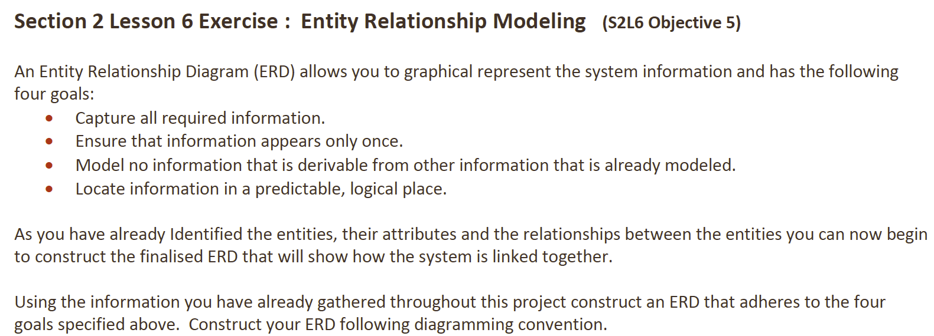

**Answer**

+----------------------------+ +----------------------------+

| CUSTOMER | | TEAM |

+----------------------------+ +----------------------------+

| _Number_ |<--------1 | _Id_ |

| (# Email) | | * Name |

| * Name | | * Number of Players |

| * Address | | o Discount |

| * Phone Number | | |

| * Current Balance | | |

| o Team They Belong To | | |

+----------------------------+ +----------------------------+

1:M (A customer can represent many teams, and each team must be represented by one customer)

|

|

| (Assigned to)

|

v

+----------------------------+

| SALES REPRESENTATIVE |

+----------------------------+

| _Id_ |

| (# Email) |

| * Name |

| * Address |

| * Phone Number |

| * Commission Rate |

+----------------------------+

1:M (A sales representative is assigned to many customers)

^

|

| (Placed by)

|

+----------------------------+

| CUSTOMER |

+----------------------------+ +----------------------------+

| _Number_ |----------- | _Id_ |

| (# Email) | 1:M | * Date |

| * Name | | * Items Purchased |

| * Address | | * Item Size |

| * Phone Number | | * Color |

| * Current Balance | | * Price |

+----------------------------+ | * Number of Units |

| * Total Order Price |

+----------------------------+

1:M (A customer can place many orders, but each order is placed by one customer)

|

| (Includes)

|

v

+----------------------------+ +----------------------------+

| ORDER | | ITEM |

+----------------------------+ +----------------------------+

| _Id_ |----------- | _Number_ |

| * Date | M:M | * Name |

| * Items Purchased | | * Description |

| * Item Size | | * Price |

| * Color | | * Category |

| * Price | | o Color |

| * Number of Units | | o Size |

| * Total Order Price | +----------------------------+

+----------------------------+

M:M (An order can include many items, and an item may be part of many orders)

|

| (Listed in)

|

v

+----------------------------+ | INVENTORY LIST |

| ITEM | +----------------------------+

+----------------------------+ |

| _Number_ |----------- | _Id_ |

| * Name | M:1 | * Cost of the Unit |

| * Description | | * Units on Hand |

| * Price | +----------------------------+

| * Category |

| o Color |

| o Size |

+----------------------------+

M:1 (Each item must be listed in the inventory, and the inventory contains multiple items)

**DFo_3_1_1_Project**

**Question**:

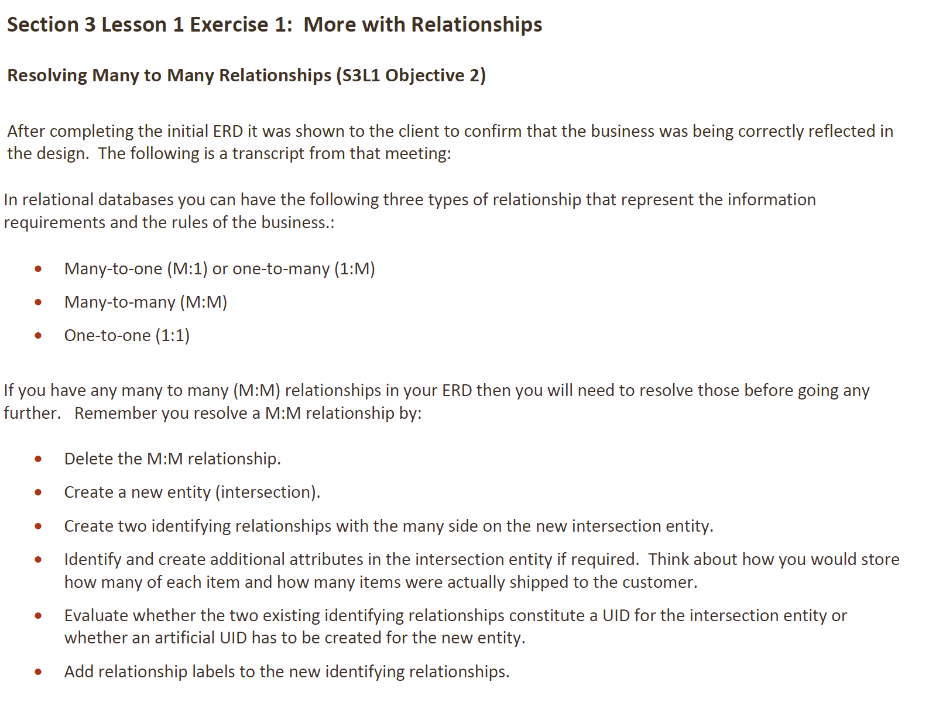

**Answer**:

+----------------------------+ +----------------------------+

| ORDER | | ITEM |

+----------------------------+ +----------------------------+

| _Order_ID_ | | _Item_ID_ |

| * Date | | * Name |

| * Customer_ID | | * Price |

| * Total Price | | * Category |

+----------------------------+ +----------------------------+

|

|

v

+----------------------------+

| ORDER_ITEM |

+----------------------------+

| _Order_Item_ID_ |

| * Order_ID |

| * Item_ID |

| * Quantity |

| * Shipped Quantity |

+----------------------------+

(Tracks items in each order with quantities)

---

+----------------------------+ +----------------------------+

| TEAM | | SALES REPRESENTATIVE |

+----------------------------+ +----------------------------+

| _Team_ID_ | | _SalesRep_ID_ |

| * Name | | * Name |

| * Discount | | * Commission Rate |

+----------------------------+ +----------------------------+

|

|

v

+----------------------------+

| TEAM_SALESREP |

+----------------------------+

| _Team_SalesRep_ID_ |

| * Team_ID |

| * SalesRep_ID |

+----------------------------+

(Assigns sales representatives to teams)

**DFo_3_1_2_Project**

**Question**

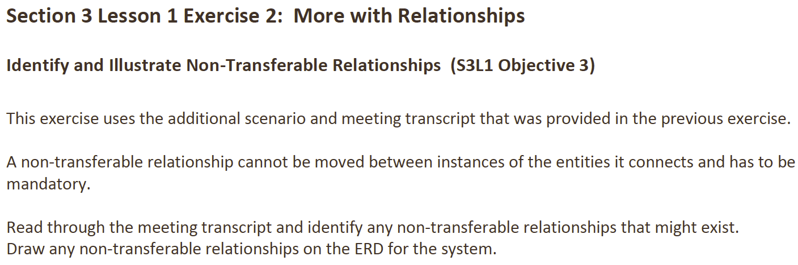

**Answer**

+----------------------------+ +----------------------------+

| CUSTOMER | | TEAM |

+----------------------------+ +----------------------------+

| # Number_ |----------- | # Id |

| (# Email) | 1:M | * Name |

| * Name | | * Number of Players |

| * Address | | o Discount |

| * Phone Number | | |

| * Current Balance | | |

| o Team They Belong To | | |

+----------------------------+ +----------------------------+

Represents / Represented by

|

| (Assigned to)

|

v

+----------------------------+

| SALES REPRESENTATIVE |

+----------------------------+

| # Id |

| (# Email) |

| * Name |

| * Address |

| * Phone Number |

| * Commission Rate |

+----------------------------+

Assigned to / Assigned to (non-transferable)

|

|

v

+----------------------------+ +----------------------------+

| ORDER | ORDERED ITEM

+----------------------------+ +----------------------------+

| # Id_ |-----------

| * Date | 1:M | # Order_Item_ID |

| * Time | | * Quantity Ordered |

| * Items Purchased | | * Quantity Shipped |

| * Price | | |

| * Number of Units | | |

| * Total Order Price | | |

| o Item Size | | |

| o Color | +----------------------------+

+----------------------------+

Places / Placed by (non-transferable)

|

| (Includes)

|

v

+----------------------------+

| ITEM | +----------------------------+

+----------------------------+ | INVENTORY LIST |

| # Number |----------- | # Id_ |

| * Name | M:1 | * Cost of the Unit |

| * Description | | * Units on Hand |

| * Price | +----------------------------+

| * Category |

| o Color |

| o Size |

+----------------------------+

Represented by / On (Inventory List)

**DFo_3_1_3_Project**

**Question**:

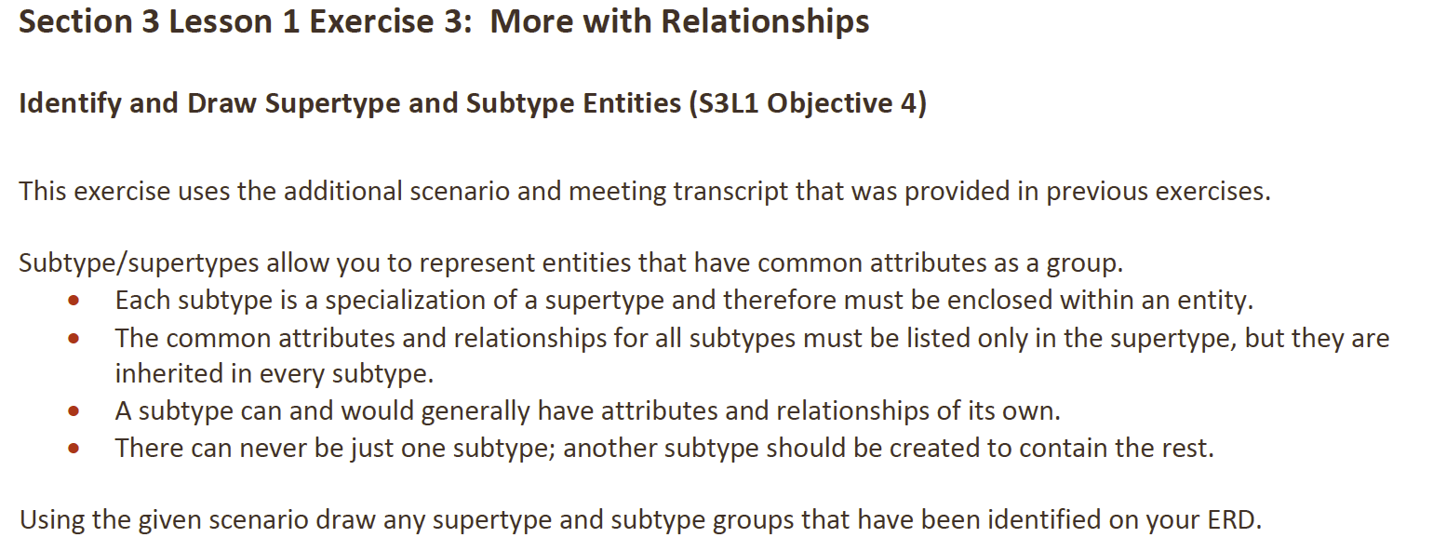

**Answer**:

+----------------------------+ +----------------------------+

| CUSTOMER | | TEAM |

+----------------------------+ +----------------------------+

| # Customer_ID |----------- | # Team_ID |

| * Name | 1:M | * Name |

| * Email | | * Number of Players |

| * Address | | o Discount |

| * Phone Number | | |

| * Balance | | |

+----------------------------+ +----------------------------+

Represents / Represented by

|

|

--------------------------

| |

v v

+---------------------+ +------------------------+

| INDIVIDUAL CUSTOMER | | TEAM CUSTOMER |

+---------------------+ +------------------------+

| # Customer_ID | | # Customer_ID |

| * Purchase History | | * Team Name |

| * Complaints | | * Discount |

+---------------------+ | * Assigned Sales Rep |

+------------------------+

---

+----------------------------+ +----------------------------+

| SALES REPRESENTATIVE | | ORDER |

+----------------------------+ +----------------------------+

| # SalesRep_ID |----------- | # Order_ID |

| (# Email) | 1:M | * Date |

| * Name | | * Time |

| * Address | | * Items Purchased |

| * Phone Number | | * Price |

| * Commission Rate | | * Number of Units |

+----------------------------+ | * Total Order Price |

Assigned to | o Item Size |

| o Color |

+----------------------------+

Placed by / Places

---

+----------------------------+ +----------------------------+

| ORDERED ITEM | | ITEM |

+----------------------------+ +----------------------------+

| # Order_Item_ID |----------- | # Item_ID |

| * Quantity Ordered | M:M | * Name |

| * Quantity Shipped | | * Description |

| * Order_ID | | * Price |

| * Item_ID | | * Category |

+----------------------------+ | o Color |

Part of / Includes | o Size |

+----------------------------+

---

+----------------------------+ +----------------------------+

| INVENTORY LIST | | ITEM |

+----------------------------+ +----------------------------+

| # Inventory_ID |----------- | # Item_ID |

| * Cost of the Unit | M:1 | * Name |

| * Units on Hand | | * Description |

+----------------------------+ | * Price |

Includes | o Color |

| o Size |

+----------------------------+

**DFo_3_1_4_Project**

**Question**:

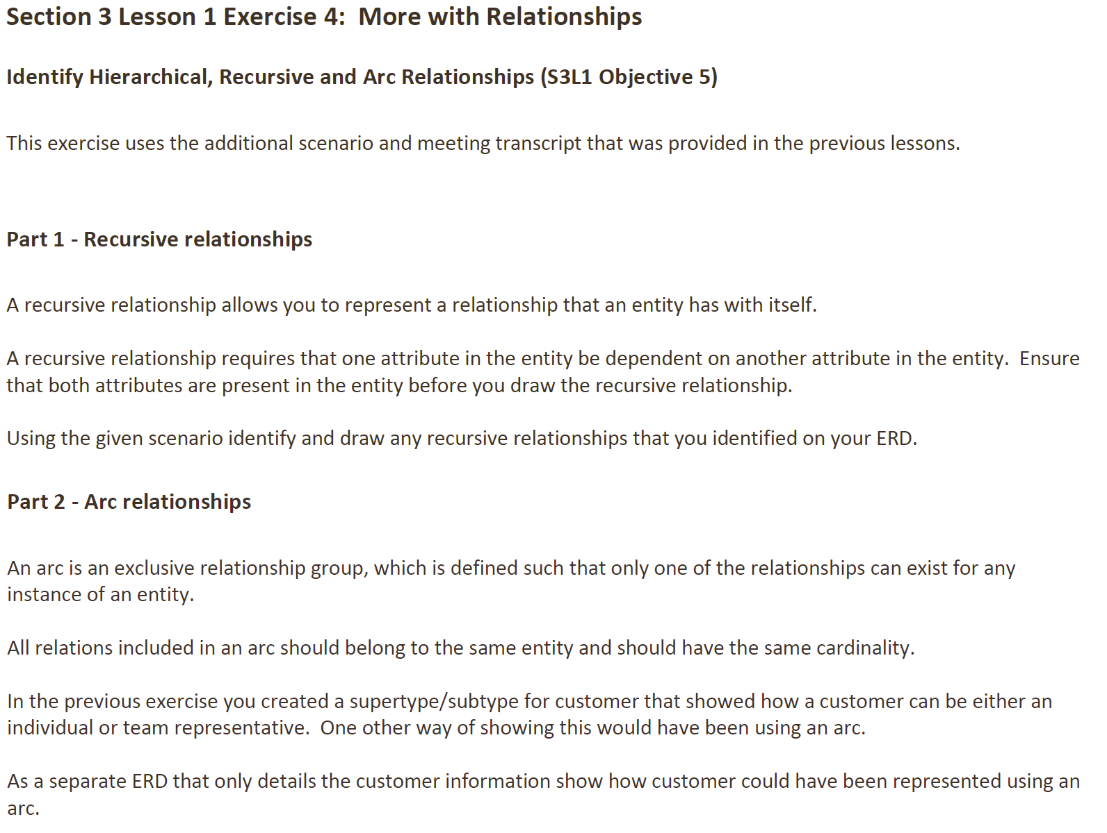

**Answer**:

*Part 1 – Recursive Relationship*

+----------------------------+

| SALES REPRESENTATIVE |

+----------------------------+

| # SalesRep_ID |

| * Name |

| * Email |

| * Address |

| * Phone Number |

| * Commission Rate |

| o Supervisor_ID | (Recursive relationship)

+----------------------------+

SalesRep_ID (Self-referencing)

*Part 2 – Arc Relationship*

+----------------------------+

| CUSTOMER |

+----------------------------+

| # Customer_ID |

| * Name |

| * Email |

| * Address |

| * Phone Number |

| * Balance |

| |

| (Arc Relationship) |

|-----------------------------|

| * Individual Purchase |

| * Team Purchase |

+----------------------------+

**DFo_3_2_Project**

**Question**:

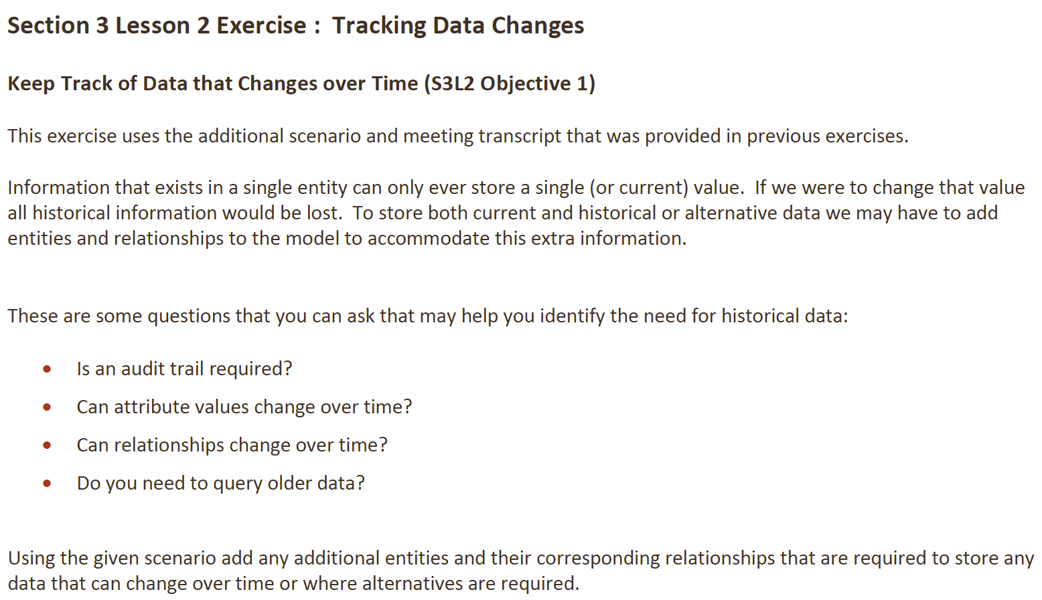

**Answer**:

+----------------------------+ +----------------------------+

| CUSTOMER | | CUSTOMER_HISTORY |

+----------------------------+ +----------------------------+

| # Customer_ID |----------- | # History_ID |

| * Name | 1:M | * Customer_ID |

| * Email | | * Change_Date |

| * Address | | * Old_Name |

| * Phone_Number | | * Old_Email |

+----------------------------+ | * Old_Address |

| * Old_Phone_Number |

+----------------------------+

---

+----------------------------+ +----------------------------+

| TEAM | | TEAM_HISTORY |

+----------------------------+ +----------------------------+

| # Team_ID |----------- | # History_ID |

| * Name | 1:M | * Team_ID |

| * Number_of_Players | | * Change_Date |

| * Discount | | * Old_Number_of_Players |

+----------------------------+ | * Old_Discount |

| * Old_SalesRep_ID |

+----------------------------+

---

+----------------------------+ +----------------------------+

| ITEM | | ITEM_PRICE_HISTORY |

+----------------------------+ +----------------------------+

| # Item_ID |----------- | # History_ID |

| * Name | 1:M | * Item_ID |

| * Description | | * Change_Date |

| * Price | | * Old_Price |

| * Category | | * New_Price |

+----------------------------+ +----------------------------+

By adding entities such as **Customer_History**, **Team_History**, and **Item_Price_History**, we can effectively track changes in important data over time, ensuring that both current and historical data are available for queries and audits.

**DFo_3_3_1_Project**

**Question**:

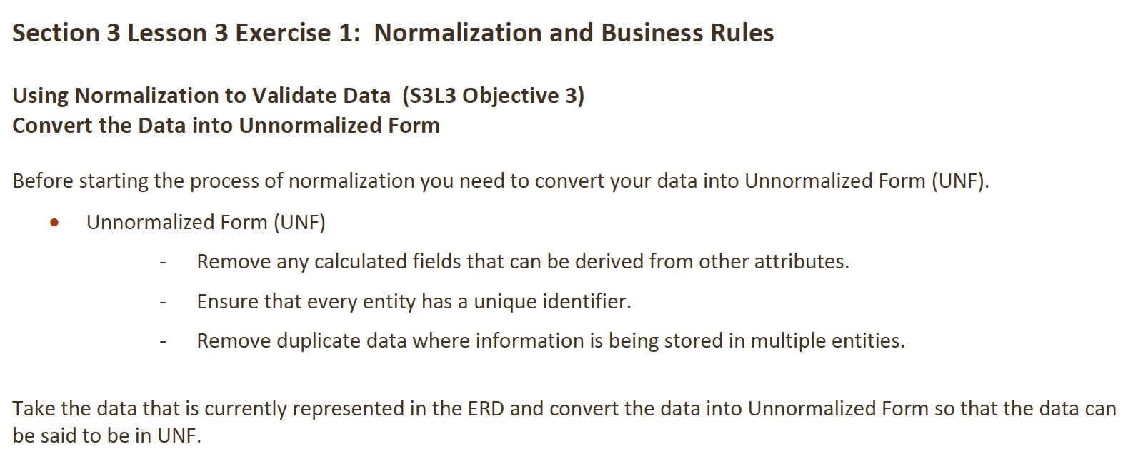

**Answer**:

+----------------------------+

| CUSTOMER |

+----------------------------+

| # Customer_ID |

| * Name |

| * Address |

| * Phone Number |

| * Balance |

| o Team_ID (FK) |

+----------------------------+

(Links to Team for Team Customers)

|

| Represents/Represented By

|

v

+----------------------------+

| TEAM |

+----------------------------+

| # Team_ID |

| * Name |

| * Number of Players |

| o Discount |

+----------------------------+

(Discount based on number of players)

|

| Assigned to

|

v

+----------------------------+

| SALES REPRESENTATIVE |

+----------------------------+

| # SalesRep_ID |

| * Name |

| * Email |

| * Address |

| * Phone Number |

+----------------------------+

|

| Assigned to

|

v

+----------------------------+ +----------------------------+

| ORDER | | ORDERED ITEM |

+----------------------------+ +----------------------------+

| # Order_ID |----------- | # Order_Item_ID |

| * Date | 1:M | * Order_ID (FK) |

| * Customer_ID (FK) | | * Item_ID (FK) |

+----------------------------+ | * Quantity |

(Placed by Customer) | * Shipped Quantity |

+----------------------------+

|

| Part of/Includes

v

+----------------------------+

| ITEM |

+----------------------------+

| # Item_ID |

| * Name |

| * Price |

+----------------------------+

**DFo_3_3_2_Project**

**Question**:

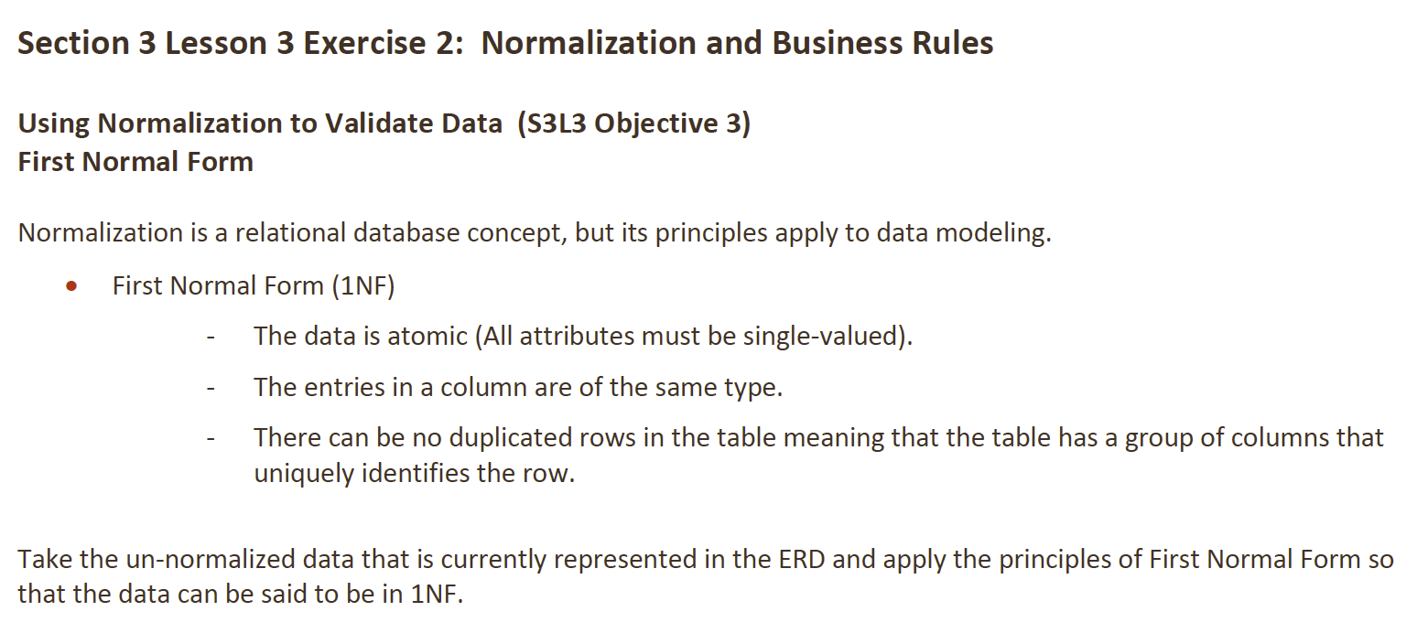

**Answer**:

**Customer Table**

|  |  |  |
| --- | --- | --- |
| **Customer_ID** | **Name** | **Email** |
| 1 | John Doe | john@mail.com |
| 2 | Jane Doe | jane@mail.com |

**Team Table**

|  |  |  |  |
| --- | --- | --- | --- |
| **Team_ID** | **Team Name** | **Number of Players** | **Discount** |
| A | Team A | 12 | 10% |
| B | Team B | 9 | 5% |

**Customer-Team Relationship Table**

|  |  |
| --- | --- |
| **Customer_ID** | **Team_ID** |
| 1 | A |
| 1 | B |

**Order Table**

|  |  |  |
| --- | --- | --- |
| **Order_ID** | **Customer_ID** | **Date** |
| 1 | 101 | 9/4/2024 |

**Order_Item Table**

|  |  |  |  |
| --- | --- | --- | --- |
| **Order_ID** | **Item_ID** | **Quantity** | **Shipped_Quantity** |
| 1 | 1 | 2 | 2 |
| 1 | 2 | 1 | 1 |

**Sales Representative Table**

|  |  |  |
| --- | --- | --- |
| **SalesRep_ID** | **Name** | **Email** |
| 1 | Alice | alice@mail.com |
| 2 | Bob | bob@mail.com |

**SalesRep-Customer/Team Relationship Table**

|  |  |
| --- | --- |
| **SalesRep_ID** | **Customer_ID/Team_ID** |
| 1 | 101 |
| 1 | A |
| 1 | B |

**DFo_3_3_3_Project**

**Question**:

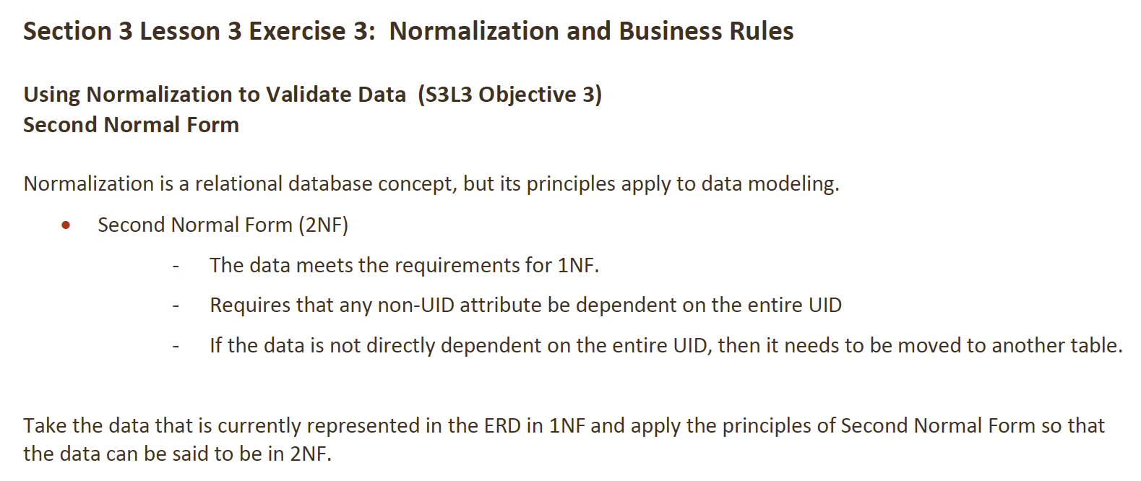

**Answer:**

+----------------------------+

| CUSTOMER |

+----------------------------+

| # Customer_ID |

| * Name |

| * Email |

| * Address |

| * Phone Number |

+----------------------------+

|

| (Represents / Represented by)

v

+----------------------------+

| TEAM |

+----------------------------+

| # Team_ID |

| * Team Name |

| * Number of Players |

| o Discount |

+----------------------------+

|

| (Relationship)

v

+----------------------------+

| CUSTOMER_TEAM RELATIONSHIP|

+----------------------------+

| * Customer_ID (FK) |

| * Team_ID (FK) |

+----------------------------+

---

+----------------------------+

| SALES REPRESENTATIVE |

+----------------------------+

| # SalesRep_ID |

| * Name |

| * Email |

| * Address |

| * Phone Number |

+----------------------------+

|

| (Assigned to)

v

+----------------------------+

| ORDER |

+----------------------------+

| # Order_ID |

| * Customer_ID (FK) |

| * Date |

+----------------------------+

(Placed by Customer)

---

+----------------------------+

| ORDERED ITEM |

+----------------------------+

| # Order_Item_ID |

| * Order_ID (FK) |

| * Item_ID (FK) |

| * Quantity |

| * Shipped Quantity |

+----------------------------+

(Includes / Part of)

|

| (Includes)

v

+----------------------------+

| ITEM |

+----------------------------+

| # Item_ID |

| * Name |

| * Price |

| * Category |

+----------------------------------------------+

**DFo_3_3_4_Project**

**Question**:

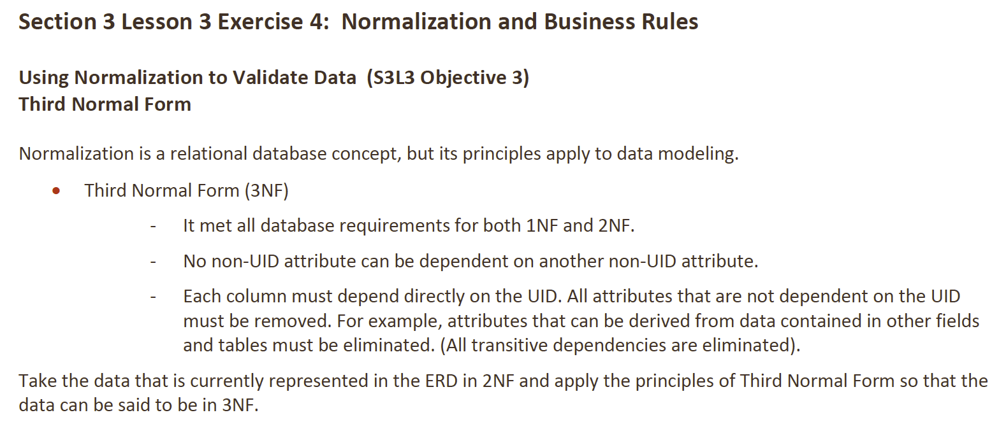

**Answer**:

+----------------------------+

| CUSTOMER |

+----------------------------+

| # Customer_ID |

| * Name |

| * Email |

| * Address |

| * Phone Number |

+----------------------------+

|

| (Represents / Represented by)

v

+----------------------------+

| TEAM |

+----------------------------+

| # Team_ID |

| * Team Name |

| * Number of Players |

+----------------------------+

|

| (Assigned to)

v

+----------------------------+

| CUSTOMER_TEAM RELATIONSHIP|

+----------------------------+

| * Customer_ID (FK) |

| * Team_ID (FK) |

+----------------------------+

---

+----------------------------+

| SALES REPRESENTATIVE |

+----------------------------+

| # SalesRep_ID |

| * Name |

| * Email |

| * Address |

| * Phone Number |

+----------------------------+

|

| (Assigned to)

v

+----------------------------+

| ORDER |

+----------------------------+

| # Order_ID |

| * Customer_ID (FK) |

| * Date |

+----------------------------+

(Placed by Customer)

---

+----------------------------+

| ORDERED ITEM |

+----------------------------+

| # Order_Item_ID |

| * Order_ID (FK) |

| * Item_ID (FK) |

| * Quantity |

| * Shipped Quantity |

+----------------------------+

(Includes / Part of)

|

| (Includes)

v

+----------------------------+

| ITEM |

+----------------------------+

| # Item_ID |

| * Name |

| * Price |

| * Category |

+----------------------------+

**DFo_3_4_Project**

**Question**:

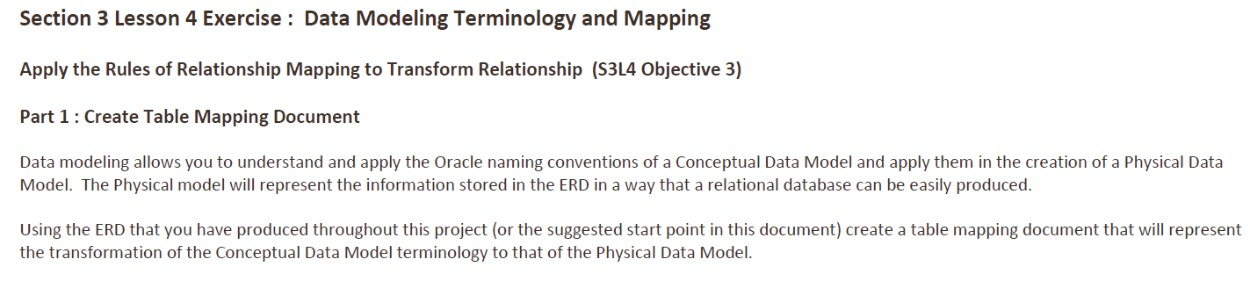

**Answer**:

**Team Table**

|  |  |  |  |  |
| --- | --- | --- | --- | --- |
| **Table Name** | **Table Short Name** | **Key Type** | **Optionality** | **Column Name** |
| teams | tem | pk | * | team_id |
|  |  |  | * | name |
|  |  |  | * | number_of_players |
|  |  |  | o | discount |

**Sales Representative Table**

|  |  |  |  |  |
| --- | --- | --- | --- | --- |
| **Table Name** | **Table Short Name** | **Key Type** | **Optionality** | **Column Name** |
| sales_representatives | sre | pk | * | sre_id |
|  |  | uk | * | email |
|  |  |  | * | first_name |
|  |  |  | * | last_name |
|  |  |  | * | phone_number |
|  |  |  | * | commission_rate |
|  |  | fk1 | o | supervisor_id |

**Order Table**

|  |  |  |  |  |
| --- | --- | --- | --- | --- |
| **Table Name** | **Table Short Name** | **Key Type** | **Optionality** | **Column Name** |
| orders | odr | pk | * | order_id |
|  |  |  | * | date |
|  |  |  | * | time |
|  |  |  | * | number_of_units |
|  |  | fk1 | * | ctr_number |

**Ordered Items Table**

|  |  |  |  |  |
| --- | --- | --- | --- | --- |
| **Table Name** | **Table Short Name** | **Key Type** | **Optionality** | **Column Name** |
| ordered_items | oim |  | * | quantity_ordered |
|  |  |  | * | quantity_shipped |
|  |  | fk1 | * | order_id |
|  |  | fk2 | * | item_number |

**Item Table**

|  |  |  |  |  |
| --- | --- | --- | --- | --- |
| **Table Name** | **Table Short Name** | **Key Type** | **Optionality** | **Column Name** |
| items | itm | pk | * | item_number |
|  |  |  | * | name |
|  |  |  | * | description |
|  |  |  | * | category |
|  |  | o | o | color |
|  |  | o | o | size |
|  |  | fk1 | * | inventory_list_id |

**Inventory List Table**

|  |  |  |  |  |
| --- | --- | --- | --- | --- |
| **Table Name** | **Table Short Name** | **Key Type** | **Optionality** | **Column Name** |
| inventory_list | ilt | pk | * | inventory_id |
|  |  |  | * | unit_cost |
|  |  |  | * | units_on_hand |

**Price History Table**

|  |  |  |  |  |
| --- | --- | --- | --- | --- |
| **Table Name** | **Table Short Name** | **Key Type** | **Optionality** | **Column Name** |
| price_history | prh | pk | * | start_date |
|  |  |  | * | start_time |
|  |  |  | * | price |
|  |  | o | o | end_date |
|  |  | o | o | end_time |
|  |  | fk1 | * | item_number |