***The Power of Six: Riding into the Future with Internet of Things (IoT), Fog/Edge Computing, Cloud Native Computing, Voice Computing, AI and Blockchain Revolutions To Build Smart Homes, Smart Offices, Smart Buildings, Smart Factories, Smart Cities, and Autonomous Drones, Vehicles, and Robotics***

***Join the Trillion-Dollar Industry Now***

**internet of things (IoT), voice and edge Computing Specialist**

**A Program DEsigned for absolute beginners:**

**No background in programming or electronics required**

***Free Seminar on Sunday, September 2, 2018 at 1:00 pm***

***Classes only on Sundays or Evenings***

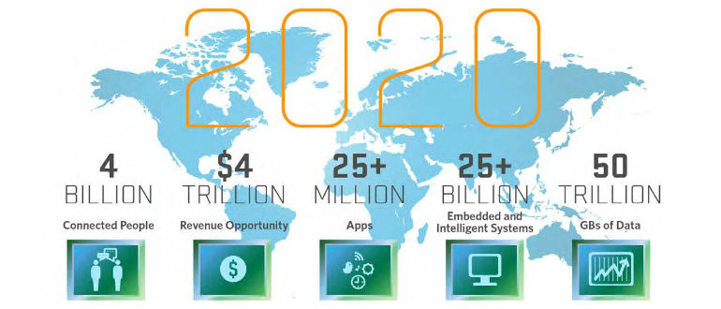***Classes starting from Sunday, September 9, 2018 at 1:00 pm***

***IoT Questions and Descussions: https://www.facebook.com/groups/iot.dev.pk/***

|  |  |
| --- | --- |
| **Type** | **What we will Cover in this Course** |
| Gateway OS (Fog) and Cloud | Raspbian for Fog and Linux for Cloud (Docker) |
| Edge OS | Amazon FreeRTOS and Azure Sphere |
| Gateway Software | Azure IoT Edge |
| Programming Languages | C, JavaScript, TypeScript, Solidity, and AssemblyScript (Web Assembly) |
| Virtual Assistant | Google Assistant |
| Gateway Hardware (Fog) | Raspberry PI 3 B+ and Raspberry PI Zero WH |
| Microcontroller | ESP32 with Amazon FreeRTOS |
| Crossover Microcontroller | MT3620 with Azure Sphere |
| Cloud Computing | Azure IoT Hub, MQTT |
| Networking (Star and Mesh) | WiFi, Bluetooth 4.2, Dotdot over ZigBee 3.0, and Dotdot over Thread 1.1 |
| Cloud IoT Services | AWS IoT Services and Azure IoT Services |
| Tools and Libraries | Node-RED and Johnny-Five |
| Serverless | Azure Cloud Functions |
| Artificial Intelligence (AI) | Keras for Deep Learning |
| Payment Blockchain | IOTA-Machine-to-Machine (M2M) Micro Payments |
| Smart Contract Blockchain | Ethereum |

The Internet of things (IoT) is the inter-networking of physical devices, vehicles (also referred to as "connected devices" and "smart devices"), buildings, and other items—embedded with electronics, software, sensors, actuators, and network connectivity that enable these objects to collect and exchange data. IoT is expected to offer advanced connectivity of devices, systems, and services that goes beyond machine-to-machine (M2M) communications and covers a variety of protocols, domains, and applications. The interconnection of these embedded devices (including smart objects), is expected to used in automation in nearly all fields, while also enabling advanced applications like a smart homes, and expanding to areas such as smart cities. Autonomous Smart Drones, Vehicles, and Robotics are expected to use the same architecture.

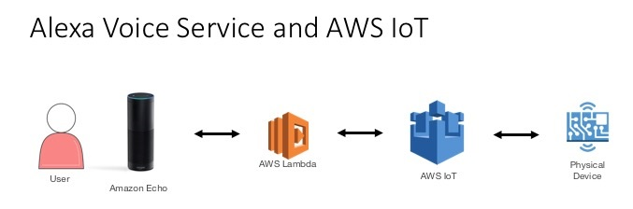

Amazon’s Alexa and the Google Assistant – one of these helpful voice assistants are the best way to control your smart devices, instead of pulling out your phone and tapping the screen. The future of the internet of things will be shaped by these two major assistants.

According to Gartner, Inc., there will be nearly 20.8 billion devices on the Internet of Things by 2020. ABI Research estimates that more than 30 billion devices will be wirelessly connected to the Internet of things by 2020. With the emergence of digital economy, the global Internet of Things (IoT) market spend will grow from $625.2 billion in 2015 to $1.29 trillion in 2020 -- with a compound annual growth rate (CAGR) of 15.6 per cent.

**Five Pillars of Full Stack IoT and Smart Home/Factory Development:**

**Amazon’s Echo and Google Home: The OS for the IoT**

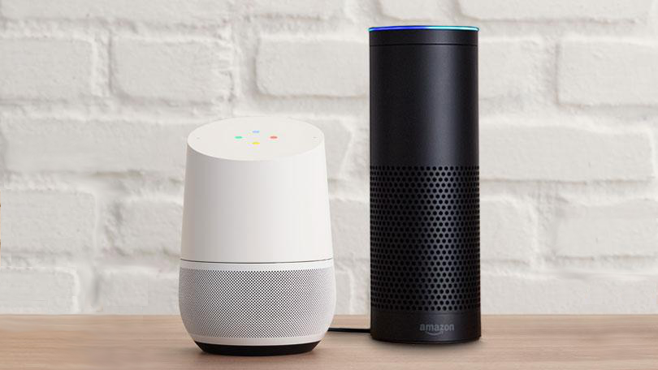Amazon's Echo (Alexa) and Google Home have become the operating systems (OS) for the Internet of Things (IoT), just as Google Android and Apple iOS have done with mobile. It provides a voice based conversational interface to the IoT platform. The functionality can also be used from Android and iPhone.

**Embedded Systems**

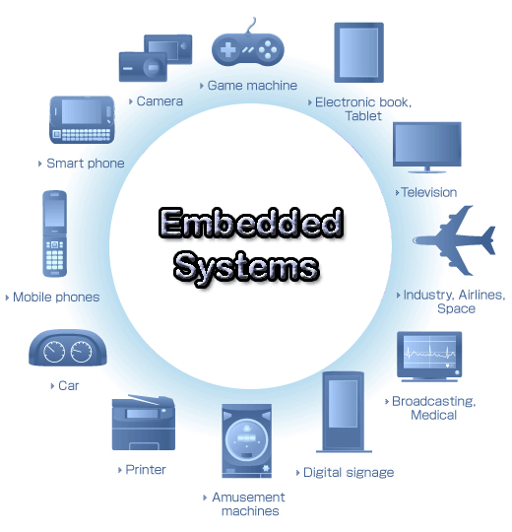An embedded system is a computer system with a dedicated function within a larger mechanical or electrical system, often with real-time computing constraints. It is embedded as part of a complete device often including hardware and mechanical parts. Embedded systems control many devices in common use today. Ninety-eight percent of all microprocessors are manufactured as components of embedded systems.

Examples of properties of typically embedded computers when compared with general-purpose counterparts are low power consumption, small size, rugged operating ranges, and low per-unit cost. This comes at the price of limited processing resources, which make them significantly more difficult to program and to interact with. However, by building intelligence mechanisms on top of the hardware, taking advantage of possible existing sensors and the existence of a network of embedded units, one can both optimally manage available resources at the unit and network levels as well as provide augmented functions, well beyond those available. For example, intelligent techniques can be designed to manage power consumption of embedded systems.

Modern embedded systems are often based on microcontrollers (i.e. CPU's with integrated memory or peripheral interfaces), but ordinary microprocessors (using external chips for memory and peripheral interface circuits) are also common, especially in more-complex systems. In either case, the processor(s) used may be types ranging from general purpose to those specialized in certain class of computations, or even custom designed for the application at hand. A common standard class of dedicated processors is the digital signal processor (DSP).

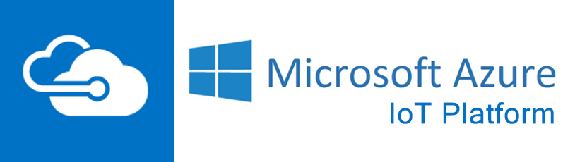**Amazon and Azure Web Services IoT Cloud, Fog and Edge Services**

AWS and Azure have built IoT specific services, such as AWS Greengrass, AWS IoT and Azure IoT Edge. They help you collect and send data to the cloud, make it easy to load and analyze that information, and provide the ability to manage your devices, so you can focus on developing applications that fit your needs.

**AI and Deep Learning**

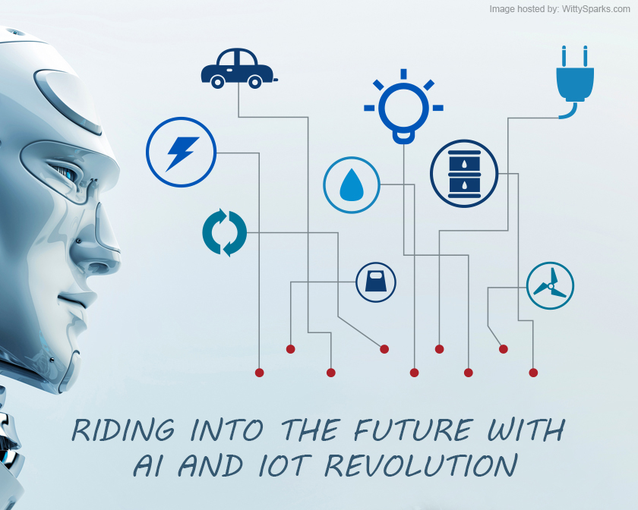Artificial intelligence, or AI, which allows machines to reason and learn in ways once associated only with humans. Combine AI with IoT, and you have something vastly more interesting than either one by itself—the ability to recognize meaningful patterns buried in mountains of data, and do so in fractions of a second, in ways that would be exceptionally difficult for most humans. Better yet, the algorithms get smarter over time. For example, the massive amount of geographic and demographic information, usage patterns, and finer data points collected by products like the Smart Fridge creates a big opportunity to discover consumer behavior patterns and eventually profit from these insights.

**Blockchain and Smart Contracts**

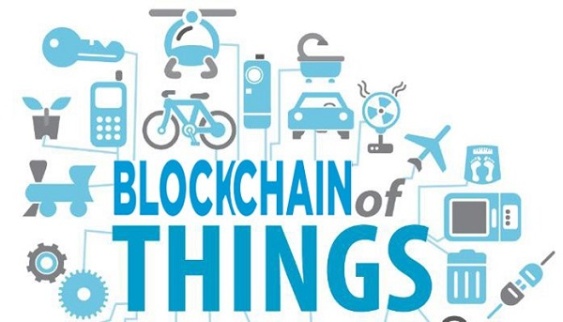Blockchains use a decentralized network to support online transactions. With a distributed nature, it is basically a self-powered ledger that meticulously maintains the same immutable record of all entries (or transactions) on all nodes in the network.

One of the biggest issues in IoT is knowing who you are connecting to. That requirement for trust mechanisms across millions or billions of sensors is what makes a distributed system like a blockchain vital.

Any inputs provided by individual users in the network – be they humans or machines – will therefore be able to share information across in a secure manner. This is where the Internet of Things reveals its highly useful integration with blockchain. Any system of interconnected IoT devices can use blockchains to reliably organize, store, and share streams of data.

Where blockchain distributes a ledger system, the "contract" concept introduced by Ethereum Blockchain extends the function of the ledger to include a language for terms of agreement and measurements to determine if certain conditions have been met. "A smart contract can be designed to execute automatically when the conditions are met". There is no doubt IoT combined with smart contracts on blockchain will be beneficial in industrial IoT use cases in the beginning and will latter expand to consumers.

**Fee: Rs. 9,000 per Semester (The duration of the course is nine months i.e. two Semesters).**

**Class Time 2 hours of classes two days a week**

**Sunday: 1:00 pm – 3:00 pm**

**Friday: 7:00 pm - 9:00 pm**

**The Minimum Lab Kit:**

Raspberry Pi 3 B+ and/or Pi Zero W with Soldered Header

ESP32 Development Board

MicroSD Card with Adapter - 16GB (Class 10)

Wall Adapter Power Supply - 5.25V DC 2.4A (USB Micro-B)

Humidity and Temperature Sensor - RHT03

PIR Motion Sensor (JST)

Breadboard - Self-Adhesive (White)

LED - Assorted (20 pack)

Resistor 10K Ohm 1/6th Watt PTH - 20 pack

Resistor 330 Ohm 1/6 Watt PTH - 20 pack

Jumper Wires - Connected 6in. (M/M, 20 pack)

Jumper Wires - Connected 6in. (M/F, 20 pack)

**Additional Lab Kit:**

Azure Sphere MT3620 Development Kit

<https://www.seeedstudio.com/Azure-Sphere-MT3620-Development-Kit-p-3052.html>

**Course Outline: Two Semesters of Course work**

**Semester I: IoT Edge and Voice Computing**

**Semester I A: Introduction to Web of Things and Getting Started with Raspberry PI**

In part 1A we lay the basis of the Web of Things, what it is, and how it compares and relates to the Internet of Things. We will also get you started with Raspberry PI the predominately used Edge hardware.

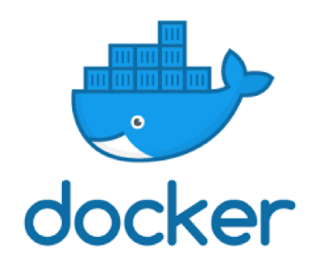

**Module B: Docker Deep Dive**

This course provides a soup-to-nuts learning experience for core Docker technologies, including the Docker Engine, Images, Containers, Registries, Networking, Storage, and more. All of the behind the scenes theory is explained, and all concepts are clearly demonstrated on the command line. No prior knowledge of Docker or Linux is required.

**Module C: Version Control with Git**

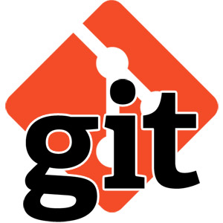 You won't find a top programmer, web developer, or AI enginner who doesn't use version control. Because it helps you produce better results and makes collaboration easy. Around the world, in teams large and small, Git is an essential part of the tool chain. We will start learning our learning process by covering Git and Github.

**Semester I D: JavaScript/TypeScript, and Node 10/Express**

We will start the module by building a solid foundation in Functional and Object-Oriented Programming using JavaScript (ES 2015) and TypeScript using Node.js 10. Assuming no prior programming experience on the part of the student this module starts by focusing on the fundamentals of composing code with JavaScript. Introduction to only server based JavaScript/TypeScript is covered i.e. Node.js 10. You'll learn about the syntax and structure of the language including operators and expressions, control structures, methods, and arrays using Node. In this module we will also learn Git, the distributed version control system. We will also review Git based GitHub and BitBucket services.

**Semester II E: Edge Computing - Azure IoT Edge**

In this module we will cover the Edge solutions from Microsoft: Azure IoT Edge. In this module we will also learn to develop cloud serverless functions and containers using Azure IoT Edge.

**Semester II F: Electronics for IoT**

In this module we learn basics of electronics required for IoT.

**Semester I G: Building the Web of Things using Raspberry Pi**

It is a hands-on module that teaches you how to design and implement scalable, flexible, and open IoT solutions using web technologies. This module focuses on providing the right balance of theory, code samples, and practical examples to enable you to successfully connect all sorts of devices to the web and to expose their services and data over REST APIs.

**Semester I H: Voice Computing using Google Assistant**

In this module we will learn to control devices with the Google Assistant by building apps that integrate Smart Home functionality.

**Detailed Semester I Course Outline:**

|  |  |  |
| --- | --- | --- |
|  | **Topic** | **Reading Material** |
| 1 | Introduction to IoT | Chapter 1, Building the Web of Things by Dominique Guinard and Vlad Trifa  <https://www.amazon.com/Building-Web-Things-examples-Raspberry/dp/1617292680/ref=sr_1_1>  <https://www.dropbox.com/s/3k160kbwpg4e61v/iot_intro.pptx?dl=0>  **Web of Things Quiz 1** |
| 2 | Getting Started with Raspberry PI | <https://www.techrepublic.com/article/how-to-set-up-your-raspberry-pi-3-model-b/>  <https://www.howtoforge.com/tutorial/howto-install-raspbian-on-raspberry-pi/>  Note:  You can start working with Raspbian right way on your Windows or Mac without owning a PI:  <https://thepi.io/how-to-run-raspberry-pi-desktop-on-windows-or-macos/>  <https://www.raspberrypi.org/downloads/raspberry-pi-desktop/>  To install Guest additions:  <https://www.neontribe.co.uk/debian-virtualbox-guest-additions/> |
| 3 | Using Raspbian/Linux OS and the Command Line | Chapters 1-7, Linux: Easy Linux for Beginners by Felix Alvaro  **Linux and the Command Line Quiz** |
| 4 | Docker Deep Dive | <https://blog.alexellis.io/getting-started-with-docker-on-raspberry-pi/>  <https://medium.freecodecamp.org/the-easy-way-to-set-up-docker-on-a-raspberry-pi-7d24ced073ef>  Chapters 1-8, Docker Deep Dive by Nigel Poulton  To Learn Docker you can install it on your Windows, Mac, or Linux/Raspbian  **Docker Deep Dive Quiz** |
| 5 | Version Control with Git | <https://projects.raspberrypi.org/en/projects/getting-started-with-git/4>  <https://projects.raspberrypi.org/en/projects/getting-started-with-git>  Chapters 1, 2, and 3, Learn Version Control with Git: A step-by-step course for the complete beginner by Tobias Günther  **Git Quiz** |
| 6 | Programming JavaScript on Raspbian | <http://thisdavej.com/beginners-guide-to-installing-node-js-on-a-raspberry-pi/>  Chapters 1 to 42, Smarter way to learn JavaScript by Mark Myers  **JavaScript Quiz 1: Covers Chapters 1-20**  **JavaScript Quiz 2: Covers Chapter 21-42** |
| 7 | Typed Express using Node.js on Raspbian | <https://github.com/panacloud/learn-typed-express>  Express in Action: Writing, building, and testing Node.js applications by Evan M. Hahn  <https://www.manning.com/books/express-in-action> |
| 8 | A crash course on TypeScript with Node.js | <https://github.com/panacloud/learn-typescript>  <https://www.typescriptlang.org/docs/handbook/typescript-in-5-minutes.html>  <https://blog.sourcerer.io/a-crash-course-on-typescript-with-node-js-2c376285afe1>  <https://itnext.io/building-restful-web-apis-with-node-js-express-mongodb-and-typescript-part-1-2-195bdaf129cf>  <https://fettblog.eu/typescript-node-visual-studio-code/>  **Typed Express Quiz** |
| 9 | IoT Data Architecture | What Is the Difference Between Cloud Computing and Edge Computing?  <https://www.apriorit.com/dev-blog/531-cloud-edge-computing>  Azure IoT Reference Architecture Sections 1 – 3.6  <https://aka.ms/iotrefarchitecture>  **IoT Data Architecture Quiz** |
| 10 | Azure IoT Edge Version 2 | <https://www.hackster.io/saka/azure-iot-edge-for-dummies-blink-an-led-e8b2e4>  <https://docs.microsoft.com/en-us/azure/iot-edge/how-to-install-iot-edge-linux-arm>  <https://en.wikipedia.org/wiki/Edge_computing>  <https://docs.microsoft.com/en-us/azure/iot-edge/about-iot-edge>  <https://docs.microsoft.com/en-us/azure/iot-edge/tutorial-node-module>  <https://docs.microsoft.com/en-us/azure/iot-edge/>  <https://azure.microsoft.com/en-us/services/iot-edge/>  **Azure IoT Edge Quiz** |
| 11 | Electronics for IoT | <https://ocw.cs.pub.ro/courses/iot/courses/02>  **Introduction to Electronics for IoT Quiz** |
| 12 | Hello Web of Things | Chapter 2  Building the Web of Things: With examples in Node.js and Raspberry Pi by Dominique Guinard and Vlad Trifa |
| 13 | Node.js for Web of Things | Chapter 3, Building the Web of Things by Dominique Guinard and Vlad Trifa |
| 14 | Getting started with embedded systems | Chapter 4, Building the Web of Things by Dominique Guinard and Vlad Trifa |
| 15 | Building networks of Things | Chapter 5, Building the Web of Things by Dominique Guinard and Vlad Trifa |
| 16 | Access: Web APIs for Things | Chapter 6, Building the Web of Things by Dominique Guinard and Vlad Trifa |
| 17 | Implementing web Things | Chapter 7, Building the Web of Things by Dominique Guinard and Vlad Trifa |
| 18 | Compose: Physical mashups | Chapter 10, Building the Web of Things by Dominique Guinard and Vlad Trifa |
| 19 | Role of Voice in IoT Applications | The Role of Voice in IoT Applications  <https://www.strategyanalytics.com/access-services/enterprise/iot/reports/report-detail/the-role-of-voice-in-iot-applications>  From Alexa to Industry: Opportunities for a Voice-powered Internet of Things (IoT)  <http://www.smart2zero.com/news/voice-powered-iot-opportunities-are-many-says-report>  The role of voice technology in IoT expands beyond consumers  <https://internetofthingsagenda.techtarget.com/feature/The-role-of-voice-technology-in-IoT-expands-beyond-consumers>  How Internet of Things Voice Recognition Will Transform the Technology Landscape  <https://www.sierrawireless.com/iot-blog/iot-blog/2017/07/how_iot_voice_recognition_will_transform_the_technology_landscape/>  How Voice Assistants Will Transform the IoT Ecosystem  <https://www.jabil.com/insights/blog-main/how-voice-assistants-will-transform-the-iot-ecosystem.html>  Thinking About Adding Voice Capabilities to Your Product? Consider This  <https://medium.com/iotforall/thinking-about-adding-voice-capabilities-to-your-product-consider-this-741c93848e2a>  How edge computing makes voice assistants faster and more powerful  <https://www.networkworld.com/article/3262105/lan-wan/how-edge-computing-makes-voice-assistants-faster-and-more-powerful.html> |
| 20 | Building Google Assistant with Raspberry PI | <https://developers.google.com/assistant/sdk/guides/library/python/>  <https://github.com/shivasiddharth/GassistPi> |
| 20 | Voice Apps for IoT | Voice Applications for Alexa and Google Assistant by Dustin A. Coates  <https://www.manning.com/books/voice-applications-for-alexa-and-google-assistant> |
| 21 | Google Assistant Voice Apps using Dialogflow, action-on-google and Firebase functions | <https://developers.google.com/actions/>  <http://dialogflow.com/> |
| 22 | Google Assistant Smart Home Apps | <https://developers.google.com/actions/smarthome/> |
| 23 | Alexa skills using Alexa skill kit, ask Cli and Amazon Lambda Functions | <https://developer.amazon.com/alexa-skills-kit>  <https://developer.amazon.com/docs/smapi/quick-start-alexa-skills-kit-command-line-interface.html>  <https://aws.amazon.com/lambda/> |
| 24 | Alexa Smart Home Apps | <https://developer.amazon.com/alexa/smart-home> |

**Semester II: IoT Leaf Device Programming, Cloud Computing, AI and Blockchain**

**Semester II A: C Programming for Embedded Systems**

A hands-on module teaches the C programming language in the context of embedded systems. As well as giving students a full grounding in the C programming language, this module teaches delegates how to program a modern embedded microcontroller using real-time development tools. The examples and exercises are tuned to the practical requirements of embedded microcontroller programming. What will you learn?

* The syntax and semantics of the C language for embedded programming
* The principles of embedded software programming and real-time programming
* How to program an embedded microcontroller in C
* A practical introduction to real-time development tools
* How to debug a C program on an ESP32 device
* How to access memory-mapped peripherals using C
* How to write interrupt handlers in C
* An introduction to real-time operating systems and scheduling
* An introduction to low power software design
* Best practices for embedded programming

**Semester II B: Hardware Programming and Prototyping with ESP32 and FreeRTOS**

ESP32 is a low-cost, low-power system on a chip (SoC) series with Wi-Fi & dual-mode Bluetooth capabilities. FreeRTOS the de-facto standard solution for microcontrollers and small microprocessors including ESP32 and its kernel is a market leading real time operating system (or RTOS). This hands-on module will teach you how to design and implement IoT solutions using ESP32 and Amazon FreeRTOS. It will step you through assembling and programming a number of projects using on ESP32/FreeRTOS using C. What you will learn:

* ESP32 architecture overview
* Discover the concepts of Real-Time multitasking
* Understand Real-Time constraints
* Determinism
* Preemption
* Interrupts
* Understand the FreeRTOS architecture
* Discover the various FreeRTOS services and APIs
* Learn how to develop FreeRTOS applications

**Semester II C: Hardware Prototyping with MT3620 and Azure Sphere**

This module will step you through assembling and programming a number of projects using on MT3620 microcontrollers and Azure Sphere.

**Semester II D: IoT Cloud Computing using Azure IoT Hub**

In this module we will covers IoT Hub which is a managed service, hosted in the cloud, that acts as a central message hub for bi-directional communication between your IoT application and the devices it manages. You can use Azure IoT Hub to build IoT solutions with reliable and secure communications between millions of IoT devices and a cloud-hosted solution backend. You can connect virtually any device to IoT Hub.

**Semester II E: IoT, AI, and Blockchain, Time To Reimagine The Art Of The Possible**

We are all captivated by powerful technologies such as the Internet of Things, artificial intelligence, and blockchain, all powered by cloud, edge, and fog computing. Individually, these technologies deserve all the attention they're getting as enablers and disruptors, yet we've barely started unlocking the full potential of any one of them. In this module we will approach them together? Their transformative effect becomes multiplicative, almost demanding that we reimagine the art of the possible.

In end of this module we will discuss and implement another emerging aspect of the blockchain economy, machine-to-machine (M2M) transactions. We will cover, how machines can use blockchain to become autonomous market participants with their own bank accounts. We will then cover advances in artificial intelligence (AI) that allow machines in the Internet of Things (IoT) to be able to lease themselves out, schedule and pay for their own maintenance, purchase their own replacement parts and keep their own transactional records, using blockchain.

**Detailed Semester II Course Outline:**

|  |  |  |
| --- | --- | --- |
|  | **Topic** | **Reading Material** |
| 1 | C Programming | <https://drive.google.com/file/d/0B7ytv6n26nvMY0gzbmV2bjdlWG8/view> |
|  | Hardware Prototyping with ESP32 and Amazon FreeRTOS | <https://www.eetimes.com/author.asp?section_id=36&doc_id=1327623>  <http://icircuit.net/esp32-introduction-freertos/1297>  <https://aws.amazon.com/freertos/getting-started/>  <https://www.freertos.org/simple-freertos-demos.html>  <https://docs.aws.amazon.com/freertos/latest/userguide/freertos-dev-guide.html>  Simulator:  <https://docs.aws.amazon.com/freertos/latest/userguide/getting_started_windows.html> |
| 2 | WebAssembly (wasm) for IoT | <https://github.com/WebAssembly/design/blob/master/HighLevelGoals.md>  <https://www.youtube.com/watch?v=hYrg3GNn1As>  <https://webassembly.org/getting-started/developers-guide/>  <https://github.com/mbasso/awesome-wasm>  <https://webassembly.studio/> |
| 3 | Hardware Prototyping using MT3620 and Azure Sphere | <https://azure.microsoft.com/en-us/services/azure-sphere/>  <https://www.mediatek.com/products/azureSphere/mt3620>  <https://www.seeedstudio.com/Azure-Sphere-MT3620-Development-Kit-p-3052.html> |
| 4 | Cloud Computing: Azure IoT Hub and MQTT | <https://docs.microsoft.com/en-us/azure/iot-hub/about-iot-hub>  <https://azure.microsoft.com/en-us/services/iot-hub/> |
| 5 | AI for IoT | <https://www.ibm.com/developerworks/library/iot-deep-learning-anomaly-detection-5/index.html> |
| 6 | Ethereum Smart Contracts for IoT | <https://medium.com/@darthrevan344/blockchain-ethereum-iot-poc-machine-maintenance-part-i-272524c16edf>  <https://hackernoon.com/a-smart-contract-for-a-smart-car-db08eda4bb4f>  <https://medium.com/async-la/running-a-things-network-application-on-a-private-ethereum-blockchain-2cfe58975318> |
| 7 | IOTA — The Future of IoT and Blockchain | <https://medium.com/@MartinRosulek/how-iota-makes-future-for-internet-of-things-af14fd77d2a3> <https://medium.com/@Alibaba_Cloud/iota-the-future-of-iot-and-blockchain-86239a353d81> |
| 8 | IoT, Blockchain and AI: The new Holy Trinity | <https://www.livemint.com/Technology/IQT80RY789I3pXEHorFETI/The-power-of-three-AI-IoT-and-blockchain.html>  <https://www.linkedin.com/pulse/iot-blockchain-artificial-intelligence-new-holy-trinity-mohit-agrawal/> |

**The Teaching Team:**

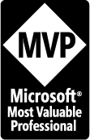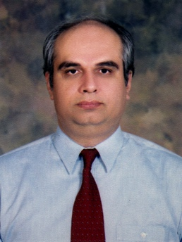**Mr. Zia U. Khan** (http://www.facebook.com/ziakhan.edu) will be the co-instructor for this course. He is the CEO of Panacloud (Pvt.) Ltd. He has fifteen years of experience in teaching computer science subjects and has extensive experience in development of business and financial software solutions. For eight consecutive years, in 2007, 2008, 2009, 2010, 2011, 2012, 2013 and 2014 he has received the Most Valuable Professional (MVP) Award from Microsoft USA. He has a Master of Science in Engineering (MSE), Master of Business Administration (MBA), and Master of Accountancy (MAC) in MIS, all three from Arizona State University. He is also a CPA and CMA in USA.

**Mr. M Inzamam Malik**

He is a Lead Voice Computing Developer in Panacloud, and has more than two years experience in bot design and development.

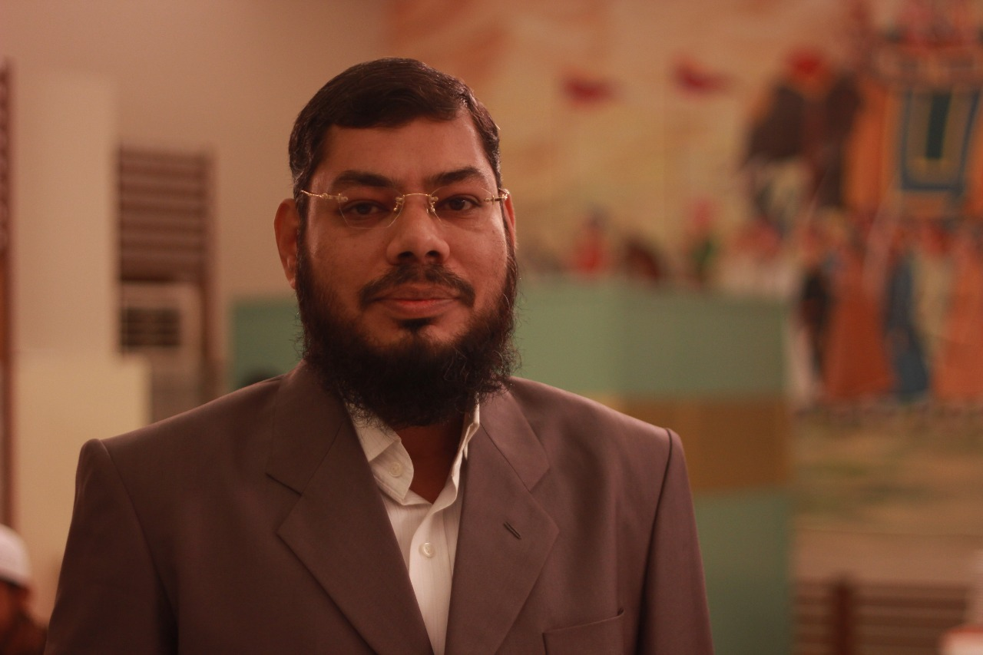**Mr. Anjum Ali** has more then 18 years of experience in embedded software development (C/C++, Assembly) and web application development (Java, J2EE, EJB) as well as leading the teams offshore. He has vast knowledge and experience in hardware, software design/development that targets industries and homes. He has used major microcontroller and microprocessor for IOT and automation including Zilog, Intel, Atmel, Microchip, espressif.

interfacing the electronic devices, and bring them online is his hobby.

**Mr. Syed Shahrukh Haider**

He has over eight years of hand-on experience in area of Embedded System Designing & Applications, with about six years of engineering teaching experience. He has obtained a postgraduate degree from renowned university of Scotland in area of Electronics and Embedded Systems.

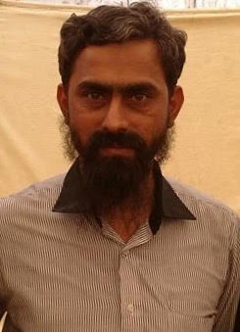

**Mr. Inam ul Haq** is the CTO of Zaavia and has over a decade of software development and teaching experience. He will be the co-instructor for this course. He is the academic supervisor of Saylani Mass Training Program, which is teaching computer science to thousands of students completely free of cost.

**Mr. Zeeshan Hanif**, CTO Panacloud with more than ten years of experience in application development.