Web Assembly Installation Instruction

Option 1: Using Ubuntu in Virtualbox
- Install Ubuntu
  - If you want to install Ubuntu on Virtualbox then follow this video: https://www.youtube.com/watch?v=QbmRXJJKsvs
- To update Ubuntu run following command in terminal
  - sudo apt update && sudo apt upgrade
- Install CMake (https://cmake.org/)
  - To install directly from terminal run following command
  - sudo apt-get -y install cmake
- Install WABT (WebAssembly Binary Toolkit)
  - Open terminal and go to any directory where you want to clone the source code of WABT
  - Run following commands:
  - git clone --recursive https://github.com/WebAssembly/wabt
  - cd wabt
  - mkdir build
  - cd build
  - cmake ..
  - sudo make install
- To verify your installation run following command:
  - wat2wasm -- it should show you list of option that can be used
- For code editor install visual studio code:
  - https://code.visualstudio.com/
  - Download .deb file and install it

Option 2: Windows Subsystem for Linux on Windows 10

Windows subsystem for Linux helps you run all the commands in linux environment. Complete instructions to install Ubuntu in Windows subsystem can be found here:
https://docs.microsoft.com/en-us/windows/wsl/install-win10
This option is useful when you want to keep all your code and project in Windows but execute commands in Linux environment.

- Enable “Windows Subsystem for Linux” feature
Open PowerShell as Administrator and run:
Enable-WindowsOptionalFeature -Online -FeatureName Microsoft-Windows-Subsystem-Linux
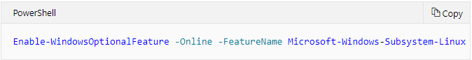
- Restart your computer when prompted.
- Install your Linux Distribution of Choice, in our case we will install Ubuntu
- Open the Microsoft Store in Windows and search for Ubuntu.
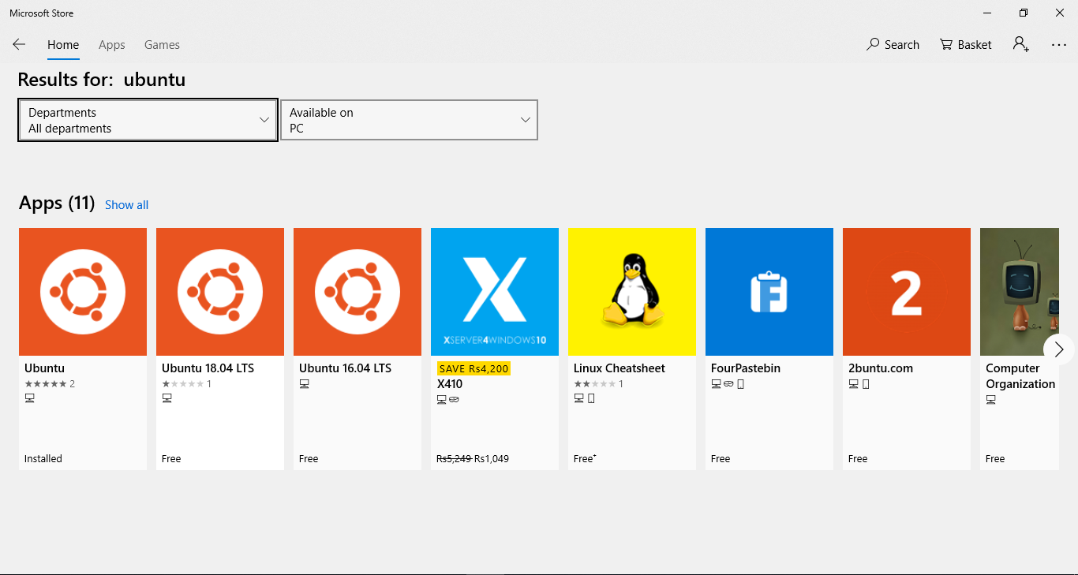
- Click the first app in list named “Ubuntu”
- From the Ubuntu's page, select "Get"
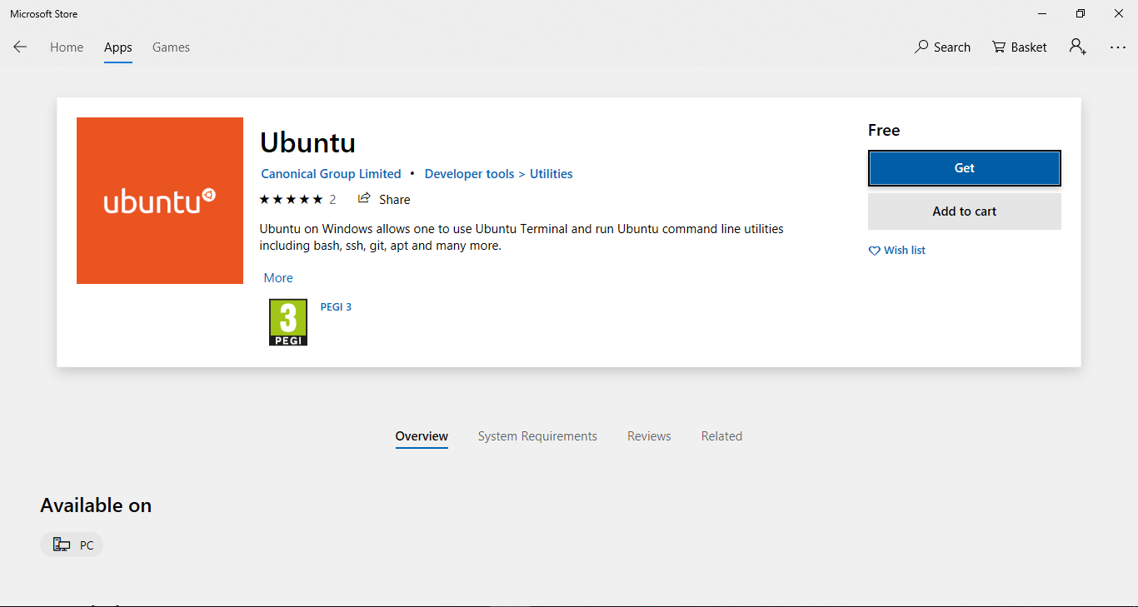
- Launch a Ubuntu -- The first time a newly installed distro runs, a Console window will open, and you'll be asked to wait for a minute or two for the installation to complete.

- Setting up a new Linux user account
Once installation is complete, you will be prompted to create a new user account (and its password).
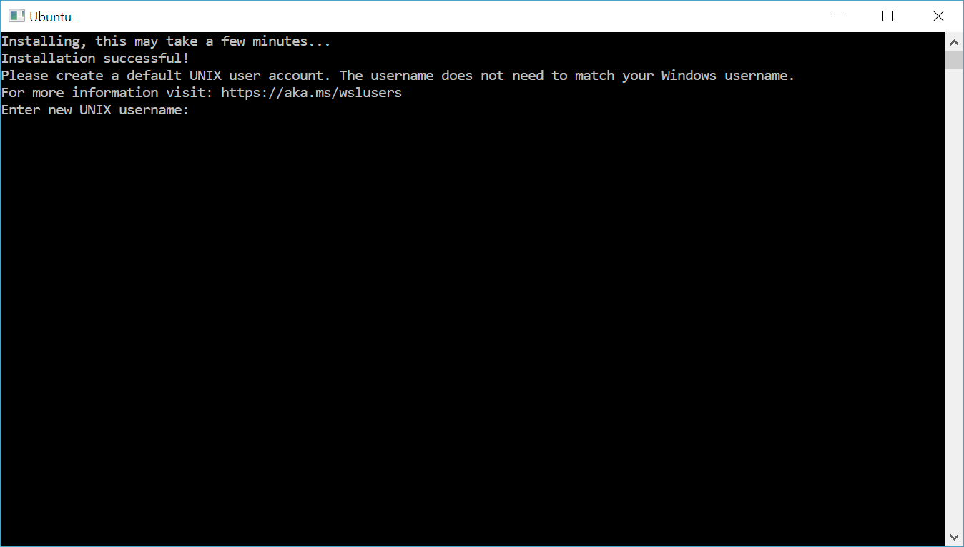
- Update & upgrade your Ubuntu's packages
sudo apt update && sudo apt upgrade
- You're done with setup of Linux on Windows Subsystem for Linux
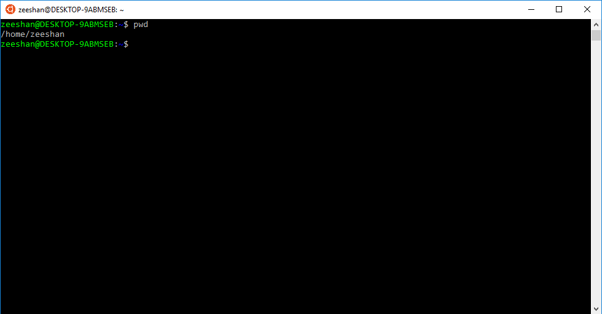
- You will need to access your C or D drive as you files and code will be in C or D drive and you will use Linux for commands execution
“The WSL has access to your PC’s file system through /mnt/<drive letter>/ directories (or mount points). For example, your C:\ and D:\ root directories in Windows would be available through /mnt/c/ and /mnt/d/ respectively in the WSL”
- Install CMake (https://cmake.org/)
  - To install directly from terminal run following command
  - sudo apt-get -y install cmake
- Install WABT (WebAssembly Binary Toolkit)
  - Open terminal and go to any directory where you want to clone the source code of WABT
  - Run following commands:
  - git clone --recursive https://github.com/WebAssembly/wabt
  - cd wabt
  - mkdir build
  - cd build
  - cmake ..
  - sudo make install
- To verify your installation run following command:
  - wat2wasm -- it should show you list of option that can be used
- Install run code studio on Windows 10
  - https://code.visualstudio.com/
  - Download and install .exe file

