Active Inference for Port Selection in Fluid Antenna Systems Under Partial CSI
Kian Fotovat¹ and Kamran Fotovat²
¹Dept. of Electrical and Computer Engineering, University of Tehran, Tehran, Iran
²Iran University of Science and Technology, Tehran, Iran
Abstract—Fluid antenna systems (FAS) enhance spatial diversity by activating a few radiating ports among many candidate positions, but selecting good ports conventionally requires channel state information (CSI) across all ports, incurring prohibitive acquisition overhead. We recast FAS port selection as active inference under partial CSI: the transmitter measures only the ports it activates, infers the remaining ports from a spatio-temporal generative model (Jakes spatial correlation and a first-order temporal model) through a complex Kalman belief, and selects ports by minimizing the expected free energy (EFE), which unifies expected achievable rate, information gain, and antenna-switching cost in a single objective. A greedy submodular selector yields low decision latency, and an observe-then-precode protocol keeps the served-port CSI fresh. Simulations show that the proposed method attains 84–89% of a full-CSI genie's sum rate while observing only 20% of the ports, surpasses naive, deep-reinforcement-learning, and bandit baselines on the switching-aware objective, requires no training, and remains robust to Doppler and to model mismatch, for which the spatial correlation can be learned online.
Index Terms—Fluid antenna systems, port selection, active inference, expected free energy, partial CSI, Kalman filtering.

I. INTRODUCTION
Fluid antenna systems (FAS), also referred to as movable-antenna systems, employ radiating elements whose position can be reconfigured within a small aperture, providing spatial degrees of freedom beyond those of fixed antenna arrays [1]. By activating a small number of ports out of many candidate positions, an FAS can capture favorable channel conditions with few radio-frequency chains. The central control problem is port selection: deciding which ports to activate so as to maximize throughput.
Selecting ports well, however, conventionally presupposes channel state information (CSI) over all candidate ports. Because the number of ports is large and the aperture is densely sampled, acquiring this CSI incurs substantial pilot and training overhead, which grows with the array size. Existing approaches largely sidestep rather than confront this cost. Learning-based selectors, whether deep reinforcement learning (DRL) with attention over ports [2] or online bandit methods [3], typically assume full CSI and/or require extensive training. Channel estimation methods for FAS, such as the successive Bayesian reconstructor [4] and sequential linear MMSE estimation [5], reconstruct the channel accurately but address estimation rather than the joint decision of what to sense, what to serve, and when to move.
We argue that port selection is most naturally posed as active acquisition under partial CSI, and that active inference [6] provides a principled framework for it. Our contributions are:
1) We formulate FAS port selection as active inference under partial observability, removing the unrealistic full-CSI assumption of prior work.
2) We develop a model-based agent that maintains a complex Kalman belief over all ports from a spatio-temporal prior, and selects ports by minimizing an expected free energy (EFE) that unifies expected rate, information gain, and switching cost in a single objective.
3) We give a greedy submodular selector with an (1−1/e) guarantee on the information term and O(NM) latency, together with an observe-then-precode protocol that makes performance robust to Doppler.
4) We show through simulation that the method attains 84–89% of a full-CSI genie while observing 20% of ports, beats naive, DRL, and bandit baselines on the switching-aware objective with zero training, and can learn the spatial correlation online under model mismatch.
II. SYSTEM MODEL AND PROBLEM FORMULATION
We consider a base station whose fluid antenna comprises N = Nₓ×Nᵧ candidate ports arranged on a two-dimensional grid over a sub-half-wavelength aperture. Each slot the base station activates M of the N ports (one per RF chain) to serve K single-antenna users, with N ≥ M ≥ K. Let hₖ(t) ∈ ℂᴺ denote the channel of user k over all N ports in slot t.
A. Spatio-temporal channel model
Ports on a dense aperture are spatially correlated. Following Jakes' model, the correlation between ports i and j is
Rᵢⱼ = J₀(2π dᵢⱼ / λ), (1)
where J₀(·) is the zeroth-order Bessel function and dᵢⱼ the inter-port distance. The channel evolves as a first-order Gauss–Markov (AR(1)) process,
hₖ(t) = ρ hₖ(t−1) + √(1−ρ²) eₖ(t), eₖ ~ ᶜᴺ(0, βₖ R), (2)
with temporal correlation ρ = J₀(2π f_D T_s) set by the Doppler f_D. The stationary distribution is hₖ ~ ᶜᴺ(0, βₖ R).
B. Partial observability
The key departure from prior work is that full CSI is unavailable. Activating a port set S yields noisy pilots only on those M ports,
yₖ(t) = P_S hₖ(t) + n, n ~ ᶜᴺ(0, σₑ² I), (3)
where P_S selects the active rows; the remaining N−M ports are hidden and must be inferred.
C. Precoding, rate, and objective
The base station applies a robust MMSE precoder W built from its belief and serves the users; the achievable rate of user k is Rₖ = log₂(1 + SINRₖ). Moving the fluid element between ports costs delay and energy, modeled by a switching cost C_t = |S_t △ S_{t−1}| and E_sw = e_sw C_t. The long-term objective is
max Σ_t [ Σₖ Rₖ(t) − η_sw E_sw(t) ]. (4)
III. ACTIVE-INFERENCE PORT SELECTION
A. Belief (perception)
The agent maintains a per-user Gaussian belief q(hₖ) = ᶜᴺ(μₖ, Σₖ) over all N ports, updated by a complex Kalman filter. The predict step encodes CSI aging, μ ← ρμ and Σ ← ρ²Σ + (1−ρ²)βₖR, and the measurement update uses the Joseph form for numerical stability. Because the innovation covariance is regularized by σₑ²I, the (rank-deficient) prior requires no artificial jitter, and the belief is calibrated: its covariance matches the realized estimation error.
B. Expected free energy (action)
A candidate port set S is scored by its expected free energy (in bits):
G(S) = −α·Prag(S) − β·Epis(S) + Switch(S), (5)
where the pragmatic term is the expected robust-MMSE sum rate under the belief (an imperfect-CSI lower bound that grows conservative as uncertainty grows); the epistemic term is the mutual information Epis(S) = Σₖ log₂ det(I + P_S Σₖ P_Sᴴ / σₑ²), which is monotone submodular and, through the off-diagonals of Σ, also sharpens correlated neighbors; and the switching term is η_sw e_sw |S △ S_prev|. Exploration and exploitation are thus unified in one objective rather than bolted on.
C. Observe-then-precode and greedy selection
Two design choices make the agent both accurate and fast. First, within a slot the agent selects on the predicted belief but then senses the activated ports and precodes on the updated belief; this observe-then-precode ordering keeps the served-port CSI error near σₑ² instead of the aging floor, and, as shown below, removes the dependence on Doppler. Second, since choosing M of N is combinatorial, S is built greedily by adding the port of largest marginal G; the epistemic term's submodularity yields an (1−1/e) guarantee and the cost is O(NM), about 20 ms per slot versus seconds for exhaustive search.
When the spatial correlation is unknown or non-Jakes, R can be estimated online from the co-observed pilots (a normalized empirical correlation), which restores performance under model mismatch.
IV. SIMULATION RESULTS
Unless stated otherwise, N = 25 (5×5, sub-λ/2), K = 3, M = 5 (a 20% observation budget), SNR 15 dB, σₑ² = 10⁻³, ρ = 0.9, and η_sw = 1, averaged over Monte-Carlo channel realizations. Baselines are a full-CSI genie (rate ceiling), a naive no-inference selector, random selection, a DRL policy (a Transformer port scorer trained by policy gradient), and a combinatorial-UCB bandit.
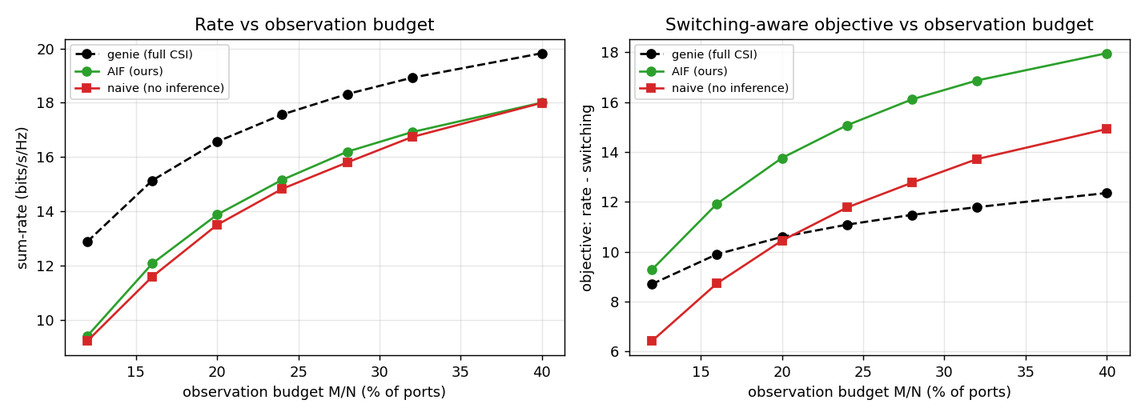
Fig. 1. Rate and switching-aware objective versus observation budget M/N. The proposed method tracks 73–91% of the genie rate and exceeds it on the objective for budgets ≥ ~18%.
Observation budget. As the budget grows, the agent tracks 73–91% of the genie's rate and, on the switching-aware objective, exceeds the genie because it barely moves the antenna. At the 20% operating point it attains about 84% of genie rate.
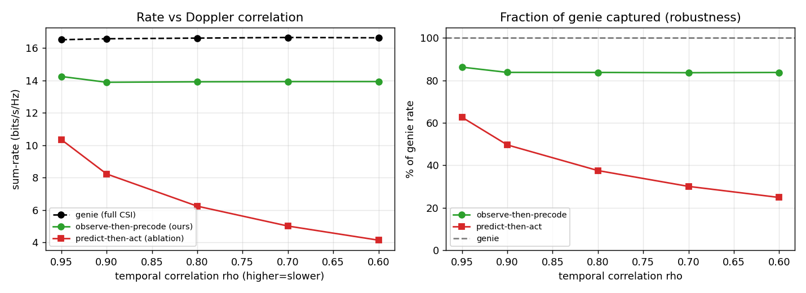
Fig. 2. Observe-then-precode versus predict-then-act across Doppler. The proposed protocol holds at 84–89% of genie and is flat in ρ; predict-then-act collapses.
Protocol and Doppler robustness. Observe-then-precode reaches 84–89% of the genie and is essentially flat across ρ, whereas precoding on the predicted (aged) belief degrades from 64% to 25% as the channel speeds up.
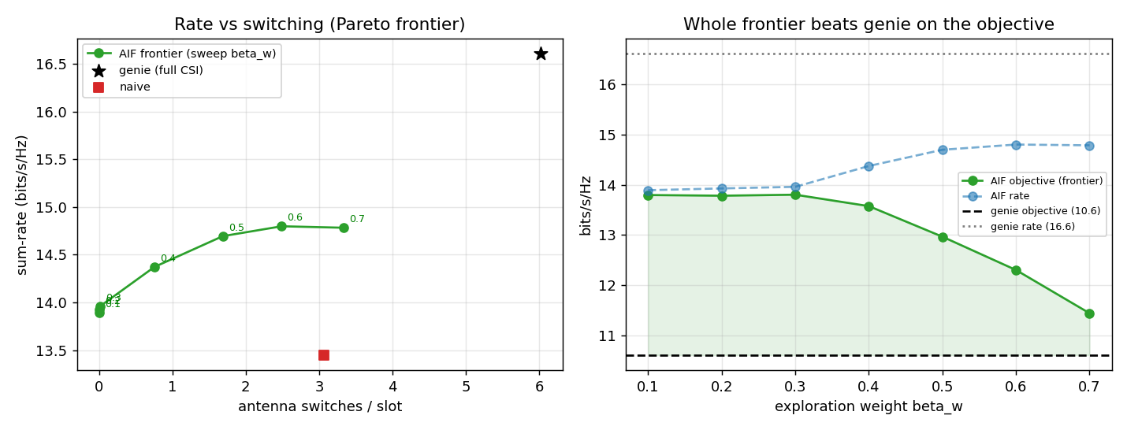
Fig. 3. Sweeping the exploration weight traces a Pareto frontier that dominates the genie: from 84% rate at near-zero switching to 89% rate, the whole frontier beats the genie objective.
Frontier. Sweeping the exploration weight yields a frontier that dominates the genie, from 84% rate at near-zero switching to a maximum of 89% rate; the entire frontier beats the genie's objective while switching far less.
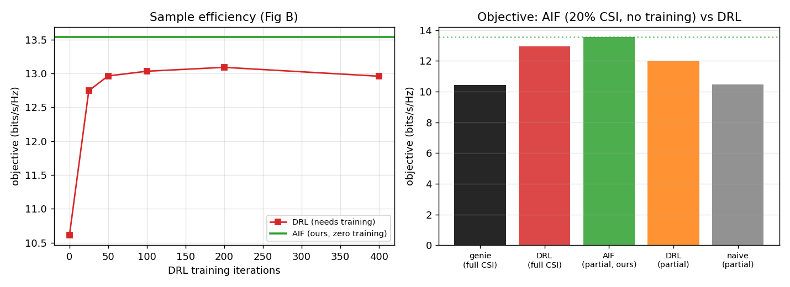
Fig. 4. Versus DRL. The proposed method (zero training, 20% CSI) meets or exceeds a fully trained full-CSI DRL on the objective; the DRL needs ~100–200 episodes to plateau.
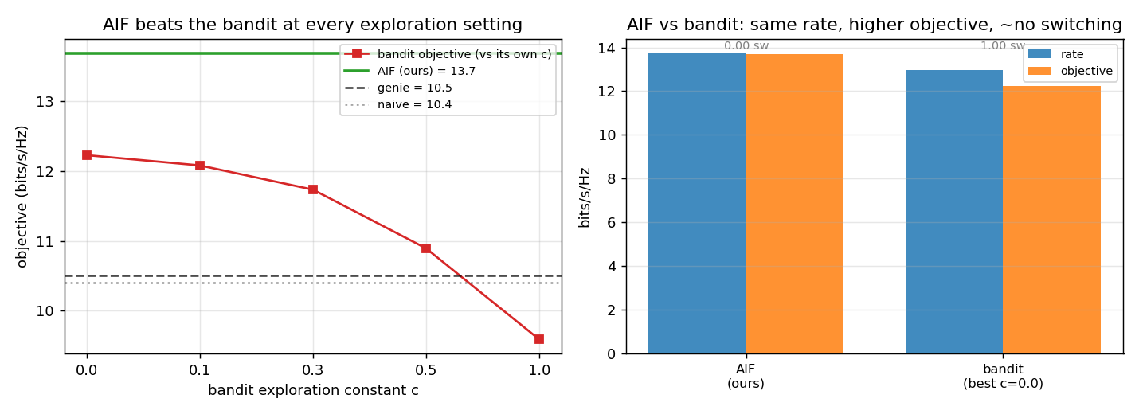
Fig. 5. Versus a bandit. The proposed method beats a combinatorial-UCB bandit at every exploration setting: comparable rate, higher objective, and roughly 100× less switching.
Comparison with learning baselines. The proposed agent needs no training yet meets or exceeds a fully trained full-CSI DRL on the objective, and beats the bandit at every exploration setting (+12% over its best) with about 100× less switching, because a model-free learner has no persistent per-port signal to exploit in the equal-average-power regime and thus pays a perpetual exploration cost.
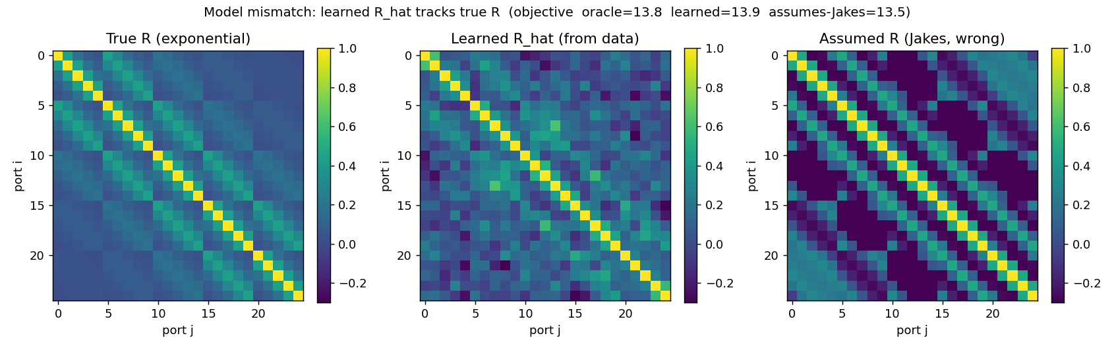
Fig. 6. Model mismatch. On a non-Jakes (exponential-correlation) channel, learning R online recovers the oracle objective, whereas assuming Jakes loses.
Model mismatch. When the true correlation is non-Jakes, an agent that wrongly assumes Jakes loses performance, while learning R online recovers the oracle result.
V. CONCLUSION
We posed fluid-antenna port selection as active inference under partial CSI, unifying expected rate, information gain, and switching cost in a single expected-free-energy objective over a spatio-temporal Kalman belief. The method matches most of the full-CSI performance while observing a fraction of ports, wins the switching-aware objective against naive, DRL, and bandit baselines without any training, and is robust to Doppler and to model mismatch. Future work includes tracking a moving spatial hotspot with a latent-envelope belief, scaling to large arrays where the low-rank channel makes acquisition even cheaper, a Gaussian-process belief front-end, and a distance-weighted switching model.
. ACKNOWLEDGMENT
[Disclosure placeholder — per the venue's policy, state any use of AI writing assistance here, e.g., grammar/formatting support, with the authors accountable for all content. Remove or adapt as required.]
. REFERENCES
[1] K. K. Wong et al., “Fluid antenna systems,” IEEE Trans. Wireless Commun., 2021. [VERIFY]
[2] Switching-cost-aware deep reinforcement learning for dynamic port selection in FAS, IEEE Commun. Lett., 2026. [VERIFY]
[3] J. Zou, S. Sun, and C. Wang, “Online learning-induced port selection for fluid antenna in dynamic channel environment,” IEEE Wireless Commun. Lett., 2024. [VERIFY]
[4] Z. Zhang, J. Zhu, L. Dai, and R. W. Heath, “Successive Bayesian reconstructor for channel estimation in fluid antenna systems,” IEEE Trans. Wireless Commun., 2025. [VERIFY]
[5] C. Skouroumounis and I. Krikidis, “Fluid antenna with linear MMSE channel estimation for large-scale cellular networks,” IEEE Trans. Commun., 2023. [VERIFY]
[6] T. Parr, G. Pezzulo, and K. J. Friston, Active Inference: The Free Energy Principle in Mind, Brain, and Behavior. MIT Press, 2022. [VERIFY]

