**Realistic Motorcycle Controller by BoneCracker Games**

You can easily setup your motorcycle with this package. Highly customizable and easy to understand.

**RealisticMotorcycleController.cs**

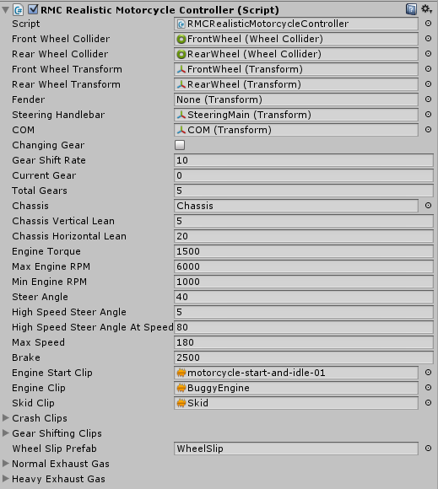

**Layers**

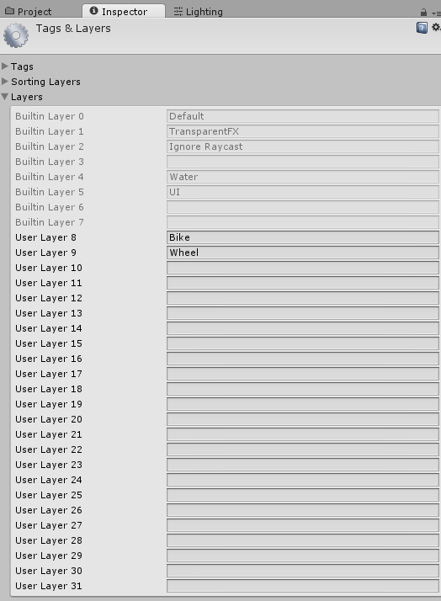

Script needs these 2 layers; "Bike", and "Wheel". Create them under Edit --> Project Settings --> Tags and Layers. Change your whole bike model’s layer to “Bike”, and then wheelcollider's layer to "Wheel".

**How to Setup a Motorcycle**

First thing you have to do is, ensure that your model has proper pivot positions and X, Y, Z angles. Z should face to front, X to right, and Y to up. If your motorcycle model hasn't proper pivot positions and angles, edit the model in any modelling software ( I prefer 3ds Max).

This is the unconfigured example basic model of the police motorcycle;

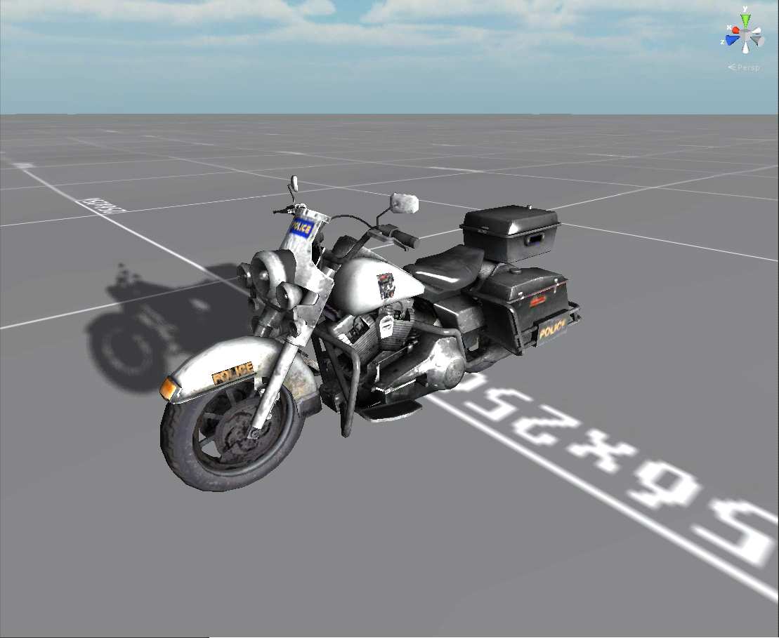

Create front and rear wheelcolliders at proper positions, and attach "RMCWheelSkidmarks" script to each wheelcollider if you want to make skidmarks on the ground. You will find “RMCSkidmarksManager” prefab in Prefabs folder. Just drag and drop to your scene.

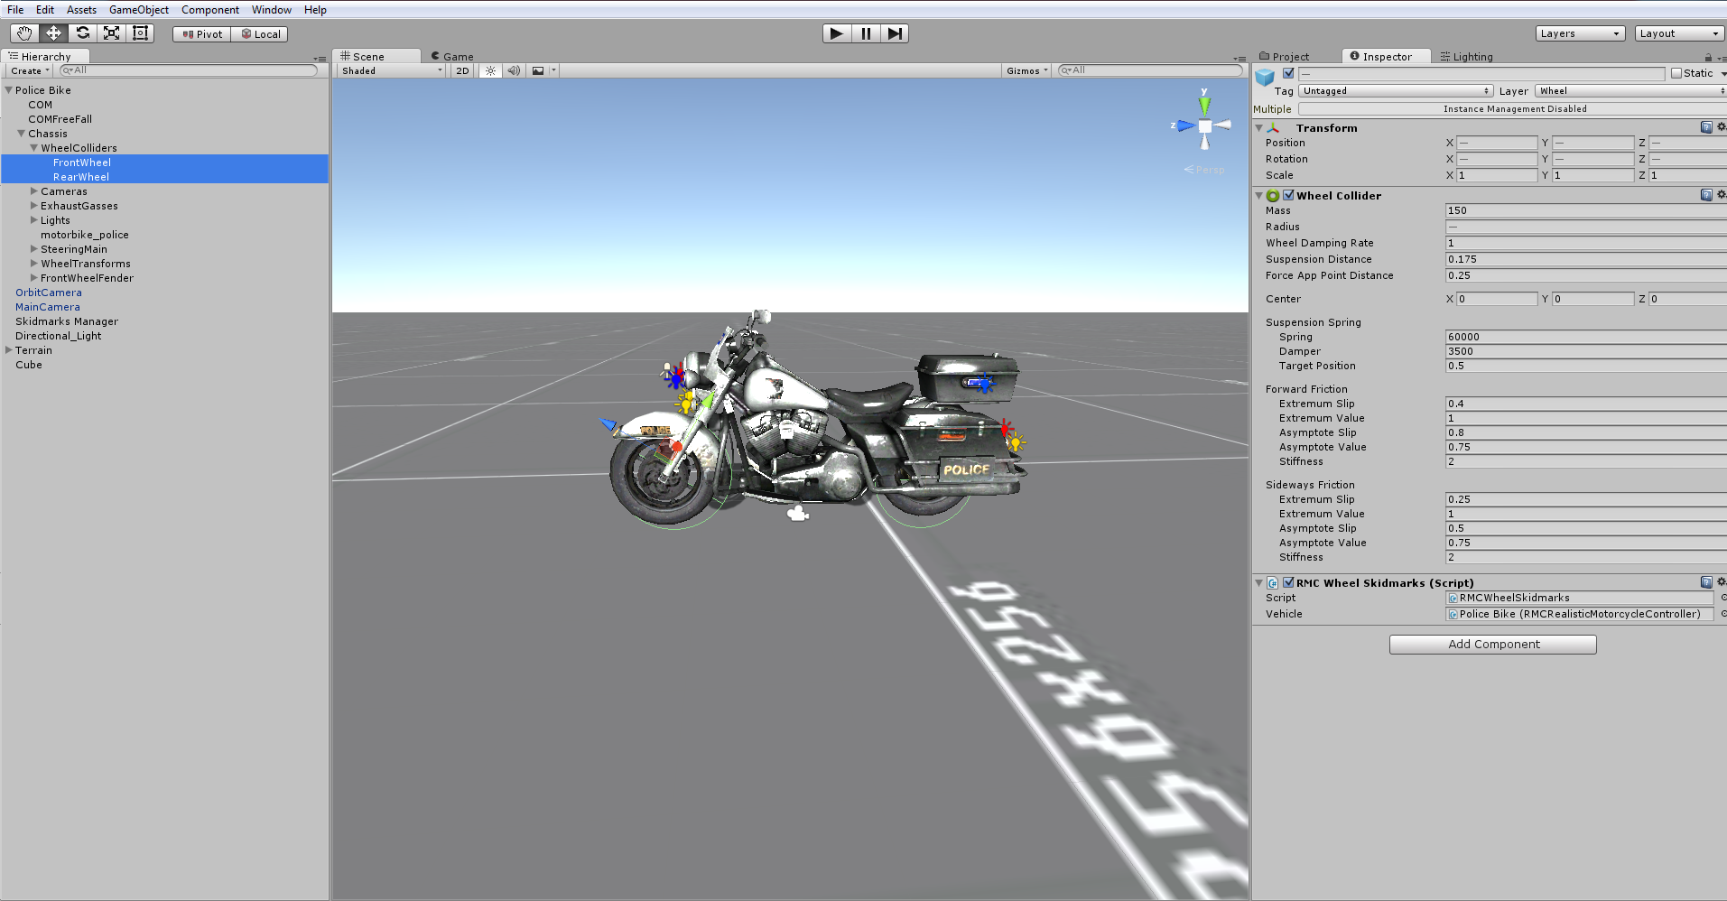

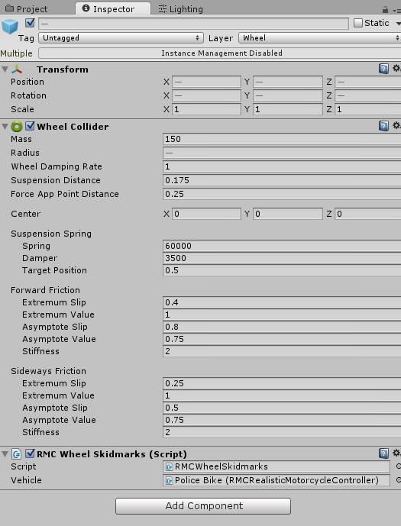

Current forward and sideway friction values are fine. Default values would behave like a wagon wheel. As you noticed, front wheel collider radius and X rotation is different. Motorcycle could crash to any bump on the road without this angle. If your motorcycle has fender, you must setup like this;

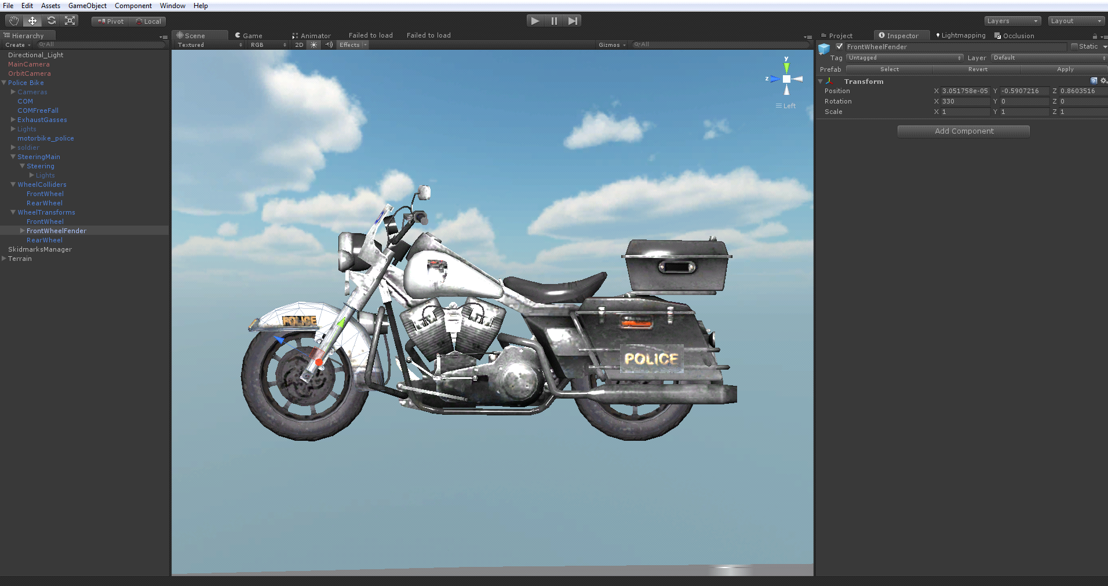

Fender will move by Y direction only. So, Y direction of the fender model should face just like this. And same thing for steering bar;

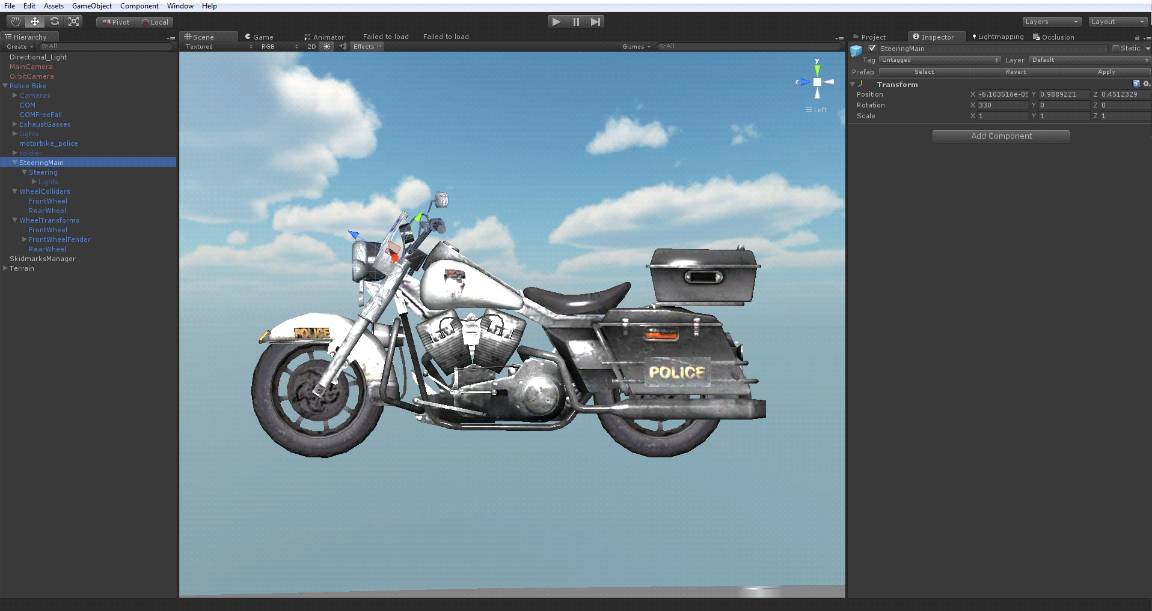

COM is the most IMPORTANT thing for realistic behavior. You must find best COM position after few tries. Changing little bit X, Y, or Z position of the COM will change entire behavior of the vehicle. If your COM at wrong position, motorcycle will lean to wrong side. You have to careful about this thing;

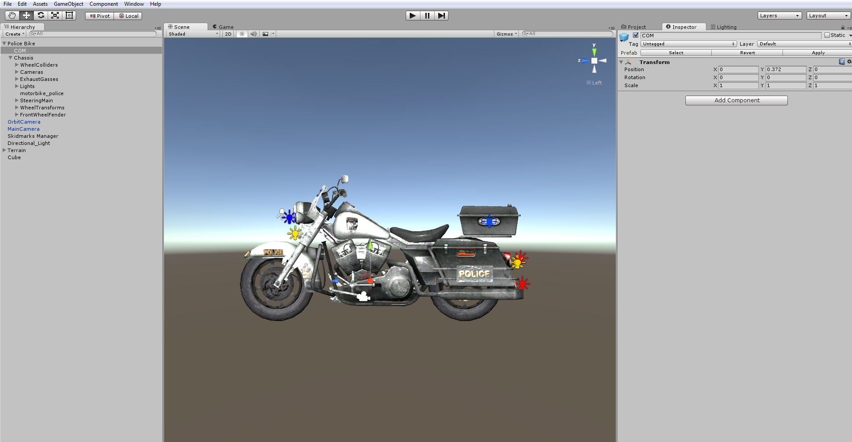

Normal and heavy exhaust gasses. Just drag and drop to your scene. If you don't want to use them, just leave;

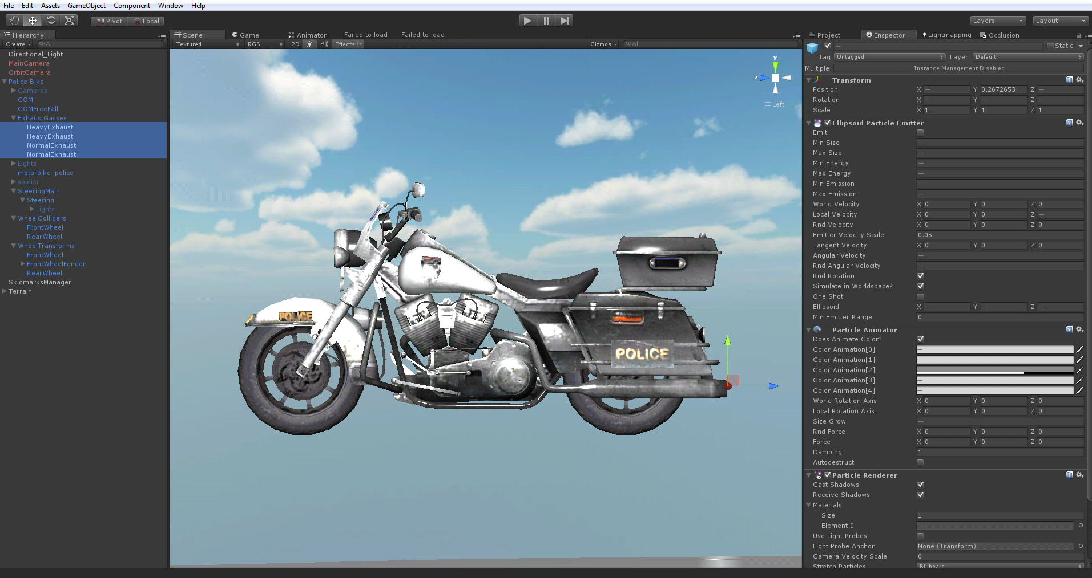

Finally, attach "RMCRealisticMotorcycleController" to root of the motorcycle. Script will attach rigidbody too. Select your wheel transforms and their colliders in inspector panel, set your engine torque, brake torque, lean values, and other stuff. Then select your COM, Fender and Steering Bar just like on screenshot;



Actually, motorcycle is not leaning to sideways physics based. Just rotating “Chassis” gameobject by Z axis based on rigidbody angular velocity. This system is used by many popular games like GTA, Battlefield, etc... So, all leanable objects must be parented to “Chassis” gameobject. Just check out motorcycle prefab for more information.

Select your engine start sound, engine sound, and crash sounds. Then your wheelslip prefab if you want to use tire smokes.

Basically, setup a motorcycle just like this. Be careful about your COM position and wheelcollider values. Changing them little bit, you could get much different results.

**You can find updated documentation on** [**http://bugra381.wix.com/bonecrackergames**](http://bugra381.wix.com/bonecrackergames)

**Thank you for purchasing my asset!**

**If you have any questions about package, please e-mail to bonecrackergames@gmail.com**