**Contextual inquiry customers**

The first interviewee is KunJu Lee, a university student majoring in Medical Science. He is a friend of one of this group’s members, Hyung-Min Jeon. She wanted to interview someone whose major was related to the medical sciences, so she selected him, and he agreed to this interview.

Our secondcustomer was Rao Ehsan, 25-year-old, a university student major in Machinal engineering. He is a friend of one of this group’s members, Kamran Javed. He wanted to interview someone whose major is not related to computer, so he selected him, and he agreed to this interview.

Our last customer was Eun Jin Oh, in order to utilize our products in various fields, we asked people who have various majors. She is 23 years old. She is a college student with a physical therapy department.

**Contextual inquiry results**

The price of the product should be around 100000 KRW.

The product would have light weight, glorious design and should be easy to wear. It would have alarm functionality as well.

The product will be helpful for overweight people who need dietary control or people who want to lose weight or eat an irregular amount of food when having a meal.

**Analysis of new and existing tasks**

People have problem to measure daily diet. Many cannot control diet. It leads to different diseases. We will provide of a convenient way to measure. Not attach many devices to their bodies. Only one sensor should be applied for measuring.

The shape of the gear will be the same as the shape of a wristwatch so it is easy to wear. In addition to exiting tasks we must add alarm function in our product and should decrease weight as much as possible to make it user friendly.

**Three tasks your application will support**

-Calculating the diet a user has eaten

-Sending the diet information to the smartphone application synched with the product and recording it

-Alarm function to make users eat at a regular time of day every day

**Sketches**

Application GUI Sketch:

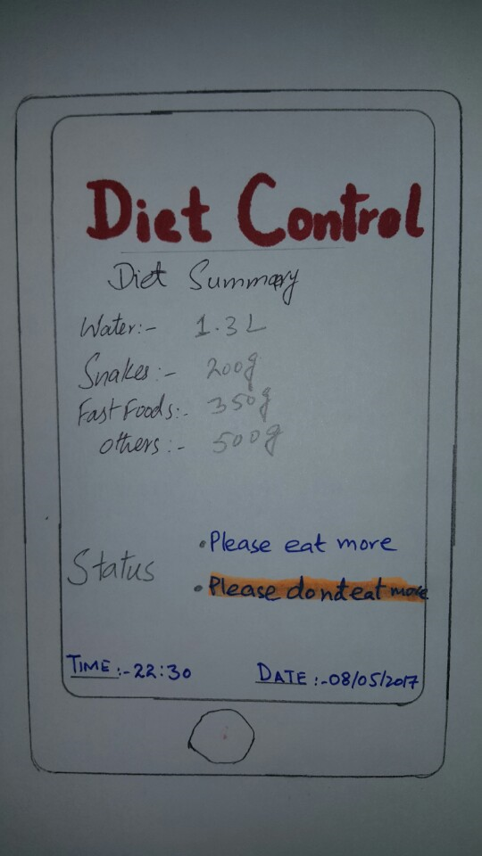

Sensor:

