**Problem and solution overview**

Nowadays, obesity is a big issue that threatens the health of many people. Also, people today do not eat a regular amount of food on a regular schedule every day. Some even get health problems due to eating too little. Such people sometimes use a smartphone application to manually record the calories he or she has eaten, but it is not really convenient and people may easily to forget to do so.

To solve such problems, we suggest a product that calculates the calories one has eaten every meal, every day. A wearable device with a sensor estimates the calories the user has eaten, and sends the information to his or her mobile smartphone, in which an application synchronized with the device records the calories one has eaten automatically.

**Contextual inquiry customers**

The first interviewee was Kun-Ju Lee, a university student majoring in Medical Science. He is a friend of one of this group’s members, Hyung-Min Jeon. She wanted to interview someone whose major was related to the medical sciences and have seen real patients in a doctor’s perspective, so she selected him, and he agreed to the interview.

Our secondcustomer was Rao Ehsan, a 25-year-old university student major in Machinal engineering. He is a friend of one of this group’s members, Kamran Javed. He wanted to interview someone whose major is not related to computer, so he selected him, and he agreed to the interview.

Our last customer was Eun Jin Oh, a 23-year-old university student majoring in physical therapy. She is a friend of one of this group's members, Da-Jin Lee. She wanted to interview someone to find a way to utilize the product for therapeutic purposes. So, she selected her, and she agreed to the interview.

**Contextual inquiry results**

According to the interviewees, the price of the product should be around 100000 Korean Won, but at the same time should be lower than it: Kun-Ju Lee suggested the product should be in the range of 70000 Korean Won~100000 Korean Won, Rao Ehsan thought about 100000 Korean Won would be appropriate, and Eun Jin Oh said the product’s price should be around 100000 Korean Won, but no more than that.

The interviewees suggested that the product should be lightweight, have a nice design and should be easy to wear and take off, since the product must be easy to use in people’s daily lives.

The three interviewees answered that the product will be helpful for a wide range of people who need dietary control: Patients who need to look out on their diet, overweight people who want to watch out how much calories they eat, and people who eat an irregular amount of food when having a meal.

However, the interviewees showed different opinions on whether they themselves would, and other people should, use it when they do not need to look out on their diet. Kun-Ju Lee said he would not use it when he does not need to lose weight, while Rao Ehsan and Eun Jin Oh said they would use it even when they do not need to lose weight. Rao Ehsan also suggested everyone should use the product, whether on a diet or not, to control their diet to be routine.

The interviewees also showed different opinions on whether the product would be a help in curing people with anorexia; they all agreed that such a patient should go see a doctor first but they did not agree on whether the device would help people with anorexia if the product was used along with the diagnosis and treatment given by a doctor. Kun-Ju Lee thought the product would help if used along with the diagnosis and treatment given by the doctor, while Rao Ehsan and Eun Jin Oh thought the product would not help people with anorexia in all cases.

Among the interviewees, Rao Ehsan and Eun Jin Oh suggested the product would be better if it had an alarm function as well, to make people eat on a regular schedule every day.

**Analysis of new and existing tasks**

People have problem to measure daily diet. Many cannot control diet. It leads to different diseases. We will provide of a convenient way to measure. Not attach many devices to their bodies. Only one sensor should be applied for measuring.

The shape of the gear will be the same as the shape of a wristwatch so it is easy to wear. In addition to exiting tasks we must add alarm function in our product and should decrease weight as much as possible to make it user friendly.

**Three tasks your application will support**

-Calculating the diet a user has eaten

-Sending the diet information to the smartphone application synched with the product and recording it

-Alarm function to make users eat at a regular time of day every day

**Sketches**

Application GUI Sketch:

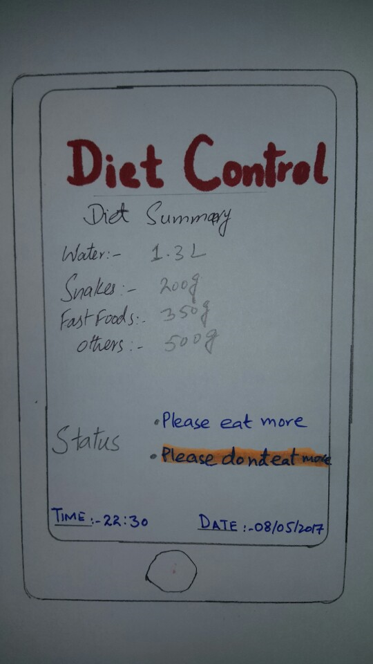

Sensor:

