**Task Analysis and Sketch**

**Team: Diet Control System (DCS)**

* **Da-Jin Lee :** (2017710282)Electronic and Computer Engineering,

Team manager (coordinate the big picture)

* **Kamran Javed** : (2016712418)

Electronic and Computer Engineering,

Design (visual/interaction)

* **Hyung-Min Jeon :** (2017710680)

Electronic and Computer Engineering,

Documentation (writing) User testing Development (prototyping)

**Interview qualitative data analyzed by ground theory (with open and axial coding)**

|  |  |  |  |
| --- | --- | --- | --- |
| **Question** | **Answer from 1st Interview**  **(KunJu Lee)** | **Answer from 2nd Interview**  **(Eun-Jin Oh)** | **Answer from 3rd Interview**  **(Rao Ehsan)** |
| If you had such a product, would you use it? Why or why not? | I think it is not necessary. An application that lets people manually record the calories eaten already exists, and I think that is enough. | I will use it. Instead, I would like to have a nice appearance to carry around in my daily life. | Yes I will use it. It is appreciated and it should be easy to use. |
| When using this, what do you think would be inconvenient? If you wanted to make life easier, what parts should be fixed? | The feeling when a person wears it could be inconvenient. The product would have to be easy to wear and take off, and its design would have to be considered as a key factor when developing it. | When I eat rice that I wear around the neck, I think this product will be uncomfortable. | Yes due to weight of gear it will be inconvenient. |
| How much would you pay for this product? Why? | About 70000~100000 Korean Won would be appropriate. The price would change according to the functions in it, but I think a price around that would be reasonable. | If you are under 100,000 won, you will live. I have seen that the price of the Bluetooth product from the other L products of the existing company is about 100,000 won. Therefore, it will live if it is less than 100,000 won. | About 100000 KRW would be appropriate. |
| In what ways do you think this product could be used? (ex. For treating obesity) | It could be used for patients who need dietary control. | Diets are needed for epilepsy patients. Now, it seems to be possible to use this method, and it is also possible to use it for the patient and the athlete who manages the body. | Everyone should use this to control its routine diet. |
| If you were on a diet, would this product help you? If not, why? | Yes, I think it would help. | It may be helpful but it seems to depend on the will of the person. I think that if you really want to do it with your will, there will be a lot of help for your diet. | Yes, I think it will help if it would have alarm functionality. |
| Would you keep on using it even after you succeed on your diet? | I think I would not use it. Yes, I think it would help such people. | I will continue to use. The reason is that diet requires maintenance of body shape. | Yes, I think I will use it to quantify myself. |
| Do you think this could be used to improve the eating habits of people who tend to eat an irregular amount of food when having a meal? | Yes, I think it would help such people. | Yes. I think it will help. It is important to count every time. I would like to have function that can help people to eat regularly by setting time of the meal as an alarm. | Yes, I think it will help such people to avoid irregular habits. |
| Do you think this could be used in treating anorexia? | It would help treat people with anorexia, but the product alone would not cure them; they should visit the doctor. | It seems to be difficult. Because even if you use this product, you can know the total calories, but anorexia (anorexia) is a sickness.It does not solve the cause of the disease. | No, It will not help people to treat with anorexia, but they have to visit the doctor as well. |
| Would you use this every day? | Yes, if I needed to. | I use it every day during the diet period. But I would not use it every day unless it is a diet period. | Yes, I will. If it has glorious design. |
| Would you recommend this to someone you know? Why? | If someone really needs to look out on his or her calories, yes. A person using the application I mentioned in #1 may forget to record his or her diet/calories. | Yes. If this product really comes out, I will introduce it to other people. | Yes, I want to recommend this to my lab mate because he is overweight, I think this product will help him to take care of his diet. |

**Standard Task Analysis Questions**

**1. Who is going to use the system?**

- It could be used for patients who need dietary control. For example, it can help control the diet of epileptic patients. Also, it could be used by people on a diet, so various people can use it.

**2. What tasks do they now perform?**

- An application records the calories when the user eats or drinks. A device in sync with the application calculates the calories of the food users eat.

**3. What tasks are desired?**   
- Calculating the calories of what people eat and drink during the day and recording it in the application.

**4. How are the tasks learned?**   
- It is possible to check the calories of people have eaten or drank by using a device resembling Bluetooth earphones and synchronized with a smartphone application. The calorie of drinking or eating a food is shown separately, and a message on the display will indicate whether the user has eaten too much or eaten too less.

**5. Where are the tasks performed?**

-Anywhere in daily life. It is available on every meal every day, and the device is convenient to wear.

**6. What is the relationship between customer & data?**   
-Our product helps to adjust people’s diets by providing the application and device to the user immediately. Calculated data allows the user to check the calories to eat or drink during a day, and displays a status indicator when the user is eating too much or too little.

**7. What other tools does the customer have?**

-Users can set an alarm to go off on their routine meal time.

**8. How do users communicate with each other?**

- Communication between users is not possible, but the function of this is not necessary.

**9. How often are the tasks performed?**

-The tasks are performed whenever the user eats or drinks.

**10. What are the time constraints on the tasks?**

-The calculating and recording of calories should be done on real-time.

**11. What happens when things go wrong?**

-If the Bluetooth communication between the mobile phone and the device does not work, the user will not be able to check the calories he or she has eaten or drank on that meal. Also, if the application gets a runtime error, the user may not be able to view the calories he or she has eaten and drank.

**Three Tasks Based on new Results:**

Now from all above scenario, we can easily conclude that the tasks from contextual inquiry assignment are now giving better results because of the advancement in the system and its parameters.

Task1: [Simple]

Now the 1st task is simple to perform as it is just measuring and monitoring the diet of the body and it is not difficult to takeover because now system is much better than previous.

Task2: [Moderate]

This is the 2nd task in which we should make it cheap. For this we must update system.

Task3: [Complex]

This is the little bit complex task in which we should alarm at limit of diet taken. It is little complex but we use alarm functionality of phone to achieve it.

**Sketches of new interface idea:**

**Sketch 1:**

Application GUI Sketch:

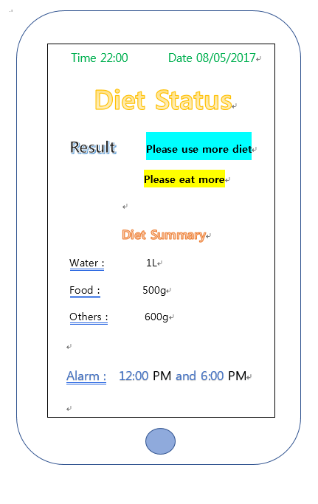

Sensor:

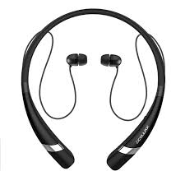

**Sketch 2:**

Application GUI Sketch:

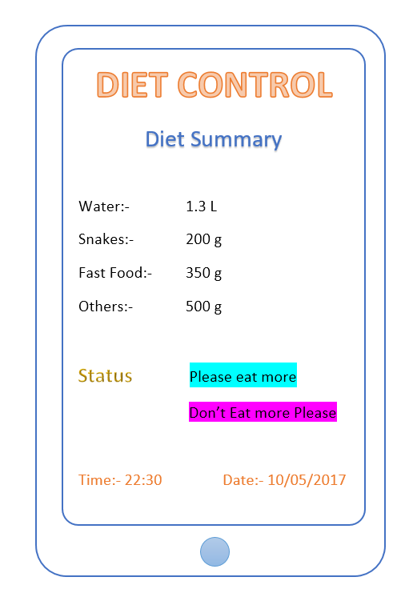

Sensor:

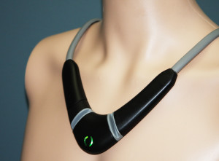

**Sketch 3:**

Application GUI Sketch:

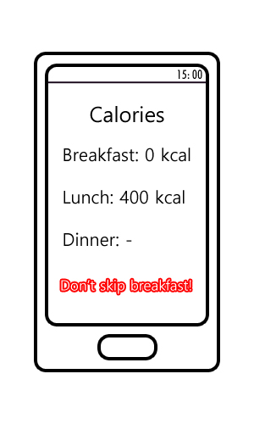

Sensor:

