**HCI Design Project Report**

**Title: Diet Control System**

**Team**

**Members Name and Role:**

**Kamran Javed:**

**Student ID. (2016712418)**

**Department of Electrical and Computer Engineering**

Team manager (coordinate the big picture)

**Da-Jin Lee:**

**Student ID. (2017710282)**

**Department of Electrical and Computer Engineering**

Design (visual/interaction)

**Hyung-Min Jeon:**

**Student ID. (20177110680)**

**Department of Electrical and Computer Engineering**

Documentation (writing)

Introduction and Mission Statement

Diseases related to nutrition are now a major hazard to human health and the major challenges to constitute medical care. A crucial step to solve the problems is to monitor the daily food intake of a person accurately and easily. For this, I present Auto-Dietary a portable system for monitoring and food intakes recognize in everyday life.

A crucial factor in maintaining a healthy life is to balance the energy intake and expenditure. Deviations in this equilibrium can lead to diseases such as obesity, anorexia and other eating disorders, which, moreover, can become chronic diseases seriously if not treated. A critical step to solve the problems is to measure continuously daily caloric balance. There are measuring many off-the-shelf solutions calories, like Fitbit, Philips Direct Life, etc. However, continuously and non-invasively monitoring calorie intake remains a challenge.

Prototype

Diet Control System to solve this problem. Diet Control System is mainly composed of two components: an embedded system unit for acoustic data acquisition and pre-processing, and an application running on the smartphone that food implements kind of recognition and provides an information interface for its users. An embedded hardware prototype will be developed to collect food intake sensor data, culminating in a high-fidelity microphone worn on the subject neck accurately recording acoustic signals while eating in a non-invasive manner. The acoustic data will be pre-processed and then sent a smartphone via Bluetooth, where the foods will be recognized. Android application is developed to measure daily diet. It is very simple and straightforward application to use. User interface of application is shown in fig. 1.

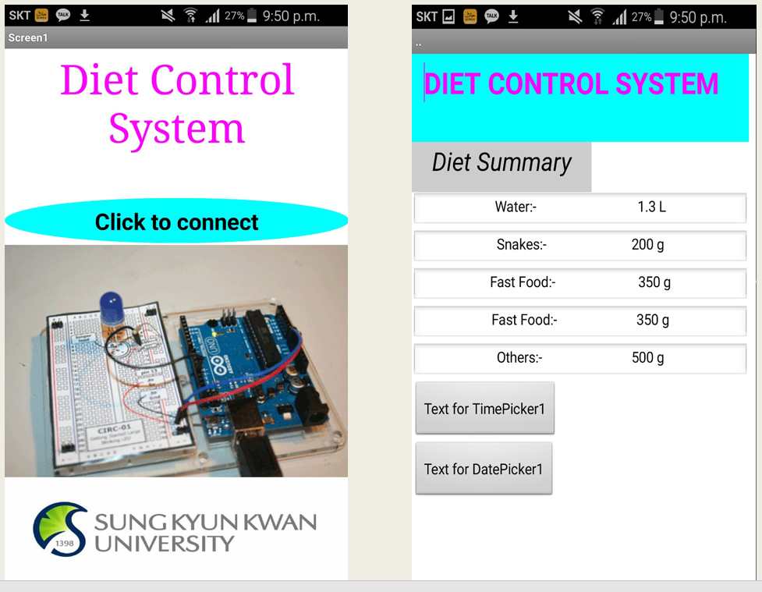

Figure 1: Application Interface

Method

The main architecture of the system shown in Fig. 2. The rest of this section presents the hardware design of embedded system unit and the smartphone application.

*A. Acoustic Sensors*

A high-precision and high-fidelity throat microphone is employed to pick up acoustic signals during eating. The microphone is worn over the user’s neck close to the jaw. The throat microphone converts vibration signals from the skin surface to acoustic signals rather than picking up sound wave pressure as most common microphones do. This principle enables very high quality signals to be collected for the specific purpose of Auto Dietary by efficiently reducing the interference from ambient noise. Additionally, the throat microphone is comfortable to wear and can be better accepted by users.

*B. Hardware Board*

An embedded hardware board is designed for data pre-processing and transmission. When acoustic data are collected from the throat microphone and input from Mic In, they are amplified and filtered for better signal quality. Then the analogy signals are converted to digital signals for later steps. The amplifier adopted is LM358, featured by its high common-mode rejection ratio, low noise and high gain. The total gain of the amplifier is 250, and the cut-off frequency of the low-pass filter is 3000Hz. The adopted AD converter is TLV2541 with a sampling rate of 8000Hz and 12 bit resolution.

The digital signals are then sent to a micro-controller via the I2C interface. Sound signals are segmented into frames for later processing. The micro-controller is also responsible for frame admission control of raw signals from the throat microphone.

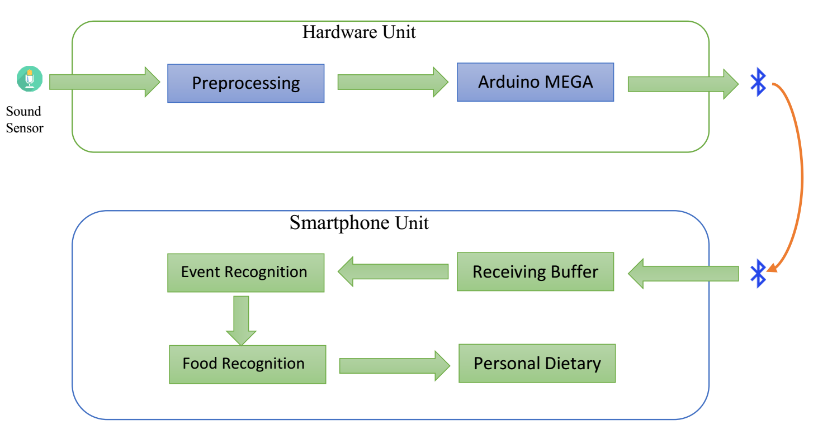

Figure 2: System Architecture

*C. Smartphone Application*

The application developed on the smartphone side has two major roles. First, it performs food type recognition by implementing the main algorithms detailed in the next section. Second, it serves as a data manager and provides an interface to the user. Fig. 1 gives some screenshots of the application. To use our system, a user simply wears and power on Auto Dietary, and start the application. When the user starts to eat, the system will perform food type recognition and store the detailed data into a database.

Based on the key information and main framework provided by Auto Dietary, developers can further expand the application with new features on personal health management.

Results

Sound signal produce while eating food and drinking water are independent variable for Diet Control System. That is converted to electrical signal produce by transductor is dependent signal. Result of electrical signal for two different food is shown in Fig. 3.

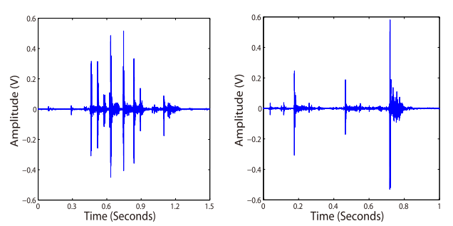

Figure 3: Time domain features for food two different foods.

Discussion

This Diet Control System will be a comprehensive and provisional solution to the food intake recognition in everyday life. I will be an embedded hardware food intake sensor data, which is marked by a throat microphone wear comfortably on the user’s neck accurately recording acoustic signals allows development while eating in a non-invasive manner.