**Design Exploration**

**Team: Diet Control System (DCS)**

* **Kamran Javed** (2016712418): Electronic and Computer Engineering
  + Team manager (coordinate the big picture)
* **Da-Jin Lee** (2017710282): Electronic and Computer Engineering
  + Design (visual/interaction)
* **Hyung-Min Jeon** (2017710680): Electronic and Computer Engineering
  + Documentation (writing), User testing Development (prototyping)

**1) Sensory, physical, and emotional engagement**

**- Sensory Mimicking & Emotional Staging**

The device has ON/OFF buttons, product length control buttons and a Bluetooth earphone. This product is attached to the neck by attaching two sensors on both sides on the front.

The necklines of people are different, and since the device needs to hang around the neck, the length-adjusting function was added. Increasing the length of the product is manual, while shortening the length of the product is done with additional buttons.

Whenever the user drinks or eats, the total daily calories of the drinks, meals and snacks are stored real-time in a mobile phone application or smart watch.

If a user eats too much, he or she will get an alarm message notifying that he or she has eaten too much, and if the user’s calorie intake is too low, he or she will get an alarm message notifying that he or she has eaten too less.

Since the range of people who could use this product is very wide, it will be made easy to use by writing the abbreviation of each function on each button of the device.

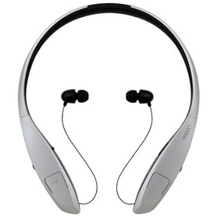

**- Physical Inspiring**

There are many preexistent smartphone applications that tell users their calorie intake, but for most of the applications the users have to guess the calorie of each food or drink. Here, it is difficult for a person to accurately measure the calories of the food he or she has eaten. Also, food calorie calculation results made manually by people are usually lower than the actual calories the food has.

Our device uses a smartphone laser technology that accurately calculates calories. Products related to activities or the environment can be calibrated with the new laser technology(NutriRay3D), which, in our device, enables for the calories to be measured and recorded in users’ smartphones every meal. The technology can analyze 9000 different foods with an accuracy of 90%, so the user doesn’t need to guess the calories in the food he or she is eating. This laser technique was developed while conducting research related to cancer.

The laser function is implemented inside our device. It calculates the volume of the food by arranging the points and then shooting the points on the food. It is possible to distinguish what the food is, and the result of calorie calculation is stored into our smartphone application synchronized with the device.

However, for example, in a sandwich, a user may insert information directly in case the calorie amount is written on the product. It is possible to manage food calories manually by using the application. Still, it is inconvenient, so we put a sensor on the neck device and measured the calories with laser signal detection. This will make the recording of calories more accurate.

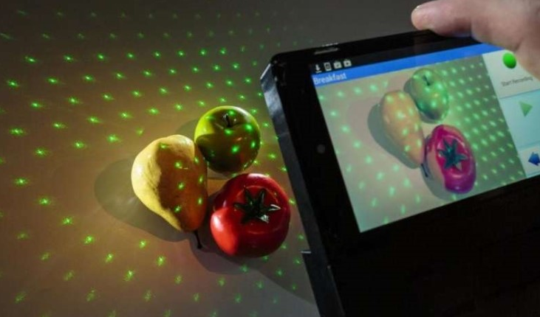

**2) BMW features (Beautiful product by Design Humaneering, Meaningful product by Embodied Cognition, and wonderful product by Gamification)**

Beautiful-The shape of our device should not be strange for people to use in everyday life. It will look like a Bluetooth earpiece, and it should look beautiful and fashionable. Also, it should not be heavy because you have to hang around your neck.

Meaningful-The application continues to update its user’s calorie intake whenever the user eats or drinks. Through this the user can watch out on his or her calorie intake per meal.

Wonderful-Users will keep interested in watching out for their calorie intake since the mobile application and device gives real-time feedback to the user, like in a game.