COMP3123 Assignment 1 API Test Evidence
Student number 101564373
Postman outputs and error responses, MongoDB records and ownership relationships, HTTP security headers, health checks and local application logs are recorded in the following screenshots.
GitHub repository https://github.com/kamranomars-sudo/101564373_COMP3123_Assignment1

Postman collection test results
Screenshot 1 Source evidence page 1
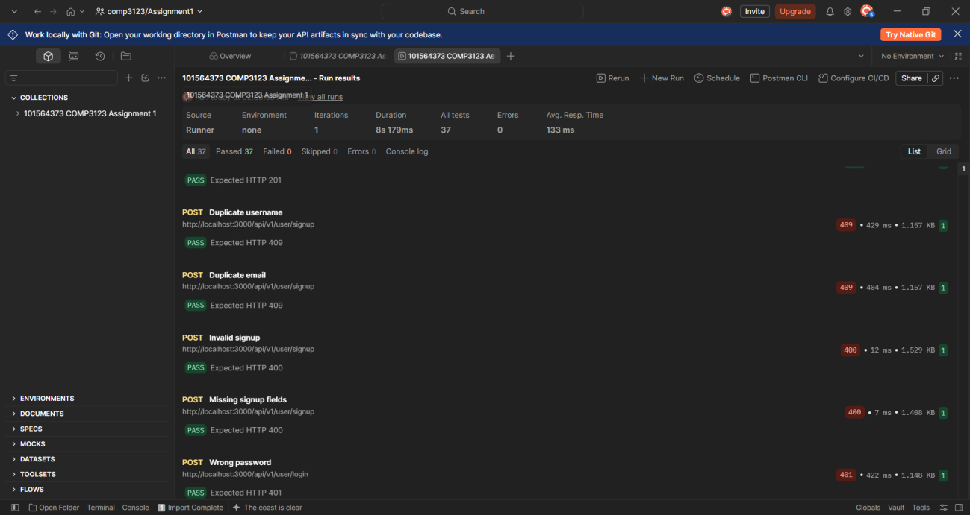

Postman collection test results
Screenshot 2 Source evidence page 1
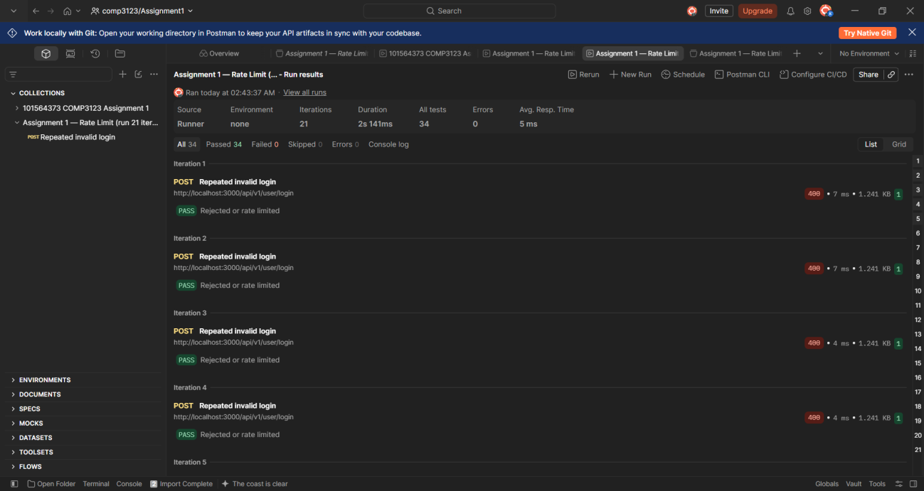

Postman collection test results
Screenshot 3 Source evidence page 2
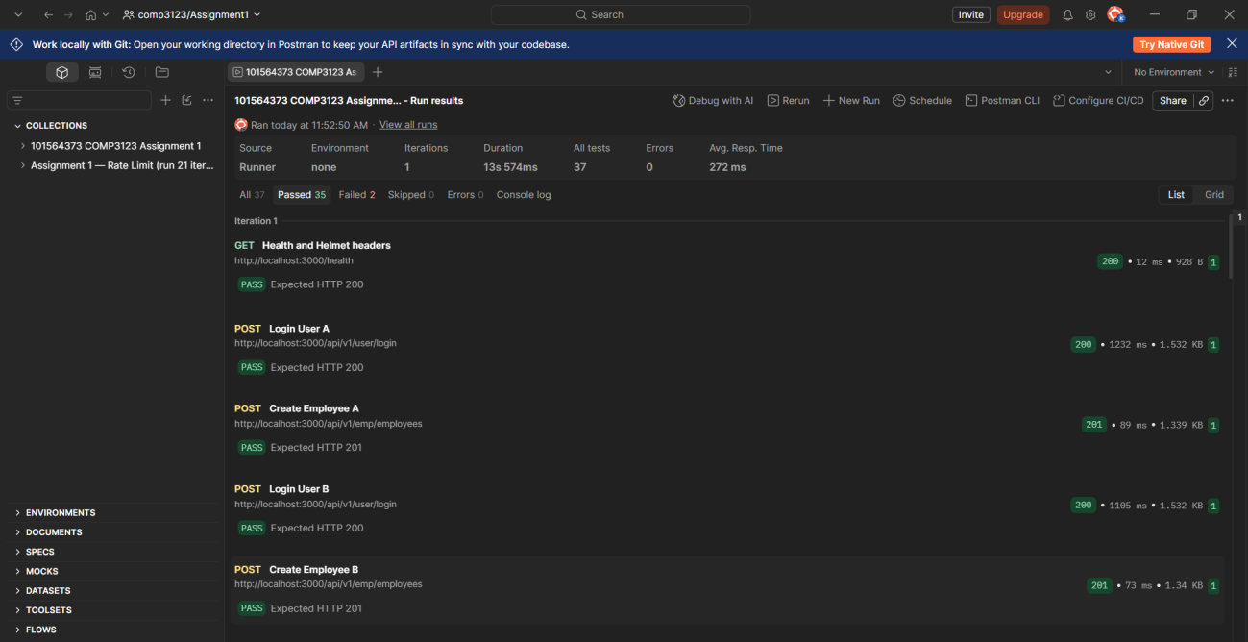

Repeated signup conflict results
Screenshot 4 Source evidence page 2
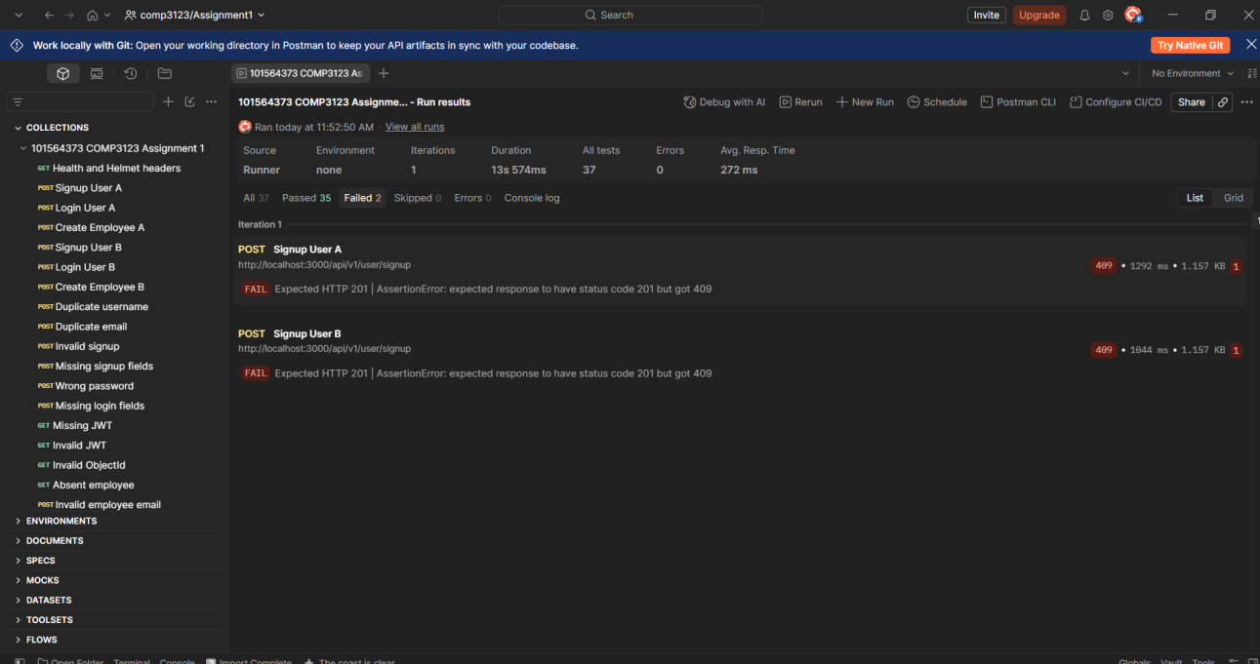

Authentication rate limiting
Screenshot 5 Source evidence page 3
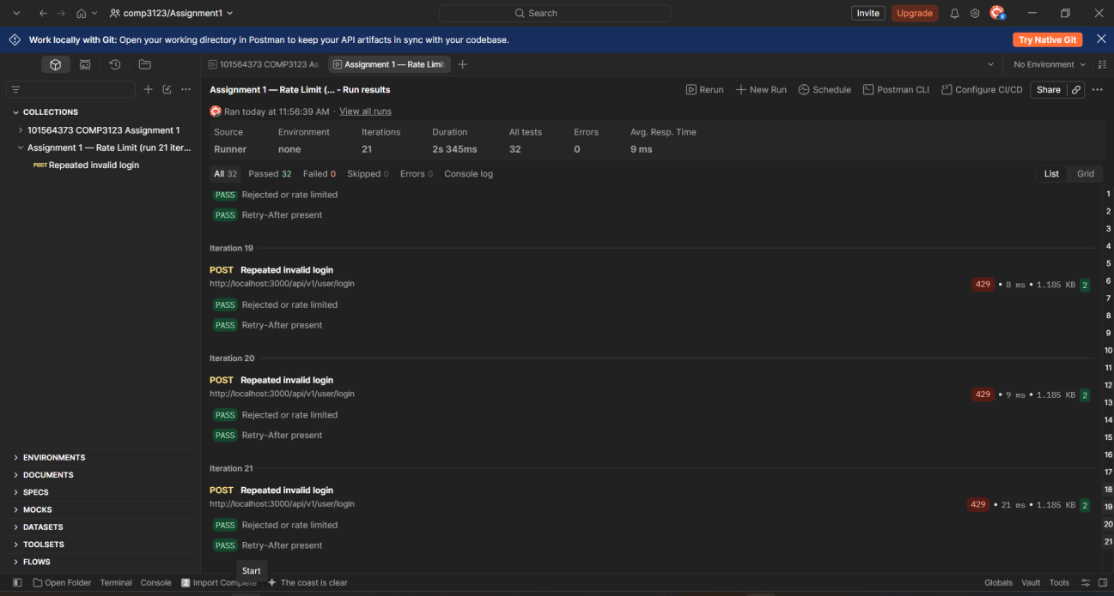

MongoDB users and hashed passwords
Screenshot 6 Source evidence page 3
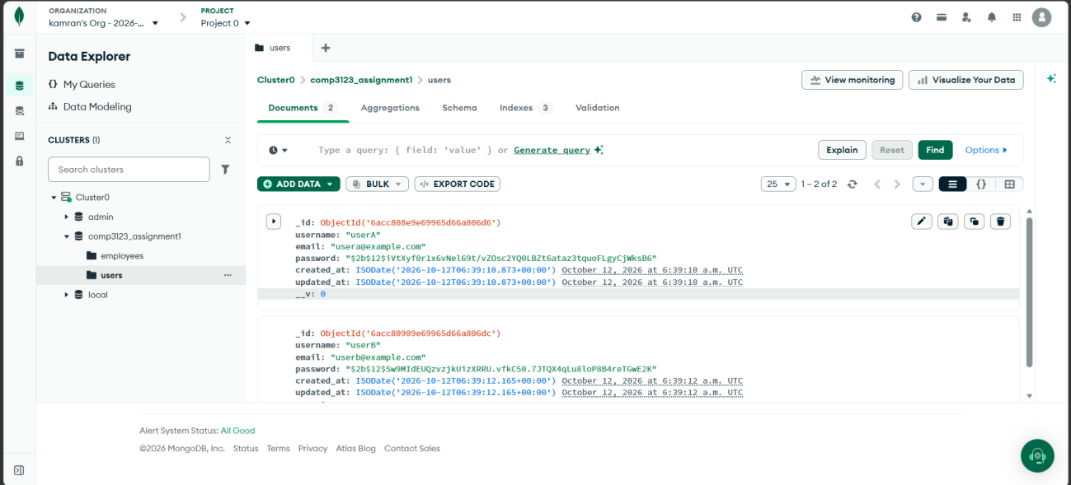

MongoDB employee ownership for User A
Screenshot 7 Source evidence page 4
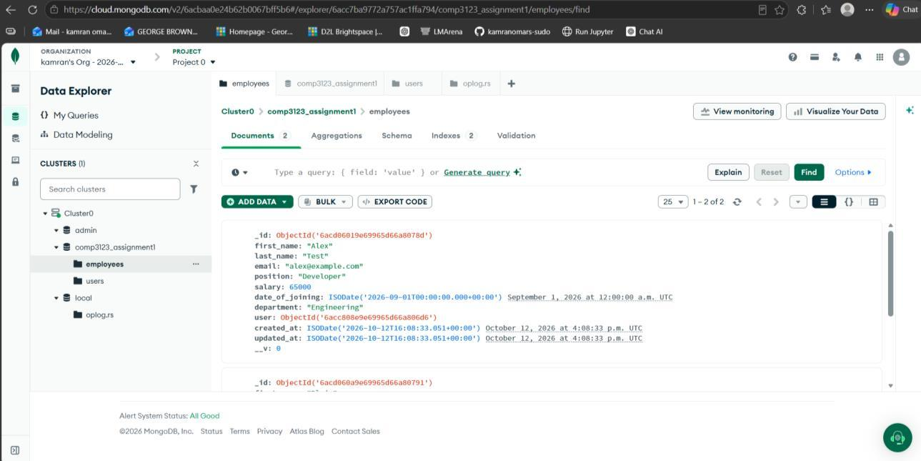

MongoDB employee ownership for User B
Screenshot 8 Source evidence page 5
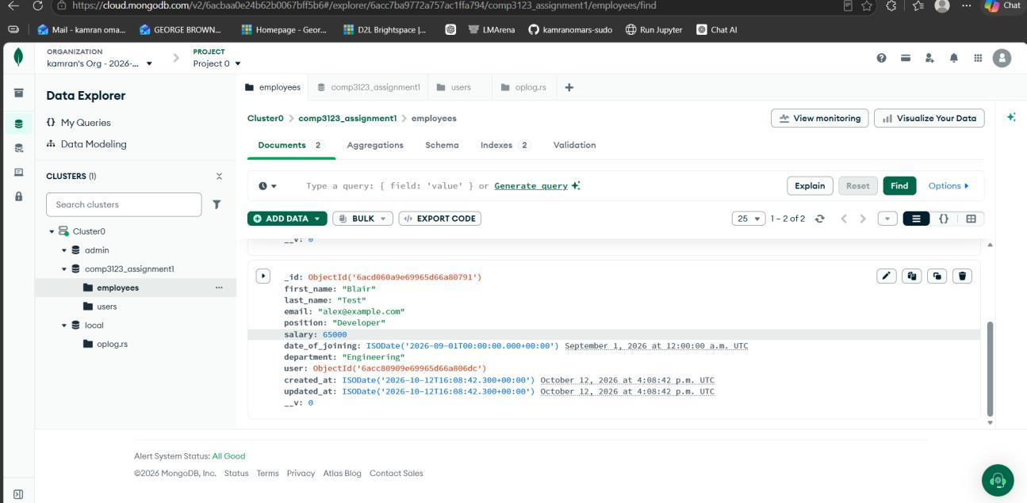

Cross user retrieval rejection
Screenshot 9 Source evidence page 5
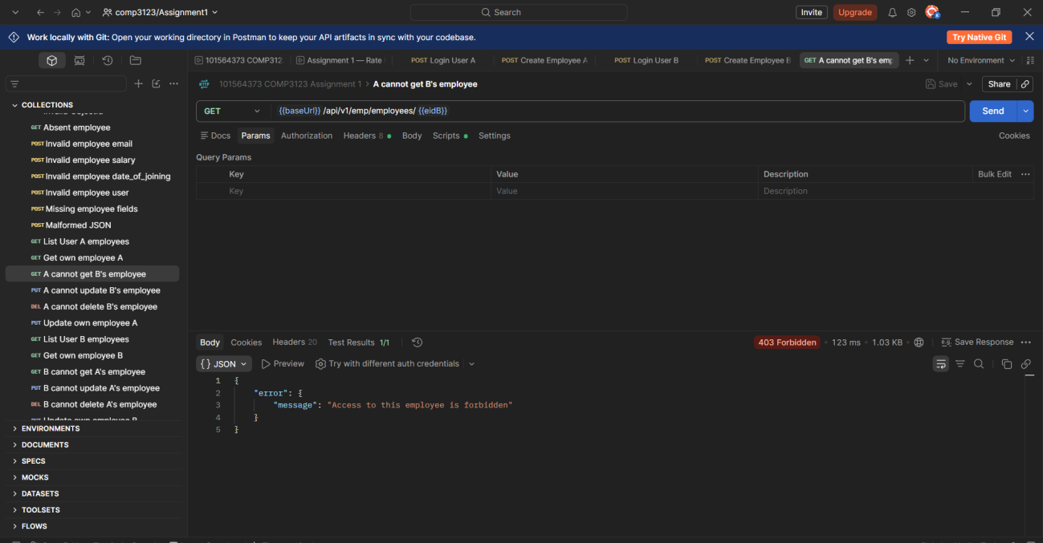

Cross user retrieval rejection
Screenshot 10 Source evidence page 6
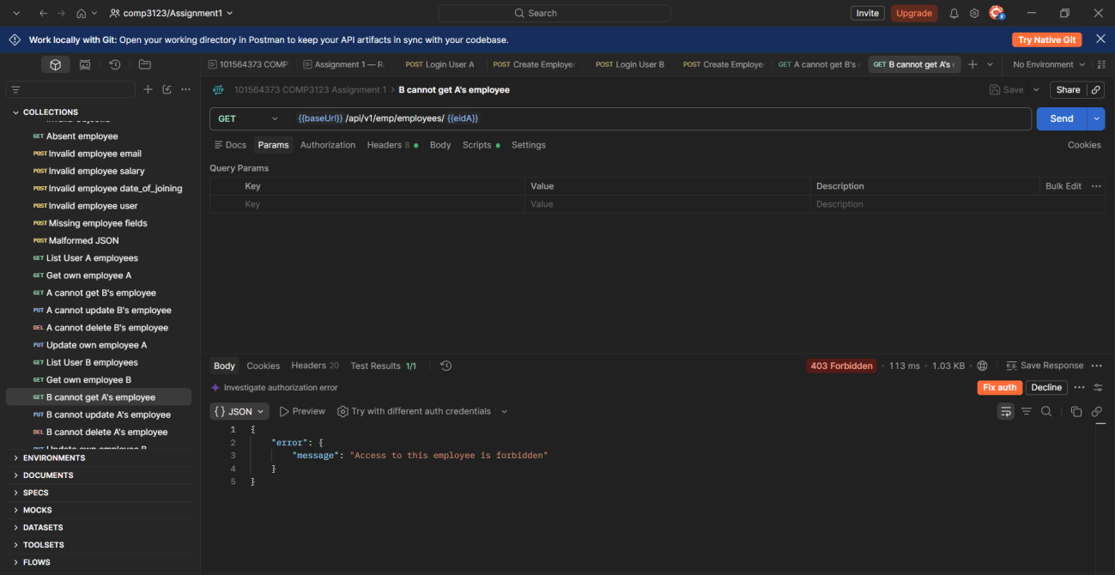

Cross user update rejection
Screenshot 11 Source evidence page 6
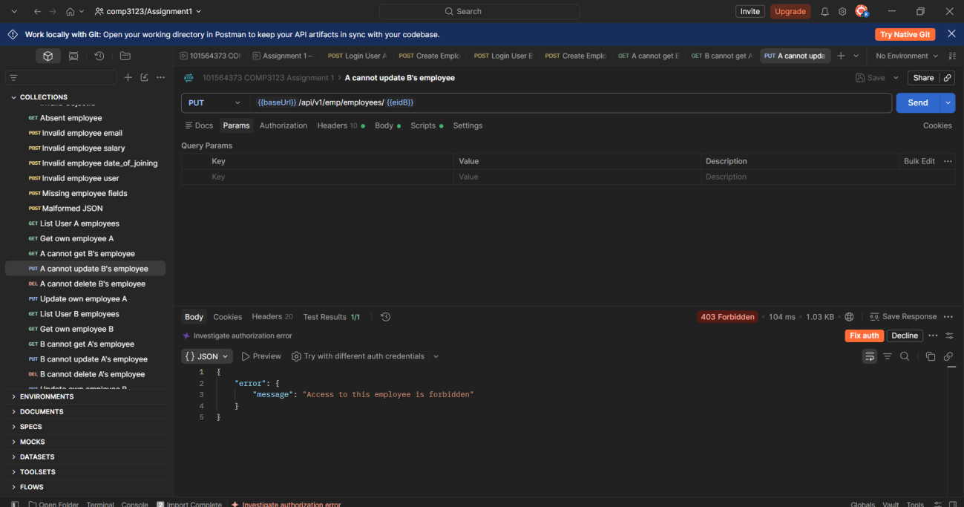

Cross user update rejection
Screenshot 12 Source evidence page 7
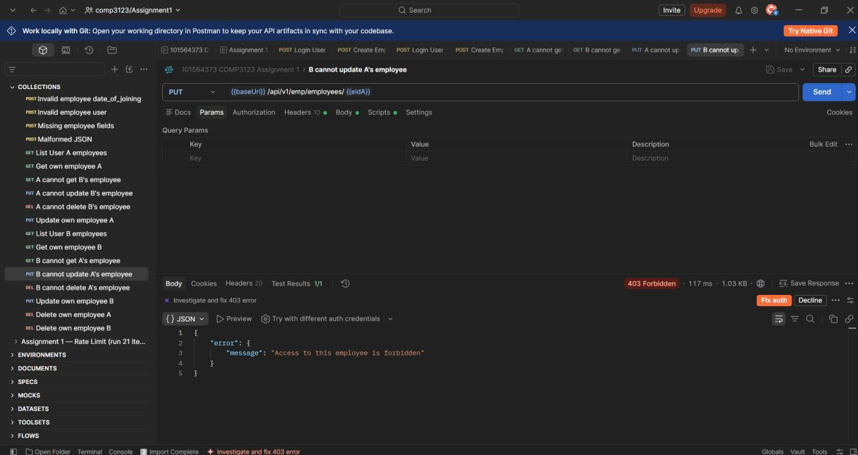

Cross user deletion rejection
Screenshot 13 Source evidence page 8
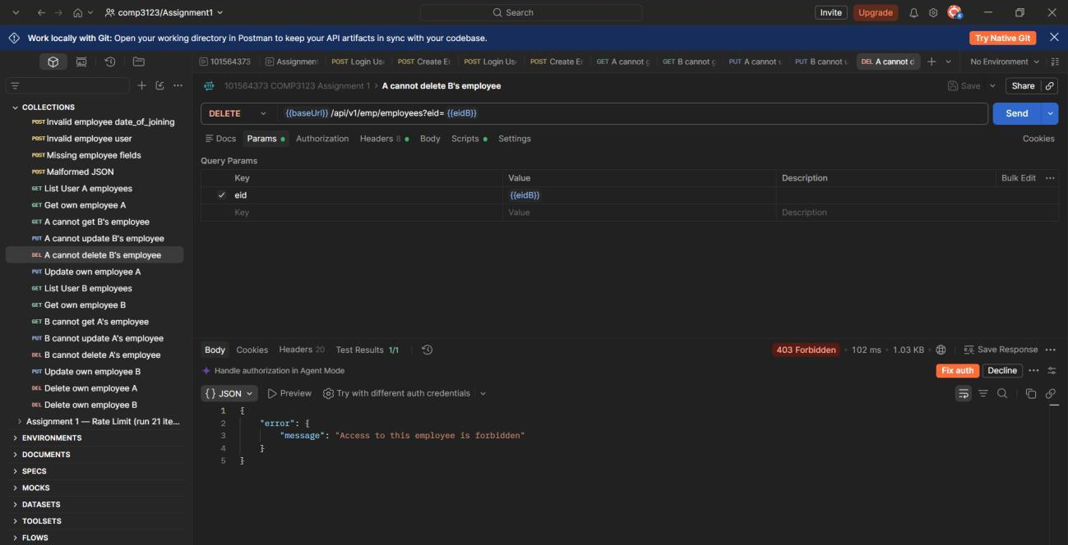

Cross user deletion rejection
Screenshot 14 Source evidence page 8
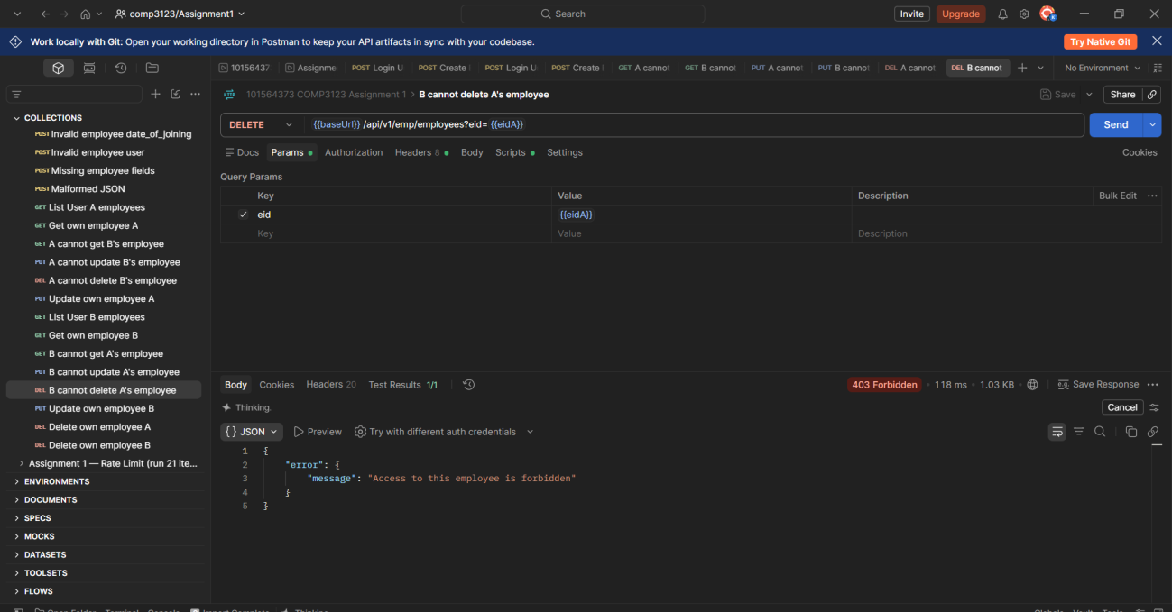

Employee lists filtered by owner
Screenshot 15 Source evidence page 9
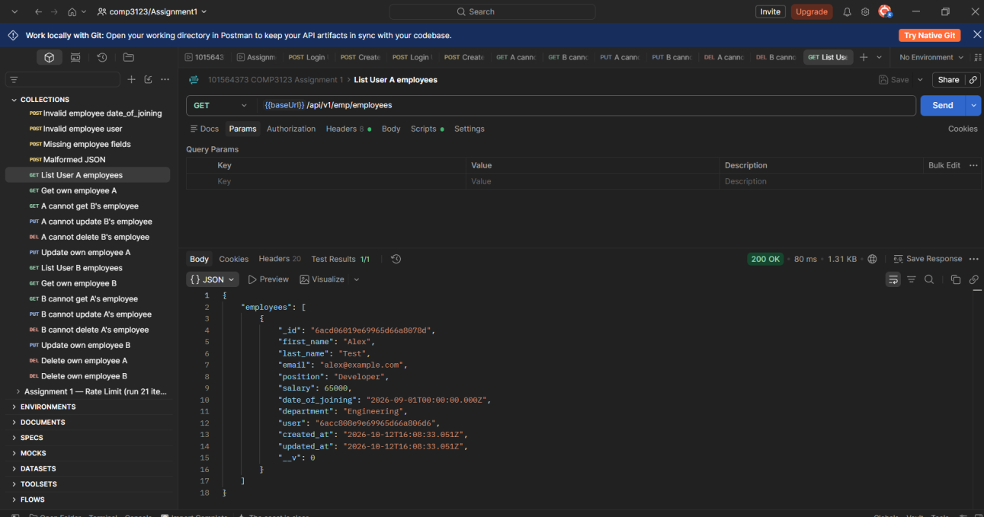

Employee lists filtered by owner
Screenshot 16 Source evidence page 9
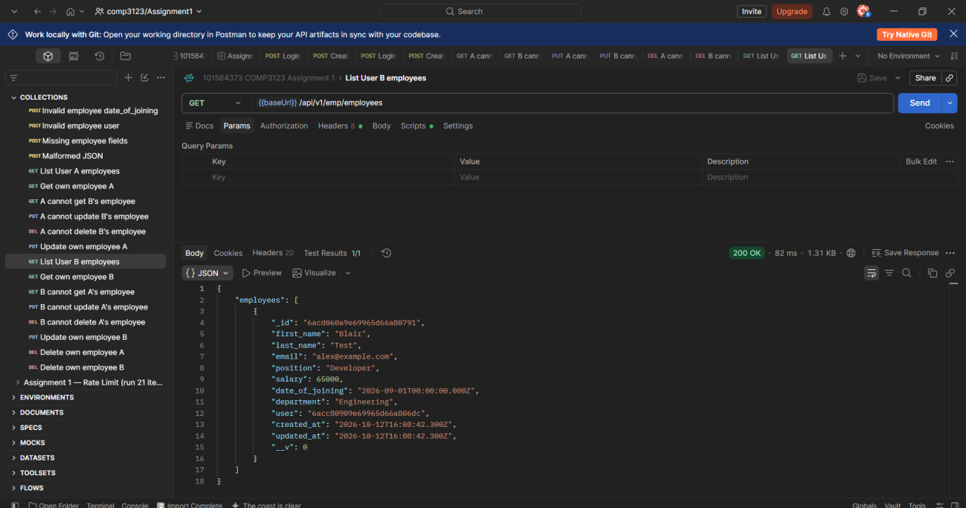

Successful employee updates
Screenshot 17 Source evidence page 10
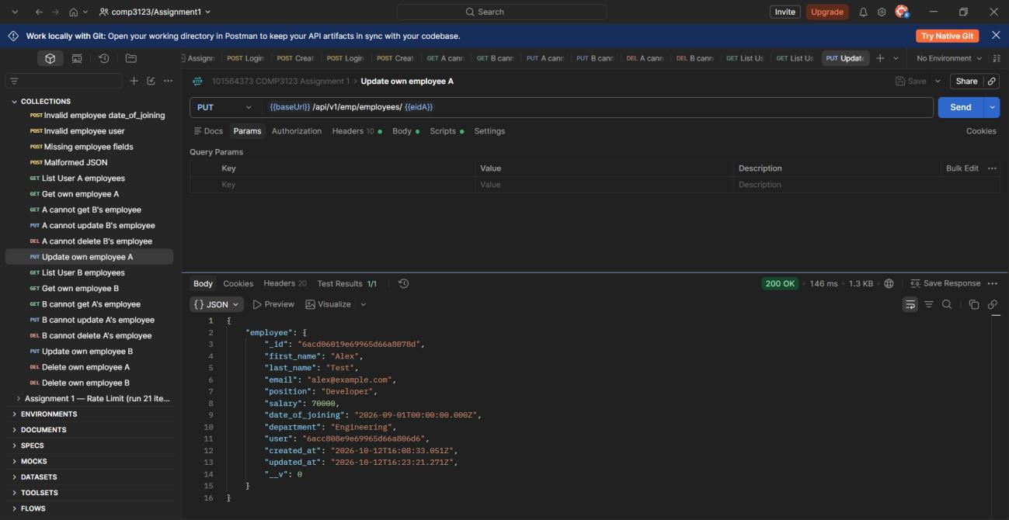

Successful employee updates
Screenshot 18 Source evidence page 10
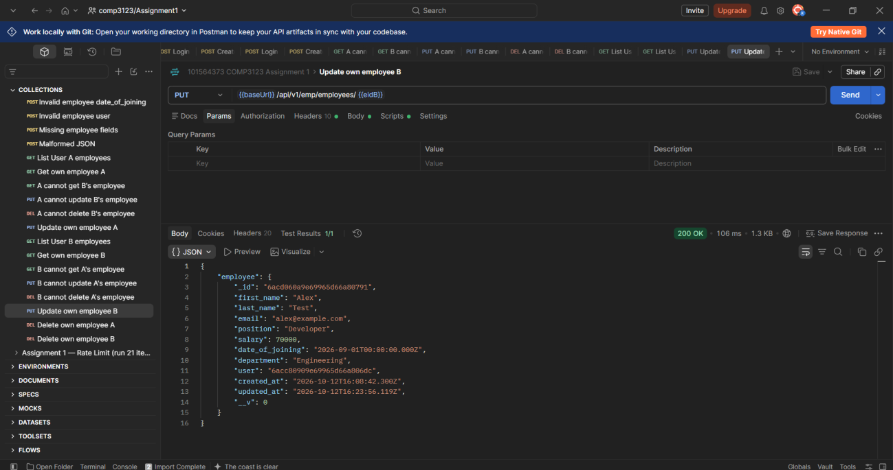

Successful employee deletions
Screenshot 19 Source evidence page 11
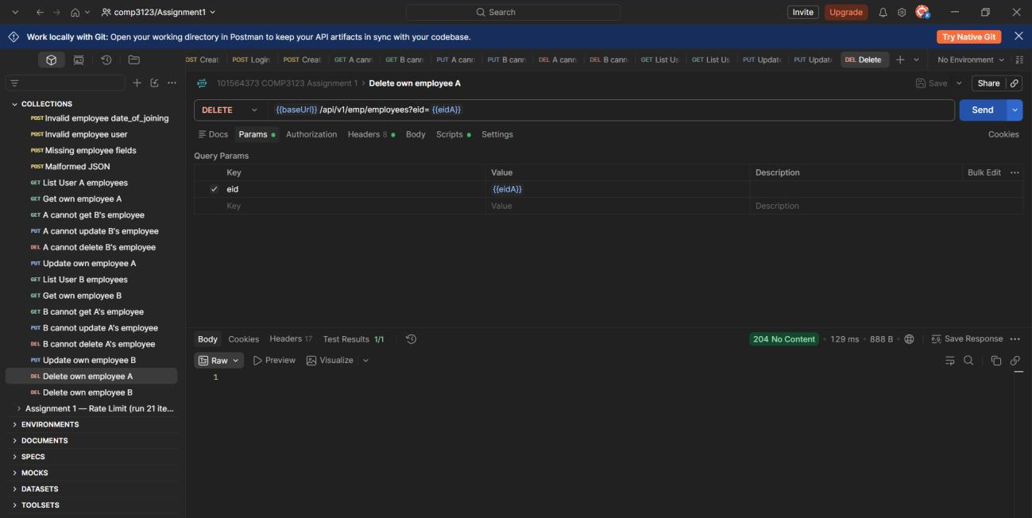

Successful employee deletions
Screenshot 20 Source evidence page 11
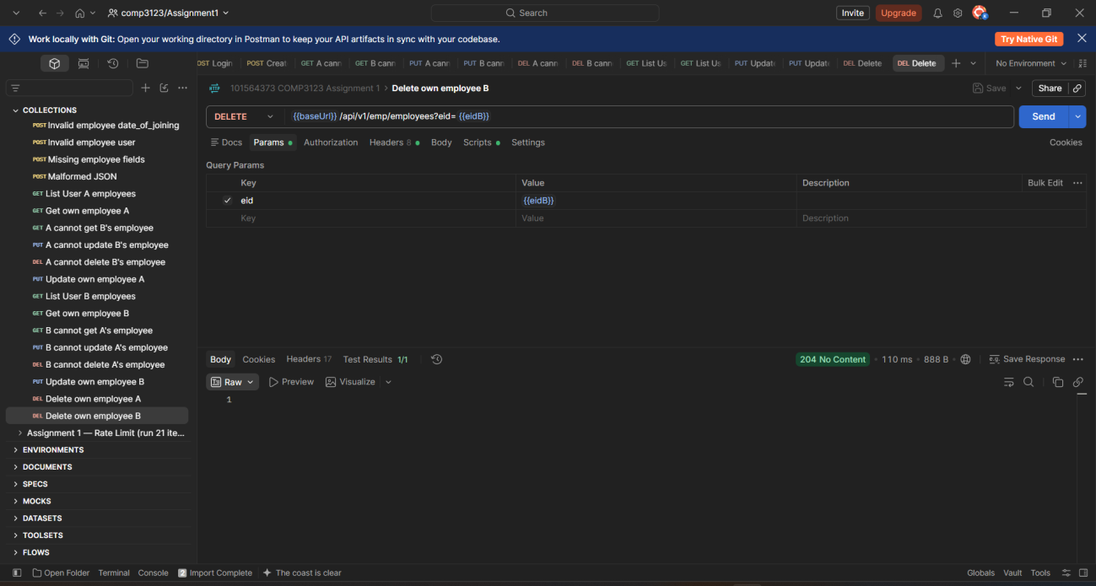

Employee input validation
Screenshot 21 Source evidence page 12
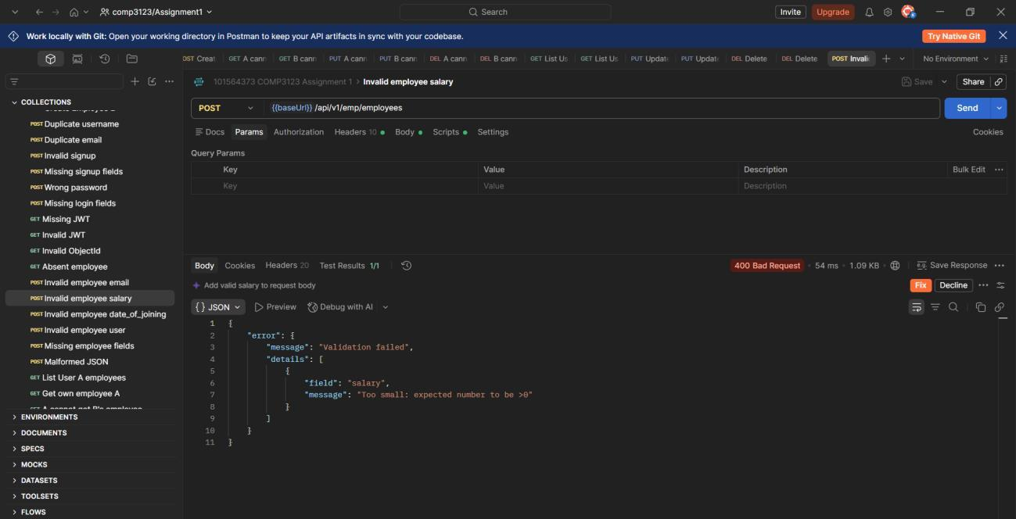

Missing authentication token
Screenshot 22 Source evidence page 12
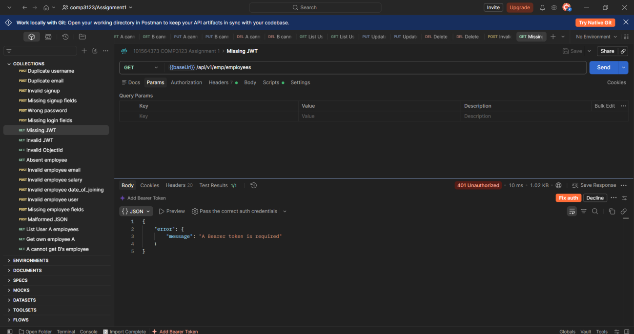

Health check
Screenshot 23 Source evidence page 13
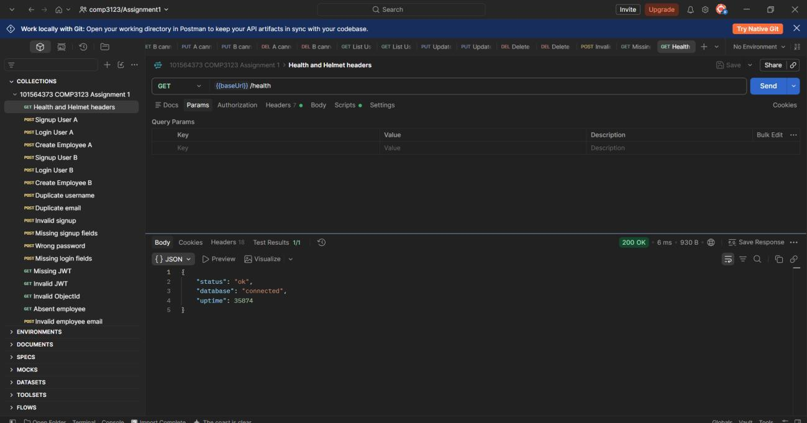

Helmet security headers
Screenshot 24 Source evidence page 13
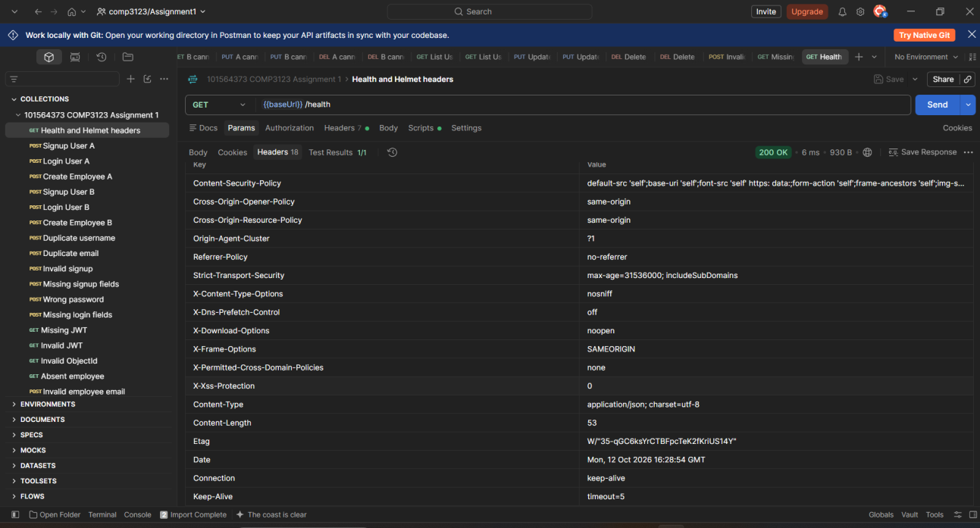

Local application logs
Screenshot 25 Source evidence page 14
