1. **If alkareem has a target of let’s say 50 lakh a month, once that is achieved, then the rest of the sales are set into the next month. It can be achieved by allowing the SALES operator to input a manual date for sales. Instead of auto picking. (done)**
2. There should be an option for the sales person to add comments. For example, is a sales person goes to a customer to receive january’s installment, let’s say the customer did not pay for any reason. The sales person or recovery officer can input a comment on that customer’s profile. (will do tomorrow)
3. **Cash transactions module** (done)
4. Sold items and transactions can’t be deleted. No child data can be deleted if it has parent data. (done)
5. Processing number of each customer for each sale. Always unique for each sale. I guess we already have that (done)
6. Add relevant elements to the product sub tab > dropdown (done)
7. Inventory management. (done)
8. Customers based on zones and sub zones.
9. 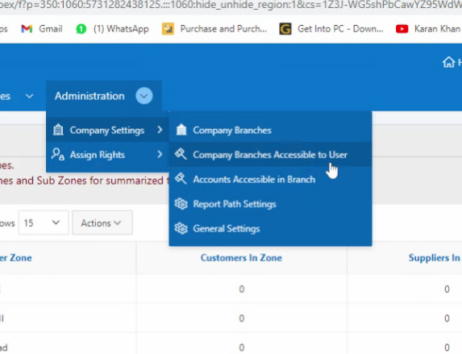Company settings
10. Rights based on modules and submodules - LATER
11. **Sales return and purchase return (done)**
12. Allow to add Sale price on cash sales to be added (done)
13. SALES crash when amount received is added as 0 (done)
14. Staff’s salary (AVO, MO particularly) shall be generated only when they close previous month’s accounts (done)
15. Add 4 guarantors instead of 3 (done)
16. Add another field for users above REMARKS input, it should be “Managers approval” this field should take the name of manager who approves the form/case (done)
17. A person who buys anything from 1 to 25th pays the next installment on coming 1st. If a person buys a thing on 26th of a month, then the next installment comes on a month later. (done)
18. SMS to customers with pending installments – will add more details to this point
19. Add upload document feature when GRN form submits(will do tomorrow)
20. Also show old balance in GRN for the specific vendor (will do tomorrow)