Kamron White

Cybr 410 data/database security

6/9/22

1. The link for the github repository is <https://github.com/kamronw99/CSD-310-.git> .
2. Here is the screenshot for the local directory setup instructions. 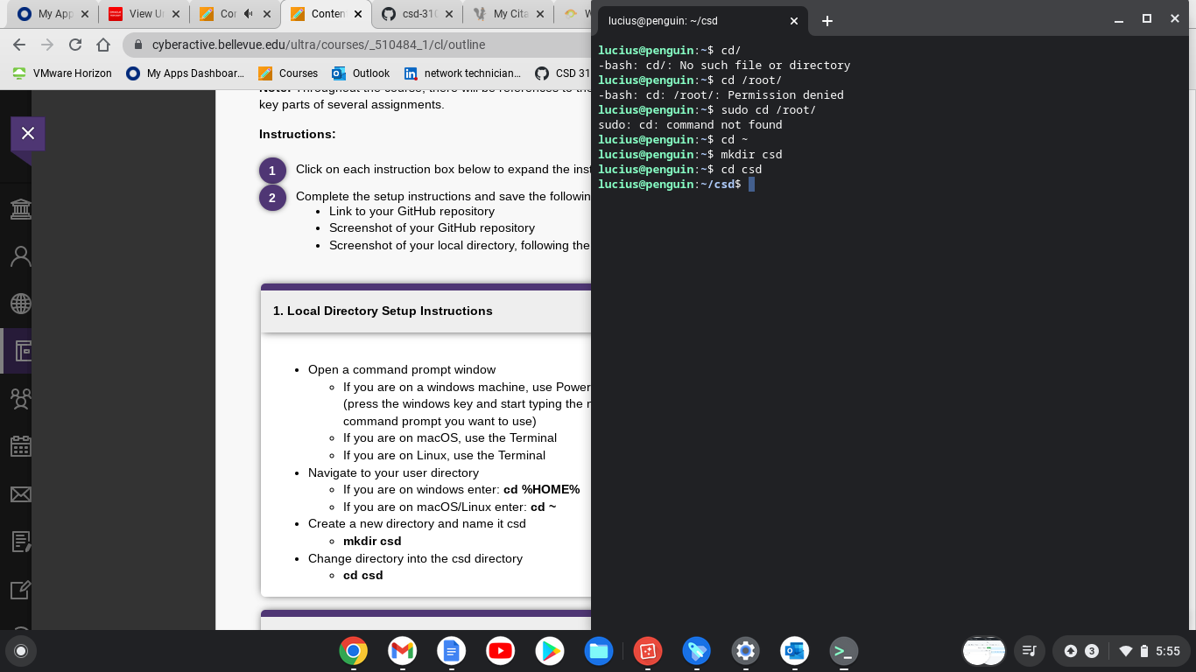
3. The next one took me a bit, however these are the instructions for the cloning of the repository on github.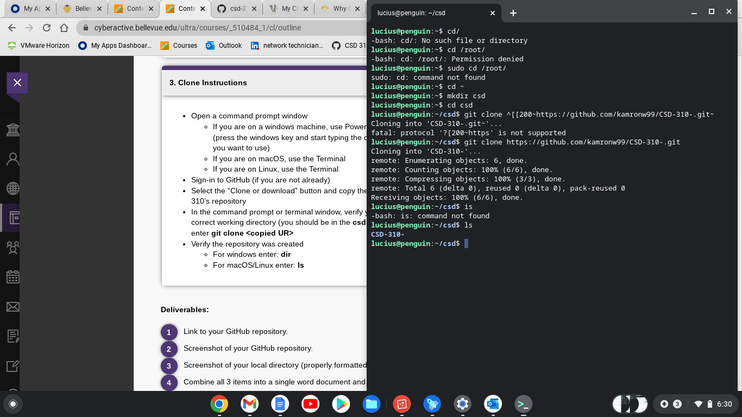
4. For the instructions in the github website I believe I made the readme.md and ignorefiles correctly but correct me if I did do them wrong. After looking again I realized the readme.md and ignorefile were settings i could've added at the time of creation. I did it again with the following repository.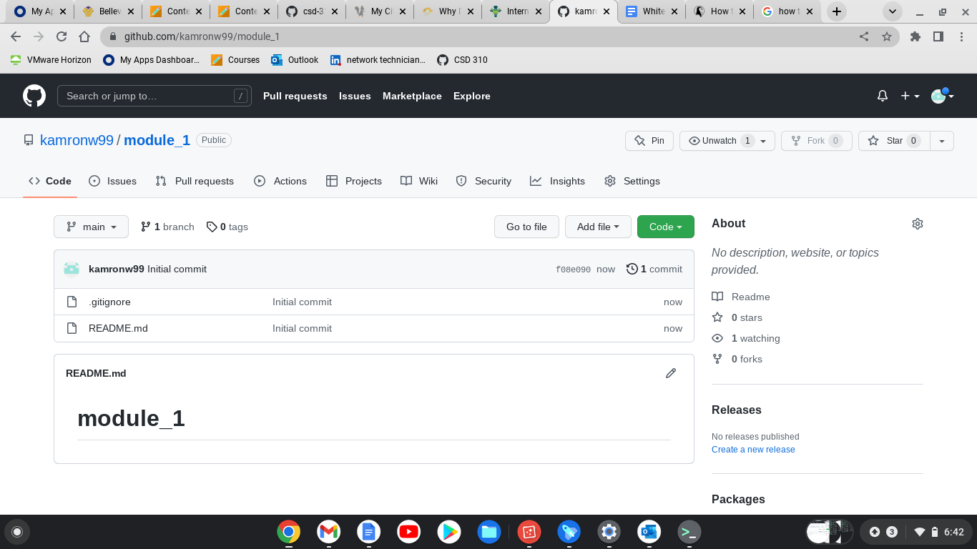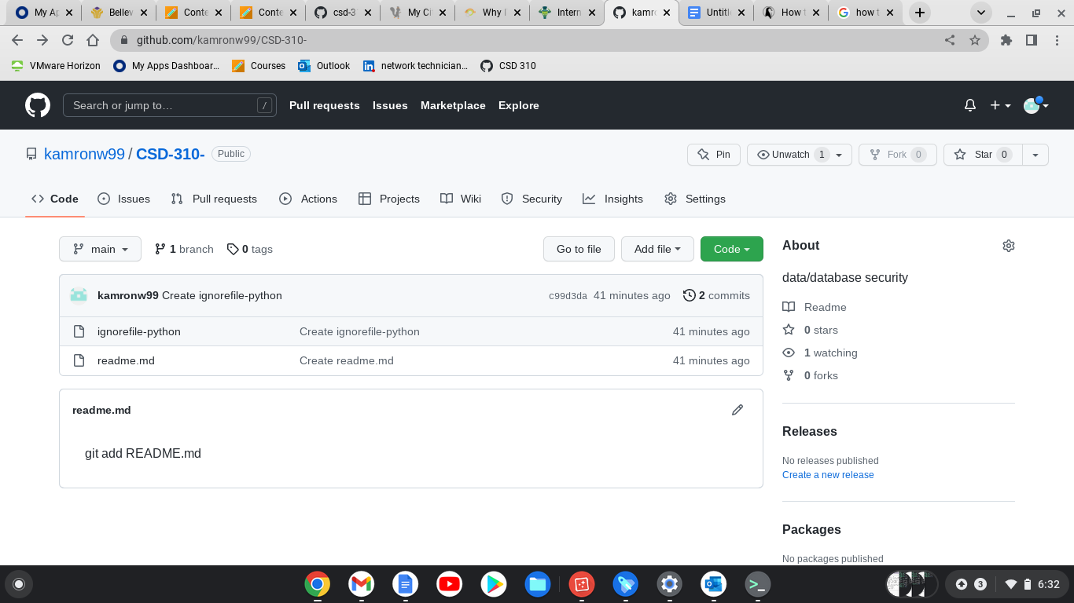
5. For the repository structure I uploaded this assignment into github and named it Assignment_1 under the module_1 section.