DDL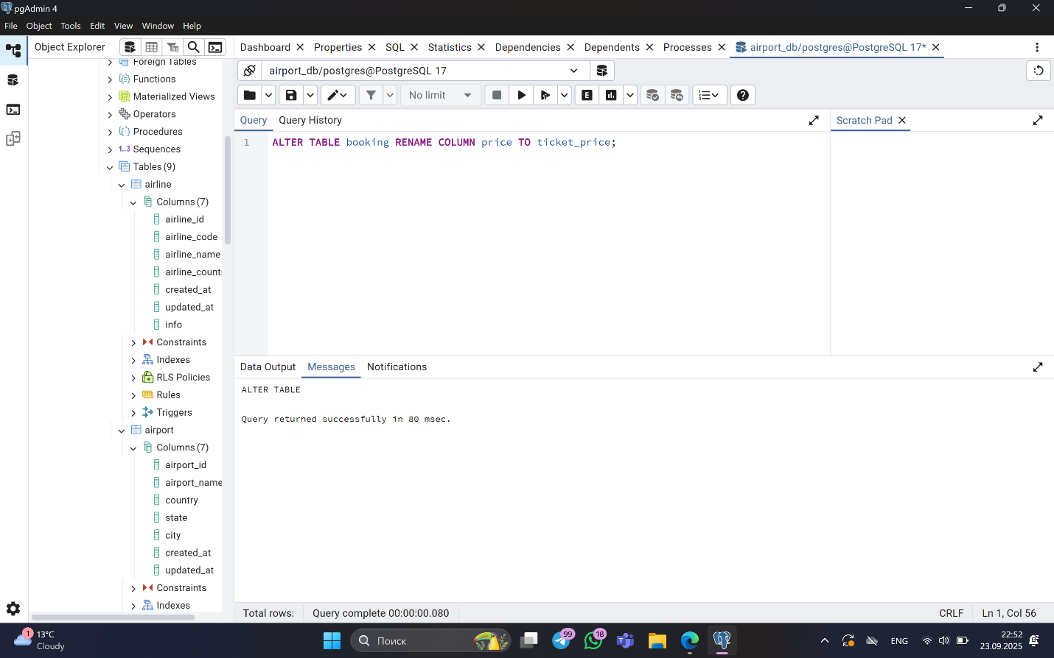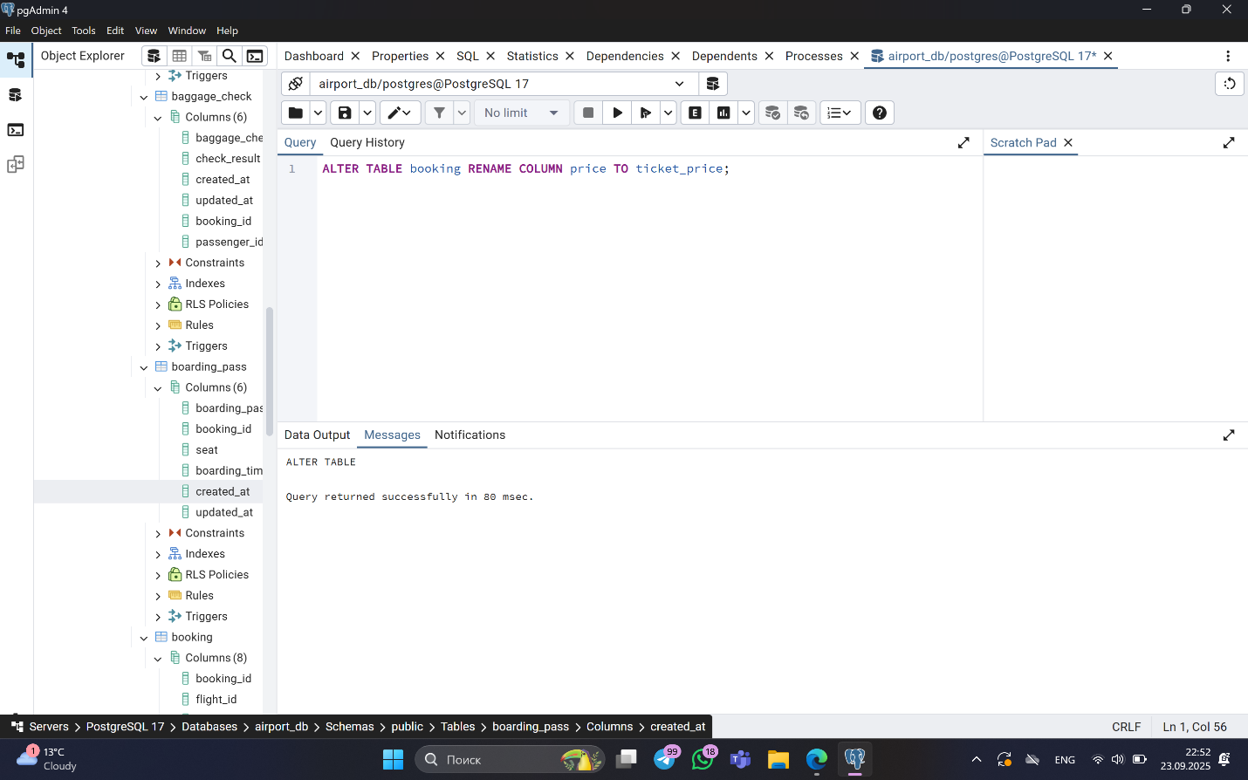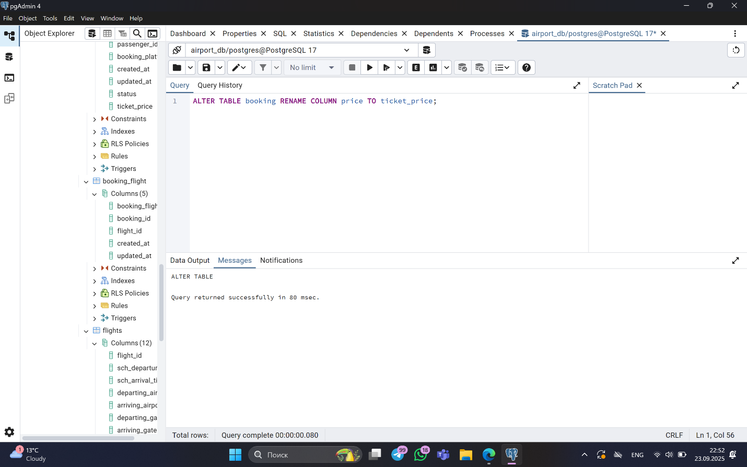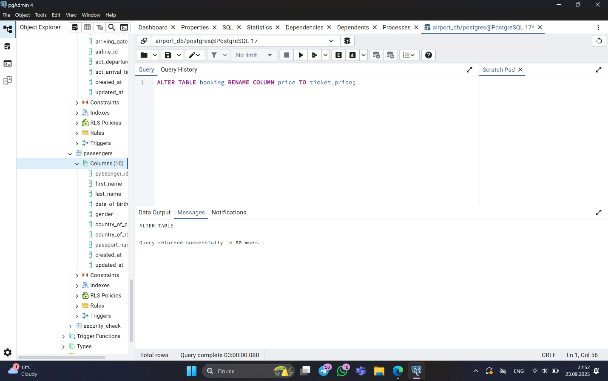



Sample: CREATE TABLE airline_info (

airline_id INT PRIMARY KEY,

airline_code VARCHAR(30) NOT NULL,

airline_name VARCHAR(50) NOT NULL,

airline_country VARCHAR(50) NOT NULL,

created_at TIMESTAMP NOT NULL,

updated_at TIMESTAMP NOT NULL,

info VARCHAR(50) NOT NULL

);

CREATE TABLE booking (

booking_id INT PRIMARY KEY,

flight_id INT NOT NULL,

passenger_id INT NOT NULL,

booking_platform VARCHAR(50) NOT NULL,

created_at TIMESTAMP NOT NULL,

updated_at TIMESTAMP NOT NULL,

status VARCHAR(50) NOT NULL,

price DECIMAL(7,2) NOT NULL

5. ALTER TABLE airline_info RENAME TO airline;

6.

ALTER TABLE booking RENAME COLUMN price TO ticket_price;

7.

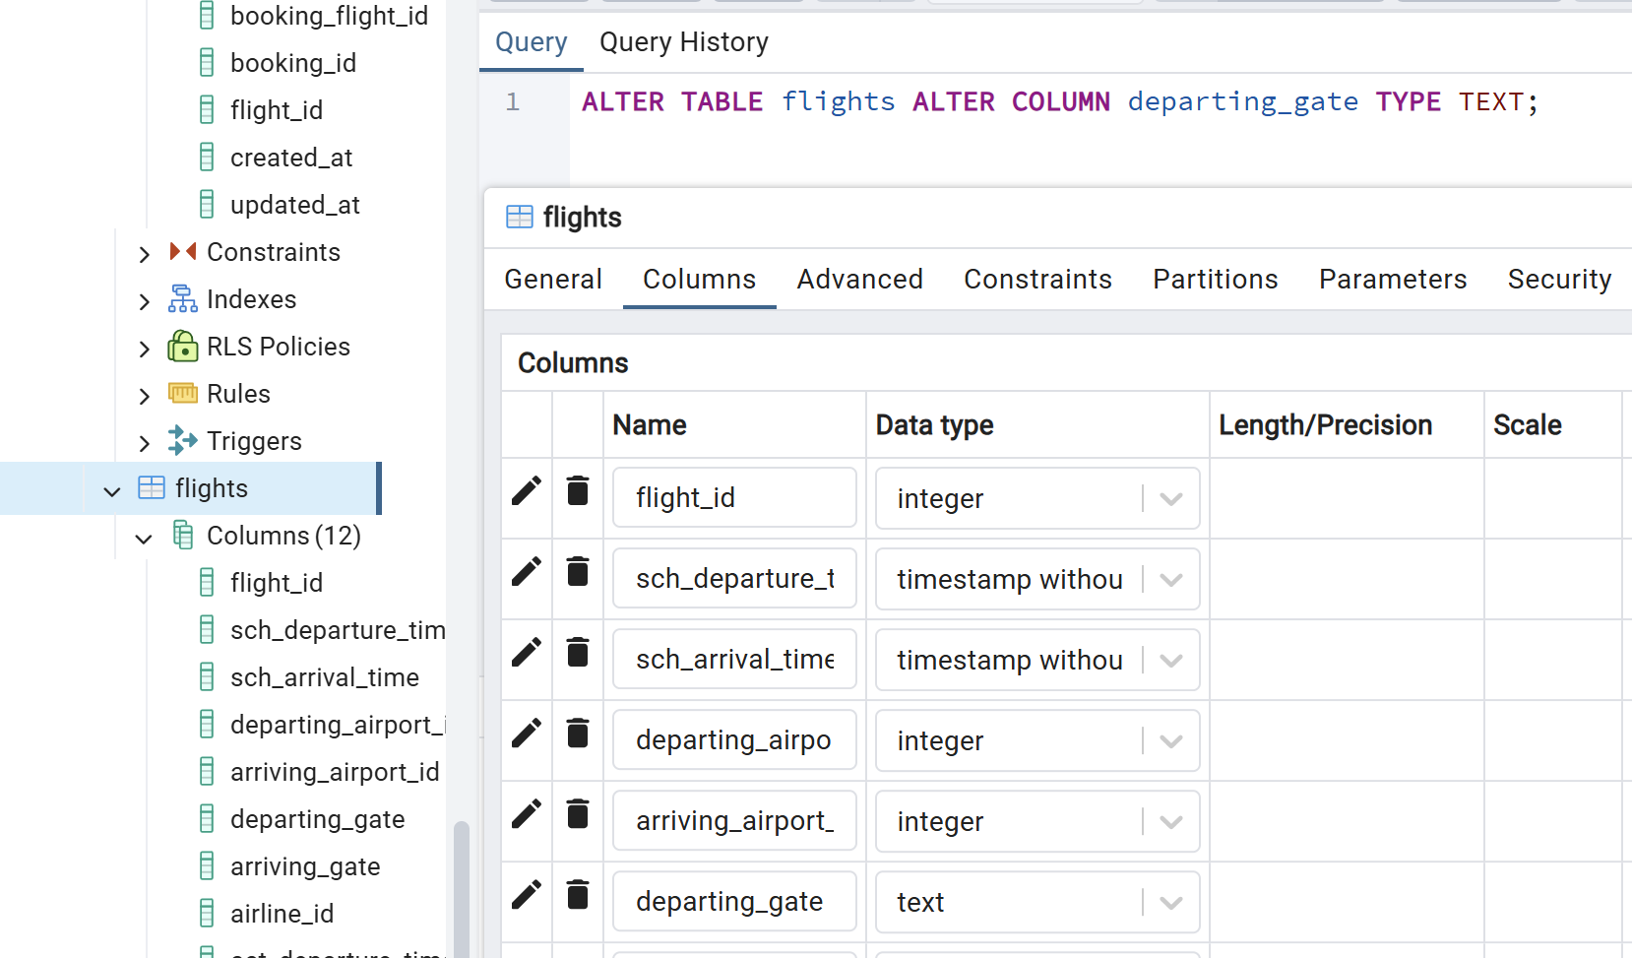

8.

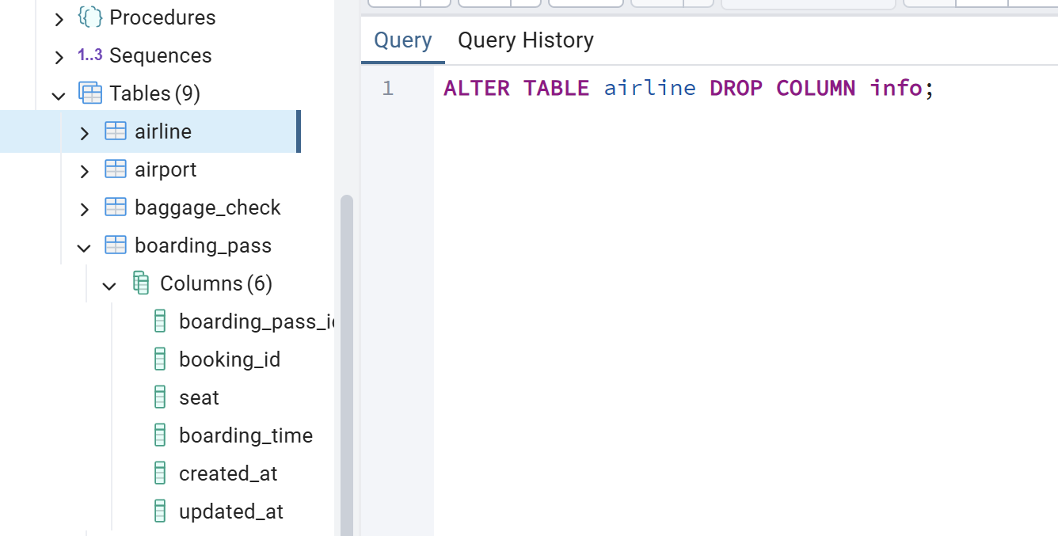

9.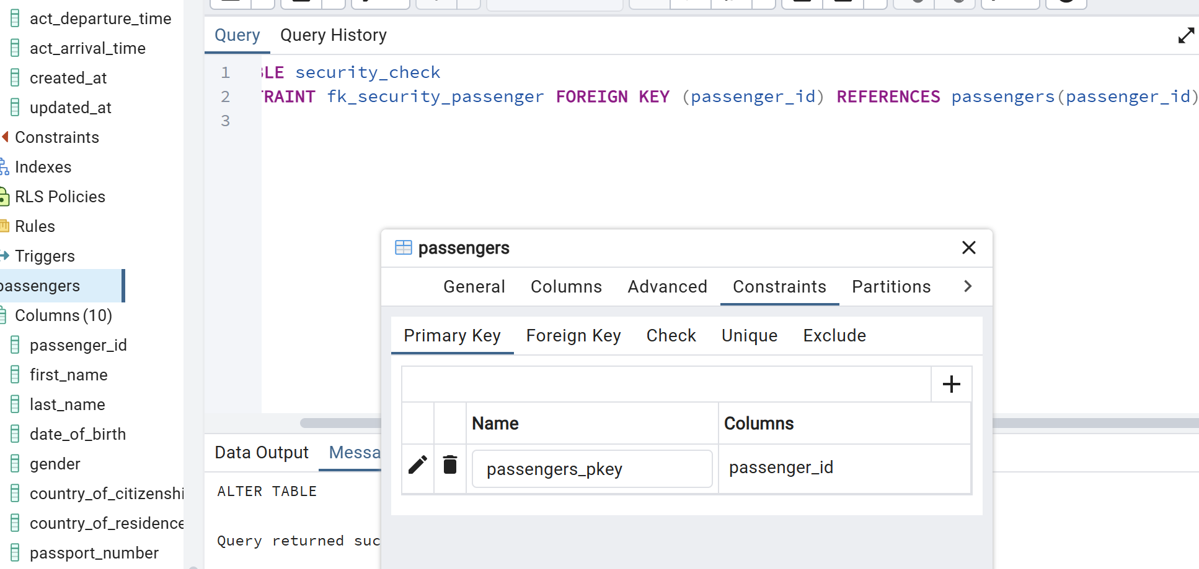

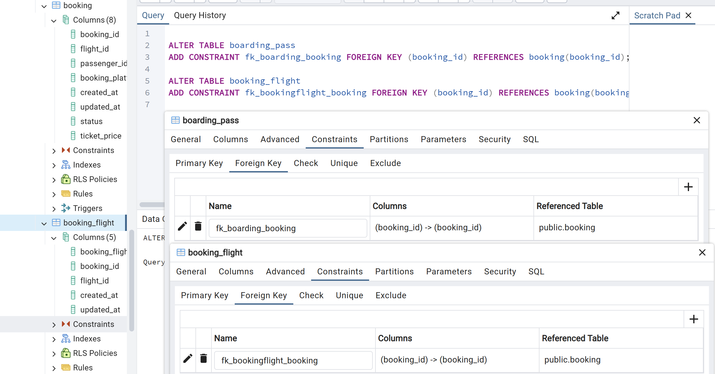

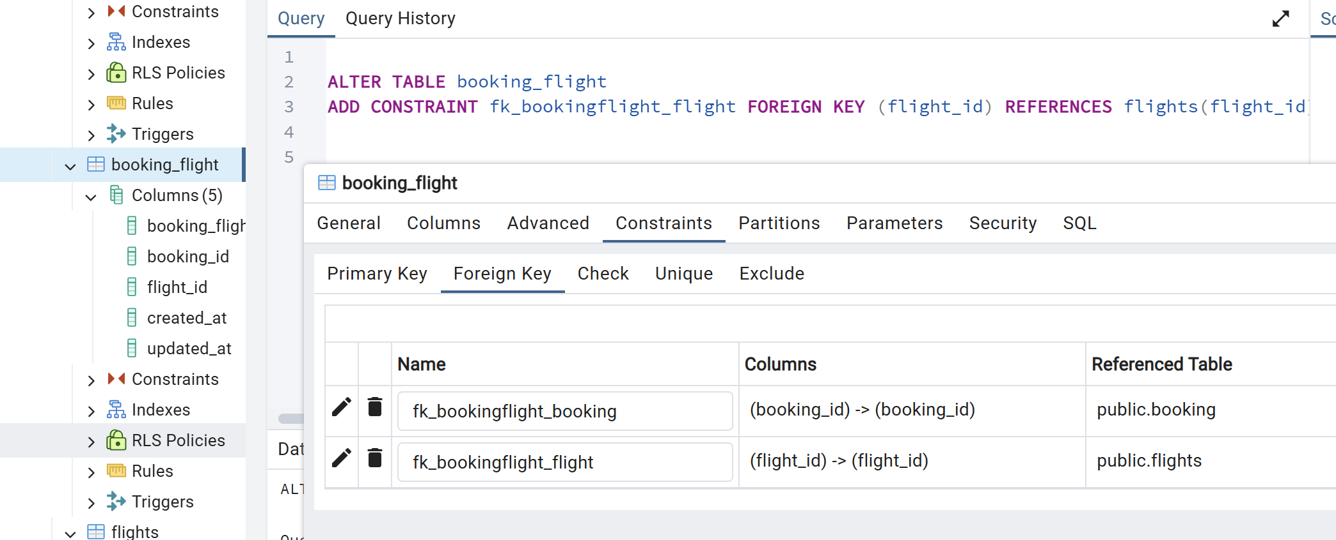

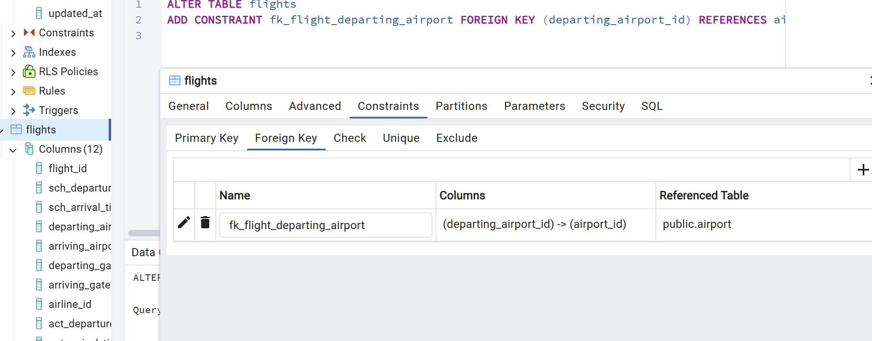

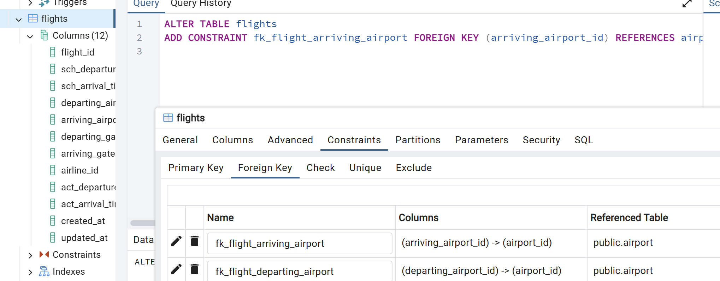

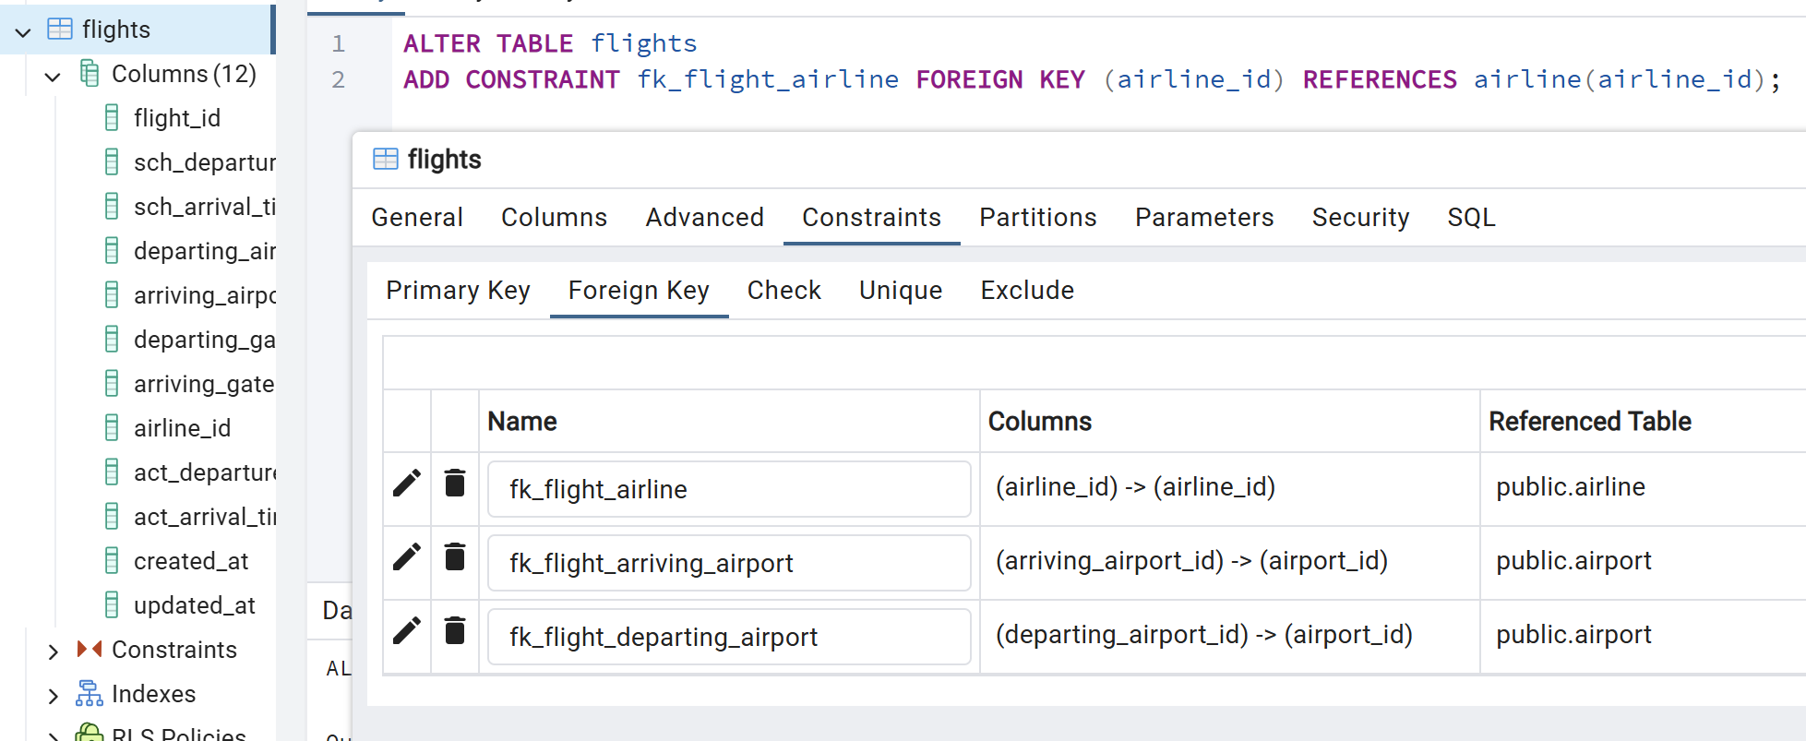

DML

1. INSERT INTO airport (airport_id, airport_name, country, state, city, created_at, updated_at)

SELECT g, 'Airport_' || g, 'Country_' || g, 'State_' || g, 'City_' || g, NOW(), NOW()

FROM generate_series(1, 200) g;

2.

INSERT INTO airline (airline_id, airline_code, airline_name, airline_country, created_at, updated_at)

VALUES (1, 'KZ001', 'KazAir', 'Kazakhstan', NOW(), NOW());

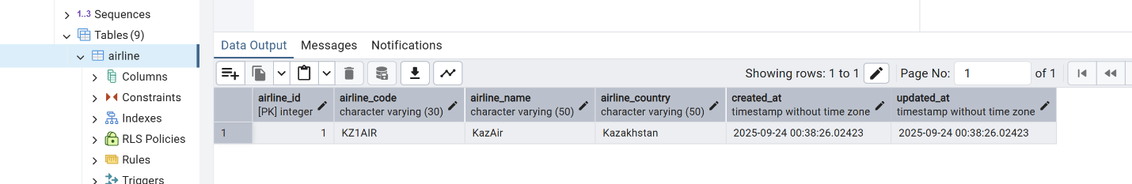

3.

UPDATE airline

SET airline_country = 'Turkey'

WHERE airline_name = 'KazAir';

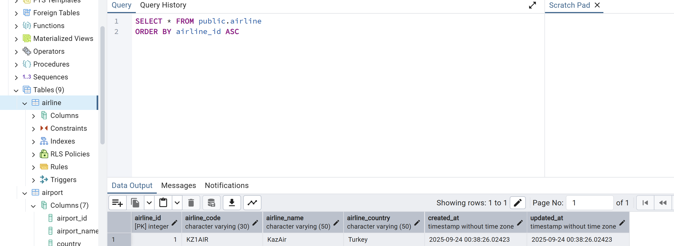

4.

INSERT INTO airline (airline_id, airline_code, airline_name, airline_country, created_at, updated_at)

VALUES

(2, 'FR001', 'AirEasy', 'France', NOW(), NOW()),

(3, 'BR001', 'FlyHigh', 'Brazil', NOW(), NOW()),

(4, 'PL001', 'FlyFly', 'Poland', NOW(), NOW());

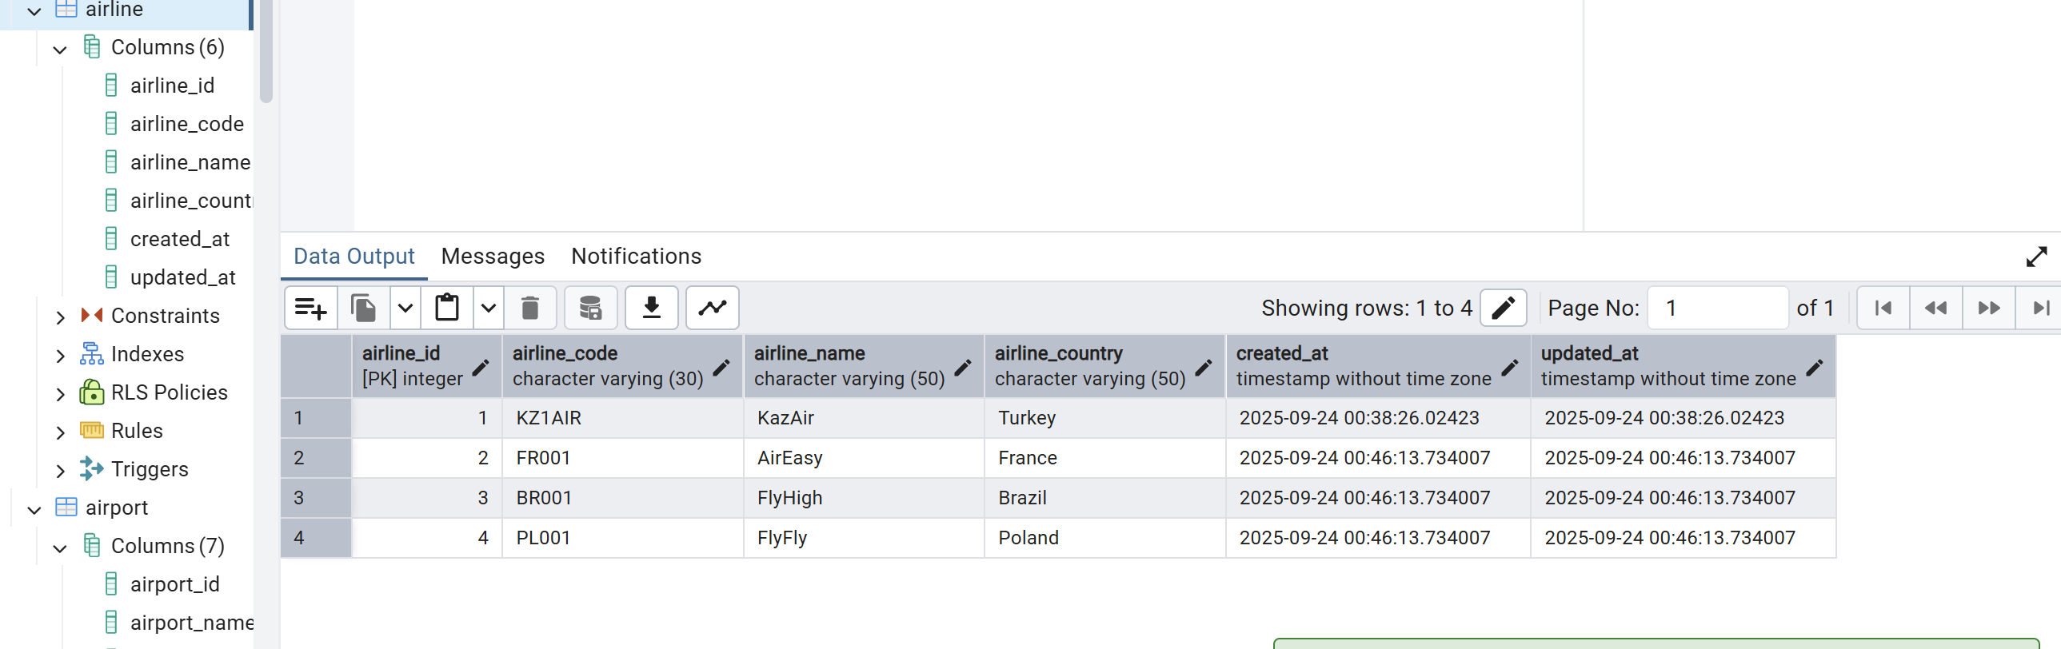

5.

DELETE FROM flights

WHERE EXTRACT(YEAR FROM sch_arrival_time) = 2024;

6. UPDATE booking

SET ticket_price = ticket_price * 1.15;

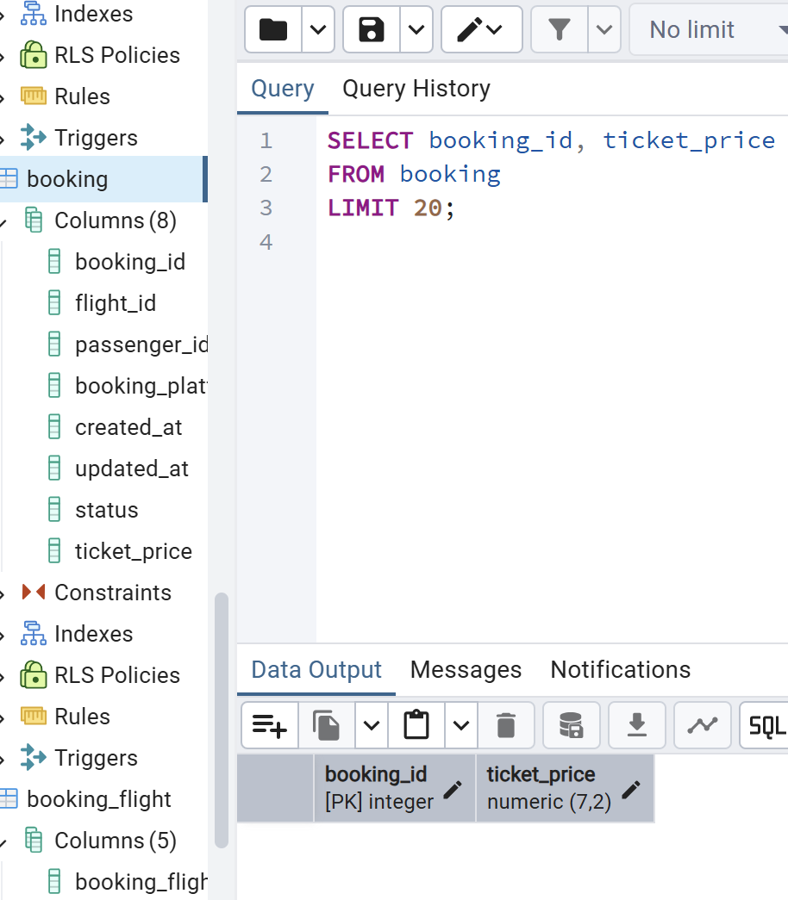

7.

DELETE FROM booking

WHERE ticket_price < 10000;