**Eco-bin**

The Eco Bin project aims to improve waste management in communities by introducing smart bins that collect and sort rubbish efficiently. Users will be taught how to sort their rubbish from the organic separate from the inorganic wastes. Users will be offered services of eco-architecture services whereby reuse of waste in an eco-friendly way will be taught at a fee.

Methods of data collection for my case study

I used methods like observation and interviews whereby I found out for poor disposal of wastes has hindered people from having a conducive environment.

Users

The people to use the app will be those that require their waste recycled and managed.

Administration of the app: Managed by the us the app administrators who will track all the logs on the app and its content.

Waste will be managed from a waste recycling center one with the necessary facilities to manage large amounts of waste.

Eco-bin user interactions

1. User Registration: Users create an account that is name, address, number, email etc.

2. Login: Users log into their accounts.

3. Waste architecture: User subscribes to learn how they can reuse their wastes other ways like building houses using bottles, building eco-friendly gardens.

4. Schedule Pickup: Users organize a waste pickup service whereby he subscribes to the service and he is prompted to input his address

5.Admin Manage Content: Admin updates recycling guidelines and center information plus updating the user database.

6. Sorting Mechanism: The Eco Bin can sort recyclables from general waste using an automatic sorting mechanism. This ensures that recyclable materials are processed correctly, promoting recycling and reducing landfill waste.

7. User Notifications: Community members can receive notifications via a mobile app about when the Eco Bin is full or when special recycling events are taking place. This keeps the community informed and engaged in waste management efforts.

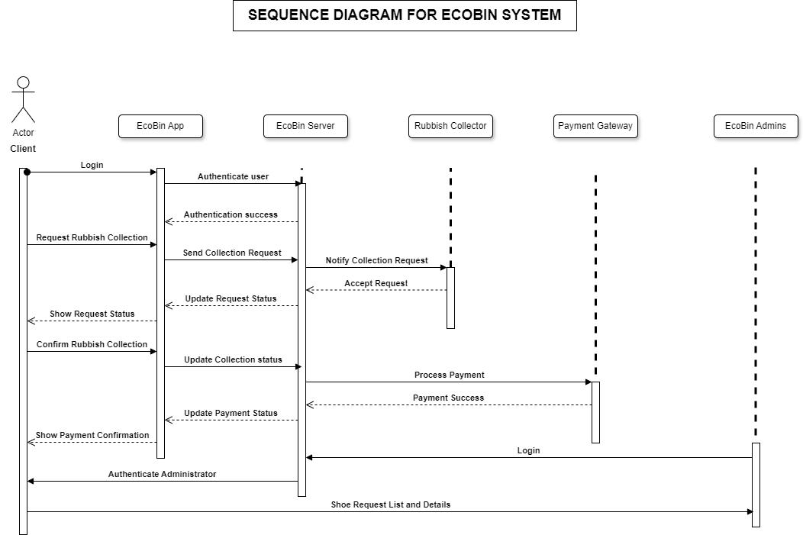

**User case Diagram of Eco Bin**

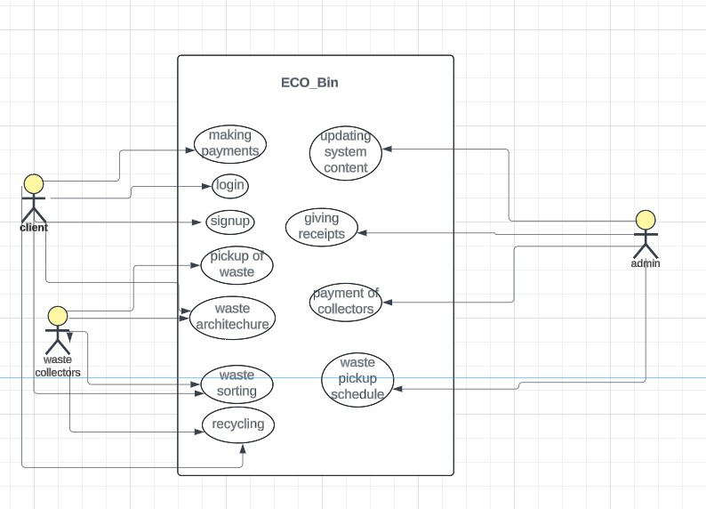

**USECASE DIAGRAM**

