Add state diagram

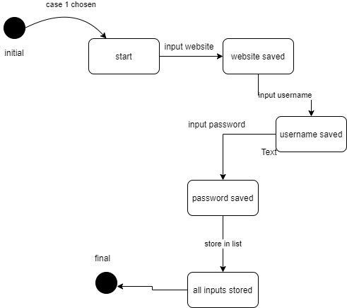

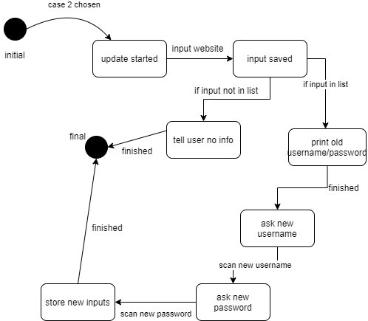update state diagram

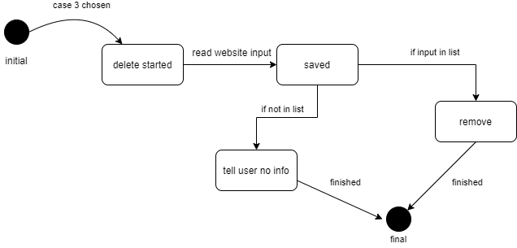delete state diagram

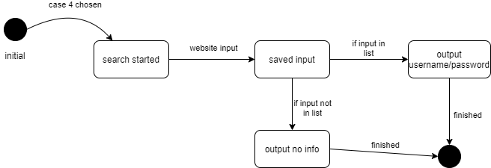search state diagram

View all state diagram

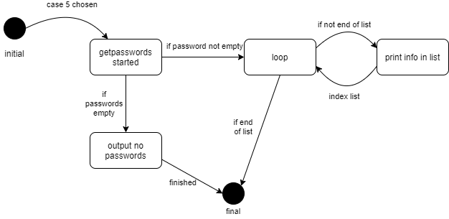

Grant Henderson R11314979

Password Manager Use Case Specifications

Use Case Description: The Add case allows the user to add a website and the username and password for that website. The use case starts when the user selects the add option by inputting ‘1’. The password manager will then prompt the user for the website they wish to add their credentials for. After adding a website, the program will prompt the user for the username then the password. After the user has added their credentials, the program confirms the addition and asks the user if they want to return to the main menu or exit.

Use Case Name: Add

Actors:

Any user

Triggers:

The user wants to add credentials for a website to the manager.

Preconditions:

The program is operational.

Post Conditions:

The user has added a website and its credentials to the manager.

Normal Flow:

1. The user starts the program. 2. The user inputs ‘1’ for the add function. 3. The manager prompts user for the website. 4. The user enters the website. 5. The manager prompts the user for their username. 6. The user enters their username. 7. The manager prompts the user for their password. 8. The user enters their password. 9. The manager adds the website and credentials to its list. 10. The manager asks if user would like to return to the main menu or exit.

Use Case Description: The Update case allows the user to update any existing website credentials. The use case starts when the user enters ‘2’ for the update function on the main menu. The update function asks the user for a website name. If the website does not exist an error message is printed. If there is a matching website the program will display the current credentials of the website then prompt the user to enter the new username and then the password. The program will print a confirmation that the credentials were successfully changed. Afterwards, the program will ask if the user wants to return to main menu or exit.

Use Case Name: Update

Actors:

Any user

Triggers:

The user wants to update a website’s credentials in the manager.

Preconditions:

The program is operational. The manager has a website’s credentials stored.

Post Conditions:

The user has updated a website’s credential in the manager.

Normal Flow:

1. The user starts the program. 2. The user inputs ‘2’ for the update function. 3. The manager prompts user for the website. 4. The user enters the website. 5. The manager searches to see if the website exists. 6. The manager displays the current credentials of the website. 7. The manager asks the user for a new username. 8. The enters a new username. 9. The manager asks the user for a new password. 10. The user enters the new password. 11. The manager replaces the old credentials with the new ones. 12. The manager asks if user would like to return to the main menu or exit.

Use Case Description: The Delete case allows user to remove any website and credentials stored within the manager. The use case begins when the user selects the delete option from the main menu by entering ‘3’. The manager then prompts the user for the name of the website they wish to remove. If the user enters a website that is not stored in the manager, it will output an error and return the user to the menu. Otherwise, the manager will delete the website and credentials from its list. The manager will confirm it was successful then ask the user whether they wish to return to main menu or exit.

Use Case Name: Delete

Actors:

Any user

Triggers:

The user wants to delete a website and its credentials from the manager.

Preconditions:

The program is operational. The manager has a website’s credentials stored.

Post Conditions:

The user has deleted a website and its credentials from the manager.

Normal Flow:

1. The user starts the program. 2. The user inputs ‘3’ for the delete function. 3. The manager prompts user for the website. 4. The user enters the website. 5. The manager searches to see if the website exists. 6. The manager deletes the website and credentials. 7. The manager asks if user would like to return to the main menu or exit.

Use Case Description: The Search case allows the user to search and see current credentials for a given website. The search function begins when user inputs ‘4’ for the search function. If there are no websites in the manager and error message is displayed and the user is returned to the main menu. Otherwise, the search function asks the user for a website name. If the website does not exist the manager will output an error message. If it does exist, the manager will print the username and password for the given website. The manager then asks the user if they would like to return to the main menu or to exit.

Use Case Name: Search

Actors:

Any user

Triggers:

The user wants to search the credentials of a website in the manager.

Preconditions:

The program is operational. The manager has a website’s credentials stored.

Post Conditions:

The user is shown a website and its credentials.

Normal Flow:

1. The user starts the program. 2. The user inputs ‘4’ for the search function. 3. The manager checks to see if there are any websites stored. 4. The manager prompts user for the website. 5. The user enters the website. 6. The manager searches to see if the website exists. 7. The manager displays the website’s credentials to the user. 8. The manager asks if user would like to return to the main menu or exit.

Use Case Description: The View case allows user to see all currently stored websites and their usernames and passwords. The view use case starts when the user selects the view option from the main menu. If there are no websites stored, the manager will output an error message. Otherwise, the manager will display all websites and their usernames and passwords. The program will then ask the user if they would like to return to the main menu or exit.

Use Case Name: View

Actors:

Any user

Triggers:

The user wants to view all currently stored websites and their credentials.

Preconditions:

The program is operational. The manager has a website’s credentials stored.

Post Conditions:

The user is displayed all stored websites and their credentials.

Normal Flow:

1. The user starts the program. 2. The user inputs ‘5’ for the view function. 3. The manager checks to see if there are any websites stored. 4. The manager prints the websites and their usernames and passwords. 5. The manager asks if user would like to return to the main menu or exit.