AMOS SS25 Project #2 Intelligent Document Management System
Project name | Bit & Beam: Intelligent Building Document Management System
Project mission | We aim to build a secure, multi-tenant backend that stores uploaded permits, certificates, and maintenance reports; applies AI-driven OCR and metadata extraction to classify and validate each document; and provides a web UI where users can query and filter their building records using plain language. By implementing and demonstrating a full workflow — from document upload to automatic processing and natural-language search on sample data — we will create the technical foundation for a production-ready system that significantly reduces the time and effort required to manage building documents.
Industry partner | BUILD.ING Consultants + Innovators GmbH
Team logo | 
Project summary | In today’s fast-paced construction and building administration landscape, managing the flood of permits, certificates, and maintenance reports can be a costly bottleneck. The Intelligent Document Management System tackles this head-on by providing a secure, multi-tenant backend that ingests documents via UI or API, applies AI-driven OCR and metadata extraction (using Apache Tika and Ollama), and automatically classifies each file—be it a building permit, energy certificate, or inspection report—so a construction or planning team never wastes time on manual sorting or data entry. A C#/.NET Core API paired with an Angular frontend lets users validate extracted fields in real time and then query files from their document repository in plain language (for example, “Summarize this fire permit”) with results served instantly via Ollama. Multiple models can be configured on a self-hosted GPU-powered server, which ensures that the data never leaves your infrastructure and all data protection regulations are met. Containerized with Docker and backed by PostgreSQL, this end-to-end workflow — from upload through AI processing to natural-language interaction — is designed for rapid deployment, scalability, and dramatic reductions in compliance-related workload, empowering building professionals to focus on safety and efficiency rather than paperwork.
Project illustration | 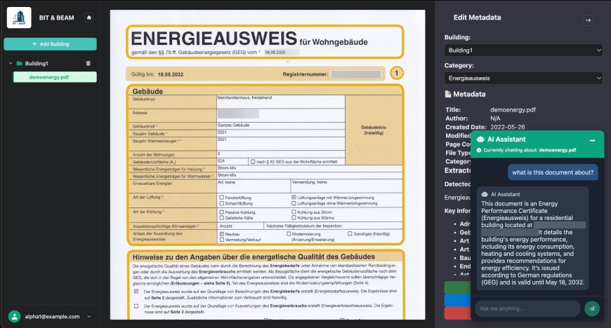
Team photo | 
Project repository | https://github.com/amosproj/amos2025ss02-building-documentation-management-system

