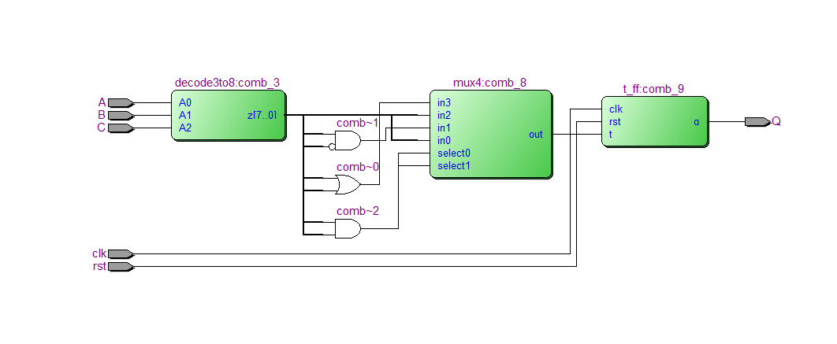

Function simulation

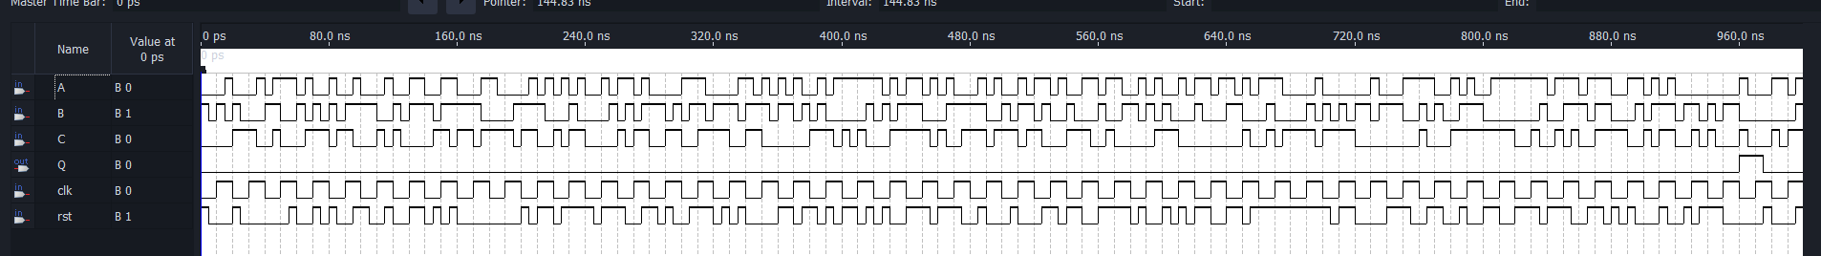

Timing simulation

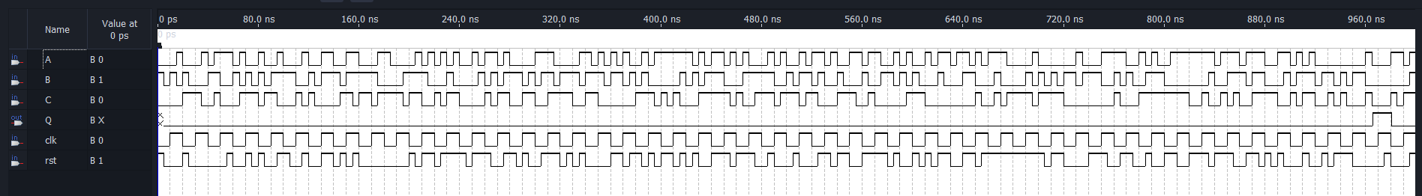

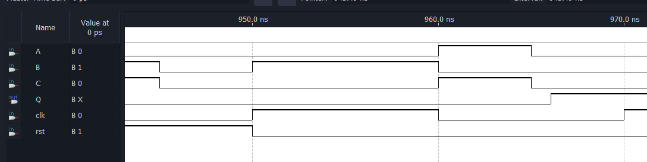

t­delay