**Business Requirement for Nom Nom Express**

Contents

1. System Overview 2

2. Requirements Scope 2

2.1 In Scope 2

2.2 Out of Scope 3

3. Functional Requirements 3

3.1 UML Use Case Diagram 3

3.1 UML Use Case Specifications 4

4. Non-Functional Requirements 5

5. Data Model 5

6. UI Screen Mockups 6

7. Change Log 7

**Table of Figures**

Figure 1 – Application Architecture 2

Figure 2 - UML Use Case Diagram 1 3

Figure 3 - UML Use Case Diagram 2 4

Figure 4 - Data Model Diagram 16

Figure 5 - Cart 16

Figure 6 - Login Screen 17

Figure 7 - Menu Items - 1 17

Figure 8 - Menu Items - 2 17

Figure 9 - Customer Registration Form 18

Figure 10 - Checkout Process 18

Figure 11 - Admin Page Example 19

## System Overview

Our web storefront will be created using HTML, CSS and JavaScript utilizing Bootstrap as a framework tool, Apache with PHP support for the web server middle-ware and MySQL for the database backend.

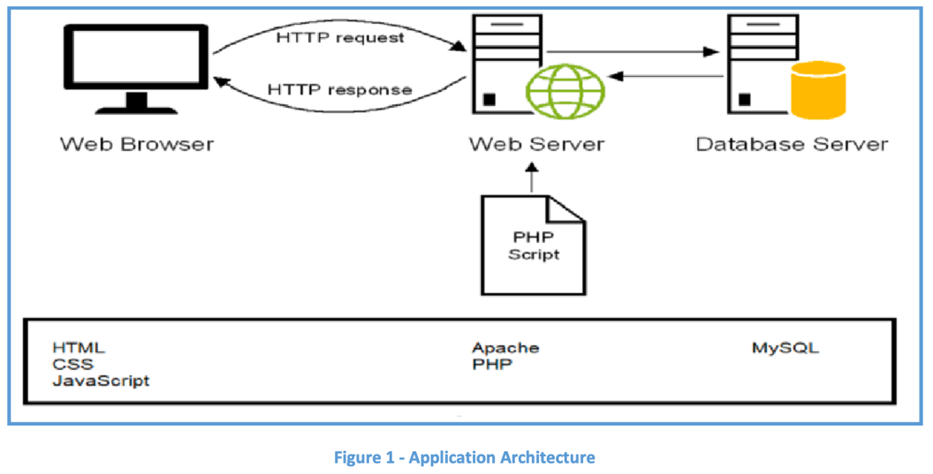

Figure 1 – Application Architecture

## Requirements Scope

### 2.1 In Scope

* R01 – The client must be able to log into an admin account
* R02 – The admin account must be able to add products to the web site
* R03 - Must be able to display products by categories
* R04 - Customers must register to place orders
* Must provide a fully functioning shopping cart utility where a customer can:
  + R05 - display the selected items currently in the cart
  + R06 - add selected products to the cart
  + R07 - delete products (individually or all) from the cart
  + R08 - adjust the quantity of a selected product currently in the cart
  + R09 - preserve the contents of the cart if the user’s session is disconnected accidentally
  + R10 - have the cart accessible regardless from any machine the customer is logging in
  + R11 - provide a confirmation email sent to the client after they place their order
  + R12 - include a secure, online payment process
* R13 - Allow customers to view their order history
* R14 - Provide an intuitive, consistent look and feel to the user interface
* R15 - Use free open-source software
* R16 - Have the system fully tested and up and running in 8 weeks (this is a firm deadline)

If time allows:

* + R29 – Must be mobile friendly
* R24 - Allow customers to provide reviews for any of the products they have purchased
* R25 - Must be able to display the evaluation reviews for any products
* R27 - Provide customers with appropriate product recommendations when they log in

### 2.2 Out of Scope

* R20 - Must provide a search facility for the products
* R28 - allow the order to be shipped to a different address and person other than the user
* R21 - Allow customers to change their order after they have created it
* R22 - Allow customers to search their order history
* R23 - Allow customers to view the status of their orders
* R26 - Allow customers to change their registration information
* R28 - Provide customers with any product recommendations when they look at a particular product

## Functional Requirements

* R01 – The client must be able to log into an admin account
* R02 – The admin account must be able to add products to the web site
* R03 - Must be able to display products by categories
* R04 - Customers must register to place orders
* Must provide a fully functioning shopping cart utility where a customer can:
  + R05 - display the selected items currently in the cart
  + R06 - add selected products to the cart
  + R07 - delete products (individually or all) from the cart
  + R08 - adjust the quantity of a selected product currently in the cart
  + R11 - Create a unique file for each order that contains the order confirmation information so that at a future date, the information in the file can be sent to the client as an email message
  + R12 - include a secure, online payment process
* R13 - Allow customers to view their order history

### 3.1 UML Use Case Diagram

Figure - UML Use Case Diagram 2

### 3.1 UML Use Case Specifications

|  |  |  |  |
| --- | --- | --- | --- |
| **Use Case Name:** | Update store info | **Use Case ID:** | **UC-001** |
| **Primary Actor:** | Admin | | |
| **Description:** | Admin can update the restaurant address and working hours. | | |
| **Triggering Event:** | Admin decides to make changes to the restaurant's information | | |
| **Steps Performed (Main Path)** | | | |
| 1. Admin Navigates to store information | | | |
| 1. Admin clicks update store info button | | | |
| 1. Store info form opens up | | | |
| 1. Admin updates the information as needed | | | |
| 1. Validate the given information when clicking save, the system updates the new info in the database | | | |
| 1. System updates the restaurant information on the website | | | |
| **Extensions or Alternate Scenarios** | | | |
| 5b. If the Admin attempts to save incomplete or invalid information, the website displays an error message and prompts the Admin to correct the information | | | |
|  | | | |
| **Pre-Conditions:** | Admin is logged into their admin account | | |
| **Post-Conditions:** | The restaurant's information is updated and reflected in the Nom Nom Express Food Delivery website | | |
| **Assumptions:** | Changes to restaurant information do not conflict with any ongoing orders or services | | |
| **Success Guarantee:** | Admin can efficiently update restaurant information, ensuring that accurate and up-to-date details are displayed to customers | | |
| **Outstanding Issues:** | What is valid information? | | |
| **Priority:** | Low | | |

|  |  |  |  |
| --- | --- | --- | --- |
| **Use Case Name:** | Change existing menu item | **Use Case ID:** | **UC-002** |
| **Primary Actor:** | Admin | | |
| **Description:** | Admin changes menu information for a restaurant in the Nom Nom Express Food Delivery website | | |
| **Triggering Event:** | Admin decides to make changes to the restaurant's menu items, descriptions, prices, or availability | | |
| **Steps Performed (Main Path)** | | | |
| 1. Admin Navigates to menu items table | | | |
| 1. Admin clicks the edit menu item button in the table row for the specific item | | | |
| 1. Change menu item form opens up | | | |
| 1. Admin edits the relevant menu item information as needed (e.g., updating the description, price, or availability status) | | | |
| 1. The Admin confirms the changes by clicking save | | | |
| 1. The System validates the menu item information for accuracy and completeness | | | |
| 1. The system updates the menu item in the database | | | |
| 1. The system updates the menu item on the admin page | | | |
| **Extensions or Alternate Scenarios** | | | |
|  | | | |
|  | | | |
| **Pre-Conditions:** | Admin is logged into their admin account | | |
| **Post-Conditions:** | The menu item information is updated and reflected in the Nom Nom Express Food Delivery website. | | |
| **Assumptions:** | There are existing menu items in the database | | |
| **Success Guarantee:** | Admin has successfully updated the menu information | | |
| **Outstanding Issues:** | What is a valid change? | | |
| **Priority:** | Medium/Low | | |

|  |  |  |  |
| --- | --- | --- | --- |
| **Use Case Name:** | Delete Menu Items | **Use Case ID:** | **UC-003** |
| **Primary Actor:** | Admin | | |
| **Description:** | Delete/disable an item from the menu | | |
| **Triggering Event:** | The item is no longer available for order | | |
| **Steps Performed (Main Path)** | | | |
| 1. Admin Navigates to menu items table | | | |
| 1. Admin clicks the delete menu item button in the table row for the specific item | | | |
| 1. System asks to confirm choice | | | |
| 1. Admin clicks the confirm changes button | | | |
| 1. The system removes the item | | | |
|  | | | |
| **Extensions or Alternate Scenarios** | | | |
| 2b. If they do not want to delete the item they can click the disable item button in the same row | | | |
| 5b. If disable was clicked the system updates the items disabled_item column to Y | | | |
| **Pre-Conditions:** | Admin is logged in | | |
| **Post-Conditions:** | Menu is updated | | |
| **Assumptions:** | There are items on the menu to delete/disable | | |
| **Success Guarantee:** | The item is removed from the menu | | |
| **Outstanding Issues:** | Will disabling the item remove it from the menu? | | |
| **Priority:** | Low | | |

|  |  |  |  |
| --- | --- | --- | --- |
| **Use Case Name:** | Add items | **Use Case ID:** | **UC-004** |
| **Primary Actor:** | Admin | | |
| **Description:** | Add an item to the menu | | |
| **Triggering Event:** | The admin has a new item to add to the menu | | |
| **Steps Performed (Main Path)** | | | |
| 1. Admin navigates to the add menu item form | | | |
| 1. Admin enters the new items information into the add to menu form | | | |
| 1. Admin clicks save button | | | |
| 1. The System validates the form | | | |
| 1. If the Form is valid the system inserts the item into the menu_items table | | | |
| 1. System adds a menu item entry to the admin page menu item table | | | |
|  | | | |
| **Extensions or Alternate Scenarios** | | | |
|  | | | |
|  | | | |
| **Pre-Conditions:** | Admin is logged in | | |
| **Post-Conditions:** | Menu is updated | | |
| **Assumptions:** | There is a new item to add to the menu | | |
| **Success Guarantee:** | Item has been added to the database and website | | |
| **Outstanding Issues:** | What kind of validation is needed? Should we have it be disabled when entered or live immediately? | | |
| **Priority:** | Medium | | |

|  |  |  |  |
| --- | --- | --- | --- |
| **Use Case Name:** | Login | **Use Case ID:** | **UC-005** |
| **Primary Actor:** | Admin/Customer | | |
| **Description:** | Admin/Customers log in to their existing accounts in the Nom Nom Express Food Delivery website | | |
| **Triggering Event:** | Admin/Customers wish to access the websites features by logging in | | |
| **Steps Performed (Main Path)** | | | |
| 1. Customer opens the Nom Nom Express Food Delivery website on their device | | | |
| 1. Clicks on login tab in navigation bar that opens an offcanvas login screen | | | |
| 1. Customer enters their registered unique username | | | |
| 1. The customer enters their password | | | |
| 1. The customer clicks the "Login" button | | | |
| 1. The System checks the username / password in the database | | | |
| 1. If there is a match the system starts a session and redirects to landing page | | | |
| 1. When user is logged in add to cart button and cart will be visable | | | |
| **Extensions or Alternate Scenarios** | | | |
| 3b. Admin enters their unique username | | | |
| 4b. Admin enters their password | | | |
| 7b. If there is a match for an admin user the system starts a session and redirects to the admin page | | | |
| **Pre-Conditions:** | Customer has a device with internet access | | |
| **Post-Conditions:** | Customer is successfully logged in to their existing account | | |
| **Assumptions:** | Customer has valid credentials | | |
| **Success Guarantee:** | Customer can effectively log in to their existing account | | |
| **Outstanding Issues:** | What are the issues around security? | | |
| **Priority:** | High | | |

|  |  |  |  |
| --- | --- | --- | --- |
| **Use Case Name:** | Register | **Use Case ID:** | **UC-006** |
| **Primary Actor:** | Customer | | |
| **Description:** | Customers registers for new accounts in the Nom Nom Express Food Delivery website | | |
| **Triggering Event:** | Customers wish to access the websites features by creating a new account | | |
| **Steps Performed (Main Path)** | | | |
| 1. Customer opens the Nom Nom Express Food Delivery website on their device | | | |
| 1. Customer clicks the login button on the top left of the navigation bar | | | |
| 1. Login modal will pop up from left | | | |
| 1. Customer clicks the “Register an account" option at the bottom of the modal | | | |
| 1. Privacy Policy modal appears. | | | |
| 1. Customer must accept it to proceed or it will close login modal. | | | |
| 1. The website presents a registration form on another page | | | |
| 1. Customer enters their firstname, lastname, username, phone number, email address, home address, and password (retype), then click “Register” button.   Home address form should have Province, City, Street address, and Postal Code. | | | |
| 1. The system validates the registration information whether if:  * The username and email address are unique. * Phone Number, Email and home address are valid (maybe just regex?) * Password is secure enough, not too simple | | | |
| 1. When the information is valid, the system inserts a new customer account in the database | | | |
| 1. Customer is redirected back to the original view with logged in already (same as when login) | | | |
| **Extensions or Alternate Scenarios** | | | |
| 7a. If the customer's registration information is not valid, the app displays an error message and prompts the customer to correct the information | | | |
|  | | | |
| **Pre-Conditions:** | Customer has a device with internet access | | |
| **Post-Conditions:** | Customer has successfully created a new account | | |
| **Assumptions:** | The customer has the necessary information to register for the service | | |
| **Success Guarantee:** | Customer can effectively log in to their existing account or create a new one | | |
| **Outstanding Issues:** | What are the issues around security?  What are the criteria of the secure password? | | |
| **Priority:** | High | | |

|  |  |  |  |
| --- | --- | --- | --- |
| **Use Case Name:** | Filter by Category | **Use Case ID:** | **UC-007** |
| **Primary Actor:** | Customer | | |
| **Description:** | Customer can filter the current menu page to view items that fit the filtered criteria | | |
| **Triggering Event:** | Customer decides to narrow down their search | | |
| **Steps Performed (Main Path)** | | | |
| 1. All Categories are listed at navigation bar on the top. | | | |
| 1. Customer clicks a specific category | | | |
| 1. Select from the database where category = selected category | | | |
| 1. Only selected category items are listed on display | | | |
| **Extensions or Alternate Scenarios** | | | |
|  | | | |
|  | | | |
| **Pre-Conditions:** | Customer can access the website | | |
| **Post-Conditions:** | Customer can now view items based on their specific category choice | | |
| **Assumptions:** | There are items available under the given category | | |
| **Success Guarantee:** | Customer can now view a smaller menu based on their selection | | |
| **Outstanding Issues:** | Are there any items available under that category? What happens when there is nothing in the category? | | |
| **Priority:** | Low | | |

|  |  |  |  |
| --- | --- | --- | --- |
| **Use Case Name:** | Put items into cart | **Use Case ID:** | **UC-008** |
| **Primary Actor:** | Customer | | |
| **Description:** | Customer navigates through the menu, selects items, and adds them to their shopping cart for future purchase | | |
| **Triggering Event:** | Customer decides selects items to add to the cart | | |
| **Steps Performed (Main Path)** | | | |
| 1. Customer browses the online menu, viewing available items and their descriptions | | | |
| 1. Customer selects an item by clicking on it, can view item picture, description and a price | | | |
| 1. The customer clicks the "Add to Cart" button | | | |
| 1. The system adds the selected item to the customer's shopping cart | | | |
| 1. The customer can view the current contents of their shopping cart (name of the product, picture, quantity, price for item and total price) | | | |
| 6. The system saves the cart and its items | | | |
| 7. The customer can continue adding more food items to the cart or proceeds to checkout   |  | | --- | | **Extensions or Alternate Scenarios** | | | | |
| 5a. The customer can adjust quantity of cart  5b. The customer decides to remove items from the cart: The system allows the customer to remove items individually or clear the entire cart.  7a. The customer adds a food item to the cart when the cart already contains the same item. The system will allow duplicate, separate instances of the same food item in the cart | | | |
| **Pre-Conditions:** | The customer is logged in their account | | |
| **Post-Conditions:** | After completing the "Put item into cart" use case, the customer has one or more items in their shopping cart | | |
| **Assumptions:** | The customer is a registered user of Nom Nom Express and is in good standing within the system | | |
| **Success Guarantee:** | Customer now has item(s) in their order | | |
| **Outstanding Issues:** | Does the system track if the cart already contains an existing food item? | | |
| **Priority:** | High | | |

|  |  |  |  |
| --- | --- | --- | --- |
| **Use Case Name:** | Adjust the quantity | **Use Case ID:** | **UC-009** |
| **Primary Actor:** | Customer | | |
| **Description:** | The use case allows a customer to modify the quantity of food items within their shopping cart while using the Nom Nom Express website | | |
| **Triggering Event:** | Customer wishes to update the quantity of food items in their shopping cart on the Nom Nom Express website | | |
| **Steps Performed (Main Path)** | | | |
| 1. The customer can view the current contents of their shopping cart (name of the product, picture, quantity, price for item and total price) | | | |
| 2. The customer selects a food item for which they want to adjust the quantity | | | |
| 3. The customer can see the plus (+) and minus (-) buttons located next to the quantity input field. | | | |
| 4. The customer can increase the quantity by clicking the plus button and decrease the quantity by clicking the minus button | | | |
| 5. The minus button is disabled if the quantity is already at 1 to prevent further decrease | | | |
| 6. The system updates the shopping cart with the new quantity | | | |
| 7. The customer can view the updated contents of their shopping cart | | | |
| 8.The system saves the cart with the updated quantities | | | |
| 9. The customer can continue adjusting quantities or proceed to checkout | | | |
|  | | | |
|  | | | |
|  | | | |
| **Extensions or Alternate Scenarios** | | | |
|  | | | |
|  | | | |
| **Pre-Conditions:** | The customer is logged in their account | | |
| **Post-Conditions:** | After completing this use case, the customer has adjusted the quantity of one or more food items in their shopping cart on the Nom Nom Express website | | |
| **Assumptions:** | The customer is a registered user of Nom Nom Express and is in good standing within the system | | |
| **Success Guarantee:** | Customer has modified the quantity of food items in their shopping cart, and the cart reflects the updated quantities | | |
| **Outstanding Issues:** |  | | |
| **Priority:** | High | | |

|  |  |  |  |
| --- | --- | --- | --- |
| **Use Case Name:** | Delete items from cart | **Use Case ID:** | **UC-010** |
| **Primary Actor:** | Customer | | |
| **Description:** | The use case allows a customer to remove individually or all items at once from their shopping cart while using the Nom Nom Express website | | |
| **Triggering Event:** | Customer wishes to adjust the contents of their shopping cart by deleting either a single item or all items from the cart on the Nom Nom Express website | | |
| **Steps Performed (Main Path)** | | | |
| 1. The customer can view the current contents of their shopping cart (name of the product, picture, quantity, price for item and total price) | | | |
| 2. The customer selects one or more items they want to delete by checking the checkboxes | | | |
| 3. The customer clicks the "Delete" button | | | |
| 4. The system removes the selected food items from the cart | | | |
| 5. The customer can view the updated contents of their shopping cart | | | |
| 6. The system saves the cart with the updated contents | | | |
| 7. The customer can continue managing the cart or proceed to checkout | | | |
|  | | | |
|  | | | |
|  | | | |
|  | | | |
|  | | | |
|  | | | |
| **Extensions or Alternate Scenarios** | | | |
|  | | | |
| 2a. The customer chooses to remove all items from the cart by clicking the "Clear Cart" button  2b. The system clears the entire cart  5a If the cart becomes empty after deleting selected items, the system displays a message indicating that the cart is now empty | | | |
| **Pre-Conditions:** | The customer is logged in their account | | |
| **Post-Conditions:** | After completing this use case, the customer has successfully managed the contents of their shopping cart by either deleting a single item or removing all items from the cart | | |
| **Assumptions:** | The customer is a registered user of Nom Nom Express website | | |
| **Success Guarantee:** | Customer has modified the quantity of food items in their shopping cart, and the cart reflects the updated quantities | | |
| **Outstanding Issues:** | After completing this use case, the customer's shopping cart reflects all changes, either with the selected food item removed or with all items cleared, based on the customer's choice. | | |
| **Priority:** | High | | |

|  |  |  |  |
| --- | --- | --- | --- |
| **Use Case Name:** | Checkout Order | **Use Case ID:** | **UC-011** |
| **Primary Actor:** | Customer | | |
| **Description:** | Customer checks out their order, reviews order details & submits for payment processing.  Once payment is processed the order is complete and an order confirmation file is saved. | | |
| **Triggering Event:** | Customer clicks ‘Checkout’ button from order (cart) screen | | |
| **Steps Performed (Main Path)** | | | |
| 1. From the order page, customer selects ‘Checkout’ button | | | |
| 1. ‘Order Details’ modal window displays items in order including price per item and subtotal | | | |
| 1. Customer confirms order details by clicking ‘Next’ button; ‘Order Details’ modal window closes | | | |
| 1. ‘Payment Details’ modal window displays payment form | | | |
| 1. Customer enters info; when all fields have valid entries, ‘Next’ button is enabled | | | |
| 1. Customer confirms payment information by clicking ‘Next’ button; ‘Payment Details’ modal window closes, payment information is temporarily saved in preparation for processing | | | |
| 1. ‘Delivery Details’ modal window displays customer address, phone and email information (per registration) | | | |
| 1. Customer confirms Delivery details by clicking ‘Next’ button; ‘Payment Details’ modal window closes | | | |
| 1. ‘Order Confirmation’ modal window displays order details including shipping fees, taxes and total amount to be charged to payment method | | | |
| 1. Customer confirms placing order by clicking ‘Submit Order’ button; ‘Order Confirmation’ modal window closes | | | |
| 1. ‘Processing’ modal window displays ‘Processing Payment’ while sending order and waiting for payment results; Once payment processed successfully modal window displays ‘Order Successful’ | | | |
| 1. Customer clicks ‘ok’ button to close modal window | | | |
| 1. System creates a unique file for each order that contains the order confirmation information so that at a future date, the information in the file can be sent to the client as an email message per CR01 | | | |
| 1. System inserts order details into the orders table and deletes the applicable items from the cart table | | | |
| **Extensions or Alternate Scenarios** | | | |
| 5a. Customer enters invalid information.  The field will display an error message until valid information is entered. | | | |
| 11a. Payment is not processed successfully.  The modal window displays ‘Payment invalid’ and an error message if available. Customers can return to payment form and repeat steps 5-13. | | | |
| **Pre-Conditions:** | Customer is logged in, with items in their Order (cart) | | |
| **Post-Conditions:** | Modal window displays ‘Order Successful’ and file saved with order confirmation | | |
| **Assumptions:** | Customer is a current user in good standing within the system with valid registration information entered (billing/shipping addresses, phone, email) | | |
| **Success Guarantee:** | Order Completed | | |
| **Outstanding Issues:** | If there is an error during the checkout process, what is the appropriate action? What is the risk of this occurring? How much information specific to payment do we need to retain in the database? | | |
| **Priority:** | High | | |

|  |  |  |  |
| --- | --- | --- | --- |
| **Use Case Name:** | View Order History | **Use Case ID:** | **UC-012** |
| **Primary Actor:** | Customer | | |
| **Description:** | View history by order number listed in most to least recent order.  May click on order to view order details | | |
| **Triggering Event:** | Customer wishes to view their order history | | |
| **Steps Performed (Main Path)** | | | |
| 1. From any page, Customer clicks account tab on navigation menu | | | |
| 1. Customer scrolls to order history section (past registration information section) | | | |
| 1. Customer is presented a list of their orders with summary info visible (order number, order date, total), sorted to most recent on top | | | |
| 1. Customer can select any order (by clicking the row) to expand to full order details;   Additional rows appear below summary row: one row per item including item name, quantity and cost, plus one more row displaying shipping fee & taxes for the order | | | |
| Customer can collapse full details by clicking order summary row again | | | |
| **Extensions or Alternate Scenarios** | | | |
| 3a. Customer has not placed any orders to date.  The message “No Orders Yet” will be displayed in lieu of order list. | | | |
| 3b. The system is unable to display the order history for some reason.  A system error message is generated, displayed to the Customer and sent to the appropriate authority. | | | |
| **Pre-Conditions:** | Customer must be logged into the system | | |
| **Post-Conditions:** | Customer sees displayed order history and can expand and orders details as desired | | |
| **Assumptions:** | Customer is a current user in good standing within the system | | |
| **Success Guarantee:** | Customer sees displayed order history | | |
| **Outstanding Issues:** | What to do if there are a lot of orders? Display 20 per page or one continuous page? | | |
| **Priority:** | Low | | |

## Non-Functional Requirements

* R09 - preserve the contents of the cart if the user’s session is disconnected accidentally
* R10 - have the cart accessible regardless from any machine the customer is logging in
* R14 - Provide an intuitive, consistent look and feel to the user interface
* R15 - Use free open-source software
* R16 - Have the system fully tested and up and running in 8 weeks (this is a firm deadline)

## Data Model

Figure 4 - Data Model Diagram

*>*

## UI Screen Mockups

6.1 The following screen is for UC-010 / UC-011 and shows the current contents of the shopping cart*.*

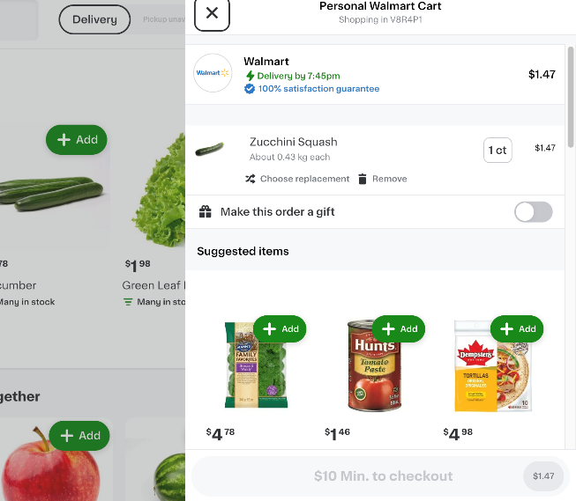

Figure 5 - Cart

6.2 The following screen is the for use case UC-006 and shows the login screen modal/offcanvas.

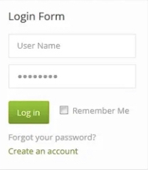

Figure 6 - Login Screen

6.3 The following screens are for use case UC-008 / UC-009 and shows a category filter to the left and add to cart buttons on all items. Figure 8 also shows what the website header will look like.

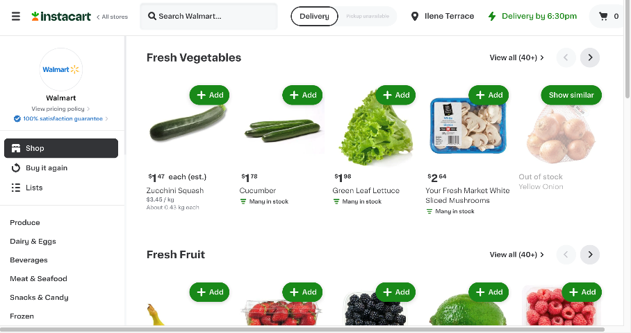

Figure 7 - Menu Items - 1

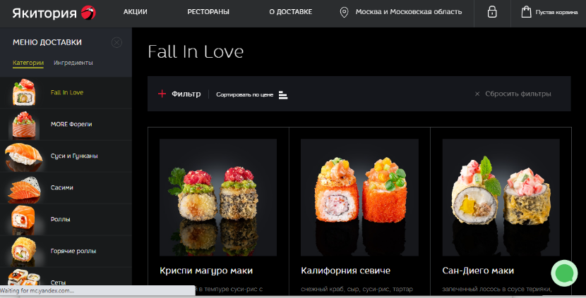

Figure 8 - Menu Items - 2

6.4 The following screen is for use case UC-007 and shows a general customer registration form with name, address, and email fields

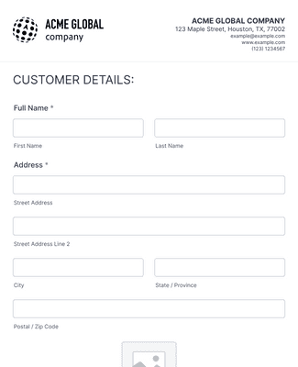

Figure 9 - Customer Registration Form

6.5 The following screen is for use case UC-012 and shows the general checkout process modal

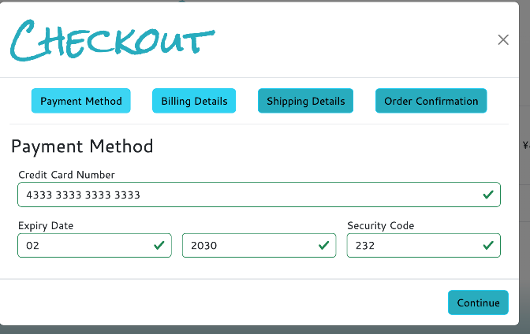

Figure 10 - Checkout Process

6.6 The following screen is for use case UC-002 – UC-005 and shows what the general layout for the admin page menu items will be

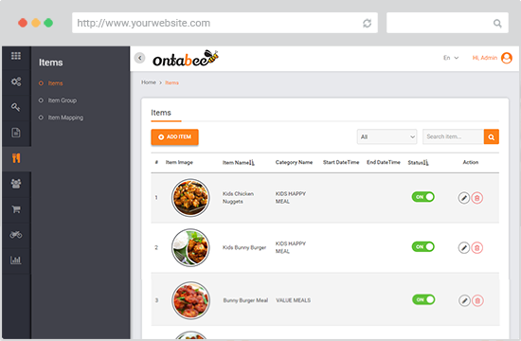

Figure 11 - Admin Page Example

## Change Log

*<Record any changes to the BRD caused by change request orders.>*

|  |  |  |
| --- | --- | --- |
| **Change Request Id** | **Issue Date** | **Description** |
| 01 | 2023-09-26 | Confirmation email was supposed to be sent to the customer when order is complete, however, affected by change request, server need to save unique files containing what the customer ordered for each order and save them. |
|  |  |  |
|  |  |  |