Added DriveHQ cloud services for storage and to see the files which you upload from your application then you need to open browser and enter URL as ‘https://drivehq.com/’ to get below page
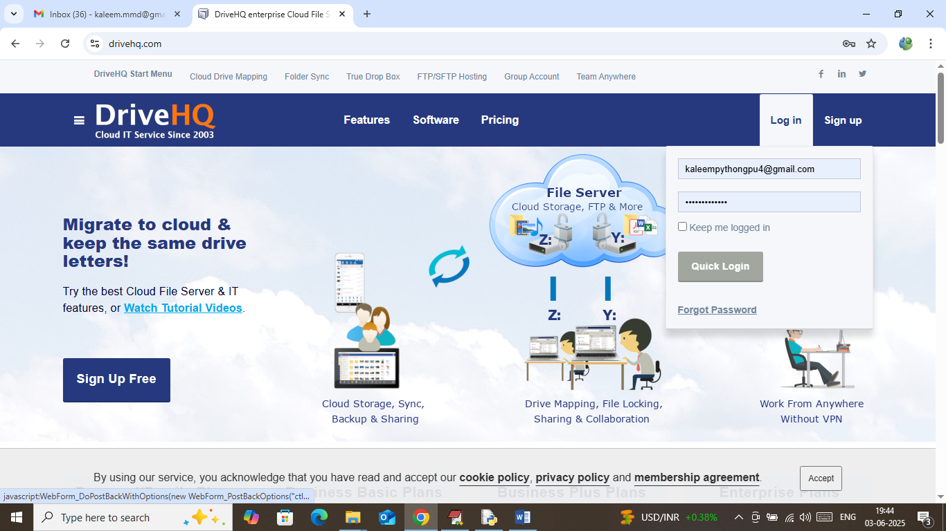
In above screen click on Login and then enter below username and password
Username = kaleempythongpu3@gmail.com
Password = Offenburg965#
After login will get below page
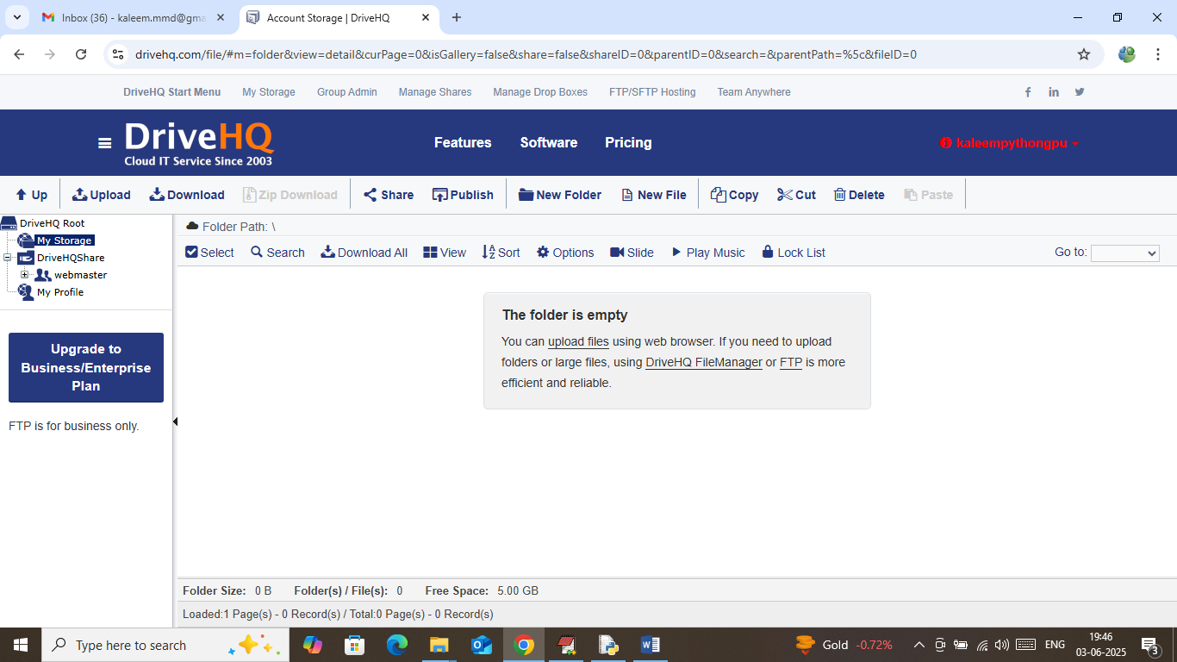
In above screen from left side menu click on ‘My Storage’ link to get above page and now we can upload files from our application to see in above cloud
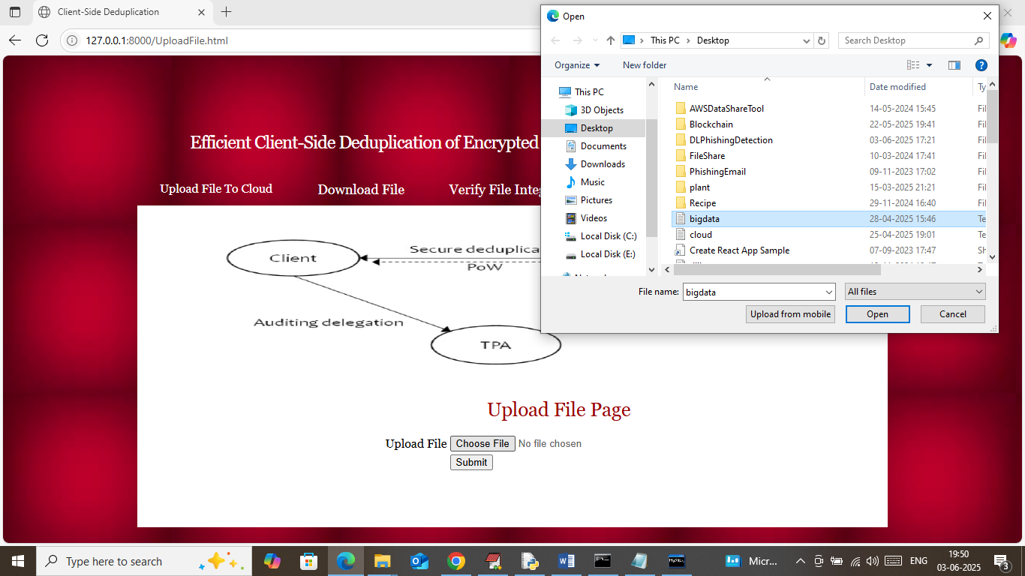
In above screen selecting and uploading bigdata.txt file and then click on ‘Open and Submit’ button to get below page
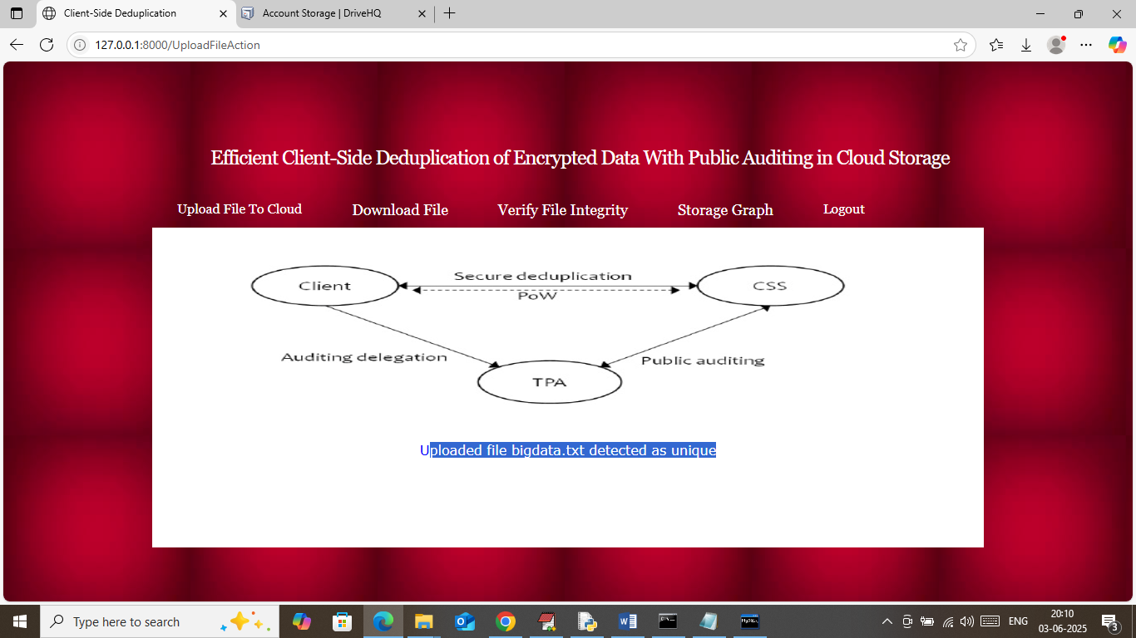
In above screen file is unique and successfully uploaded to cloud and same file you can see in below Drive HQ cloud
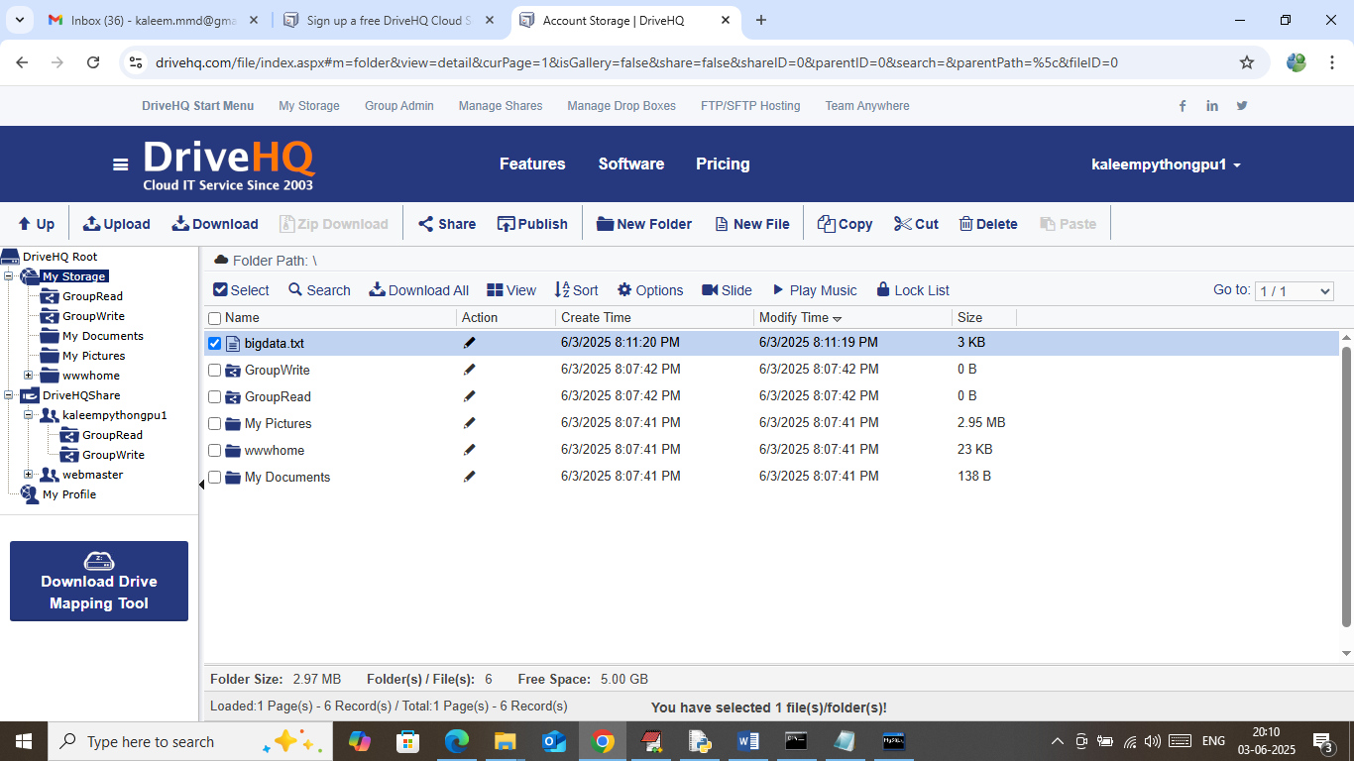
In above screen you can see ‘bigdata.txt’ file showing in Drive HQ cloud and similarly as long as you upload unique file then it will save here and only duplicates files will not come here and now I uploading same file content from different names
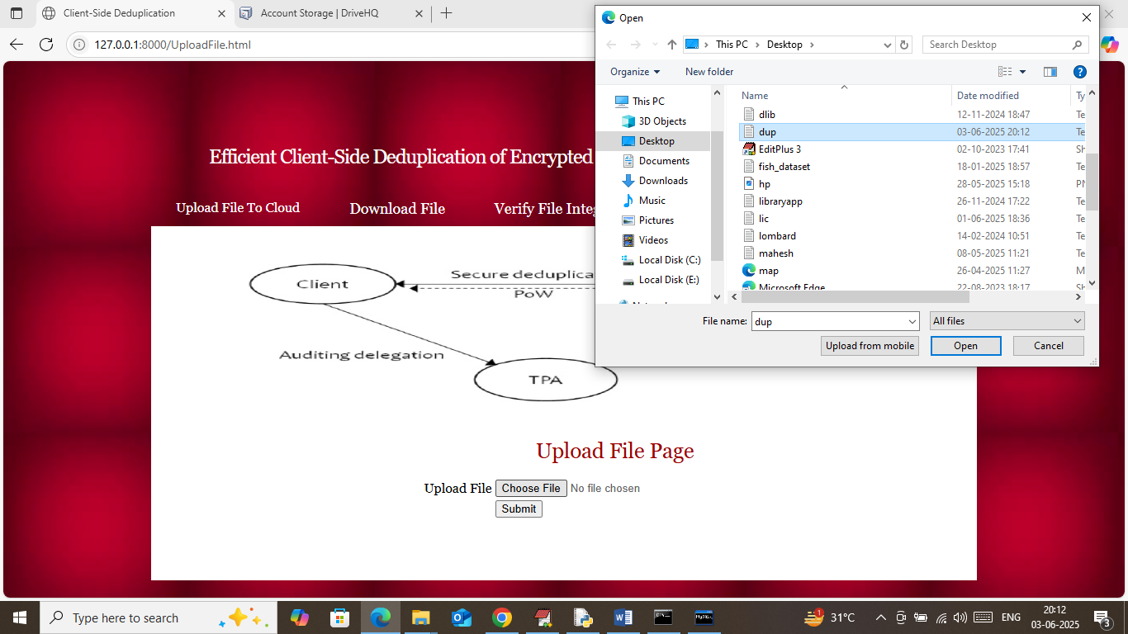
In above screen uploading another file with same content and below is the output
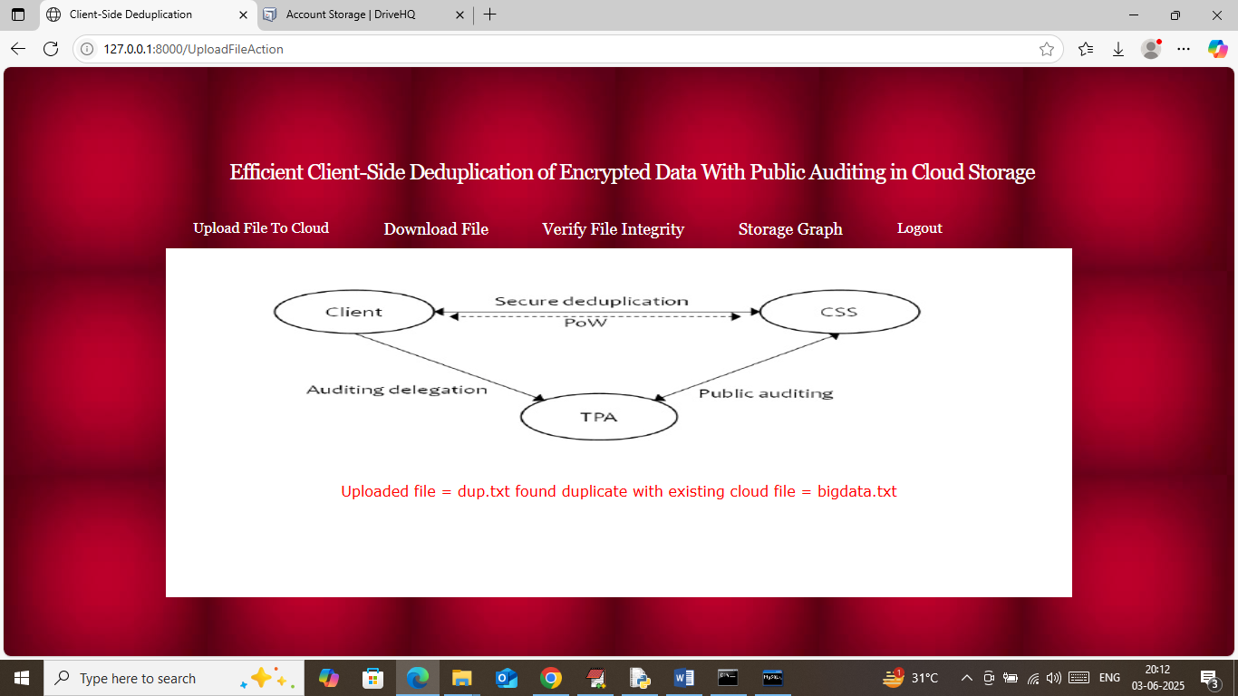
In above screen in red text can see file duplicate found and now click on ‘Download File’ to view storage size
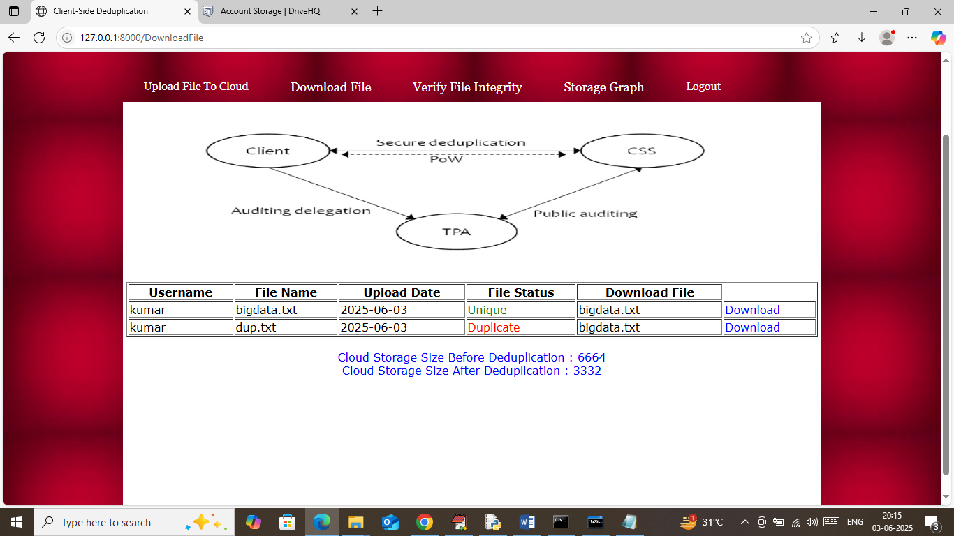
In above screen last two lines can see storage size before and after duplication and now click on ‘Storage Graph’ to view performance graph
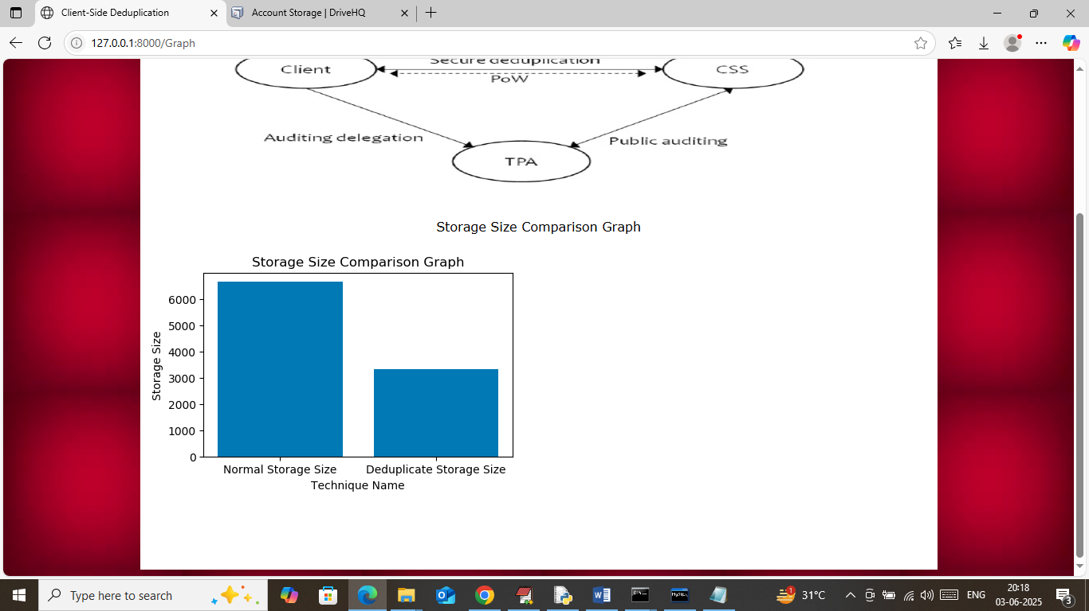
In above graph x-axis represents Storage type and y-axis represents storage size and can see after applying duplicates we can save more than 50% space

