Efficient Client-Side Deduplication of Encrypted Data with Public Auditing in Cloud Storage
Cloud services provides heavy computation or storage resources at cheaper cost so all users utilizing this services to manage their business, social or personal data. Cloud Servers (CS) will charge users and resources will be assigned based on usage and if this usage goes high then more resources and cost will be applied. This resources will be goes high due to duplicate file storage and currently all CSS facing 90% storage with duplicate data. Using CSS raise another issue of file integrity as this file saved at CSS away from users and CSS internal database employees may misuse this data which is known as Insider Attacks. Sometime some malicious attackers can also hack CSS connections to alter to steal user data.
To overcome from above duplicate and File Integrity issue author of this paper employing novel algorithm called BLS signature-based Homomorphic linear authenticator. Propose algorithm combined technique, which performs both secure Deduplication of encrypted data and public integrity auditing of data. To support the two functions, the proposed scheme performs challenge-response protocols using the BLS signature-based Homomorphic linear authenticator.
BLS Homomorphic algorithm enables us to check file integrity and file duplicate directly on encrypted data without disclosing keys to CSS or any other TPA services. Propose algorithm consists of following modules
User: user can sign up and login to cloud services, user can upload files which will get encrypted using Homomorphic algorithm and then generate authentication code which will publish to TPA (third party authentication).
TPA: TPA will receive verification POW (proof of work) request from user and then check weather current file at cloud storage signature matching with TPA available signature. If both signature matches then file integrity verification will be successful, if CSS or attacker alter file content then result into different signature and verification will get failed
CSS: cloud server will receive encrypted file data from user and then securely check duplicate content between receive file and available stored files, If duplicate file found then CSS will not save file and alert user about duplicate to save storage space. If file is unique then only it will get saved in CSS storage.
In propose work both TPA and CSS work on encrypted data for file verification and duplicate check so no outsource data can be alter, steal or hack without decryption keys.
Implementation contains following modules
- New User Sign up: user can sign up with the cloud server
- User Login: user can login to cloud server
- Upload File: using this module user can upload any file and then cloud server will encrypt file using Homomorphic encryption and then encrypted file will be compared with existing cloud files to detect duplication. If duplicate file found then cloud will not save that file and make a mark or link to exist file to avoid duplicate storage. Simultaneously user will generate POW signature and send to TPA for future file integrity check.
- Download File: using this module user can download available Files from the cloud
- Verify File Integrity: using this module user can send request to TPA to check integrity for selected file. TPA will match available file signature with cloud saved file and if both matches then only file integrity verification will be successful
SCREEN SHOTS
To run project install python 3.7.2 and then install all packages given in requirements.txt file and then install MYSQL database and then copy content from “database.txt” file and paste in MYSQL console to create database.
To run project double click on ‘runWebServer.bat’ file to start cloud server and then will get below page
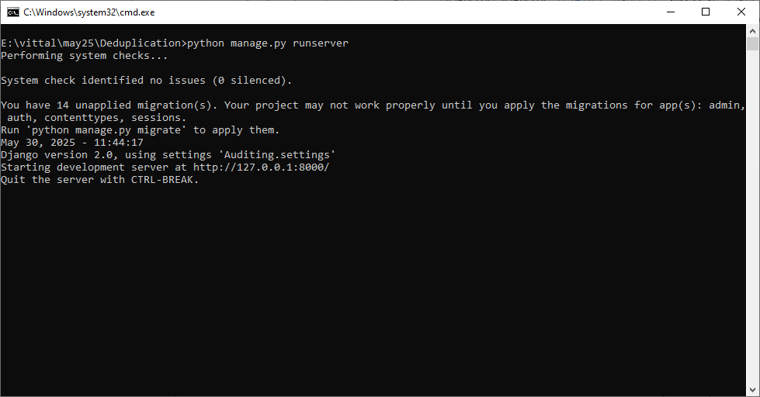
In above screen server started and now open browser and enter URL as http://127.0.0.1:8000/index.html and then press enter key to get below page
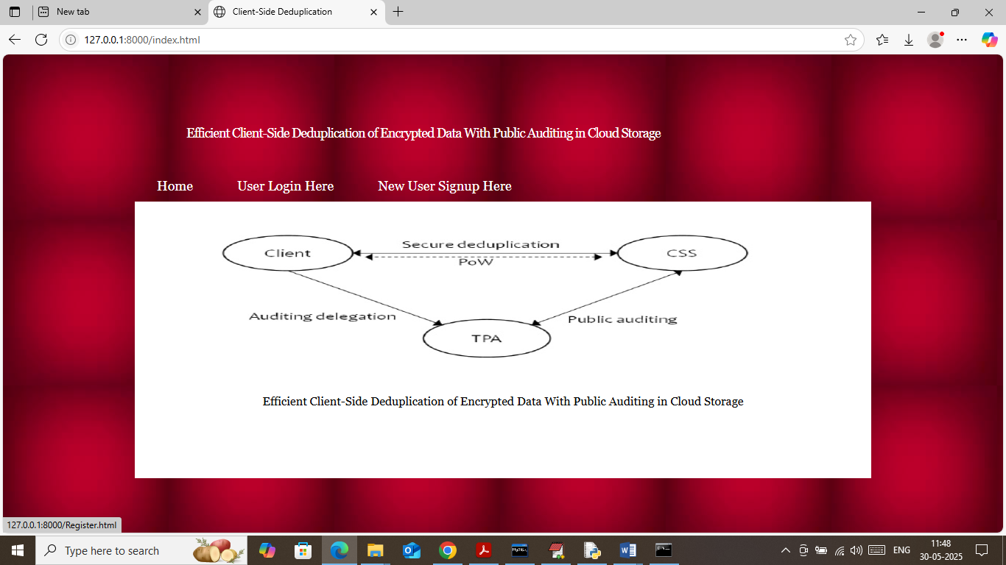
In above screen click on ‘New User Sign up’ link to get below page
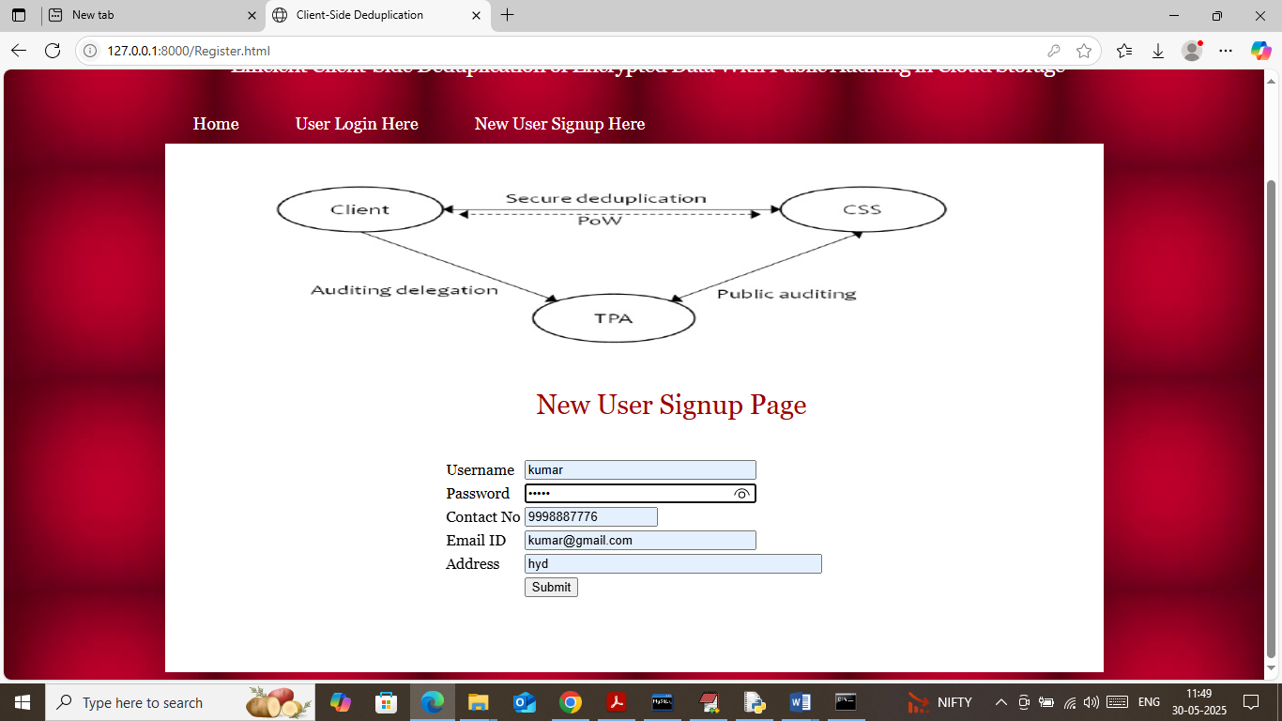
In above screen user is entering sign up details and then press button to get below page
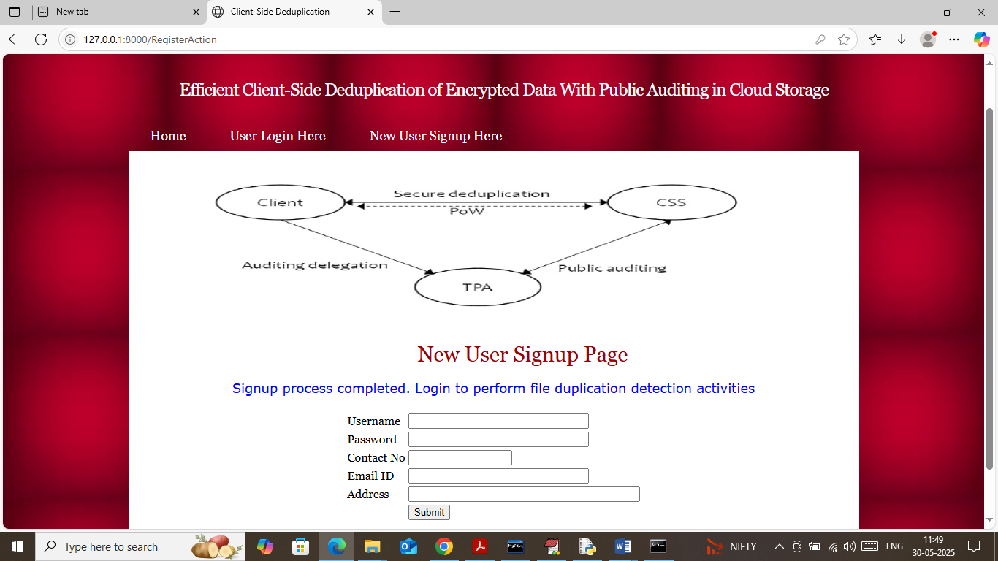
In above screen sign up completed and now click on ‘User Login’ link to get below page
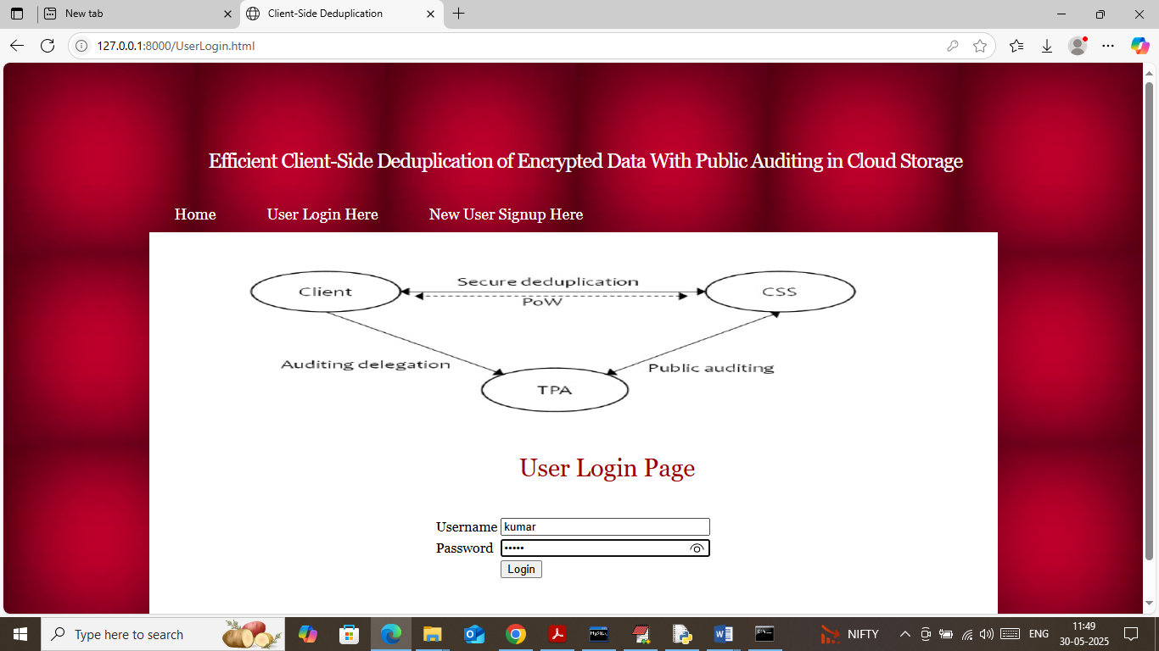
In above screen user is login and after login will get below page
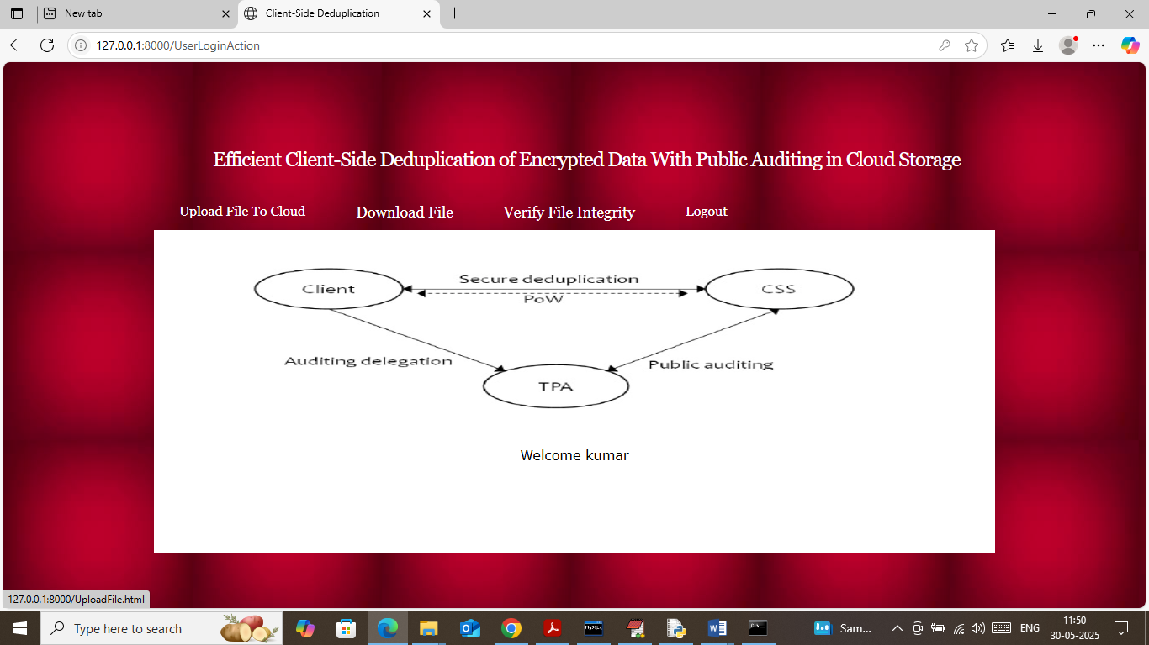
In above screen user can click on ‘Upload File to Cloud’ link to get below page
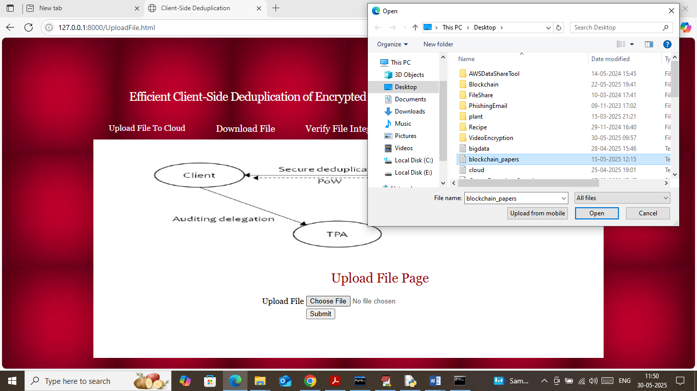
In above screen user is selecting and uploading file and then click on buttons to get below output
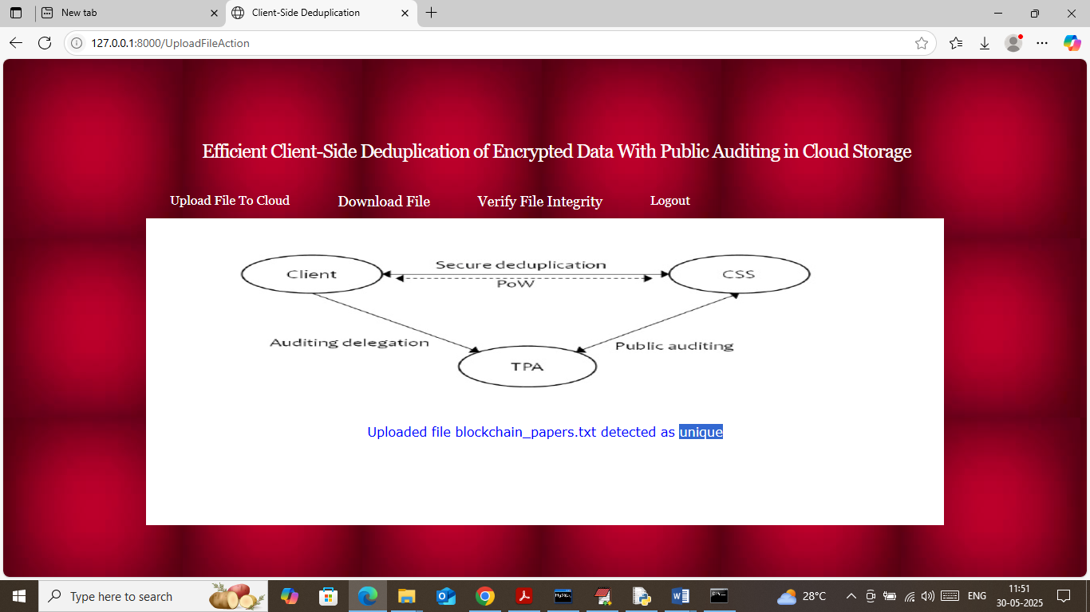
In above screen file uploaded to cloud and cloud detected file content is unique
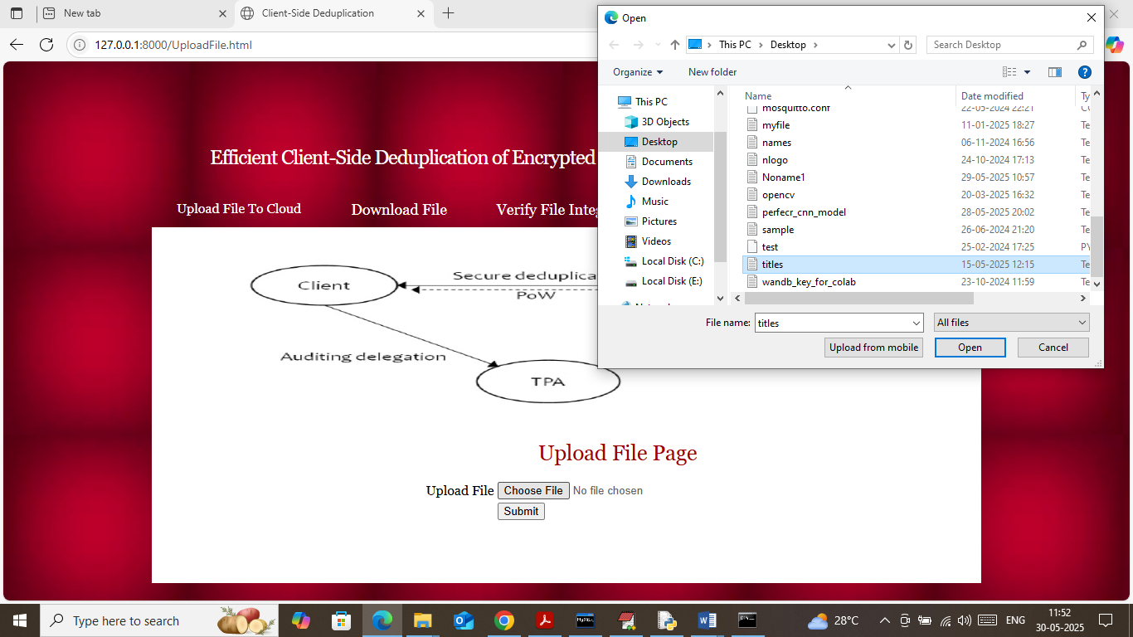
In above screen uploading another file with same content and below is the output
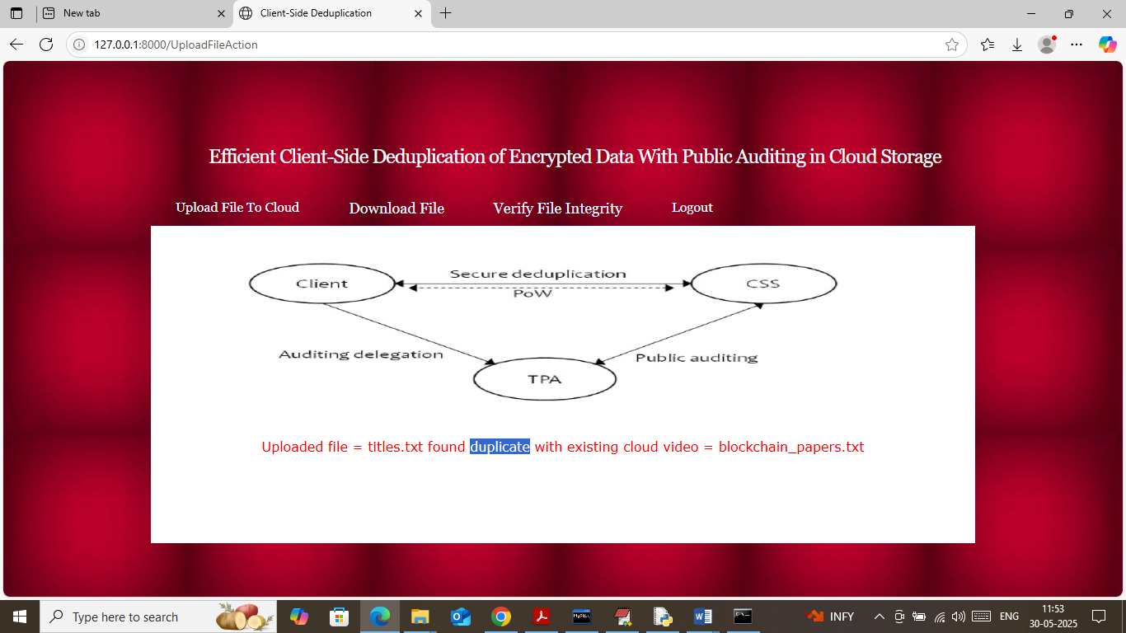
In above screen can see cloud detected duplicate with another file and will not be saved and similarly you can upload and test any other file. Now click on ‘Download File’ link to get below page
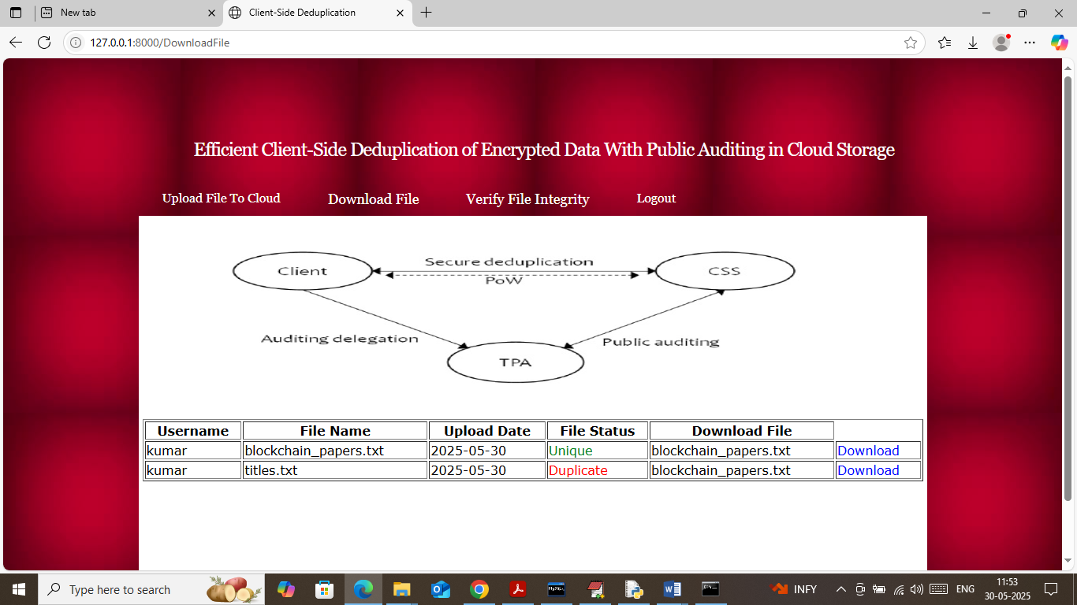
In above screen user can view list of files which are unique and duplicates and can click on ‘Download’ link to download any desired file
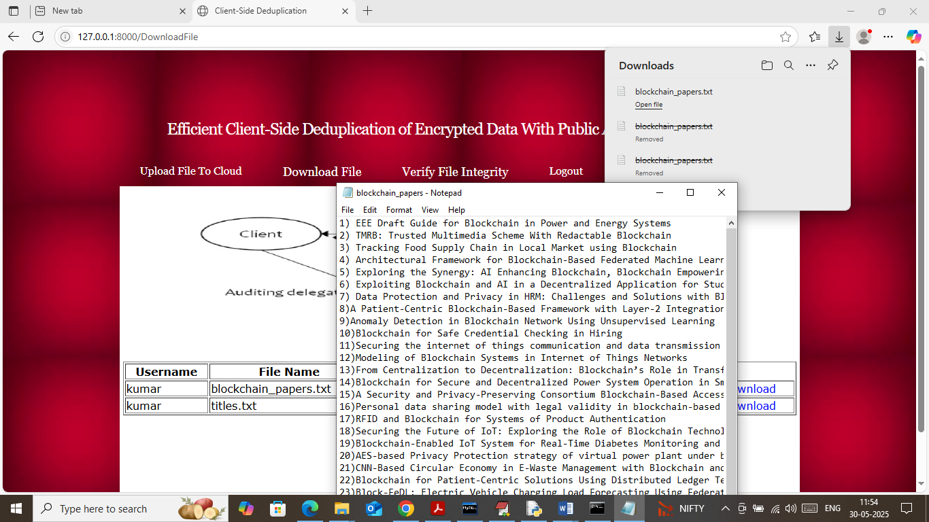
In above screen can see file downloaded in decrypted format and now click on ‘Verify File Integrity’ link to get below page
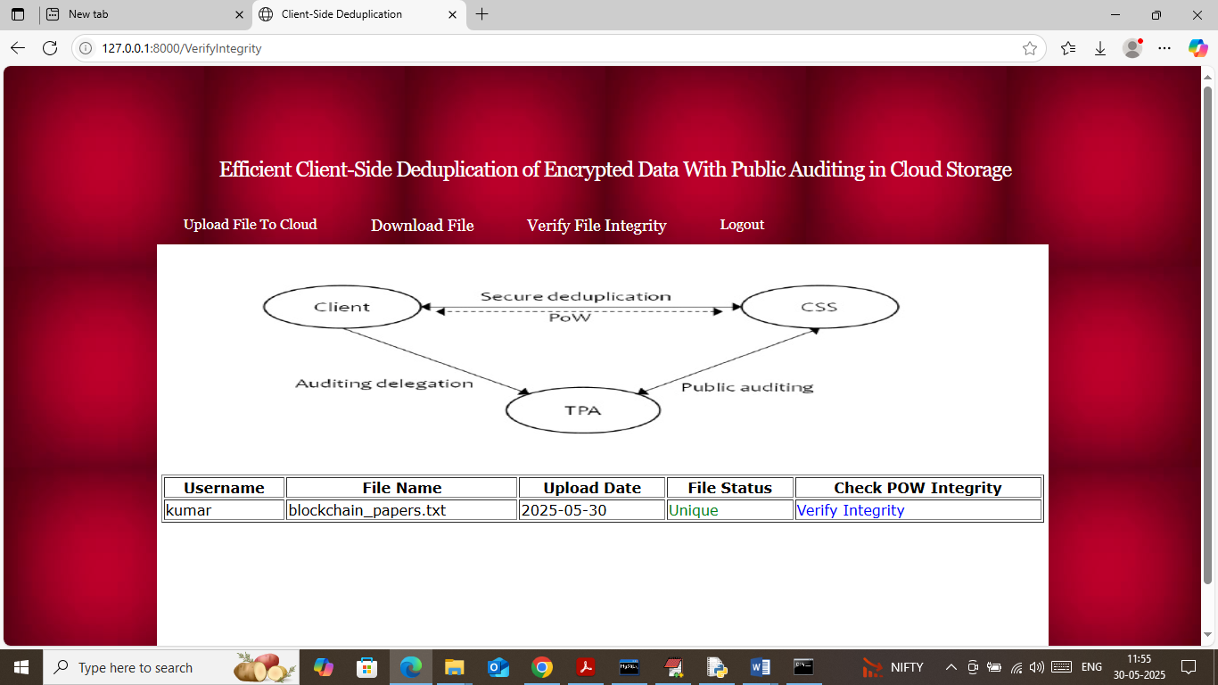
In above screen user can view list of uploaded unique files from cloud and can click on blue text ‘Verify Integrity’ link to send request to TPA weather file is same or content changed
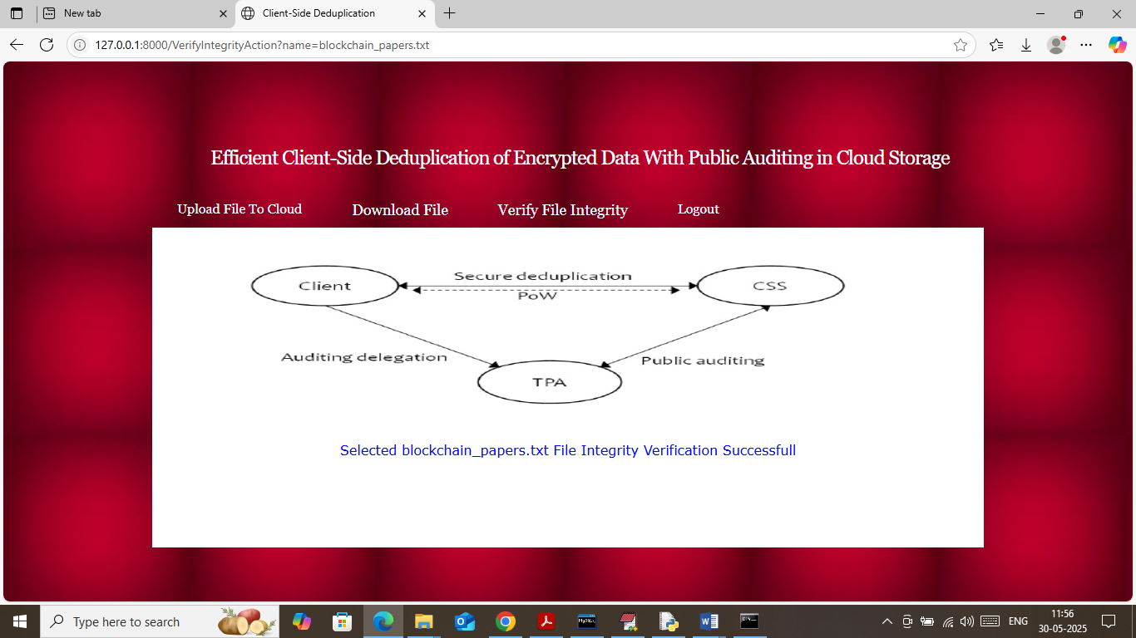
In above screen in blue text can see file verification successful. If above file changed at cloud server then will get below page. To change file just go inside ‘AuditingApp/static/files’ folder and then open any file change content and then perform re-verification to get below page
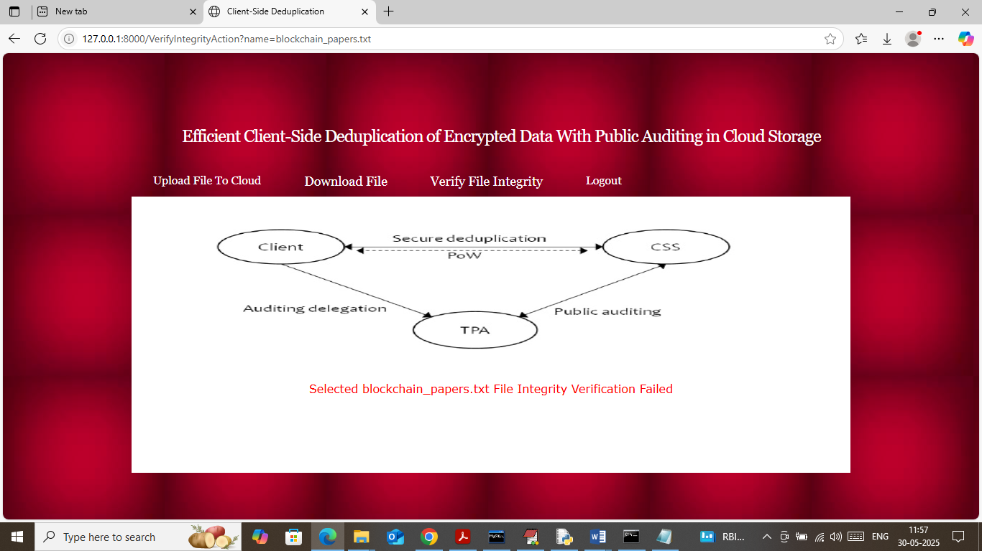
In above screen in red text can see file verification Failed.

