**JS-101**

**Assignment 1**

***Submitted by: Kamya Garg (***[***kamya@piktorlabs.com***](mailto:kamya@piktorlabs.com)***)***

***Date: 15/12/2020***

1. Execution context for factorial function using recursion.

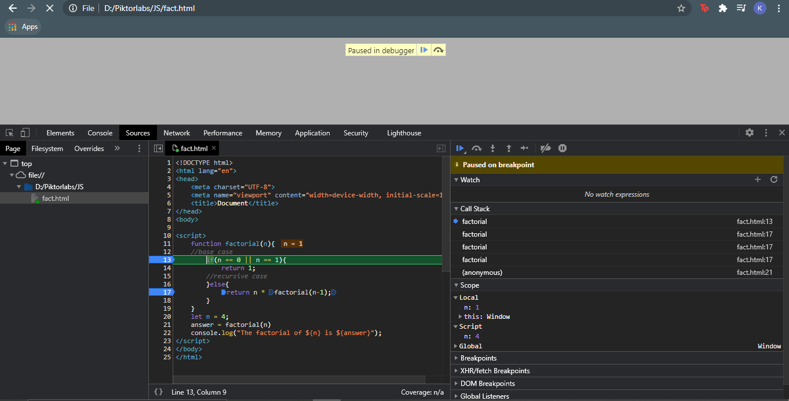

Fig 1.1 Code Execution

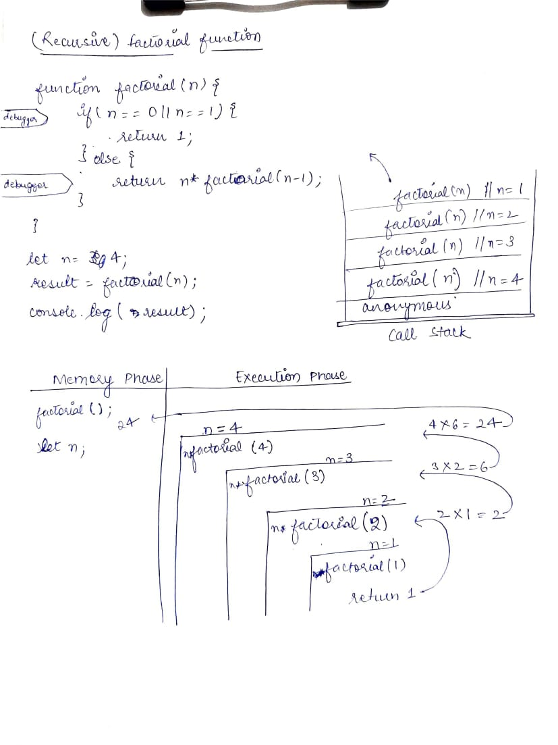

Fig 1.2 Code Working

1. Difference between undefined and not defined.

|  |  |
| --- | --- |
| Undefined | Not defined |
| This means that the variable has been declared but the value has not been set. | This means that the code references to a variable or a function that has not been declared. |
| Eg:  Let x;  Square(x);  Here, the variable ‘x’ has been declared but the value to it is not set yet. | Eg:  Let x=5;  square(y);  Here, code is referring to variable ‘y’ which is not declared anywhere in the entire code. |

1. Why is the ‘null’ an object?

Null is considered an object for web safety reasons. So much legacy code could be broken if this was to change that it was deemed better to just leave it alone, but it is not and will most likely become deprecated in the future**.**

*Reference:* [*https://www.quora.com/Why-is-null-considered-an-object-in-JavaScript*](https://www.quora.com/Why-is-null-considered-an-object-in-JavaScript)

In JavaScript, typeof null is 'object', which incorrectly suggests that null is an object (it isn’t, it’s a primitive value, consult my blog post on categorizing values for details). This is a bug and one that unfortunately can’t be fixed, because it would break existing code.

*Reference:* [*https://2ality.com/2013/10/typeof-null.html#:~:text=In%20JavaScript%2C%20typeof%20null%20is,it%20would%20break%20existing%20code.&text=The%20data%20is%20a%20reference%20to%20an%20object*](https://2ality.com/2013/10/typeof-null.html#:~:text=In%20JavaScript%2C%20typeof%20null%20is,it%20would%20break%20existing%20code.&text=The%20data%20is%20a%20reference%20to%20an%20object)*.*

1. Hoisting and Closures.

Hoisting: Creating memory space for variables and functions in the creation phase and making them available during the execution phase even when they are referenced as prior to their declaration.