CHART 1
Dynamic Sales and Profitability Analysis by Product Group
Objective: Analyze sales performance and profitability across product groups using dynamic parameters to identify high-performing and low-performing product categories.
Chart Type: Horizontal Bar Chart
Concepts: Groups + Sets + Parameters + Calculated Fields

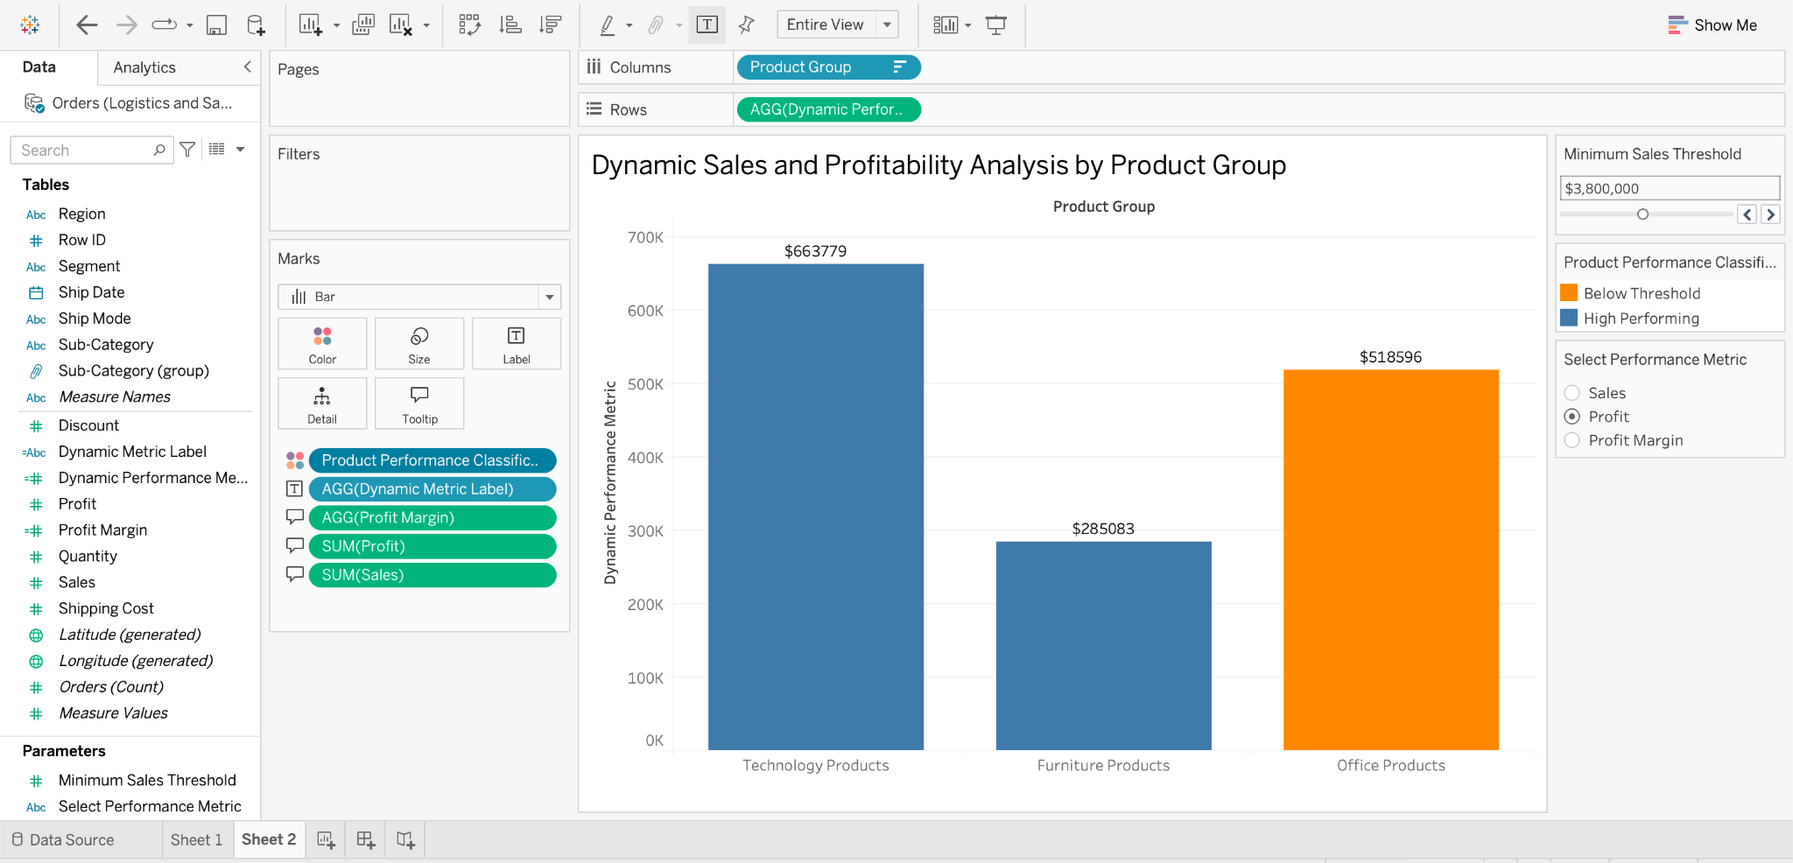
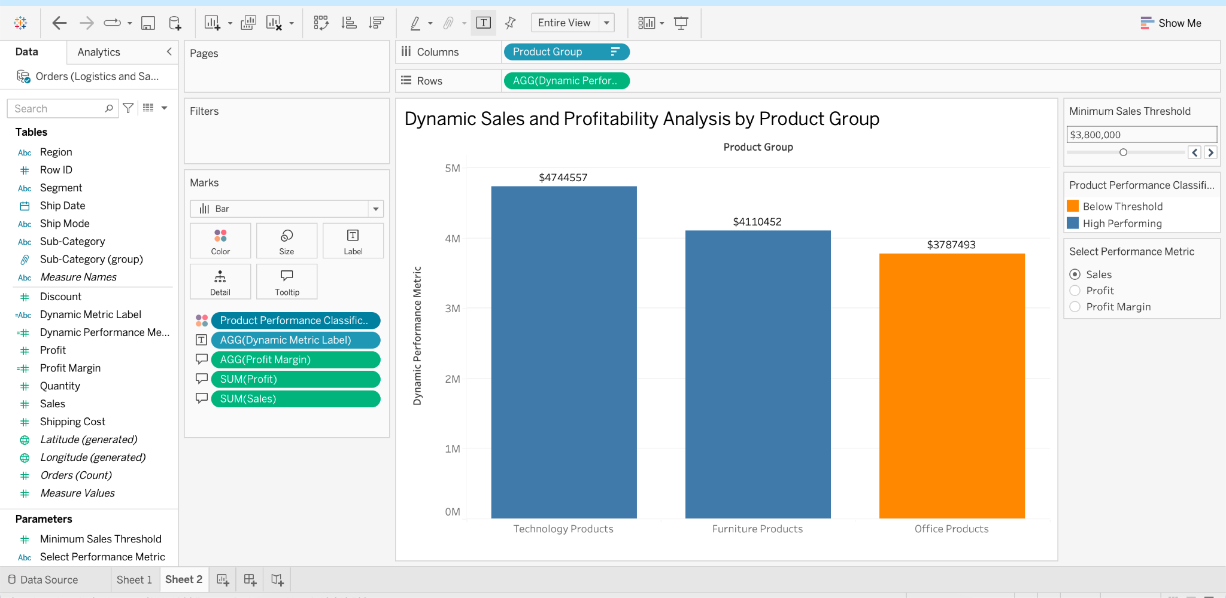
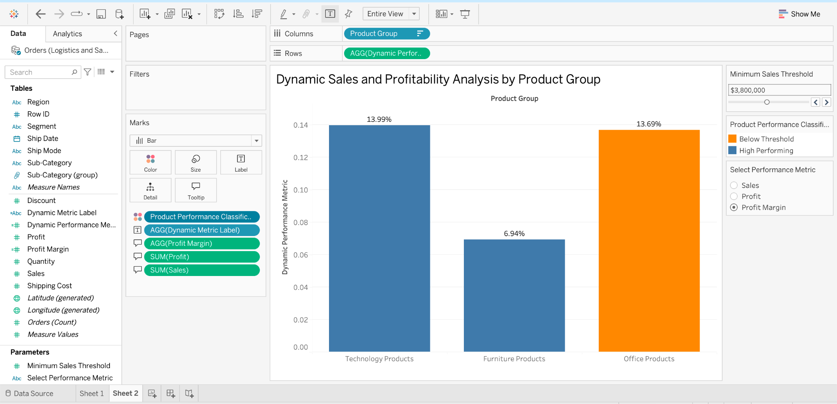
ABOVE 3 charts are selecting different PERFORMANCE METRIC on the right

The Minimum Sales Threshold parameter was configured with a step size of $100,000 to allow more precise analysis of product group performance. As the threshold increases, product groups are dynamically classified as High Performing or Below Threshold based on their total sales. At a 4 million threshold, Technology Products (4.74 million) and Furniture Products(4.11 million) are classified as High Performing, while office products (3.79 million) falls Below Threshold. When the threshold increases to $4.2 million, only Technology Products remain High Performing. At $4.8 million, all three groups fall Below Threshold. This dynamic parameter allows users to evaluate product performance under different sales targets and identify which groups consistently meet higher revenue expectations.
TOOLTIP
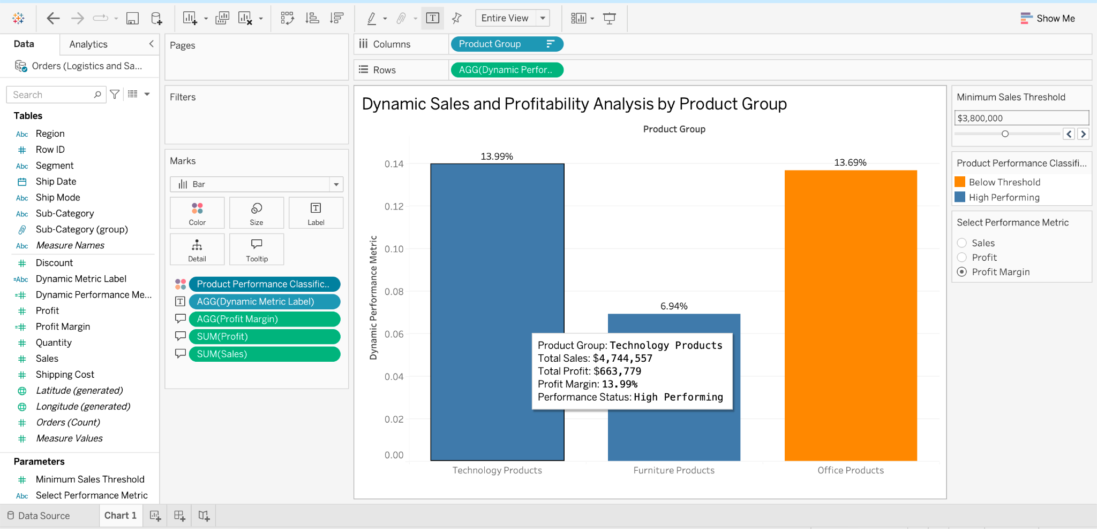

Method:
Created three product groups (Technology Products, Furniture Products, and Office Products) using Tableau's Group feature. Developed a dynamic set controlled by a Minimum Sales Threshold parameter to classify groups as High Performing or Below Threshold. Created a second parameter to switch between Sales, Profit, and Profit Margin. Used calculated fields to calculate profit margin, classify performance, and dynamically display the selected metric.
Inference:
Technology Products generated the highest sales ($4.74 million) and profit margin (13.99%). Furniture Products generated $4.11 million in sales but had the lowest profit margin (6.94%). Office Products generated $3.79 million in sales with a relatively strong profit margin of 13.69%.
At a $4 million sales threshold, Technology Products and Furniture Products are classified as High Performing, while Office Products falls Below Threshold. This demonstrates that higher sales do not necessarily indicate higher profitability.

CHART 2:
Objective: Identify the top customers generating the highest sales and allow users to change the number of customers displayed.
USING Parameter + Set + Calculated Field
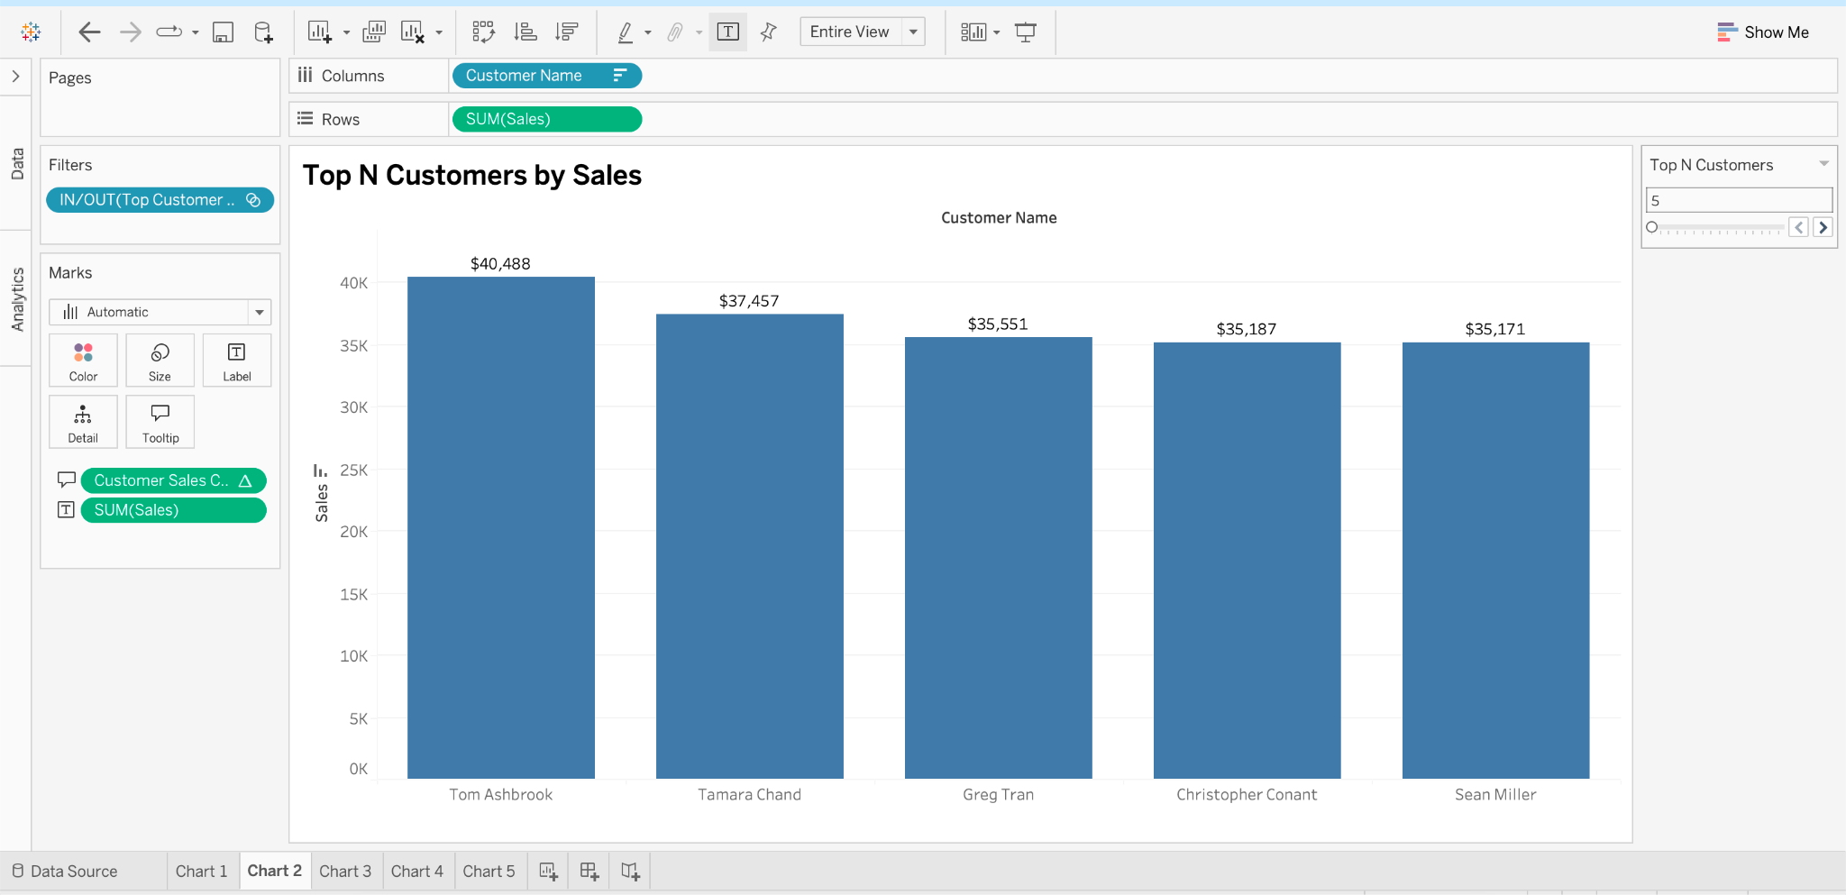

SLIDER IS WORKING
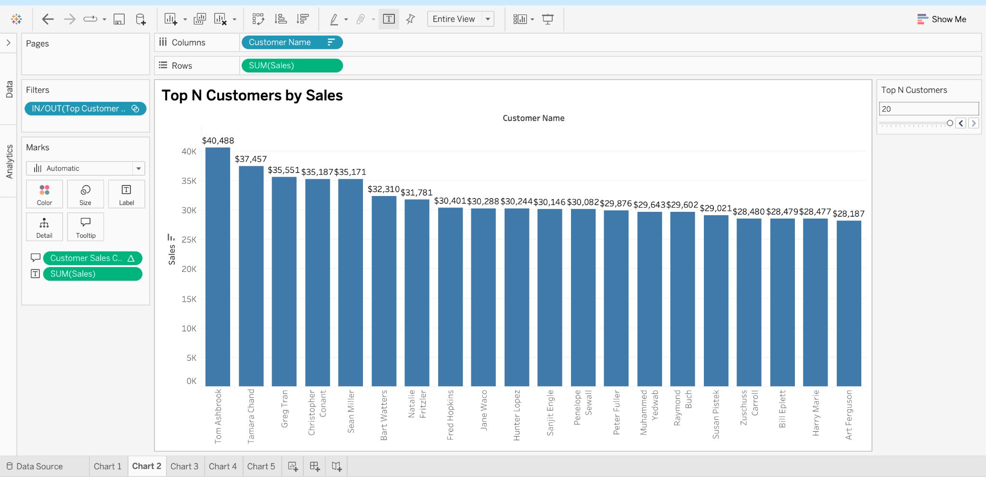
Method:
Created a dynamic Top N Customers set based on SUM(Sales) and linked it to a Top N Customers parameter ranging from 5 to 20. Applied the set as a filter to display the highest-revenue-generating customers. Created a Customer Sales Contribution calculated field to determine each customer's percentage contribution to the total sales of the selected Top N customers. Added this calculation to the tooltip and formatted sales values as currency for better readability.
Inference:
The analysis identifies Tom Ashbrook as the highest-revenue-generating customer with approximately $40,488 in sales, followed by Tamara Chand with $37,457 and Greg Tran with $35,551. The Top N parameter allows users to dynamically explore customer rankings, while the sales contribution percentage highlights each customer's relative importance within the selected group. These insights can help businesses identify valuable customers and develop targeted customer retention strategies.

CHART 3
Sales Contribution by Product Sub-Category
Objective: Compare total sales across product sub-categories using circles of different sizes.
Tableau concepts: Groups + Calculated Field

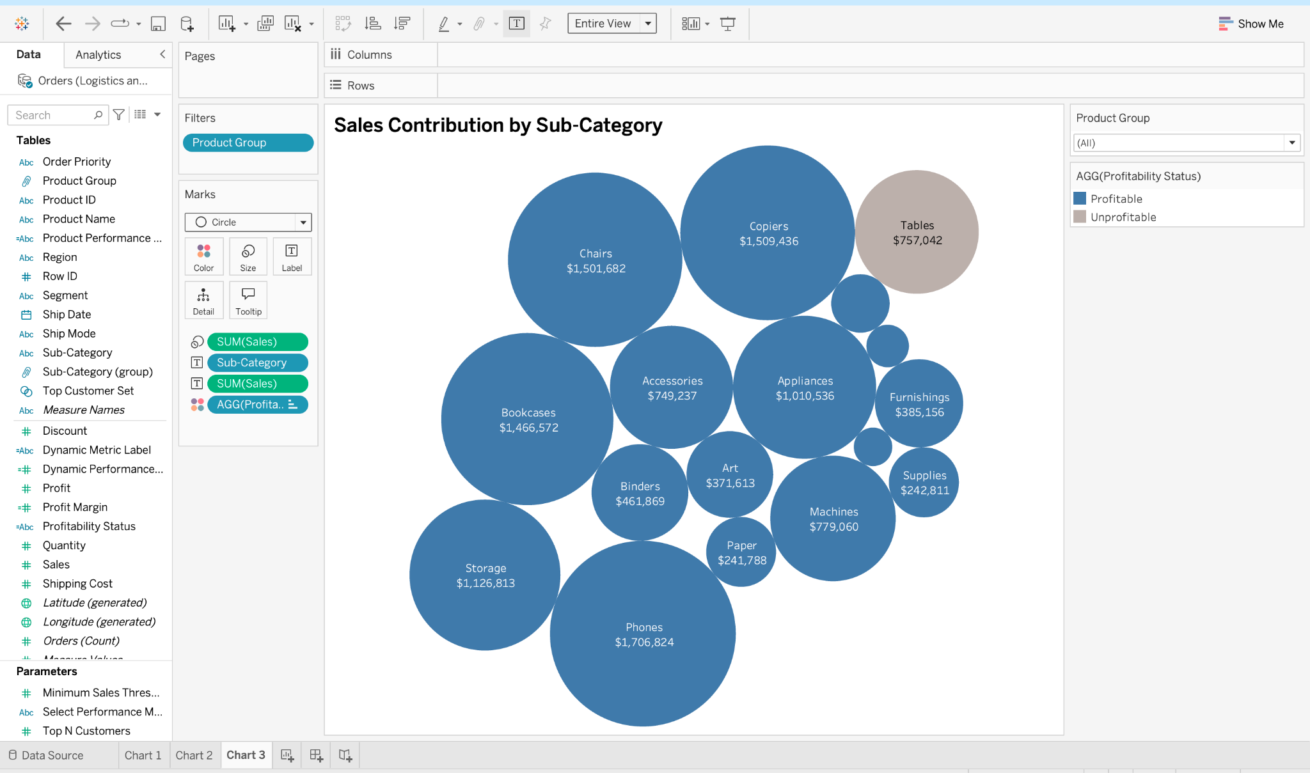
CHOOSING DIFFERENT PRODUCT GROUP
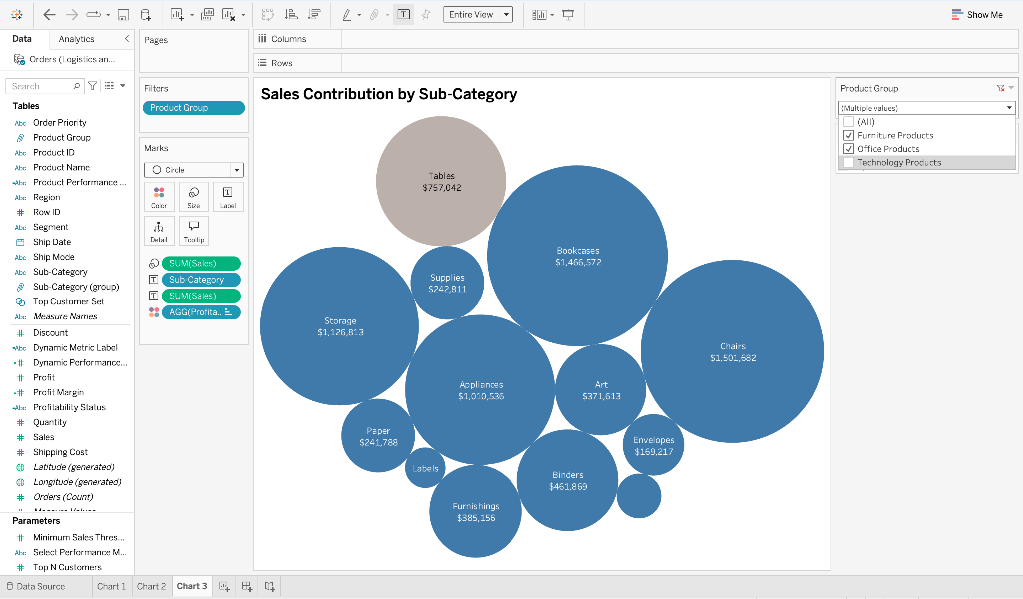

Method:
Created a packed bubble chart to analyze sales contribution across product sub-categories. Used SUM(Sales) to determine circle size and created a calculated field to classify sub-categories as Profitable or Unprofitable based on total profit. Applied the previously created Product Group field as an interactive dropdown filter to allow users to explore Technology Products, Furniture Products, and Office Products separately. Added sub-category names and sales values as labels to improve readability.
Inference:
Phones generated the highest sales of approximately 1.71 million, followed by Copiers (1.51 million), Chairs (1.50 million), and Bookcases (1.47 million). Most sub-categories were profitable, while Tables generated approximately $757,000 in sales but were classified as unprofitable. This suggests that high sales do not always guarantee profitability. The Product Group filter allows users to compare sales contributions and profitability across different product groups.

CHART 4
Sales Distribution by Transaction Value
Objective: Analyze how sales values are distributed across transactions and allow users to adjust the bin size dynamically.
Chart type: Histogram
Concepts: Bins + Parameter + Calculated field

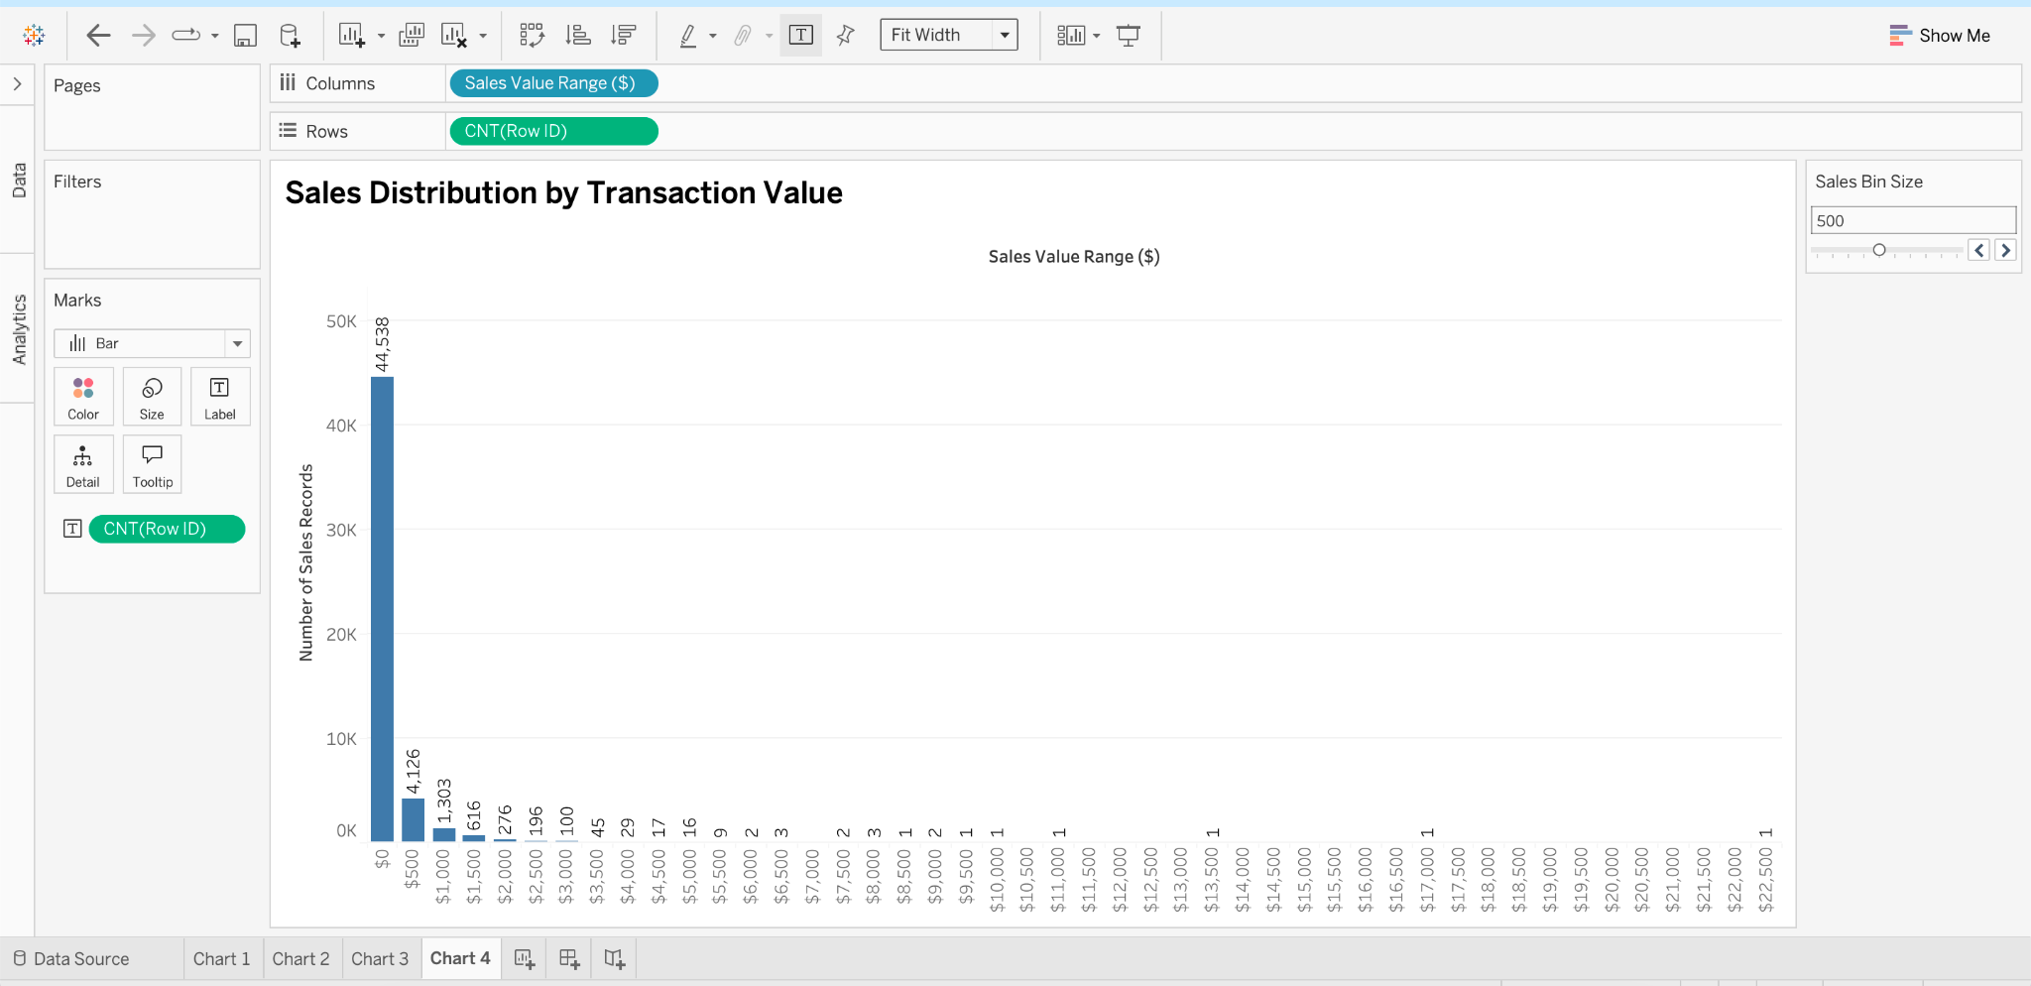
Method:
Created a histogram using Tableau's Bins feature to analyze the distribution of sales values. Developed a Sales Bin Size parameter ranging from 100 to 1,000 with a step size of 100, allowing users to dynamically adjust the size of each sales interval. Used COUNT(Row ID) to calculate the number of sales records within each bin. Formatted the sales values as currency and added frequency labels to improve readability.
Inference:
At a bin size of $500, the highest number of sales records falls within the $0 to below $500 range, containing 44,538 records. The number of records decreases significantly as sales values increase, with 4,126 records in the $500 to below $1,000 range and 1,303 records in the $1,000 to below $1,500 range. This indicates a right-skewed distribution, where most sales records have relatively low values, while only a small number have higher values. The adjustable bin size allows users to explore sales patterns at different levels of detail.

CHART 5
Monthly Sales Trends and Profitability Analysis
Objective: Analyze monthly sales trends, identify high and low sales months, and examine profitability using calculated fields.
Chart Type: Line Chart
Concepts: Parameter + Calculated Fields + Conditional Classification

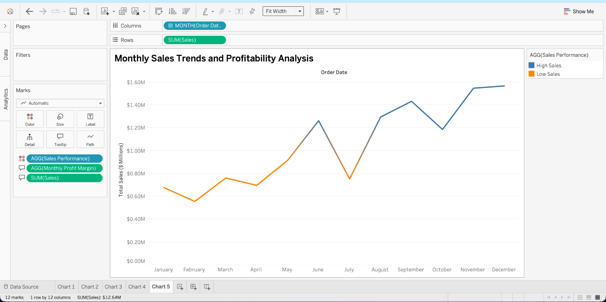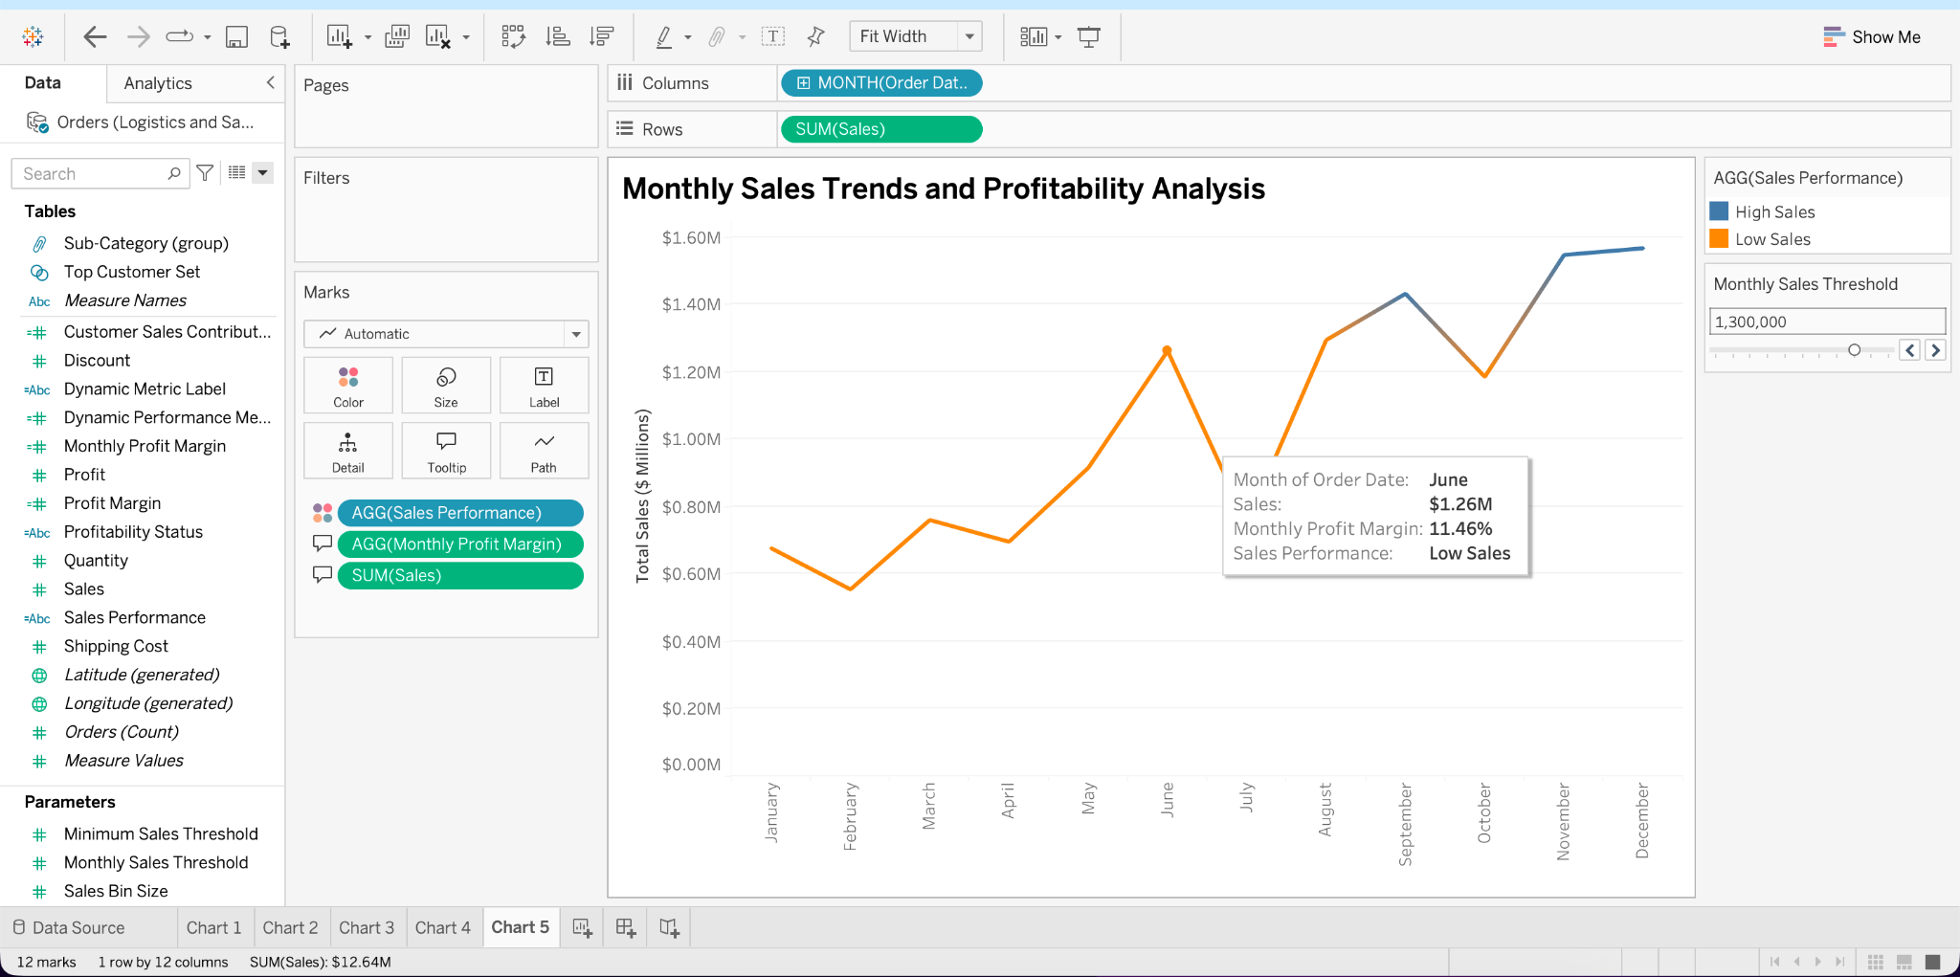

Method:
Created a line chart to analyze monthly sales patterns using Order Date and SUM(Sales). Developed a Monthly Sales Threshold parameter ranging from $500,000 to $1.5 million, allowing users to dynamically classify months as High Sales or Low Sales based on the selected threshold. Created a calculated field to calculate Monthly Profit Margin by dividing total profit by total sales. Added the profit margin to the tooltip to provide additional insights into profitability. Applied color coding to distinguish high and low sales months and formatted the sales axis in millions for better readability.

Inference:
Monthly sales fluctuate throughout the year, with February recording the lowest sales of approximately $0.55 million and December recording the highest sales of approximately $1.57 million. Sales generally increase toward the end of the year, particularly in November and December. The adjustable sales threshold allows users to identify high-performing and low-performing months under different sales expectations. For example, at a threshold of $1.1 million, months with sales of at least $1.1 million are classified as High Sales, while the remaining months are classified as Low Sales. The Monthly Profit Margin calculation provides additional insights into profitability and helps businesses evaluate seasonal sales performance and make informed marketing and inventory decisions.

