PROJECT ‘EBISU’
Game Design Overview

Confidential material. ⓒ 2024 Kamil Kulesza. All rights reserved.
Table of Contents
1 Introduction 2
2 Game Vision 2
2.1 Sum Up 2
2.2 USP 3
2.3 Other Key Features 3
2.4 General Description 3
2.5 Main References 3
2.6 Core Pillars 3
2.6.1 Pillar 1 3
2.6.2 Pillar 2 3
2.7 The scope 3
3 Core gameplay information 3
3.1 Core loops 3
3.2 3C: Character, controls, camera 4
3.2.1 Character 4
3.2.2 Controls 4
3.2.3 Camera 4
3.3 Game start, end, and goal 4
3.4 Game structure 4
4 Gameplay features 5
4.1 Main activities 5
4.1.1 Activities? 5
4.2 Feature 5
4.3 Feature 5
5 Game world 5
5.1 Setting 5
5.1.1 General premise 5
5.1.2 Story 5
5.2 Level Design 5
5.2.1 More details? 5
6 Art & Tech 5
6.1 Game stylization 5
6.2 Game Engine 5
7 Other information 6
7.1 Further expansions 6

Introduction
This document is Game Design Overview. It contains high level vision of the project and it scope. This is NOT a Game Design Document; further details will be described in future documents.
TO BE DECIDED
This is “To be decided” section. We use those in the document, to describe topics that needs additional research. Obviously, on this stage of project, a lot could change, but those are the most questionable.
The document is divided into sections:
- Introduction
- Game Vision – general information about the game, scope key features and so on
- Core gameplay information – most crucial information about the gameplay
- Gameplay features – the features that brings depth to the gameplay
- Gameworld – this section depicts setting and describes level design
- Art & tech – brief description of visual style of the game
- Other information – here we describe for example possibilities of expanding the game

Game Vision

Sum Up
Genre: Racing / Adventure
Network: Singleplayer - offline
Platforms: PC
Target Audience: Mastery driven players, JDM Enthusiasts, Japan lovers
Rating: 3+
Average Play Length Session: TBD
Time to full complete: TBD
Similar projects: Forza Horizon, Need For Speed, Touge Racer
Pillars: Player Cars, Drifting, Rivals, Maps/Routes, Shaders

Abstractions
The game will focus on following Player related experiences:

Player’s Fantasy
Mastery over skill, Rivalry, Speed and Power Fantasy (In terms of driving rather unobtainable cars)

Emotions
Excitement, Flow, Satisfaction, Frustration (motivative)

Conflict
Rival Driver, Vehicle Control, Time

USP
> Anime Racing Game
Japanese Style Touge 1v1 incorporating a blend of Speed (Racing) and Style (Drifting) with a captivating Story in crafted cell-shaded visual style

Other Key Features
- Special Scoring system where speed is not the only factor
- Eye pleasing environmental art
- Still-image (narrated? – TDB) story inserts

General Description
A game where the Players play as a newbie introduced to a JDM scene to explore their love for Touge racing and classic cars. Racing on Japan’s well known bendy and vertical roads against fellow Friends and Rivals, mastering the craft along the way and upgrading their ride.

Main References
Forza-ish (ArcadeSim) driving with Drifting inspired by Need For Speed series

Core Pillars

Pillar 1
Car models and physics

Pillar 2
Rival AI

Pillar 3
Environment and shaders

The scope
- Player Car model preparation and rigging (Materials, Bone rigging, ) – 2+ Cars
- Driving and drifting functions / physics (Controls, Engine maps, Drifting, Collison)
- Rival AI Driving (Following paths, incorporating drifting / stunts) – Tweakable Difficulty for AI
- Camera work (Different Views, Reacting to drifting, Shaking, FOV, etc.)
- Audio Design (Engine, Ambient, SFX)
- VFX Design (Tire skids and smoke, Tree leaves)
- Creating a Touge Racing Environment (Bendy Roads, Native Japan flora, etc.) – 2+ Routes, 1+ Environment, Tutorial area
- Creating and applying shaders (Cell-Shading)

Core gameplay information

Core loops
Lorem ipsum…

Figure 1: General game loop

3C: Character, controls, camera

Character
TBD
TO BE DECIDED
Nor Character Model Design, nor Animations have yet to be decided as the team has not yet made substantial research into Character modeling and rigging, at the minimum it has been decided to use a blackout model/outline of a character involving no animations

Controls
Peripherals: Keyboard + Mouse, Game Pad (Controller), Steering Wheel (TBD)
Inputs: Steering, Driving (Throttle, Brake, Handbrake), Panning around (Camera), UI Navigation
TO BE DECIDED
Steering Wheel is a “Nice to have” due to the variability of set-ups and team lacking proper equipment to test and accommodate for those.

Camera
Smoothly following and reacting to vehicle steering.
Multiple View to chooses:
- 3rd Person Chase Near and Far
- Hoor or Bumper
Applying special effects in regards to feedback like FOV (for speed), camera shake (for drifting, driving over potholes, etc.).
TO BE DECIDED
Interior (Cockpit, Dashboard) cameras, due to complexity of animations and possible model issues, would have to be either dropped or implemented with heavy compromising

Game start, end, and goal
Story introduction -> Tutorial -> Game Loop -> Story and Player Progression -> End Game

Game structure
Main Menu Layout:
- Play
  - Start / Continue Story
  - Standalone Race
  - Vehicles
- Settings
- Exit
Race Flow:
- Pre-Race Screen (vehicle selection, track preview)
- Countdown (3-2-1-Go!)
- Race Gameplay (checkpoints, timing, scoring)
- Results Screen (outcome, records)
- Progression (unlock cars, progress story)

Gameplay features

Main activities

Activities?
Lorem ipsum…

Feature
Lorem ipsum…

Feature
Lorem ipsum…

Game world

Setting

General premise
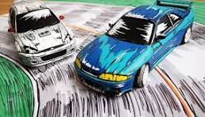
Anime style Japanese Touge racing scene

Story
Young Adult receives their firs car after successfully passing their driving license, gets invited by their friends to take part in Touge competition event

Level Design
Iconic Touge curvy, bendy, vertical tracks. Asphalt, Japanese road markings, Sakura trees
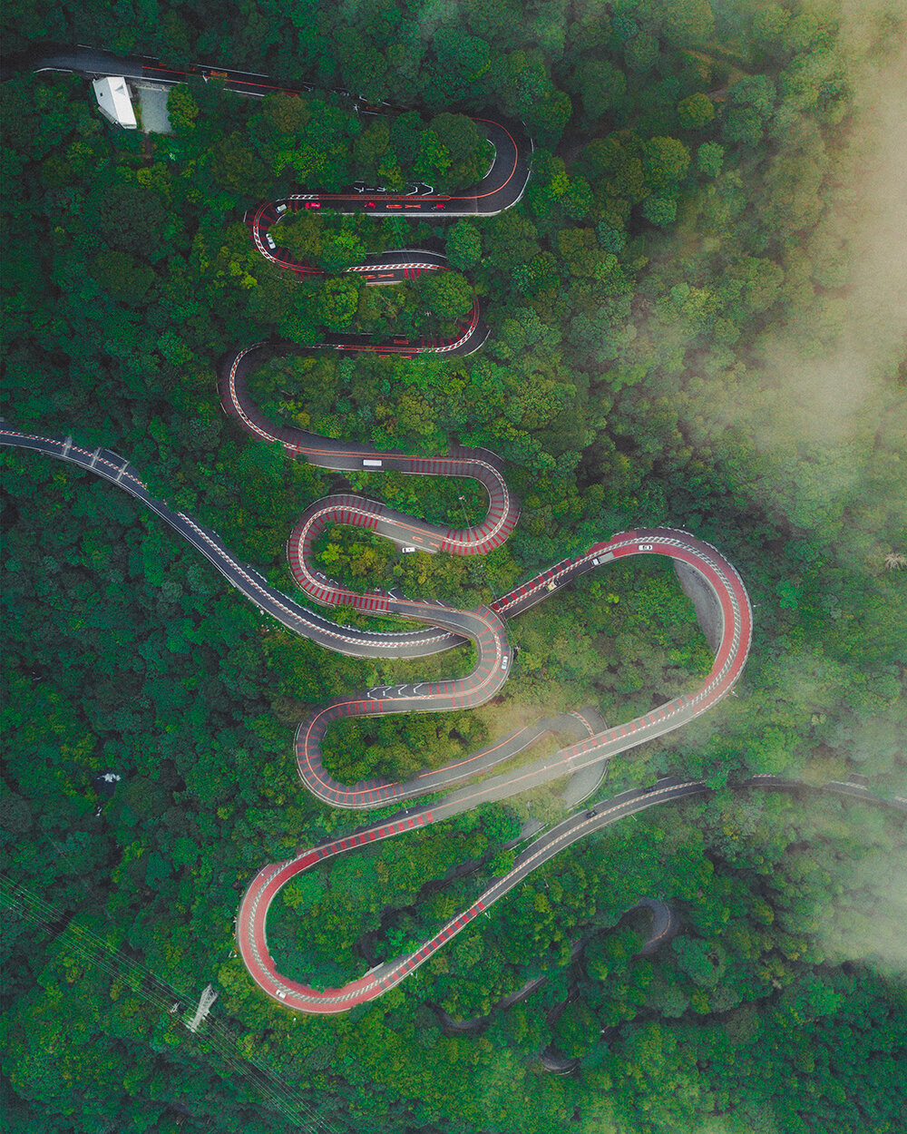
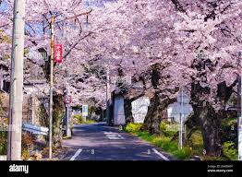

Car Selection
- Toyota AE86
- ? Honda City Turbo
- ? Toyota Starlet Glanza
- ? Nissan Skyline R34
- TBD

More details?
TBD

Art & Tech

Game stylization
Cell-shading, anime-like, native Japan, JDM

Game Engine
Unreal Engine 5

Other information

Further expansions
TBD

