Kanna Dandamudi

Enter your Particulars here

**Shakspeare PlaYS Explorer**

Contents

1. Setting Up data science project structure in a new Git repository: 3

2. Downloading DataSet from Kaggle: 5

3. Loading the Dataset as Pandas DataFrame 5

4- EDA & Feature Engineering 6

4.1- Feature Engineering 6

4.2- EDA 8

4.2.1- Number of Players in Each Play Or Should i Say: Plays with wider plots & story 8

4.2.2- Most Common Players of all Plays: Characters with presence in more than 1 play 9

4.2.3- Longest Plays: More the lines, longer the duration !!! 10

4.2.4- Plays with highest amount of cinematography 11

4.2.5- Love Birds of Shakspeare 12

4.2.6- Frequency Distribution of all Categorical Variables within Shakpears Dataset 13

5-Classification 14

5.1- Data Preprocessing 14

5.2- Naive-Bayes Classification 16

5.3 Naïve-Bayse Results: 16

5.3- Logistic Regression for classification 41

# Setting Up data science project structure in a new Git repository:

Please go to the following link. All the necessary files and script has been shared there.

<https://github.com/kan-da/Kanna_work>

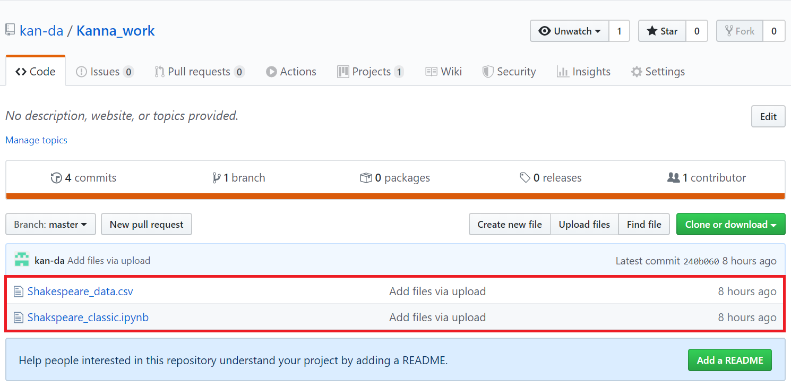

* 1. 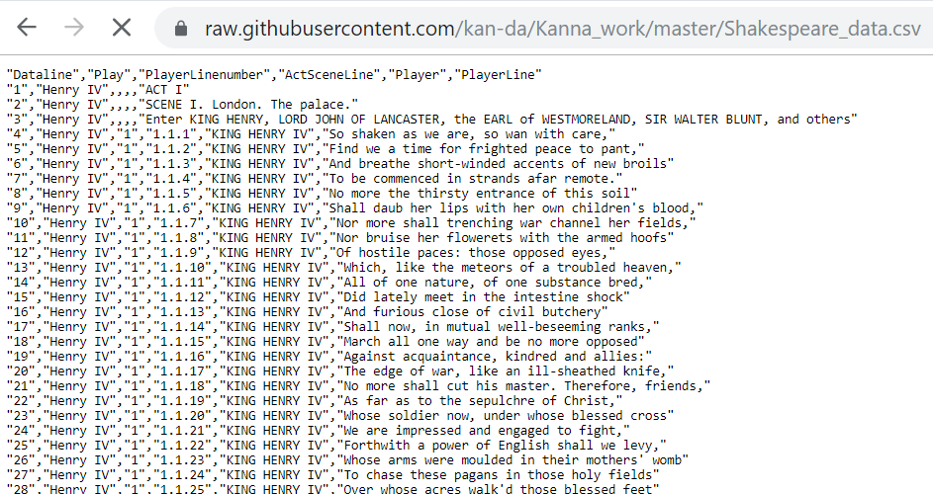Github Repository Status

* 1. Github Repository Status

# Downloading DataSet from Kaggle:

https://www.kaggle.com/kingburrito666/shakespeare-plays

# Loading the Dataset as Pandas DataFrame

First and far most important thing is to be able to load the pandas Dataframe and to be able to view the information which required and which is not required. df.describe() & df.info() are good enough to inform us about if there are any duplicates or null values in our data set. Since there were very small amount of null data so we decided to remove that.

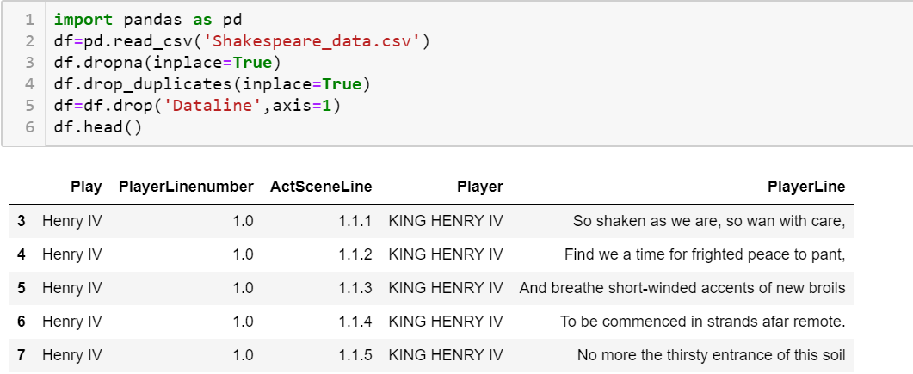

* 1. Loading DataFrame into pandas (input & output)

Dataline column is something which is not needed so we are going to remove it.

**3- Loading the Dataset as Pandas DataFrame**

First and far most important thing is to be able to load the pandas Dataframe and to be able to view the information which required and which is not required. df.describe() & df.info() are good enough to inform us about if there are any duplicates or null values in our data set. Since there were very small amount of null data so we decided to remove that.



In [1]: **import pandas as pd**

df=pd.read_csv('Shakespeare_data.csv')

df.dropna(inplace=**True**)

df.drop_duplicates(inplace=**True**)

df=df.drop('Dataline',axis=1)

df.head()

Out[1]:

|  |  |  |  |  |  |
| --- | --- | --- | --- | --- | --- |
|  | **Play** | **PlayerLinenumber** | **ActSceneLine** | **Player** | **PlayerLine** |
|  |  |  |  |  |  |
| **3** | Henry | 1.0 | 1.1.1 | KING HENRY | So shaken as we are, so wan with care, |
| IV | IV |
|  |  |  |  |
| **4** | Henry | 1.0 | 1.1.2 | KING HENRY | Find we a time for frighted peace to |
| IV | IV | pant, |
|  |  |  |
| **5** | Henry | 1.0 | 1.1.3 | KING HENRY | And breathe short-winded accents of |
| IV | IV | new broils |
|  |  |  |
| **6** | Henry | 1.0 | 1.1.4 | KING HENRY | To be commenced in strands afar |
| IV | IV | remote. |
|  |  |  |
| **7** | Henry | 1.0 | 1.1.5 | KING HENRY | No more the thirsty entrance of this soil |
| IV | IV |
|  |  |  |  |

Dataline column is something which is not needed so we are going to remove it.

# 4- EDA & Feature Engineering

## 4.1- Feature Engineering

ActSceneline column has basically three different values so we are going to split into three columns to have three features instead of one. Act means how many different acts has been there in a single play. Scene = ' How many Scenes are there in total as well as the whole scene' and finally in single scene how many individual lines were spoken.



In [2]: actsceneline=df['ActSceneLine'].str.split('.',n=-1,expand=**True**) *# We are going* *to split act scene and line*

df1=df

df1['act']=actsceneline[0]

df1['scene']=actsceneline[1]

df1['line']=actsceneline[2]

df1['words_lines']=[len(i.split(' ')) **for** i **in** df1['PlayerLine']] df1=df1.drop('PlayerLine',axis=1) df1.head()

Out[2]:

|  |  |  |  |  |  |  |  |  |
| --- | --- | --- | --- | --- | --- | --- | --- | --- |
|  | **Play** | **PlayerLinenumber** | **ActSceneLine** | **Player** | **act** | **scene** | **line** | **words_lines** |
|  |  |  |  |  |  |  |  |  |
| **3** | Henry IV | 1.0 | 1.1.1 | KING HENRY IV | 1 | 1 | 1 | 9 |
| **4** | Henry IV | 1.0 | 1.1.2 | KING HENRY IV | 1 | 1 | 2 | 9 |
| **5** | Henry IV | 1.0 | 1.1.3 | KING HENRY IV | 1 | 1 | 3 | 7 |
| **6** | Henry IV | 1.0 | 1.1.4 | KING HENRY IV | 1 | 1 | 4 | 7 |
| **7** | Henry IV | 1.0 | 1.1.5 | KING HENRY IV | 1 | 1 | 5 | 8 |

We have devised words_lines colum from indiviudal lines that have been spoken just to sum up. length of the line is directly related to the face time and if a character has spoken more words it means he has much face time and it could be concluded that he is the main character of the show or the most important character of the show.



In [3]: **import matplotlib.pyplot as plt**

**import seaborn as sns**

**from sklearn import** tree

**from sklearn.metrics import** accuracy_score

* *Figures inline and set visualization style* %**matplotlib** inline

sns.set()

## 4.2- EDA

### 4.2.1- Number of Players in Each Play Or Should i Say: Plays with wider plots & story



In [4]: plays_players=(df.groupby(['Play','Player']).count())[['PlayerLinenumber']].re set_index(drop=**False**)[['Play']]



In [5]: plt.figure(figsize = (20,10))

sns.countplot(x='Play', data=plays_players,order=plays_players['Play'].value_c

ounts().index)

plt.xticks(rotation=90,fontsize=16)

plt.title('4.2.1- Number of Players in Single Play',fontsize=20)

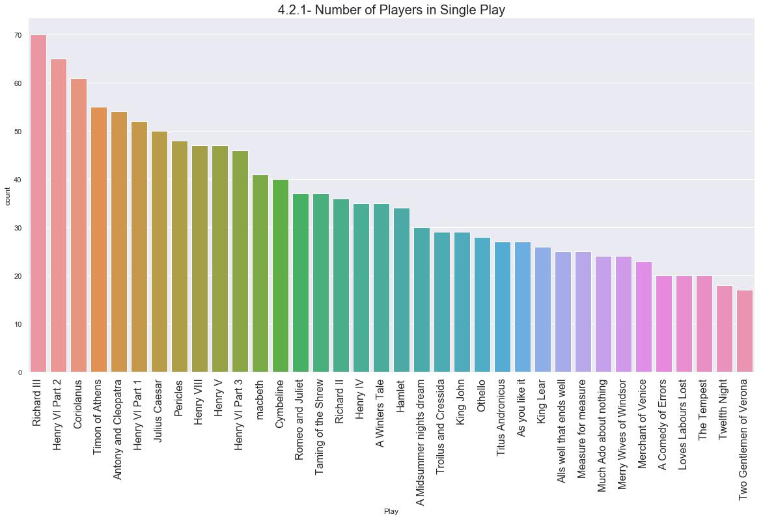

Number of players in a single play provides us a lot more information about the story and depth of the play. From the above graph we can clearly estimate that if there are more characters in a play, it must mean more wider story. So Richard III & Top10 have very wider plot.

### 4.2.2- Most Common Players of all Plays: Characters with presence in more than 1 play



In [6]: players_plays=(df.groupby(['Player','Play']).count())[['PlayerLinenumber']].re

set_index(drop=**False**)[['Player','Play']]

df2=players_plays.groupby('Player').count().sort_values(by='Play',ascending=**Fa**

**lse**).head(50).reset_index(drop=**False**)

df2['Player']=df2['Player'].str.replace('ALL','All')

df2['Player']=df2['Player'].str.replace('First ','')

df2['Player']=df2['Player'].str.replace('Second ','')

plt.figure(figsize = (20,10))

sns.barplot(x=df2['Player'], y=df2['Play'])

plt.xticks(rotation=90,fontsize=12)

plt.title('4.2.2- Players with more than 1 play(Top50)',fontsize=20)

Out[6]: Text(0.5, 1.0, '4.2.2- Players with more than 1 play(Top50)')

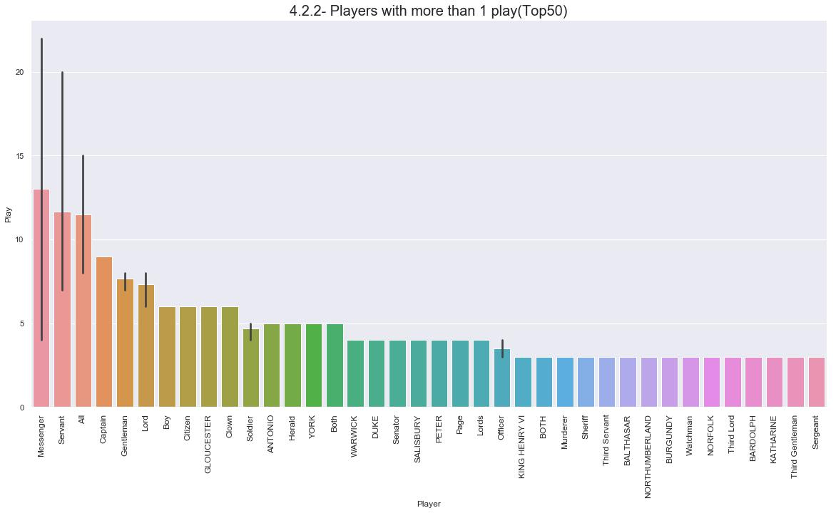

This may well be considered as less attractive feature but the number of characters in the dataset who are there in other plays as well. Although there are some names which might be written off but still there are some characters which tells about shakspeare's fondness with the characters like Gloucester, Anotonio etc.

### 4.2.3- Longest Plays: More the lines, longer the duration !!!



In [7]: max_lines=(df.groupby(['Play']).count())[['PlayerLinenumber']].reset_index(dro

p=**False**)

max_lines=max_lines.sort_values(by=['PlayerLinenumber'],ascending=**False**).reset

_index(drop=**True**)

plt.figure(figsize = (20,10))

sns.barplot(x=max_lines['Play'], y=max_lines['PlayerLinenumber'])

plt.xticks(rotation=90,fontsize=12)

plt.title('4.2.3- Plays with number of lines',fontsize=20)

Out[7]: Text(0.5, 1.0, '4.2.3- Plays with number of lines')

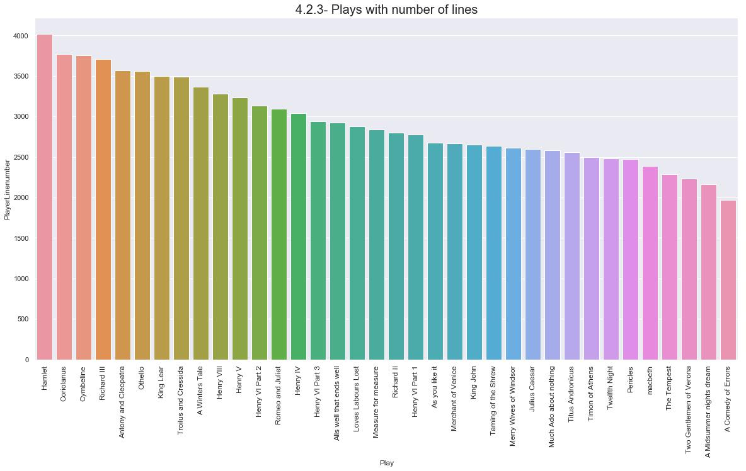

Above graph clearly shows in alphabetical order the shows which should be of longer durations than the others.

### 4.2.4- Plays with highest amount of cinematography



In [8]: max_lines=(df.groupby(['Play','act','scene']).count()).reset_index(drop=**False**) [['Play','act','scene']].groupby(['Play'

,'act']).count()

Play_with_max_scenes=max_lines.reset_index(drop=**False**)[['Play','scene']].group

by('Play').sum().reset_index(drop=**False**)

max_lines=Play_with_max_scenes.sort_values(by=['scene'],ascending=**False**).reset

_index(drop=**True**)

plt.figure(figsize = (20,10))

sns.barplot(x=max_lines['Play'], y=max_lines['scene'])

plt.xticks(rotation=90,fontsize=16)

plt.yticks(fontsize=16)

plt.title('4.2.4- Plays with number of scenes',fontsize=20)

Out[8]: Text(0.5, 1.0, '4.2.4- Plays with number of scenes')

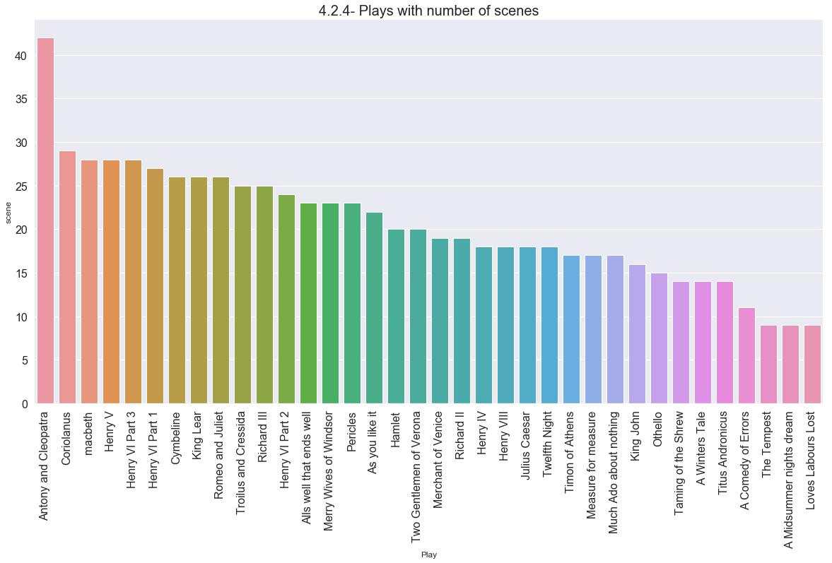

Anothony & cleapethra clearly are miles a head compared to others with highest number of different scenes.

### 4.2.5- Love Birds of Shakspeare



In [9]: facetime=df[['Player','words_lines']]

max_lines=facetime.groupby(['Player']).sum().reset_index(drop=**False**).sort_valu

es(by=['words_lines'],ascending=**False**).reset_index(drop=**True**)[:20]

plt.figure(figsize = (20,10))

sns.barplot(x=max_lines['Player'], y=max_lines['words_lines'])

plt.xticks(rotation=90,fontsize=12)

plt.yticks(fontsize=16)

plt.title('4.2.5- Star Players of Shakspeare(Top20)',fontsize=20)

Out[9]: Text(0.5, 1.0, '4.2.5- Star Players of Shakspeare(Top20)')

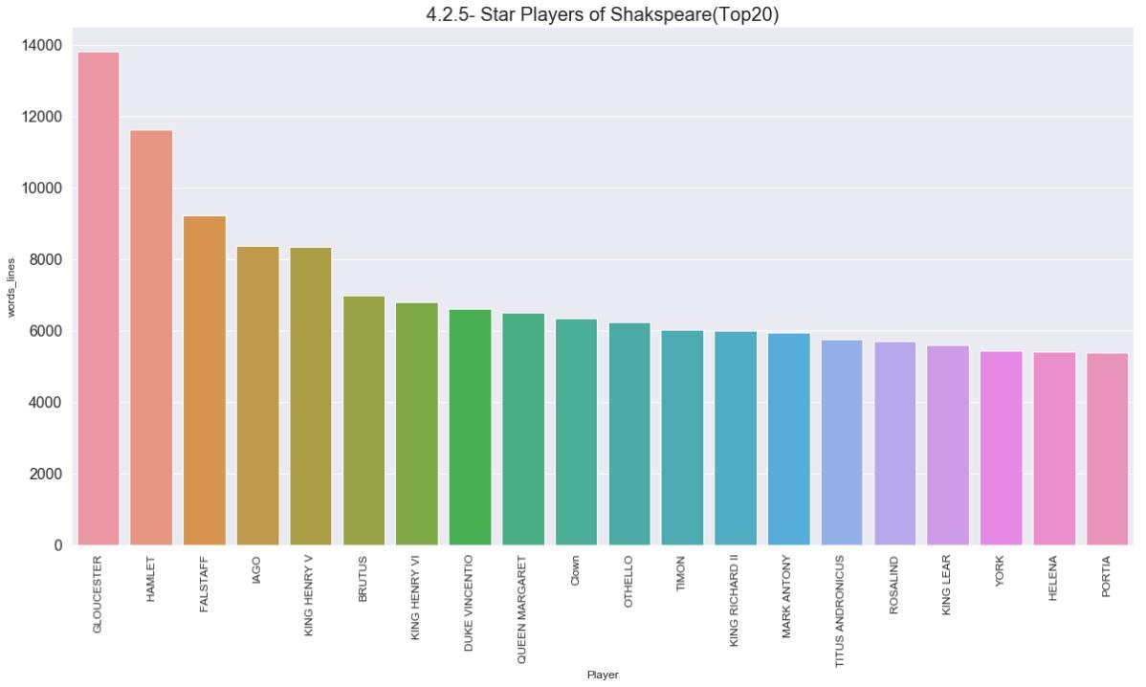

Above mentioned all characters of shakspeare are the higest number of line\words holders of shakspeare.

### 4.2.6- Frequency Distribution of all Categorical Variables within Shakpears Dataset



In [10]: df2=df1.drop(['words_lines','PlayerLinenumber'],axis=1)

fig, ax = plt.subplots(4, 2, figsize=(20, 15))

**for** variable, subplot **in** zip(df2.columns, ax.flatten()):

sns.countplot(df2[variable], ax=subplot,order=df2[variable].value_counts()

.index)

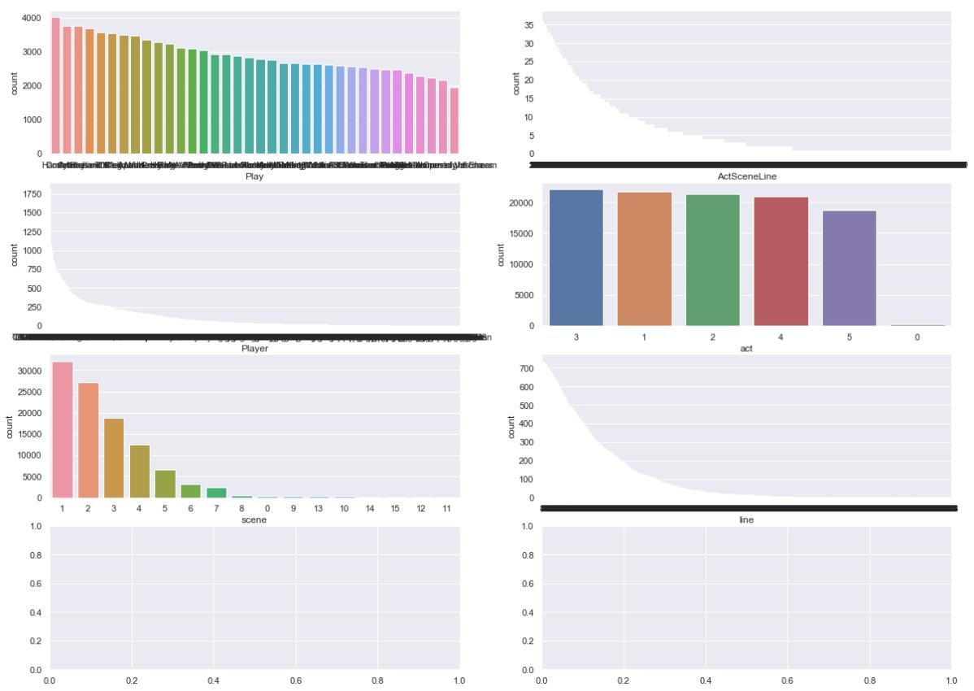

# 5-Classification

## 5.1- Data Preprocessing

This is the method for connverting the non-numerical data into numerical data. What this method will do is basically convert the each column into an array and for the unique items in that particular column, it will convert into particular index untill all unique words occur in the column. After that it will simply assign the corresponding element index.



In [11]: **def** handle_non_numerical_data(df):

columns = df.columns.values

**for** column **in** columns:

text_digit_vals = {}

**def** convert_to_int(val):

**return** text_digit_vals[val]

**if** df[column].dtype!=np.int64 **and** df[column].dtype!=np.float64:column_contents = df[column].values.tolist() unique_elements = set(column_contents)

x = 0

**for** unique **in** unique_elements:

**if** unique **not in** text_digit_vals:

text_digit_vals[unique] = x

x+=1

df[column] = list(map(convert_to_int, df[column]))

**return** df



In [12]: **import pandas as pd**

**import sklearn as sk**

**from sklearn.naive_bayes import** GaussianNB

**import numpy as np**

**from sklearn.naive_bayes import** MultinomialNB

**from sklearn import** metrics

**from sklearn.model_selection import** train_test_split **from sklearn.preprocessing import** KBinsDiscretizer

data=pd.read_csv('Shakespeare_data.csv')

data.dropna(inplace=**True**)

data.drop_duplicates(inplace=**True**)

data=data.drop('Dataline',axis=1)

actsceneline=data['ActSceneLine'].str.split('.',n=-1,expand=**True**) *# We are goi* *ng to split act scene and line*

df1=data

df1['act']=actsceneline[0]

df1['scene']=actsceneline[1]

df1['line']=actsceneline[2]

df1['words_lines']=[len(i.split(' ')) **for** i **in** df1['PlayerLine']] df1=df1.drop(['PlayerLine','ActSceneLine'],axis=1)

**from sklearn.utils import** shuffle

df2=shuffle(df1).reset_index(drop=**True**)

df2.head()

Out[12]:

|  |  |  |  |  |  |  |  |
| --- | --- | --- | --- | --- | --- | --- | --- |
|  | **Play** | **PlayerLinenumber** | **Player** | **act** | **scene** | **line** | **words_lines** |
|  |  |  |  |  |  |  |  |
| **0** | A Comedy of Errors | 54.0 | ADRIANA | 2 | 2 | 134 | 9 |
| **1** | macbeth | 5.0 | LADY MACBETH | 1 | 5 | 63 | 5 |
| **2** | Romeo and Juliet | 56.0 | FRIAR LAURENCE | 5 | 3 | 264 | 9 |
| **3** | King Lear | 47.0 | EDGAR | 5 | 3 | 165 | 2 |
| **4** | King Lear | 77.0 | ALBANY | 5 | 3 | 269 | 8 |

we are going to split our train & test data and features and label data now.



In [13]: X=df2.drop(['Player'],axis=1)

Y=df2[['Player']]

df=pd.get_dummies(df2,columns=df2.columns)

X=df

Y=np.array(df2['Player'])

X_train, X_test,Y_train, Y_test=train_test_split(X,Y,test_size=0.2)

We have used above the pd.get dummies which is basically pandas version of one-hot encoding and it is much easier to implement.The reason we have used it get rid of the numerical data which might be picked up wrongly by our model. To avoid that we have used it. Next Stop ! Building the model !!

## 5.2- Naive-Bayes Classification

Naive-Bayes works on the probability principle or to be precise on the principle of conditional probability. The reason we have chosen this because it works well the categorical data. Although it tends to be a bit slower and not being used in abundance now a days but for the sake of comparison with logistic regression algoritham we are using it.



In [14]: model=GaussianNB() *# Model design*

model.fit(X_train,Y_train) *# Training our Gaussian NB Model*

GaussianPredicted=model.predict(X_test) *#testing of Gaussian NB Model*

ACCU_GAUSS=metrics.accuracy_score(Y_test, GaussianPredicted)

print("GAUSSIAN NAIVE-BAYSE HAS ACCURACY OF: "+str(ACCU_GAUSS*100))

CONFUSION_MATRIX_GAUSSIAN=metrics.confusion_matrix(Y_test, GaussianPredicted)

print('confusion matrix: Naive-Bayse Classifier')

print(CONFUSION_MATRIX_GAUSSIAN)

print('------------------------------------')

print('classification report: Naive-Bayse Classifier')

print(metrics.classification_report(Y_test,GaussianPredicted))

## 5.3 Naïve-Bayse Results:

|  |  |  |  |  |  |
| --- | --- | --- | --- | --- | --- |
| GAUSSIAN | | NAIVE-BAYSE HAS ACCURACY OF: 98.27873139650991 | | | |
| confusion matrix: Naive-Bayse Classifier | | | | | |
| [[63 | 0 | 0 ... | 0 | 0 | 0] |
| [ 0 | 1 | 0 ... | 0 | 0 | 0] |
| [ 0 | 0 | 5 ... | 0 | 0 | 0] |
| ... |  |  |  |  |  |
| [ 0 | 0 | 0 ... | 1 | 0 | 0] |
| [ 0 | 0 | 0 ... | 0 | 1 | 0] |
| [ 0 | 0 | 0 ... | 0 | 0 | 2]] |

------------------------------------

classification report: Naive-Bayse Classifier.

|  |  |  |  |  |  |  |  |
| --- | --- | --- | --- | --- | --- | --- | --- |
| 'precision', 'predict | precision | | recall | f1-score | | support | |
| AARON | 0.98 | | 0.98 | 0.98 | | 64 | |
| ABERGAVENNY | 1.00 | | 1.00 | 1.00 | | 1 | |
| ABHORSON | 1.00 | | 1.00 | 1.00 | | 5 | |
| ABRAHAM | 1.00 | | 0.50 | 0.67 | | 2 | |
| ACHILLES | 0.94 | | 1.00 | 0.97 | | 33 | |
| ADAM | 1.00 | | 1.00 | 1.00 | | 16 | |
| ADRIAN | 1.00 | | 0.75 | 0.86 | | 4 | |
| ADRIANA | 1.00 | | 0.97 | 0.99 | | 40 | |
| ADRIANO DE ARMADO | 0.98 | | 1.00 | 0.99 | | 44 | |
| AEGEON | 1.00 | | 1.00 | 1.00 | | 30 | |
| AEMELIA | 1.00 | | 1.00 | 1.00 | | 12 | |
| AEMILIUS | 1.00 | | 1.00 | 1.00 | | 4 | |
| AENEAS | 1.00 | | 0.91 | 0.95 | | 23 | |
| AEdile | 1.00 | | 1.00 | 1.00 | | 2 | |
| AGAMEMNON | 1.00 | | 0.95 | 0.98 | | 44 | |
| AGRIPPA | 1.00 | | 1.00 | 1.00 | | 14 | |
| AJAX | 0.95 | | 0.90 | 0.92 | | 20 | |
| ALBANY | 1.00 | | 0.97 | 0.99 | | 35 | |
| ALCIBIADES | 1.00 | | 1.00 | 1.00 | | 27 | |
| ALENCON | 0.86 | | 1.00 | 0.92 | | 6 | |
| ALEXANDER | 1.00 | | 1.00 | 1.00 | | 5 | |
| ALEXAS | 1.00 | | 1.00 | 1.00 | | 4 | |
| ALICE | 1.00 | | 1.00 | 1.00 | | 6 | |
| ALL | 0.33 | | 1.00 | 0.50 | | 7 | |
| ALONSO | 1.00 | | 1.00 | 1.00 | | 14 | |
| AMIENS | 1.00 | | 1.00 | 1.00 | | 9 | |
| ANDROMACHE | 1.00 | | 1.00 | 1.00 | | 1 | |
| ANGELO | 1.00 | | 1.00 | 1.00 | | 79 | |
| ANGUS | 1.00 | | 1.00 | 1.00 | | 3 | |
| ANNE | 1.00 | | 1.00 | 1.00 | | 5 | |
| ANNE PAGE | 1.00 | | 0.90 | 0.95 | | 10 | |
| ANTIGONUS | 1.00 | | 1.00 | 1.00 | | 26 | |
| ANTIOCHUS | 1.00 | | 1.00 | 1.00 | | 11 | |
| ANTIPHOLUS | 1.00 | | 1.00 | 1.00 | | 2 | |
| ANTONIO | 1.00 | | 1.00 | 1.00 | | 103 | |
| ANTONY | 1.00 | | 1.00 | 1.00 | | 51 | |
| APEMANTUS | 1.00 | | 0.96 | 0.98 | | 57 | |
| ARCHBISHOP OF YORK | 1.00 | | 1.00 | 1.00 | | 8 | |
| ARCHIDAMUS | 1.00 | | 1.00 | 1.00 | | 4 | |
| ARIEL | 1.00 | | 0.97 | 0.99 | | 40 | |
| ARMADO | 0.00 | | 0.00 | 0.00 | | 1 | |
| ARRAGON | 1.00 | | 1.00 | 1.00 | | 13 | |
| ARTEMIDORUS | 1.00 | | 1.00 | 1.00 | | 2 | |
| ARTHUR | 1.00 | | 1.00 | 1.00 | | 29 | |
| ARVIRAGUS | 1.00 | | 1.00 | 1.00 | | 29 | |
| ATTENDANT | 0.00 | | 0.00 | 0.00 | | 1 | |
| AUDREY | 1.00 | | 1.00 | 1.00 | | 5 | |
| AUFIDIUS | 0.97 | | 1.00 | 0.98 | | 61 | |
| AUSTRIA | 1.00 | | 1.00 | 1.00 | | 7 | |
| AUTOLYCUS | 1.00 | | 1.00 | 1.00 | | 70 | |
| Abbot | 1.00 | | 1.00 | 1.00 | | 2 | |
| All | 0.39 | | 0.90 | 0.55 | | 10 | |
| All Lords | 0.00 | | 0.00 | 0.00 | | 1 | |
| All Servants | 0.00 | | 0.00 | 0.00 | | 2 | |
| Apothecary | | 1.00 | 1.00 | | 1.00 | | 2 |
| Attendants | | 0.00 | 0.00 | | 0.00 | | 1 |
| BAGOT | | 1.00 | 1.00 | | 1.00 | | 6 |
| BALTHASAR | | 1.00 | 0.93 | | 0.96 | | 14 |
| BALTHAZAR | | 1.00 | 1.00 | | 1.00 | | 7 |
| BANQUO | | 0.96 | 0.96 | | 0.96 | | 25 |
| BAPTISTA | | 0.97 | 0.97 | | 0.97 | | 40 |
| BARDOLPH | | 0.94 | 0.94 | | 0.94 | | 17 |
| BARNARDINE | | 1.00 | 0.86 | | 0.92 | | 7 |
| BASSANIO | | 1.00 | 1.00 | | 1.00 | | 63 |
| BASSET | | 1.00 | 1.00 | | 1.00 | | 6 |
| BASSIANUS | | 1.00 | 1.00 | | 1.00 | | 11 |
| BASTARD | | 1.00 | 1.00 | | 1.00 | | 100 |
| BASTARD OF ORLEANS | | 0.92 | 1.00 | | 0.96 | | 11 |
| BATES | | 1.00 | 1.00 | | 1.00 | | 1 |
| BEATRICE | | 1.00 | 0.97 | | 0.99 | | 40 |
| BEDFORD | | 1.00 | 1.00 | | 1.00 | | 19 |
| BELARIUS | | 1.00 | 1.00 | | 1.00 | | 75 |
| BENEDICK | | 1.00 | 0.98 | | 0.99 | | 93 |
| BENVOLIO | | 1.00 | 0.93 | | 0.97 | | 30 |
| BERNARDO | | 1.00 | 1.00 | | 1.00 | | 11 |
| BERTRAM | | 0.98 | 1.00 | | 0.99 | | 55 |
| BEVIS | | 1.00 | 1.00 | | 1.00 | | 1 |
| BIANCA | | 0.96 | 0.92 | | 0.94 | | 25 |
| BIGOT | | 1.00 | 1.00 | | 1.00 | | 1 |
| BIONDELLO | | 0.94 | 1.00 | | 0.97 | | 34 |
| BIRON | | 0.99 | 1.00 | | 1.00 | | 135 |
| BISHOP OF CARLISLE | | 1.00 | 1.00 | | 1.00 | | 12 |
| BISHOP OF ELY | | 1.00 | 0.50 | | 0.67 | | 4 |
| BLANCH | | 1.00 | 1.00 | | 1.00 | | 14 |
| BOLINGBROKE | | 1.00 | 1.00 | | 1.00 | | 6 |
| BONA | | 1.00 | 1.00 | | 1.00 | | 2 |
| BORACHIO | | 0.88 | 0.93 | | 0.90 | | 15 |
| BOTTOM | | 0.98 | 1.00 | | 0.99 | | 46 |
| BOULT | | 1.00 | 0.92 | | 0.96 | | 12 |
| BOURBON | | 1.00 | 1.00 | | 1.00 | | 3 |
| BOYET | | 0.98 | 0.96 | | 0.97 | | 49 |
| BRABANTIO | | 0.97 | 1.00 | | 0.98 | | 29 |
| BRAKENBURY | | 1.00 | 1.00 | | 1.00 | | 8 |
| BRANDON | | 1.00 | 1.00 | | 1.00 | | 3 |
| BRUTUS | | 0.99 | 1.00 | | 0.99 | | 210 |
| BUCKINGHAM | | 0.98 | 1.00 | | 0.99 | | 138 |
| BURGUNDY | | 0.97 | 1.00 | | 0.98 | | 28 |
| BUSHY | | 1.00 | 1.00 | | 1.00 | | 9 |
| Banditti | | 1.00 | 1.00 | | 1.00 | | 1 |
| Bawd | | 1.00 | 0.90 | | 0.95 | | 20 |
| Boatswain | | 1.00 | 1.00 | | 1.00 | | 5 |
| Both | | 1.00 | 0.75 | | 0.86 | | 4 |
| Both Murderers | | 0.00 | 0.00 | | 0.00 | | 1 |
| Boy | | 0.89 | 1.00 | | 0.94 | | 25 |
| CADE | | 1.00 | 0.97 | | 0.99 | | 38 |
| CAESAR | | 0.96 | 0.92 | | 0.94 | | 26 |
| CAITHNESS | | 1.00 | 1.00 | | 1.00 | | 4 |
| CAIUS LUCIUS | | 1.00 | 1.00 | | 1.00 | | 15 |
| CALCHAS | | 1.00 | 1.00 | | 1.00 | | 8 |
| CALIBAN | | 0.88 | 1.00 | | 0.94 | | 30 |
| CAMBRIDGE | | 1.00 | 0.75 | | 0.86 | | 4 |
| CAMILLO | | 1.00 | 1.00 | | 1.00 | | 62 |
| CANIDIUS | | 1.00 | 1.00 | | 1.00 | | 10 |
| CANTERBURY | | 1.00 | 1.00 | | 1.00 | | 52 |
| CAPHIS | | 1.00 | 1.00 | | 1.00 | | 6 |
| CAPULET | | 0.98 | 1.00 | | 0.99 | | 56 |
| CARDINAL | | 1.00 | 1.00 | | 1.00 | | 16 |
| CARDINAL CAMPEIUS | | 1.00 | 1.00 | | 1.00 | | 11 |
| CARDINAL PANDULPH | | 1.00 | 1.00 | | 1.00 | | 33 |
| CARDINAL WOLSEY | | 1.00 | 1.00 | | 1.00 | | 90 |
| CASCA | | 1.00 | 0.88 | | 0.94 | | 33 |
| CASSANDRA | | 1.00 | 1.00 | | 1.00 | | 8 |
| CASSIO | | 0.96 | 0.96 | | 0.96 | | 53 |
| CASSIUS | | 1.00 | 0.98 | | 0.99 | | 104 |
| CATESBY | | 0.94 | 1.00 | | 0.97 | | 16 |
| CATO | | 1.00 | 1.00 | | 1.00 | | 1 |
| CELIA | | 1.00 | 1.00 | | 1.00 | | 51 |
| CERES | | 1.00 | 1.00 | | 1.00 | | 5 |
| CERIMON | | 1.00 | 0.96 | | 0.98 | | 23 |
| CHARLES | | 0.93 | 0.97 | | 0.95 | | 38 |
| CHARMIAN | | 1.00 | 0.94 | | 0.97 | | 16 |
| CHATILLON | | 1.00 | 1.00 | | 1.00 | | 9 |
| CHIRON | | 0.91 | 0.91 | | 0.91 | | 11 |
| CHRISTOPHER | | 1.00 | 1.00 | | 1.00 | | 1 |
| CINNA | | 0.50 | 1.00 | | 0.67 | | 1 |
| CINNA THE POET | | 1.00 | 1.00 | | 1.00 | | 1 |
| CLARENCE | | 1.00 | 1.00 | | 1.00 | | 56 |
| CLAUDIO | | 0.98 | 0.99 | | 0.98 | | 83 |
| CLEOMENES | | 1.00 | 1.00 | | 1.00 | | 3 |
| CLEON | | 1.00 | 1.00 | | 1.00 | | 27 |
| CLEOPATRA | | 1.00 | 0.99 | | 1.00 | | 125 |
| CLIFFORD | | 0.98 | 1.00 | | 0.99 | | 43 |
| CLITUS | | 1.00 | 1.00 | | 1.00 | | 1 |
| CLOTEN | | 1.00 | 1.00 | | 1.00 | | 48 |
| COMINIUS | | 0.96 | 1.00 | | 0.98 | | 51 |
| CONRADE | | 1.00 | 0.75 | | 0.86 | | 8 |
| CONSTANCE | | 1.00 | 1.00 | | 1.00 | | 56 |
| CORDELIA | | 0.92 | 1.00 | | 0.96 | | 22 |
| CORIN | | 1.00 | 0.95 | | 0.98 | | 21 |
| CORIOLANUS | | 1.00 | 0.99 | | 1.00 | | 136 |
| CORNELIUS | | 1.00 | 1.00 | | 1.00 | | 13 |
| CORNWALL | | 1.00 | 1.00 | | 1.00 | | 26 |
| COSTARD | | 1.00 | 1.00 | | 1.00 | | 34 |
| COUNTESS | | 1.00 | 1.00 | | 1.00 | | 53 |
| COURT | | 0.00 | 0.00 | | 0.00 | | 2 |
| CRANMER | | 0.96 | 1.00 | | 0.98 | | 23 |
| CRESSIDA | | 1.00 | 0.98 | | 0.99 | | 56 |
| CROMWELL | | 1.00 | 1.00 | | 1.00 | | 10 |
| CURAN | | 1.00 | 1.00 | | 1.00 | | 2 |
| CURIO | | 1.00 | 1.00 | | 1.00 | | 1 |
| CURTIS | | 1.00 | 0.83 | | 0.91 | | 6 |
| CYMBELINE | | 1.00 | 0.98 | | 0.99 | | 59 |
| Captain | | 0.85 | 0.97 | | 0.90 | | 34 |
| Carrier | | 0.00 | 0.00 | | 0.00 | | 1 |
| Chamberlain | | 1.00 | 1.00 | | 1.00 | | 23 |
| Chancellor | | 1.00 | 1.00 | | 1.00 | | 10 |
| Citizens | | 1.00 | 0.80 | | 0.89 | | 10 |
| Clerk | | 1.00 | 1.00 | | 1.00 | | 1 |
| Clown | | 0.99 | 1.00 | | 1.00 | | 142 |
| Commons | | 0.00 | 0.00 | | 0.00 | | 2 |
| Constable | | 1.00 | 0.93 | | 0.96 | | 27 |
| Courtezan | | 1.00 | 1.00 | | 1.00 | | 7 |
| Cupid | | 1.00 | 1.00 | | 1.00 | | 1 |
| DARDANIUS | | 0.00 | 0.00 | | 0.00 | | 1 |
| DAUPHIN | | 0.90 | 1.00 | | 0.95 | | 19 |
| DECIUS BRUTUS | | 1.00 | 1.00 | | 1.00 | | 12 |
| DEIPHOBUS | | 0.00 | 0.00 | | 0.00 | | 1 |
| DEMETRIUS | | 1.00 | 0.98 | | 0.99 | | 47 |
| DENNIS | | 0.00 | 0.00 | | 0.00 | | 1 |
| DERBY | | 1.00 | 1.00 | | 1.00 | | 11 |
| DERCETAS | | 1.00 | 1.00 | | 1.00 | | 2 |
| DESDEMONA | | 1.00 | 0.97 | | 0.99 | | 70 |
| DIANA | | 0.97 | 1.00 | | 0.98 | | 29 |
| DICK | | 1.00 | 1.00 | | 1.00 | | 6 |
| DIOMEDES | | 1.00 | 0.95 | | 0.97 | | 20 |
| DION | | 1.00 | 1.00 | | 1.00 | | 3 |
| DIONYZA | | 1.00 | 1.00 | | 1.00 | | 13 |
| DOCTOR BUTTS | | 1.00 | 0.50 | | 0.67 | | 2 |
| DOCTOR CAIUS | | 0.88 | 0.88 | | 0.88 | | 24 |
| DOGBERRY | | 1.00 | 1.00 | | 1.00 | | 30 |
| DOLABELLA | | 1.00 | 1.00 | | 1.00 | | 10 |
| DOMITIUS ENOBARBUS | | 0.97 | 0.94 | | 0.95 | | 66 |
| DON JOHN | | 0.92 | 1.00 | | 0.96 | | 23 |
| DON PEDRO | | 1.00 | 0.94 | | 0.97 | | 53 |
| DONALBAIN | | 1.00 | 1.00 | | 1.00 | | 5 |
| DORCAS | | 1.00 | 1.00 | | 1.00 | | 2 |
| DORSET | | 1.00 | 1.00 | | 1.00 | | 2 |
| DROMIO OF EPHESUS | | 0.89 | 1.00 | | 0.94 | | 34 |
| DROMIO OF SYRACUSE | | 0.98 | 1.00 | | 0.99 | | 61 |
| DUCHESS | | 0.97 | 1.00 | | 0.99 | | 36 |
| DUCHESS OF YORK | | 0.98 | 0.98 | | 0.98 | | 47 |
| DUKE | | 0.96 | 1.00 | | 0.98 | | 51 |
| DUKE FREDERICK | | 1.00 | 1.00 | | 1.00 | | 13 |
| DUKE OF AUMERLE | | 1.00 | 0.96 | | 0.98 | | 23 |
| DUKE OF SURREY | | 1.00 | 1.00 | | 1.00 | | 1 |
| DUKE OF VENICE | | 1.00 | 0.94 | | 0.97 | | 16 |
| DUKE OF YORK | | 1.00 | 1.00 | | 1.00 | | 49 |
| DUKE ORSINO | | 1.00 | 1.00 | | 1.00 | | 46 |
| DUKE SENIOR | | 1.00 | 1.00 | | 1.00 | | 23 |
| DUKE SOLINUS | | 1.00 | 1.00 | | 1.00 | | 20 |
| DUKE VINCENTIO | | 1.00 | 1.00 | | 1.00 | | 174 |
| DULL | | 1.00 | 1.00 | | 1.00 | | 6 |
| DUMAIN | | 0.95 | 1.00 | | 0.97 | | 19 |
| DUNCAN | | 1.00 | 1.00 | | 1.00 | | 18 |
| Doctor | | 1.00 | 1.00 | | 1.00 | | 14 |
| EARL OF DOUGLAS | | 0.91 | 1.00 | | 0.95 | | 10 |
| EARL OF SALISBURY | | 1.00 | 1.00 | | 1.00 | | 5 |
| EARL OF WORCESTER | | 1.00 | 0.97 | | 0.99 | | 40 |
| EDGAR | | 1.00 | 0.99 | | 0.99 | | 79 |
| EDMUND | | 1.00 | 1.00 | | 1.00 | | 65 |
| EDWARD | | 1.00 | 0.97 | | 0.98 | | 32 |
| EGEUS | | 1.00 | 1.00 | | 1.00 | | 7 |
| EGLAMOUR | | 0.80 | 1.00 | | 0.89 | | 4 |
| ELBOW | | 1.00 | 0.92 | | 0.96 | | 12 |
| ELY | | 1.00 | 1.00 | | 1.00 | | 4 |
| EMILIA | | 1.00 | 0.95 | | 0.98 | | 66 |
| EROS | | 1.00 | 1.00 | | 1.00 | | 9 |
| ERPINGHAM | | 1.00 | 1.00 | | 1.00 | | 1 |
| ESCALUS | | 0.98 | 0.94 | | 0.96 | | 50 |
| EUPHRONIUS | | 1.00 | 1.00 | | 1.00 | | 3 |
| EXETER | | 0.97 | 0.97 | | 0.97 | | 38 |
| EXTON | | 1.00 | 1.00 | | 1.00 | | 3 |
| Egyptian | | 0.00 | 0.00 | | 0.00 | | 1 |
| English Herald | | 1.00 | 1.00 | | 1.00 | | 1 |
| FABIAN | | 0.96 | 1.00 | | 0.98 | | 25 |
| FALSTAFF | | 1.00 | 1.00 | | 1.00 | | 204 |
| FASTOLFE | | 1.00 | 1.00 | | 1.00 | | 2 |
| FENTON | | 1.00 | 1.00 | | 1.00 | | 14 |
| FERDINAND | | 0.99 | 0.98 | | 0.98 | | 99 |
| FLAMINIUS | | 1.00 | 1.00 | | 1.00 | | 5 |
| FLAVIUS | | 0.96 | 1.00 | | 0.98 | | 50 |
| FLEANCE | | 0.00 | 0.00 | | 0.00 | | 1 |
| FLORIZEL | | 1.00 | 1.00 | | 1.00 | | 43 |
| FLUELLEN | | 1.00 | 1.00 | | 1.00 | | 54 |
| FLUTE | | 1.00 | 1.00 | | 1.00 | | 4 |
| FORD | | 0.98 | 0.98 | | 0.98 | | 62 |
| FRANCIS | | 1.00 | 0.80 | | 0.89 | | 5 |
| FRANCISCA | | 1.00 | 1.00 | | 1.00 | | 2 |
| FRANCISCO | | 0.89 | 1.00 | | 0.94 | | 8 |
| FRENCH KING | | 1.00 | 0.67 | | 0.80 | | 3 |
| FRIAR FRANCIS | | 1.00 | 0.93 | | 0.97 | | 15 |
| FRIAR JOHN | | 1.00 | 1.00 | | 1.00 | | 5 |
| FRIAR LAURENCE | | 1.00 | 1.00 | | 1.00 | | 76 |
| FRIAR PETER | | 1.00 | 0.86 | | 0.92 | | 7 |
| FRIAR THOMAS | | 1.00 | 1.00 | | 1.00 | | 1 |
| FROTH | | 1.00 | 0.75 | | 0.86 | | 4 |
| Fairy | | 1.00 | 1.00 | | 1.00 | | 7 |
| Father | | 1.00 | 1.00 | | 1.00 | | 3 |
| First Ambassador | | 1.00 | 1.00 | | 1.00 | | 2 |
| First Bandit | | 1.00 | 1.00 | | 1.00 | | 3 |
| First Brother | | 1.00 | 1.00 | | 1.00 | | 3 |
| First Captain | | 1.00 | 1.00 | | 1.00 | | 1 |
| First Citizen | | 0.94 | 1.00 | | 0.97 | | 29 |
| First Clown | | 1.00 | 1.00 | | 1.00 | | 20 |
| First Conspirator | | 1.00 | 1.00 | | 1.00 | | 2 |
| First Executioner | | 0.00 | 0.00 | | 0.00 | | 1 |
| First Fisherman | | 1.00 | 1.00 | | 1.00 | | 10 |
| First Gaoler | | 1.00 | 1.00 | | 1.00 | | 6 |
| First Gentleman | | 0.97 | 1.00 | | 0.98 | | 62 |
| First Goth | | 1.00 | 1.00 | | 1.00 | | 2 |
| First Guard | | 1.00 | 0.80 | | 0.89 | | 5 |
| First Herald | | 1.00 | 1.00 | | 1.00 | | 1 |
| First Huntsman | | 1.00 | 1.00 | | 1.00 | | 2 |
| First Keeper | | 1.00 | 1.00 | | 1.00 | | 3 |
| First Lady | | 1.00 | 0.80 | | 0.89 | | 5 |
| First Lord | | 0.91 | 1.00 | | 0.95 | | 62 |
| First Merchant | | 1.00 | 1.00 | | 1.00 | | 4 |
| First Murderer | | 0.80 | 0.86 | | 0.83 | | 14 |
| First Musician | | 1.00 | 1.00 | | 1.00 | | 1 |
| First Neighbour | | 0.00 | 0.00 | | 0.00 | | 1 |

|  |  |  |  |  |
| --- | --- | --- | --- | --- |
| First Officer | 0.91 | 1.00 | 0.95 | 10 |
| First Outlaw | 1.00 | 0.67 | 0.80 | 3 |
| First Pirate | 0.00 | 0.00 | 0.00 | 1 |
| First Player | 1.00 | 1.00 | 1.00 | 8 |
| First Priest | 1.00 | 1.00 | 1.00 | 1 |
| First Sailor | 1.00 | 1.00 | 1.00 | 1 |
| First Senator | 0.88 | 1.00 | 0.94 | 45 |
| First Servant | 0.64 | 0.93 | 0.76 | 15 |
| First Servingman | 1.00 | 0.86 | 0.92 | 7 |
| First Soldier | 0.88 | 0.95 | 0.91 | 22 |
| First Stranger | 1.00 | 1.00 | 1.00 | 3 |
| First Traveller | 0.00 | 0.00 | 0.00 | 1 |
| First Watchman | 0.92 | 1.00 | 0.96 | 11 |
| First Witch | 0.94 | 0.94 | 0.94 | 17 |
| Fool | 0.93 | 0.96 | 0.94 | 52 |
| Forester | 1.00 | 1.00 | 1.00 | 4 |
| Fourth Citizen | 1.00 | 1.00 | 1.00 | 3 |
| Fourth Lord | 0.00 | 0.00 | 0.00 | 2 |
| Fourth Messenger | 1.00 | 1.00 | 1.00 | 2 |
| Fourth Soldier | 0.00 | 0.00 | 0.00 | 1 |
| French Herald | 1.00 | 1.00 | 1.00 | 4 |
| French Soldier | 1.00 | 1.00 | 1.00 | 4 |
| Frenchman | 1.00 | 1.00 | 1.00 | 3 |
| GADSHILL | 0.89 | 1.00 | 0.94 | 8 |
| GARDINER | 1.00 | 0.93 | 0.97 | 15 |
| GEORGE | 1.00 | 1.00 | 1.00 | 8 |
| GLENDOWER | 1.00 | 1.00 | 1.00 | 15 |
| GLOUCESTER | 0.99 | 1.00 | 0.99 | 381 |
| GOBBO | 1.00 | 1.00 | 1.00 | 6 |
| GONERIL | 0.96 | 0.98 | 0.97 | 50 |
| GONZALO | 1.00 | 0.96 | 0.98 | 26 |
| GOWER | 0.99 | 0.99 | 0.99 | 78 |
| GRANDPRE | 1.00 | 1.00 | 1.00 | 3 |
| GRATIANO | 0.93 | 1.00 | 0.96 | 41 |
| GREEN | 1.00 | 1.00 | 1.00 | 2 |
| GREGORY | 1.00 | 0.75 | 0.86 | 4 |
| GREMIO | 0.95 | 0.95 | 0.95 | 41 |
| GREY | 1.00 | 1.00 | 1.00 | 3 |
| GRIFFITH | 1.00 | 0.95 | 0.98 | 21 |
| GRUMIO | 1.00 | 1.00 | 1.00 | 42 |
| GUIDERIUS | 1.00 | 0.97 | 0.99 | 35 |
| GUILDENSTERN | 1.00 | 0.90 | 0.95 | 10 |
| GUILDFORD | 1.00 | 1.00 | 1.00 | 2 |
| Gaoler | 1.00 | 1.00 | 1.00 | 2 |
| Gardener | 1.00 | 1.00 | 1.00 | 9 |
| Garter | 1.00 | 1.00 | 1.00 | 1 |
| General | 1.00 | 1.00 | 1.00 | 5 |
| Gentleman | 0.82 | 1.00 | 0.90 | 28 |
| Gentlewoman | 1.00 | 0.86 | 0.92 | 7 |
| Ghost | 1.00 | 0.94 | 0.97 | 18 |
| Ghost of CLARENCE | 1.00 | 1.00 | 1.00 | 2 |
| Ghost of GREY | 0.00 | 0.00 | 0.00 | 1 |
| Ghost of HASTINGS | 1.00 | 1.00 | 1.00 | 2 |
| Ghost of LADY ANNE | 1.00 | 1.00 | 1.00 | 3 |
| Girl | 1.00 | 1.00 | 1.00 | 1 |
| Groom | 0.00 | 0.00 | 0.00 | 1 |
| Guard | 1.00 | 1.00 | 1.00 | 1 |

|  |  |  |  |  |
| --- | --- | --- | --- | --- |
| HAMLET | 1.00 | 1.00 | 1.00 | 298 |
| HASTINGS | 0.96 | 1.00 | 0.98 | 25 |
| HECATE | 1.00 | 1.00 | 1.00 | 11 |
| HECTOR | 1.00 | 0.98 | 0.99 | 49 |
| HELEN | 1.00 | 1.00 | 1.00 | 3 |
| HELENA | 0.99 | 0.99 | 0.99 | 127 |
| HELENUS | 1.00 | 0.67 | 0.80 | 3 |
| HELICANUS | 1.00 | 1.00 | 1.00 | 30 |
| HENRY BOLINGBROKE | 1.00 | 0.98 | 0.99 | 95 |
| HENRY PERCY | 0.88 | 1.00 | 0.93 | 7 |
| HERMIA | 1.00 | 1.00 | 1.00 | 33 |
| HERMIONE | 1.00 | 1.00 | 1.00 | 39 |
| HERO | 1.00 | 1.00 | 1.00 | 22 |
| HIPPOLYTA | 1.00 | 1.00 | 1.00 | 7 |
| HOLLAND | 1.00 | 0.80 | 0.89 | 5 |
| HOLOFERNES | 0.97 | 0.97 | 0.97 | 37 |
| HORATIO | 1.00 | 1.00 | 1.00 | 66 |
| HORNER | 1.00 | 1.00 | 1.00 | 6 |
| HORTENSIO | 1.00 | 0.96 | 0.98 | 47 |
| HOTSPUR | 1.00 | 1.00 | 1.00 | 100 |
| HUBERT | 0.97 | 1.00 | 0.98 | 32 |
| HUME | 1.00 | 1.00 | 1.00 | 5 |
| HYMEN | 1.00 | 1.00 | 1.00 | 8 |
| Herald | 1.00 | 1.00 | 1.00 | 6 |
| Host | 0.90 | 0.96 | 0.93 | 27 |
| Hostess | 1.00 | 1.00 | 1.00 | 19 |
| IACHIMO | 1.00 | 1.00 | 1.00 | 100 |
| IAGO | 1.00 | 1.00 | 1.00 | 198 |
| IDEN | 1.00 | 1.00 | 1.00 | 12 |
| IMOGEN | 1.00 | 1.00 | 1.00 | 110 |
| IRAS | 1.00 | 1.00 | 1.00 | 2 |
| IRIS | 1.00 | 1.00 | 1.00 | 8 |
| ISABELLA | 0.99 | 0.98 | 0.98 | 91 |
| JAMY | 1.00 | 1.00 | 1.00 | 3 |
| JAQUENETTA | 1.00 | 0.50 | 0.67 | 4 |
| JAQUES | 1.00 | 0.97 | 0.99 | 37 |
| JAQUES DE BOYS | 1.00 | 1.00 | 1.00 | 2 |
| JESSICA | 1.00 | 1.00 | 1.00 | 16 |
| JOAN LA PUCELLE | 1.00 | 1.00 | 1.00 | 44 |
| JOHN OF GAUNT | 1.00 | 1.00 | 1.00 | 32 |
| JOHN TALBOT | 1.00 | 1.00 | 1.00 | 11 |
| JULIA | 0.98 | 0.98 | 0.98 | 55 |
| JULIET | 1.00 | 1.00 | 1.00 | 92 |
| Jeweller | 1.00 | 1.00 | 1.00 | 1 |
| Jupiter | 1.00 | 1.00 | 1.00 | 4 |
| KATHARINA | 0.98 | 1.00 | 0.99 | 41 |
| KATHARINE | 0.94 | 1.00 | 0.97 | 45 |
| KENT | 0.99 | 1.00 | 0.99 | 74 |
| KING | 1.00 | 0.99 | 0.99 | 77 |
| KING CLAUDIUS | 1.00 | 0.99 | 1.00 | 114 |
| KING EDWARD IV | 1.00 | 1.00 | 1.00 | 72 |
| KING HENRY IV | 1.00 | 1.00 | 1.00 | 84 |
| KING HENRY V | 1.00 | 1.00 | 1.00 | 201 |
| KING HENRY VI | 1.00 | 1.00 | 1.00 | 145 |
| KING HENRY VIII | 1.00 | 0.99 | 0.99 | 92 |
| KING JOHN | 1.00 | 1.00 | 1.00 | 93 |
| KING LEAR | 1.00 | 0.99 | 1.00 | 159 |

|  |  |  |  |  |
| --- | --- | --- | --- | --- |
| KING LEWIS XI | 1.00 | 1.00 | 1.00 | 13 |
| KING OF FRANCE | 1.00 | 1.00 | 1.00 | 26 |
| KING PHILIP | 1.00 | 1.00 | 1.00 | 36 |
| KING RICHARD II | 1.00 | 1.00 | 1.00 | 144 |
| KING RICHARD III | 1.00 | 0.95 | 0.98 | 104 |
| Keeper | 1.00 | 0.75 | 0.86 | 4 |
| Knight | 1.00 | 1.00 | 1.00 | 4 |
| LADY ANNE | 1.00 | 0.91 | 0.95 | 32 |
| LADY CAPULET | 1.00 | 0.90 | 0.95 | 30 |
| LADY FAULCONBRIDGE | 1.00 | 1.00 | 1.00 | 2 |
| LADY GREY | 1.00 | 0.91 | 0.95 | 11 |
| LADY MACBETH | 0.96 | 0.98 | 0.97 | 52 |
| LADY MACDUFF | 1.00 | 0.92 | 0.96 | 13 |
| LADY PERCY | 1.00 | 1.00 | 1.00 | 10 |
| LAERTES | 1.00 | 0.92 | 0.96 | 37 |
| LAFEU | 0.98 | 1.00 | 0.99 | 61 |
| LANCASTER | 1.00 | 1.00 | 1.00 | 4 |
| LARTIUS | 0.89 | 1.00 | 0.94 | 8 |
| LAUNCE | 0.97 | 1.00 | 0.99 | 39 |
| LAUNCELOT | 1.00 | 1.00 | 1.00 | 36 |
| LAVINIA | 1.00 | 1.00 | 1.00 | 15 |
| LE BEAU | 1.00 | 1.00 | 1.00 | 2 |
| LENNOX | 0.89 | 1.00 | 0.94 | 17 |
| LEONATO | 1.00 | 0.98 | 0.99 | 57 |
| LEONINE | 1.00 | 1.00 | 1.00 | 3 |
| LEONTES | 1.00 | 1.00 | 1.00 | 133 |
| LEPIDUS | 0.94 | 0.94 | 0.94 | 17 |
| LEWIS | 0.96 | 1.00 | 0.98 | 22 |
| LINCOLN | 1.00 | 1.00 | 1.00 | 2 |
| LODOVICO | 1.00 | 1.00 | 1.00 | 22 |
| LONGAVILLE | 1.00 | 0.95 | 0.98 | 22 |
| LORD BERKELEY | 1.00 | 1.00 | 1.00 | 2 |
| LORD FITZWATER | 1.00 | 1.00 | 1.00 | 6 |
| LORD POLONIUS | 1.00 | 1.00 | 1.00 | 95 |
| LORD ROSS | 1.00 | 1.00 | 1.00 | 1 |
| LORD STANLEY | 1.00 | 1.00 | 1.00 | 6 |
| LORD WILLOUGHBY | 1.00 | 1.00 | 1.00 | 3 |
| LORENZO | 1.00 | 0.98 | 0.99 | 43 |
| LOVELL | 0.93 | 1.00 | 0.96 | 13 |
| LUCE | 1.00 | 0.67 | 0.80 | 3 |
| LUCENTIO | 1.00 | 0.91 | 0.95 | 46 |
| LUCETTA | 1.00 | 0.88 | 0.94 | 17 |
| LUCIANA | 1.00 | 1.00 | 1.00 | 15 |
| LUCIANUS | 1.00 | 1.00 | 1.00 | 1 |
| LUCILIUS | 0.87 | 0.93 | 0.90 | 14 |
| LUCIO | 1.00 | 1.00 | 1.00 | 66 |
| LUCIUS | 0.98 | 0.98 | 0.98 | 56 |
| LUCULLUS | 1.00 | 1.00 | 1.00 | 8 |
| LUCY | 1.00 | 1.00 | 1.00 | 12 |
| LYCHORIDA | 1.00 | 1.00 | 1.00 | 1 |
| LYSANDER | 1.00 | 1.00 | 1.00 | 37 |
| LYSIMACHUS | 0.92 | 0.96 | 0.94 | 25 |
| Lady | 1.00 | 1.00 | 1.00 | 4 |
| Lawyer | 1.00 | 1.00 | 1.00 | 2 |
| Lieutenant | 1.00 | 1.00 | 1.00 | 3 |
| Lion | 1.00 | 1.00 | 1.00 | 2 |
| Lord | 0.91 | 1.00 | 0.95 | 53 |

localhost:8888/nbconvert/html/Desktop/PS/Shaks/Shakspeare_classic.ipynb?download=false 20/44

|  |  |  |  |  |
| --- | --- | --- | --- | --- |
| 11/23/2019 |  | Shakspeare_classic | |  |
| Lord Marshal | 1.00 | 1.00 | 1.00 | 6 |
| Lord Mayor | 1.00 | 0.67 | 0.80 | 3 |
| Lords | 1.00 | 1.00 | 1.00 | 2 |
| MACBETH | 0.99 | 1.00 | 1.00 | 153 |
| MACDUFF | 0.97 | 1.00 | 0.99 | 33 |
| MACMORRIS | 1.00 | 1.00 | 1.00 | 2 |
| MALCOLM | 1.00 | 0.95 | 0.97 | 37 |
| MALVOLIO | 0.95 | 0.97 | 0.96 | 60 |
| MAMILLIUS | 1.00 | 1.00 | 1.00 | 7 |
| MARCELLUS | 1.00 | 1.00 | 1.00 | 13 |
| MARCIUS | 0.98 | 1.00 | 0.99 | 41 |
| MARCUS | 1.00 | 1.00 | 1.00 | 8 |
| MARCUS ANDRONICUS | 0.98 | 0.98 | 0.98 | 55 |
| MARDIAN | 1.00 | 1.00 | 1.00 | 3 |
| MARGARELON | 0.00 | 0.00 | 0.00 | 1 |
| MARGARET | 0.94 | 1.00 | 0.97 | 17 |
| MARGARET JOURDAIN | 1.00 | 1.00 | 1.00 | 1 |
| MARIA | 0.88 | 0.97 | 0.92 | 37 |
| MARIANA | 0.87 | 1.00 | 0.93 | 13 |
| MARINA | 1.00 | 1.00 | 1.00 | 38 |
| MARK ANTONY | 0.99 | 0.99 | 0.99 | 143 |
| MARTIUS | 1.00 | 1.00 | 1.00 | 6 |
| MARULLUS | 1.00 | 1.00 | 1.00 | 7 |
| MECAENAS | 1.00 | 1.00 | 1.00 | 3 |
| MELUN | 1.00 | 1.00 | 1.00 | 6 |
| MENAS | 1.00 | 1.00 | 1.00 | 8 |
| MENECRATES | 1.00 | 1.00 | 1.00 | 1 |
| MENELAUS | 1.00 | 1.00 | 1.00 | 2 |
| MENENIUS | 1.00 | 0.99 | 1.00 | 128 |
| MENTEITH | 1.00 | 1.00 | 1.00 | 1 |
| MERCADE | 1.00 | 1.00 | 1.00 | 1 |
| MERCUTIO | 0.98 | 1.00 | 0.99 | 55 |
| MESSALA | 1.00 | 1.00 | 1.00 | 5 |
| METELLUS CIMBER | 1.00 | 1.00 | 1.00 | 3 |
| MICHAEL | 1.00 | 1.00 | 1.00 | 1 |
| MIRANDA | 0.96 | 1.00 | 0.98 | 24 |
| MISTRESS FORD | 1.00 | 0.94 | 0.97 | 35 |
| MISTRESS OVERDONE | 1.00 | 1.00 | 1.00 | 1 |
| MISTRESS PAGE | 1.00 | 1.00 | 1.00 | 60 |
| MISTRESS QUICKLY | 1.00 | 0.98 | 0.99 | 57 |
| MONTAGUE | 0.89 | 0.94 | 0.92 | 18 |
| MONTANO | 1.00 | 1.00 | 1.00 | 17 |
| MONTJOY | 1.00 | 0.88 | 0.93 | 16 |
| MOPSA | 1.00 | 1.00 | 1.00 | 4 |
| MOROCCO | 1.00 | 1.00 | 1.00 | 25 |
| MORTIMER | 1.00 | 1.00 | 1.00 | 39 |
| MOTH | 0.94 | 1.00 | 0.97 | 46 |
| MUTIUS | 0.00 | 0.00 | 0.00 | 1 |
| MYRMIDONS | 0.00 | 0.00 | 0.00 | 1 |
| Man | 1.00 | 1.00 | 1.00 | 7 |
| Mariner | 1.00 | 1.00 | 1.00 | 1 |
| Mayor | 1.00 | 1.00 | 1.00 | 5 |
| Merchant | 1.00 | 1.00 | 1.00 | 2 |
| Messenger | 0.92 | 1.00 | 0.96 | 98 |
| Moonshine | 1.00 | 1.00 | 1.00 | 2 |
| Mother | 1.00 | 1.00 | 1.00 | 5 |
| NATHANIEL | 0.00 | 0.00 | 0.00 | 2 |

localhost:8888/nbconvert/html/Desktop/PS/Shaks/Shakspeare_classic.ipynb?download=false 21/44

|  |  |  |  |  |
| --- | --- | --- | --- | --- |
| 11/23/2019 |  | Shakspeare_classic | |  |
| NERISSA | 1.00 | 1.00 | 1.00 | 22 |
| NESTOR | 1.00 | 1.00 | 1.00 | 28 |
| NORFOLK | 0.98 | 0.95 | 0.96 | 43 |
| NORTHUMBERLAND | 1.00 | 0.97 | 0.99 | 40 |
| NURSE | 1.00 | 1.00 | 1.00 | 1 |
| NYM | 0.95 | 1.00 | 0.97 | 18 |
| Nurse | 1.00 | 0.98 | 0.99 | 65 |
| OBERON | 1.00 | 0.98 | 0.99 | 50 |
| OCTAVIA | 1.00 | 1.00 | 1.00 | 9 |
| OCTAVIUS | 1.00 | 1.00 | 1.00 | 12 |
| OCTAVIUS CAESAR | 1.00 | 1.00 | 1.00 | 86 |
| OF AUVERGNE | 1.00 | 1.00 | 1.00 | 6 |
| OF EPHESUS | 0.98 | 0.98 | 0.98 | 48 |
| OF SYRACUSE | 1.00 | 0.96 | 0.98 | 56 |
| OF WINCHESTER | 1.00 | 0.94 | 0.97 | 17 |
| OLIVER | 0.91 | 1.00 | 0.95 | 21 |
| OLIVIA | 1.00 | 0.90 | 0.95 | 60 |
| OPHELIA | 0.97 | 1.00 | 0.99 | 39 |
| ORLANDO | 1.00 | 0.97 | 0.98 | 63 |
| ORLEANS | 0.75 | 0.60 | 0.67 | 5 |
| OSRIC | 1.00 | 0.89 | 0.94 | 9 |
| OSWALD | 1.00 | 0.92 | 0.96 | 13 |
| OTHELLO | 1.00 | 1.00 | 1.00 | 169 |
| OXFORD | 1.00 | 1.00 | 1.00 | 6 |
| Officer | 1.00 | 0.92 | 0.96 | 13 |
| Old Athenian | 1.00 | 1.00 | 1.00 | 6 |
| Old Lady | 1.00 | 0.95 | 0.97 | 19 |
| Old Man | 0.60 | 1.00 | 0.75 | 3 |
| PAGE | 0.88 | 0.96 | 0.92 | 24 |
| PANDARUS | 1.00 | 0.97 | 0.99 | 69 |
| PANTHINO | 1.00 | 1.00 | 1.00 | 5 |
| PARIS | 0.95 | 1.00 | 0.97 | 36 |
| PAROLLES | 1.00 | 0.97 | 0.98 | 66 |
| PATIENCE | 1.00 | 1.00 | 1.00 | 1 |
| PATROCLUS | 0.83 | 1.00 | 0.91 | 15 |
| PAULINA | 1.00 | 1.00 | 1.00 | 68 |
| PEASEBLOSSOM | 1.00 | 1.00 | 1.00 | 1 |
| PEMBROKE | 1.00 | 1.00 | 1.00 | 19 |
| PERDITA | 1.00 | 1.00 | 1.00 | 25 |
| PERICLES | 1.00 | 1.00 | 1.00 | 121 |
| PETER | 0.88 | 1.00 | 0.94 | 15 |
| PETO | 0.75 | 0.75 | 0.75 | 4 |
| PETRUCHIO | 1.00 | 0.99 | 1.00 | 116 |
| PHEBE | 1.00 | 0.95 | 0.98 | 22 |
| PHILARIO | 1.00 | 1.00 | 1.00 | 9 |
| PHILIP | 0.00 | 0.00 | 0.00 | 1 |
| PHILO | 1.00 | 1.00 | 1.00 | 4 |
| PHILOSTRATE | 1.00 | 1.00 | 1.00 | 2 |
| PHILOTUS | 1.00 | 1.00 | 1.00 | 5 |
| PINCH | 1.00 | 1.00 | 1.00 | 6 |
| PINDARUS | 1.00 | 0.67 | 0.80 | 3 |
| PISANIO | 1.00 | 0.91 | 0.95 | 46 |
| PISTOL | 1.00 | 1.00 | 1.00 | 35 |
| PLANTAGENET | 1.00 | 1.00 | 1.00 | 16 |
| POINS | 1.00 | 1.00 | 1.00 | 16 |
| POLIXENES | 1.00 | 0.98 | 0.99 | 43 |
| POMPEY | 0.96 | 1.00 | 0.98 | 48 |

localhost:8888/nbconvert/html/Desktop/PS/Shaks/Shakspeare_classic.ipynb?download=false 22/44

|  |  |  |  |  |
| --- | --- | --- | --- | --- |
| 11/23/2019 |  | Shakspeare_classic | |  |
| POMPHEY | 0.00 | 0.00 | 0.00 | 1 |
| PORTIA | 1.00 | 1.00 | 1.00 | 157 |
| POSTHUMUS LEONATUS | 1.00 | 1.00 | 1.00 | 83 |
| PRIAM | 1.00 | 1.00 | 1.00 | 5 |
| PRINCE | 1.00 | 1.00 | 1.00 | 16 |
| PRINCE EDWARD | 0.89 | 1.00 | 0.94 | 17 |
| PRINCE FORTINBRAS | 0.75 | 1.00 | 0.86 | 6 |
| PRINCE HENRY | 1.00 | 0.97 | 0.99 | 105 |
| PRINCESS | 1.00 | 0.94 | 0.97 | 48 |
| PROCULEIUS | 1.00 | 1.00 | 1.00 | 6 |
| PROSPERO | 0.99 | 0.99 | 0.99 | 127 |
| PROTEUS | 0.98 | 0.99 | 0.98 | 98 |
| PUBLIUS | 1.00 | 0.67 | 0.80 | 6 |
| PUCK | 1.00 | 1.00 | 1.00 | 39 |
| Page | 1.00 | 1.00 | 1.00 | 5 |
| Painter | 1.00 | 1.00 | 1.00 | 18 |
| Pandar | 1.00 | 1.00 | 1.00 | 3 |
| Pedant | 1.00 | 1.00 | 1.00 | 9 |
| Player King | 1.00 | 1.00 | 1.00 | 9 |
| Player Queen | 1.00 | 1.00 | 1.00 | 8 |
| Poet | 1.00 | 0.97 | 0.98 | 30 |
| Porter | 0.88 | 1.00 | 0.94 | 15 |
| Post | 1.00 | 1.00 | 1.00 | 10 |
| Posthumus Leonatus | 1.00 | 1.00 | 1.00 | 7 |
| Priest | 1.00 | 1.00 | 1.00 | 2 |
| Prologue | 1.00 | 1.00 | 1.00 | 9 |
| Provost | 0.97 | 1.00 | 0.98 | 31 |
| Pursuivant | 1.00 | 1.00 | 1.00 | 1 |
| Pyramus | 1.00 | 1.00 | 1.00 | 12 |
| QUEEN | 0.98 | 1.00 | 0.99 | 63 |
| QUEEN ELINOR | 1.00 | 1.00 | 1.00 | 8 |
| QUEEN ELIZABETH | 1.00 | 0.92 | 0.96 | 52 |
| QUEEN GERTRUDE | 0.94 | 0.94 | 0.94 | 32 |
| QUEEN ISABEL | 1.00 | 1.00 | 1.00 | 5 |
| QUEEN KATHARINE | 0.98 | 1.00 | 0.99 | 56 |
| QUEEN MARGARET | 1.00 | 1.00 | 1.00 | 164 |
| QUINCE | 0.93 | 1.00 | 0.96 | 13 |
| QUINTUS | 1.00 | 1.00 | 1.00 | 12 |
| RAMBURES | 1.00 | 1.00 | 1.00 | 1 |
| RATCLIFF | 1.00 | 1.00 | 1.00 | 7 |
| REGAN | 1.00 | 0.93 | 0.96 | 40 |
| REIGNIER | 0.89 | 0.89 | 0.89 | 9 |
| REYNALDO | 1.00 | 1.00 | 1.00 | 3 |
| RICHARD | 1.00 | 1.00 | 1.00 | 33 |
| RICHMOND | 1.00 | 1.00 | 1.00 | 35 |
| RIVERS | 0.90 | 1.00 | 0.95 | 19 |
| ROBERT | 1.00 | 1.00 | 1.00 | 5 |
| ROBIN | 1.00 | 1.00 | 1.00 | 1 |
| RODERIGO | 0.95 | 0.88 | 0.91 | 24 |
| ROMEO | 1.00 | 1.00 | 1.00 | 100 |
| ROSALIND | 0.99 | 1.00 | 1.00 | 146 |
| ROSALINE | 1.00 | 0.93 | 0.96 | 43 |
| ROSENCRANTZ | 0.95 | 0.95 | 0.95 | 19 |
| ROSS | 0.95 | 0.97 | 0.96 | 36 |
| RUGBY | 1.00 | 1.00 | 1.00 | 1 |
| RUTLAND | 1.00 | 1.00 | 1.00 | 3 |
| Roman | 1.00 | 1.00 | 1.00 | 4 |

localhost:8888/nbconvert/html/Desktop/PS/Shaks/Shakspeare_classic.ipynb?download=false 23/44

|  |  |  |  |  |
| --- | --- | --- | --- | --- |
| 11/23/2019 |  | Shakspeare_classic | |  |
| SALANIO | 1.00 | 1.00 | 1.00 | 13 |
| SALARINO | 1.00 | 1.00 | 1.00 | 21 |
| SALERIO | 1.00 | 0.80 | 0.89 | 5 |
| SALISBURY | 1.00 | 0.98 | 0.99 | 60 |
| SAMPSON | 1.00 | 1.00 | 1.00 | 8 |
| SANDS | 1.00 | 1.00 | 1.00 | 12 |
| SATURNINUS | 1.00 | 1.00 | 1.00 | 42 |
| SAY | 1.00 | 1.00 | 1.00 | 11 |
| SCALES | 1.00 | 1.00 | 1.00 | 1 |
| SCARUS | 0.86 | 1.00 | 0.92 | 6 |
| SCROOP | 1.00 | 1.00 | 1.00 | 1 |
| SEBASTIAN | 0.98 | 0.94 | 0.96 | 51 |
| SEMPRONIUS | 1.00 | 1.00 | 1.00 | 6 |
| SERVILIUS | 1.00 | 0.75 | 0.86 | 4 |
| SEYTON | 0.00 | 0.00 | 0.00 | 4 |
| SHALLOW | 0.95 | 0.95 | 0.95 | 21 |
| SHYLOCK | 1.00 | 0.97 | 0.99 | 72 |
| SICINIUS | 0.99 | 0.97 | 0.98 | 72 |
| SILIUS | 1.00 | 1.00 | 1.00 | 2 |
| SILVIA | 1.00 | 0.97 | 0.98 | 30 |
| SILVIUS | 0.94 | 1.00 | 0.97 | 16 |
| SIMONIDES | 1.00 | 1.00 | 1.00 | 22 |
| SIMPCOX | 1.00 | 1.00 | 1.00 | 4 |
| SIMPLE | 0.95 | 1.00 | 0.97 | 18 |
| SIR ANDREW | 0.91 | 1.00 | 0.95 | 21 |
| SIR HUGH EVANS | 1.00 | 1.00 | 1.00 | 43 |
| SIR HUMPHREY | 1.00 | 0.75 | 0.86 | 4 |
| SIR MICHAEL | 1.00 | 1.00 | 1.00 | 1 |
| SIR NATHANIEL | 0.92 | 1.00 | 0.96 | 11 |
| SIR OLIVER MARTEXT | 1.00 | 0.50 | 0.67 | 2 |
| SIR STEPHEN SCROOP | 1.00 | 1.00 | 1.00 | 8 |
| SIR TOBY BELCH | 1.00 | 0.97 | 0.99 | 70 |
| SIR WALTER BLUNT | 1.00 | 1.00 | 1.00 | 7 |
| SIWARD | 1.00 | 1.00 | 1.00 | 8 |
| SLENDER | 1.00 | 1.00 | 1.00 | 24 |
| SLY | 1.00 | 1.00 | 1.00 | 12 |
| SMITH | 1.00 | 0.80 | 0.89 | 5 |
| SNOUT | 0.00 | 0.00 | 0.00 | 2 |
| SNUG | 1.00 | 1.00 | 1.00 | 1 |
| SOMERSET | 0.93 | 0.96 | 0.95 | 27 |
| SPEED | 0.95 | 1.00 | 0.98 | 41 |
| STANLEY | 0.88 | 1.00 | 0.93 | 7 |
| STARVELING | 0.00 | 0.00 | 0.00 | 1 |
| STEPHANO | 0.97 | 1.00 | 0.99 | 35 |
| STRATO | 1.00 | 1.00 | 1.00 | 1 |
| SU FFOLK | 1.00 | 1.00 | 1.00 | 1 |
| SUFFOLK | 0.99 | 1.00 | 1.00 | 110 |
| SURREY | 1.00 | 1.00 | 1.00 | 15 |
| Scout | 1.00 | 1.00 | 1.00 | 1 |
| Scrivener | 1.00 | 1.00 | 1.00 | 1 |
| Second Apparition | 1.00 | 1.00 | 1.00 | 1 |
| Second Brother | 1.00 | 1.00 | 1.00 | 1 |
| Second Captain | 1.00 | 1.00 | 1.00 | 3 |
| Second Carrier | 1.00 | 1.00 | 1.00 | 6 |
| Second Citizen | 0.79 | 0.94 | 0.86 | 16 |
| Second Clown | 1.00 | 1.00 | 1.00 | 3 |
| Second Commoner | 1.00 | 1.00 | 1.00 | 3 |

localhost:8888/nbconvert/html/Desktop/PS/Shaks/Shakspeare_classic.ipynb?download=false 24/44

|  |  |  |  |  |
| --- | --- | --- | --- | --- |
| 11/23/2019 |  | Shakspeare_classic | |  |
| Second Conspirator | 1.00 | 1.00 | 1.00 | 3 |
| Second Fisherman | 1.00 | 0.75 | 0.86 | 4 |
| Second Gentleman | 0.85 | 1.00 | 0.92 | 41 |
| Second Gentlemen | 0.00 | 0.00 | 0.00 | 1 |
| Second Goth | 1.00 | 1.00 | 1.00 | 5 |
| Second Herald | 1.00 | 1.00 | 1.00 | 1 |
| Second Keeper | 1.00 | 1.00 | 1.00 | 3 |
| Second Lady | 1.00 | 0.50 | 0.67 | 2 |
| Second Lord | 0.97 | 1.00 | 0.98 | 60 |
| Second Merchant | 1.00 | 0.90 | 0.95 | 10 |
| Second Messenger | 1.00 | 1.00 | 1.00 | 7 |
| Second Murderer | 0.89 | 0.94 | 0.91 | 17 |
| Second Musician | 1.00 | 0.50 | 0.67 | 2 |
| Second Officer | 1.00 | 1.00 | 1.00 | 5 |
| Second Outlaw | 1.00 | 0.83 | 0.91 | 6 |
| Second Page | 1.00 | 1.00 | 1.00 | 2 |
| Second Roman | 0.00 | 0.00 | 0.00 | 1 |
| Second Sailor | 1.00 | 1.00 | 1.00 | 2 |
| Second Senator | 0.93 | 1.00 | 0.96 | 13 |
| Second Servant | 0.59 | 1.00 | 0.74 | 13 |
| Second Servingman | 1.00 | 1.00 | 1.00 | 13 |
| Second Soldier | 1.00 | 0.67 | 0.80 | 6 |
| Second Stranger | 1.00 | 1.00 | 1.00 | 2 |
| Second Watchman | 1.00 | 1.00 | 1.00 | 4 |
| Second Witch | 0.75 | 1.00 | 0.86 | 3 |
| Senator | 1.00 | 1.00 | 1.00 | 5 |
| Sentinels | 1.00 | 1.00 | 1.00 | 1 |
| Sergeant | 1.00 | 1.00 | 1.00 | 4 |
| Servant | 0.78 | 0.98 | 0.87 | 41 |
| Sexton | 1.00 | 1.00 | 1.00 | 1 |
| Shepherd | 1.00 | 0.97 | 0.99 | 36 |
| Sheriff | 1.00 | 1.00 | 1.00 | 1 |
| Sicilius Leonatus | 1.00 | 1.00 | 1.00 | 9 |
| Soldier | 0.75 | 1.00 | 0.86 | 9 |
| Some Speak | 0.00 | 0.00 | 0.00 | 1 |
| Son | 1.00 | 1.00 | 1.00 | 12 |
| Soothsayer | 0.92 | 1.00 | 0.96 | 24 |
| Spirit | 1.00 | 1.00 | 1.00 | 1 |
| Steward | 1.00 | 1.00 | 1.00 | 11 |
| Surveyor | 1.00 | 1.00 | 1.00 | 11 |
| TALBOT | 1.00 | 1.00 | 1.00 | 86 |
| TAMORA | 1.00 | 0.96 | 0.98 | 48 |
| THAISA | 0.95 | 1.00 | 0.97 | 19 |
| THALIARD | 1.00 | 1.00 | 1.00 | 5 |
| THERSITES | 1.00 | 1.00 | 1.00 | 63 |
| THESEUS | 1.00 | 0.98 | 0.99 | 57 |
| THOMAS MOWBRAY | 1.00 | 1.00 | 1.00 | 23 |
| THURIO | 0.87 | 0.93 | 0.90 | 14 |
| THYREUS | 1.00 | 0.75 | 0.86 | 4 |
| TIMANDRA | 1.00 | 0.33 | 0.50 | 3 |
| TIMON | 1.00 | 1.00 | 1.00 | 178 |
| TITANIA | 0.93 | 1.00 | 0.97 | 28 |
| TITINIUS | 1.00 | 1.00 | 1.00 | 6 |
| TITUS | 1.00 | 1.00 | 1.00 | 4 |
| TITUS ANDRONICUS | 0.99 | 1.00 | 1.00 | 128 |
| TOUCHSTONE | 1.00 | 1.00 | 1.00 | 56 |
| TRANIO | 1.00 | 0.97 | 0.98 | 63 |

localhost:8888/nbconvert/html/Desktop/PS/Shaks/Shakspeare_classic.ipynb?download=false 25/44

|  |  |  |  |  |
| --- | --- | --- | --- | --- |
| 11/23/2019 |  | Shakspeare_classic | |  |
| TREBONIUS | 1.00 | 1.00 | 1.00 | 3 |
| TRINCULO | 0.97 | 1.00 | 0.98 | 28 |
| TROILUS | 1.00 | 1.00 | 1.00 | 102 |
| TUBAL | 1.00 | 1.00 | 1.00 | 2 |
| TYBALT | 1.00 | 1.00 | 1.00 | 5 |
| TYRREL | 1.00 | 1.00 | 1.00 | 5 |
| Tailor | 1.00 | 1.00 | 1.00 | 4 |
| Third Bandit | 1.00 | 1.00 | 1.00 | 1 |
| Third Citizen | 1.00 | 1.00 | 1.00 | 22 |
| Third Conspirator | 1.00 | 1.00 | 1.00 | 4 |
| Third Fisherman | 1.00 | 1.00 | 1.00 | 2 |
| Third Gentleman | 1.00 | 1.00 | 1.00 | 32 |
| Third Goth | 0.00 | 0.00 | 0.00 | 1 |
| Third Knight | 0.00 | 0.00 | 0.00 | 1 |
| Third Lord | 1.00 | 0.67 | 0.80 | 3 |
| Third Messenger | 1.00 | 1.00 | 1.00 | 3 |
| Third Murderer | 1.00 | 0.50 | 0.67 | 2 |
| Third Musician | 0.00 | 0.00 | 0.00 | 1 |
| Third Outlaw | 1.00 | 1.00 | 1.00 | 4 |
| Third Pirate | 0.00 | 0.00 | 0.00 | 2 |
| Third Servant | 1.00 | 1.00 | 1.00 | 8 |
| Third Servingman | 1.00 | 1.00 | 1.00 | 10 |
| Third Soldier | 1.00 | 0.75 | 0.86 | 4 |
| Third Witch | 1.00 | 1.00 | 1.00 | 5 |
| Thisbe | 1.00 | 1.00 | 1.00 | 6 |
| Time | 1.00 | 1.00 | 1.00 | 9 |
| Tyrian Sailor | 1.00 | 1.00 | 1.00 | 1 |
| ULYSSES | 1.00 | 1.00 | 1.00 | 101 |
| URSULA | 0.90 | 1.00 | 0.95 | 9 |
| VALENTINE | 1.00 | 0.99 | 0.99 | 78 |
| VALERIA | 1.00 | 0.80 | 0.89 | 10 |
| VARRIUS | 1.00 | 1.00 | 1.00 | 2 |
| VARRO | 1.00 | 1.00 | 1.00 | 1 |
| VAUX | 1.00 | 1.00 | 1.00 | 3 |
| VENTIDIUS | 1.00 | 1.00 | 1.00 | 7 |
| VERGES | 0.67 | 1.00 | 0.80 | 2 |
| VERNON | 0.93 | 1.00 | 0.96 | 13 |
| VINCENTIO | 1.00 | 1.00 | 1.00 | 8 |
| VIOLA | 1.00 | 1.00 | 1.00 | 61 |
| VIRGILIA | 1.00 | 0.80 | 0.89 | 5 |
| VOLTIMAND | 1.00 | 1.00 | 1.00 | 5 |
| VOLUMNIA | 0.99 | 1.00 | 0.99 | 67 |
| Vintner | 1.00 | 1.00 | 1.00 | 1 |
| Volsce | 1.00 | 1.00 | 1.00 | 1 |
| WARWICK | 1.00 | 1.00 | 1.00 | 137 |
| WESTMORELAND | 0.94 | 0.94 | 0.94 | 18 |
| WHITMORE | 1.00 | 0.86 | 0.92 | 7 |
| WILLIAM | 1.00 | 1.00 | 1.00 | 1 |
| WILLIAM PAGE | 1.00 | 1.00 | 1.00 | 3 |
| WILLIAM STAFFORD | 0.00 | 0.00 | 0.00 | 1 |
| WILLIAMS | 1.00 | 1.00 | 1.00 | 11 |
| WOODVILE | 0.00 | 0.00 | 0.00 | 1 |
| Wall | 1.00 | 1.00 | 1.00 | 2 |
| Watchman | 1.00 | 1.00 | 1.00 | 3 |
| Widow | 0.85 | 1.00 | 0.92 | 22 |
| Wife | 1.00 | 0.50 | 0.67 | 4 |
| YORK | 0.99 | 1.00 | 1.00 | 135 |

localhost:8888/nbconvert/html/Desktop/PS/Shaks/Shakspeare_classic.ipynb?download=false 26/44

|  |  |  |  |  |
| --- | --- | --- | --- | --- |
| 11/23/2019 |  | Shakspeare_classic | |  |
| YOUNG CLIFFORD | 1.00 | 1.00 | 1.00 | 11 |
| YOUNG SIWARD | 0.00 | 0.00 | 0.00 | 1 |
| Young LUCIUS | 1.00 | 1.00 | 1.00 | 7 |
| Young MARCIUS | 0.00 | 0.00 | 0.00 | 1 |
| of BUCKINGHAM | 1.00 | 1.00 | 1.00 | 3 |
| of King Henry VI | 1.00 | 1.00 | 1.00 | 1 |
| of Prince Edward | 1.00 | 1.00 | 1.00 | 1 |
| of young Princes | 1.00 | 1.00 | 1.00 | 2 |
| micro avg | 0.98 | 0.98 | 0.98 | 21031 |
| macro avg | 0.93 | 0.92 | 0.92 | 21031 |
| weighted avg | 0.98 | 0.98 | 0.98 | 21031 |

## 5.3- Logistic Regression for classification

Logistic regression is basically prediction based on the slope of line Y=mx+c formula.



In [15]: **from sklearn.linear_model import** LogisticRegression

model=LogisticRegression()

model.fit(X_train,Y_train)

print(model)

y_expect=Y_test

y_predict=model.predict(X_test)

print('classification Report: Logistic Regression')

print(metrics.classification_report(y_expect,y_predict))

print('----------------------------------------------')

print('Accuracy Score: Logistic Regression')

print(metrics.accuracy_score(y_expect,y_predict))

classification Report: Logistic Regression

|  |  |  |  |  |
| --- | --- | --- | --- | --- |
|  | precision | recall | f1-score | support |
| AARON | 1.00 | 1.00 | 1.00 | 64 |
| ABERGAVENNY | 1.00 | 1.00 | 1.00 | 1 |
| ABHORSON | 1.00 | 1.00 | 1.00 | 5 |
| ABRAHAM | 1.00 | 1.00 | 1.00 | 2 |
| ACHILLES | 1.00 | 1.00 | 1.00 | 33 |
| ADAM | 1.00 | 1.00 | 1.00 | 16 |
| ADRIAN | 1.00 | 1.00 | 1.00 | 4 |
| ADRIANA | 1.00 | 1.00 | 1.00 | 40 |
| ADRIANO DE ARMADO | 0.98 | 1.00 | 0.99 | 44 |
| AEGEON | 1.00 | 1.00 | 1.00 | 30 |
| AEMELIA | 1.00 | 1.00 | 1.00 | 12 |
| AEMILIUS | 1.00 | 1.00 | 1.00 | 4 |
| AENEAS | 1.00 | 1.00 | 1.00 | 23 |
| AEdile | 1.00 | 1.00 | 1.00 | 2 |
| AGAMEMNON | 1.00 | 1.00 | 1.00 | 44 |
| AGRIPPA | 1.00 | 1.00 | 1.00 | 14 |
| AJAX | 0.95 | 1.00 | 0.98 | 20 |
| ALBANY | 1.00 | 1.00 | 1.00 | 35 |
| ALCIBIADES | 1.00 | 1.00 | 1.00 | 27 |
| ALENCON | 1.00 | 1.00 | 1.00 | 6 |
| ALEXANDER | 0.62 | 1.00 | 0.77 | 5 |
| ALEXAS | 1.00 | 1.00 | 1.00 | 4 |
| ALICE | 1.00 | 1.00 | 1.00 | 6 |
| ALL | 1.00 | 1.00 | 1.00 | 7 |
| ALONSO | 1.00 | 1.00 | 1.00 | 14 |
| AMIENS | 1.00 | 1.00 | 1.00 | 9 |
| ANDROMACHE | 1.00 | 1.00 | 1.00 | 1 |
| ANGELO | 1.00 | 1.00 | 1.00 | 79 |
| ANGUS | 1.00 | 1.00 | 1.00 | 3 |
| ANNE | 1.00 | 1.00 | 1.00 | 5 |
| ANNE PAGE | 1.00 | 1.00 | 1.00 | 10 |
| ANTIGONUS | 1.00 | 1.00 | 1.00 | 26 |
| ANTIOCHUS | 1.00 | 1.00 | 1.00 | 11 |
| ANTIPHOLUS | 1.00 | 1.00 | 1.00 | 2 |
| ANTONIO | 1.00 | 1.00 | 1.00 | 103 |
| ANTONY | 1.00 | 1.00 | 1.00 | 51 |
| APEMANTUS | 0.97 | 1.00 | 0.98 | 57 |
| ARCHBISHOP OF YORK | 1.00 | 1.00 | 1.00 | 8 |
| ARCHIDAMUS | 1.00 | 1.00 | 1.00 | 4 |
| ARIEL | 1.00 | 1.00 | 1.00 | 40 |
| ARMADO | 0.00 | 0.00 | 0.00 | 1 |
| ARRAGON | 1.00 | 1.00 | 1.00 | 13 |
| ARTEMIDORUS | 1.00 | 1.00 | 1.00 | 2 |
| ARTHUR | 0.97 | 1.00 | 0.98 | 29 |
| ARVIRAGUS | 1.00 | 1.00 | 1.00 | 29 |
| ATTENDANT | 0.00 | 0.00 | 0.00 | 1 |
| AUDREY | 1.00 | 1.00 | 1.00 | 5 |
| AUFIDIUS | 1.00 | 1.00 | 1.00 | 61 |
| AUSTRIA | 1.00 | 1.00 | 1.00 | 7 |
| AUTOLYCUS | 1.00 | 1.00 | 1.00 | 70 |
| Abbot | 1.00 | 1.00 | 1.00 | 2 |
| All | 1.00 | 1.00 | 1.00 | 10 |
| All Lords | 0.00 | 0.00 | 0.00 | 1 |
| All Servants | 1.00 | 1.00 | 1.00 | 2 |
| All The People | 1.00 | 1.00 | 1.00 | 1 |

localhost:8888/nbconvert/html/Desktop/PS/Shaks/Shakspeare_classic.ipynb?download=false 30/44

|  |  |  |  |  |
| --- | --- | --- | --- | --- |
| 11/23/2019 |  | Shakspeare_classic | |  |
| Apothecary | 1.00 | 1.00 | 1.00 | 2 |
| Attendants | 0.00 | 0.00 | 0.00 | 1 |
| BAGOT | 1.00 | 1.00 | 1.00 | 6 |
| BALTHASAR | 1.00 | 1.00 | 1.00 | 14 |
| BALTHAZAR | 1.00 | 1.00 | 1.00 | 7 |
| BANQUO | 1.00 | 1.00 | 1.00 | 25 |
| BAPTISTA | 1.00 | 1.00 | 1.00 | 40 |
| BARDOLPH | 1.00 | 1.00 | 1.00 | 17 |
| BARNARDINE | 1.00 | 1.00 | 1.00 | 7 |
| BASSANIO | 1.00 | 1.00 | 1.00 | 63 |
| BASSET | 1.00 | 1.00 | 1.00 | 6 |
| BASSIANUS | 1.00 | 1.00 | 1.00 | 11 |
| BASTARD | 1.00 | 1.00 | 1.00 | 100 |
| BASTARD OF ORLEANS | 1.00 | 1.00 | 1.00 | 11 |
| BATES | 1.00 | 1.00 | 1.00 | 1 |
| BEATRICE | 1.00 | 1.00 | 1.00 | 40 |
| BEDFORD | 1.00 | 1.00 | 1.00 | 19 |
| BELARIUS | 1.00 | 1.00 | 1.00 | 75 |
| BENEDICK | 1.00 | 1.00 | 1.00 | 93 |
| BENVOLIO | 1.00 | 1.00 | 1.00 | 30 |
| BERNARDO | 1.00 | 1.00 | 1.00 | 11 |
| BERTRAM | 1.00 | 1.00 | 1.00 | 55 |
| BEVIS | 1.00 | 1.00 | 1.00 | 1 |
| BIANCA | 1.00 | 1.00 | 1.00 | 25 |
| BIGOT | 1.00 | 1.00 | 1.00 | 1 |
| BIONDELLO | 1.00 | 1.00 | 1.00 | 34 |
| BIRON | 1.00 | 1.00 | 1.00 | 135 |
| BISHOP OF CARLISLE | 1.00 | 1.00 | 1.00 | 12 |
| BISHOP OF ELY | 1.00 | 1.00 | 1.00 | 4 |
| BLANCH | 1.00 | 1.00 | 1.00 | 14 |
| BOLINGBROKE | 1.00 | 1.00 | 1.00 | 6 |
| BONA | 1.00 | 1.00 | 1.00 | 2 |
| BORACHIO | 1.00 | 1.00 | 1.00 | 15 |
| BOTTOM | 1.00 | 1.00 | 1.00 | 46 |
| BOULT | 1.00 | 1.00 | 1.00 | 12 |
| BOURBON | 1.00 | 1.00 | 1.00 | 3 |
| BOYET | 1.00 | 1.00 | 1.00 | 49 |
| BRABANTIO | 1.00 | 1.00 | 1.00 | 29 |
| BRAKENBURY | 1.00 | 1.00 | 1.00 | 8 |
| BRANDON | 1.00 | 1.00 | 1.00 | 3 |
| BRUTUS | 1.00 | 1.00 | 1.00 | 210 |
| BUCKINGHAM | 1.00 | 1.00 | 1.00 | 138 |
| BURGUNDY | 1.00 | 1.00 | 1.00 | 28 |
| BUSHY | 1.00 | 1.00 | 1.00 | 9 |
| Banditti | 1.00 | 1.00 | 1.00 | 1 |
| Bawd | 1.00 | 1.00 | 1.00 | 20 |
| Boatswain | 1.00 | 1.00 | 1.00 | 5 |
| Both | 1.00 | 1.00 | 1.00 | 4 |
| Both Murderers | 0.00 | 0.00 | 0.00 | 1 |
| Boy | 1.00 | 1.00 | 1.00 | 25 |
| CADE | 0.95 | 1.00 | 0.97 | 38 |
| CAESAR | 1.00 | 1.00 | 1.00 | 26 |
| CAITHNESS | 1.00 | 1.00 | 1.00 | 4 |
| CAIUS LUCIUS | 1.00 | 1.00 | 1.00 | 15 |
| CALCHAS | 1.00 | 1.00 | 1.00 | 8 |
| CALIBAN | 1.00 | 1.00 | 1.00 | 30 |
| CALPURNIA | 1.00 | 1.00 | 1.00 | 4 |

localhost:8888/nbconvert/html/Desktop/PS/Shaks/Shakspeare_classic.ipynb?download=false 31/44

|  |  |  |  |  |
| --- | --- | --- | --- | --- |
| 11/23/2019 |  | Shakspeare_classic | |  |
| CAMBRIDGE | 1.00 | 1.00 | 1.00 | 4 |
| CAMILLO | 1.00 | 1.00 | 1.00 | 62 |
| CANIDIUS | 1.00 | 1.00 | 1.00 | 10 |
| CANTERBURY | 1.00 | 1.00 | 1.00 | 52 |
| CAPHIS | 1.00 | 1.00 | 1.00 | 6 |
| CAPULET | 0.97 | 1.00 | 0.98 | 56 |
| CARDINAL | 1.00 | 1.00 | 1.00 | 16 |
| CARDINAL CAMPEIUS | 1.00 | 1.00 | 1.00 | 11 |
| CARDINAL PANDULPH | 1.00 | 1.00 | 1.00 | 33 |
| CARDINAL WOLSEY | 1.00 | 1.00 | 1.00 | 90 |
| CASCA | 1.00 | 1.00 | 1.00 | 33 |
| CASSANDRA | 1.00 | 1.00 | 1.00 | 8 |
| CASSIO | 1.00 | 1.00 | 1.00 | 53 |
| CASSIUS | 1.00 | 1.00 | 1.00 | 104 |
| CATESBY | 1.00 | 1.00 | 1.00 | 16 |
| CATO | 1.00 | 1.00 | 1.00 | 1 |
| CELIA | 1.00 | 1.00 | 1.00 | 51 |
| CERES | 1.00 | 1.00 | 1.00 | 5 |
| CERIMON | 1.00 | 1.00 | 1.00 | 23 |
| CHARLES | 1.00 | 1.00 | 1.00 | 38 |
| CHARMIAN | 1.00 | 1.00 | 1.00 | 16 |
| CHATILLON | 1.00 | 1.00 | 1.00 | 9 |
| CHIRON | 1.00 | 1.00 | 1.00 | 11 |
| CHRISTOPHER | 1.00 | 1.00 | 1.00 | 1 |
| CINNA | 1.00 | 1.00 | 1.00 | 1 |
| CINNA THE POET | 1.00 | 1.00 | 1.00 | 1 |
| CLARENCE | 1.00 | 1.00 | 1.00 | 56 |
| CLAUDIO | 1.00 | 1.00 | 1.00 | 83 |
| CLEOMENES | 1.00 | 1.00 | 1.00 | 3 |
| CLEON | 1.00 | 1.00 | 1.00 | 27 |
| CLEOPATRA | 1.00 | 1.00 | 1.00 | 125 |
| CLIFFORD | 1.00 | 1.00 | 1.00 | 43 |
| CLITUS | 1.00 | 1.00 | 1.00 | 1 |
| CLOTEN | 1.00 | 1.00 | 1.00 | 48 |
| COMINIUS | 0.98 | 1.00 | 0.99 | 51 |
| CONRADE | 1.00 | 1.00 | 1.00 | 8 |
| CONSTANCE | 1.00 | 1.00 | 1.00 | 56 |
| CORDELIA | 1.00 | 1.00 | 1.00 | 22 |
| CORIN | 1.00 | 1.00 | 1.00 | 21 |
| CORIOLANUS | 1.00 | 1.00 | 1.00 | 136 |
| CORNELIUS | 1.00 | 1.00 | 1.00 | 13 |
| CORNWALL | 1.00 | 1.00 | 1.00 | 26 |
| COSTARD | 1.00 | 1.00 | 1.00 | 34 |
| COUNTESS | 1.00 | 1.00 | 1.00 | 53 |
| COURT | 0.00 | 0.00 | 0.00 | 2 |
| CRANMER | 1.00 | 1.00 | 1.00 | 23 |
| CRESSIDA | 1.00 | 1.00 | 1.00 | 56 |
| CROMWELL | 1.00 | 1.00 | 1.00 | 10 |
| CURAN | 1.00 | 1.00 | 1.00 | 2 |
| CURIO | 1.00 | 1.00 | 1.00 | 1 |
| CURTIS | 0.86 | 1.00 | 0.92 | 6 |
| CYMBELINE | 1.00 | 1.00 | 1.00 | 59 |
| Captain | 1.00 | 1.00 | 1.00 | 34 |
| Carrier | 0.00 | 0.00 | 0.00 | 1 |
| Chamberlain | 1.00 | 1.00 | 1.00 | 23 |
| Chancellor | 1.00 | 1.00 | 1.00 | 10 |
| Chorus | 1.00 | 1.00 | 1.00 | 53 |

localhost:8888/nbconvert/html/Desktop/PS/Shaks/Shakspeare_classic.ipynb?download=false 32/44

|  |  |  |  |  |
| --- | --- | --- | --- | --- |
| 11/23/2019 |  | Shakspeare_classic | |  |
| Citizens | 1.00 | 1.00 | 1.00 | 10 |
| Clerk | 1.00 | 1.00 | 1.00 | 1 |
| Clown | 1.00 | 1.00 | 1.00 | 142 |
| Commons | 0.00 | 0.00 | 0.00 | 2 |
| Constable | 1.00 | 1.00 | 1.00 | 27 |
| Courtezan | 1.00 | 1.00 | 1.00 | 7 |
| Cupid | 1.00 | 1.00 | 1.00 | 1 |
| DARDANIUS | 0.00 | 0.00 | 0.00 | 1 |
| DAUPHIN | 1.00 | 1.00 | 1.00 | 19 |
| DECIUS BRUTUS | 1.00 | 1.00 | 1.00 | 12 |
| DEIPHOBUS | 0.00 | 0.00 | 0.00 | 1 |
| DEMETRIUS | 1.00 | 1.00 | 1.00 | 47 |
| DENNIS | 1.00 | 1.00 | 1.00 | 1 |
| DERBY | 1.00 | 1.00 | 1.00 | 11 |
| DERCETAS | 1.00 | 1.00 | 1.00 | 2 |
| DESDEMONA | 1.00 | 1.00 | 1.00 | 70 |
| DIANA | 1.00 | 1.00 | 1.00 | 29 |
| DICK | 1.00 | 1.00 | 1.00 | 6 |
| DIOMEDES | 1.00 | 1.00 | 1.00 | 20 |
| DION | 0.75 | 1.00 | 0.86 | 3 |
| DIONYZA | 1.00 | 1.00 | 1.00 | 13 |
| DOCTOR BUTTS | 1.00 | 1.00 | 1.00 | 2 |
| DOCTOR CAIUS | 1.00 | 1.00 | 1.00 | 24 |
| DOGBERRY | 1.00 | 1.00 | 1.00 | 30 |
| DOLABELLA | 1.00 | 1.00 | 1.00 | 10 |
| DOMITIUS ENOBARBUS | 1.00 | 1.00 | 1.00 | 66 |
| DON JOHN | 1.00 | 1.00 | 1.00 | 23 |
| DON PEDRO | 1.00 | 1.00 | 1.00 | 53 |
| DONALBAIN | 1.00 | 1.00 | 1.00 | 5 |
| DORCAS | 1.00 | 1.00 | 1.00 | 2 |
| DORSET | 1.00 | 1.00 | 1.00 | 2 |
| DROMIO OF EPHESUS | 1.00 | 1.00 | 1.00 | 34 |
| DROMIO OF SYRACUSE | 1.00 | 1.00 | 1.00 | 61 |
| DUCHESS | 1.00 | 1.00 | 1.00 | 36 |
| DUCHESS OF YORK | 1.00 | 1.00 | 1.00 | 47 |
| DUKE | 1.00 | 1.00 | 1.00 | 51 |
| DUKE FREDERICK | 1.00 | 1.00 | 1.00 | 13 |
| DUKE OF AUMERLE | 1.00 | 1.00 | 1.00 | 23 |
| DUKE OF SURREY | 1.00 | 1.00 | 1.00 | 1 |
| DUKE OF VENICE | 1.00 | 1.00 | 1.00 | 16 |
| DUKE OF YORK | 1.00 | 1.00 | 1.00 | 49 |
| DUKE ORSINO | 1.00 | 1.00 | 1.00 | 46 |
| DUKE SENIOR | 1.00 | 1.00 | 1.00 | 23 |
| DUKE SOLINUS | 1.00 | 1.00 | 1.00 | 20 |
| DUKE VINCENTIO | 1.00 | 1.00 | 1.00 | 174 |
| DULL | 1.00 | 1.00 | 1.00 | 6 |
| DUMAIN | 1.00 | 1.00 | 1.00 | 19 |
| DUNCAN | 1.00 | 1.00 | 1.00 | 18 |
| Doctor | 1.00 | 1.00 | 1.00 | 14 |
| EARL OF DOUGLAS | 1.00 | 1.00 | 1.00 | 10 |
| EARL OF SALISBURY | 1.00 | 1.00 | 1.00 | 5 |
| EARL OF WORCESTER | 1.00 | 1.00 | 1.00 | 40 |
| EDGAR | 1.00 | 1.00 | 1.00 | 79 |
| EDMUND | 1.00 | 1.00 | 1.00 | 65 |
| EDWARD | 1.00 | 1.00 | 1.00 | 32 |
| EGEUS | 1.00 | 1.00 | 1.00 | 7 |
| EGLAMOUR | 1.00 | 1.00 | 1.00 | 4 |

localhost:8888/nbconvert/html/Desktop/PS/Shaks/Shakspeare_classic.ipynb?download=false 33/44

|  |  |  |  |  |
| --- | --- | --- | --- | --- |
| 11/23/2019 |  | Shakspeare_classic | |  |
| ELBOW | 1.00 | 1.00 | 1.00 | 12 |
| ELY | 1.00 | 1.00 | 1.00 | 4 |
| EMILIA | 1.00 | 1.00 | 1.00 | 66 |
| EROS | 1.00 | 1.00 | 1.00 | 9 |
| ERPINGHAM | 1.00 | 1.00 | 1.00 | 1 |
| ESCALUS | 0.98 | 1.00 | 0.99 | 50 |
| EUPHRONIUS | 1.00 | 1.00 | 1.00 | 3 |
| EXETER | 1.00 | 1.00 | 1.00 | 38 |
| EXTON | 1.00 | 1.00 | 1.00 | 3 |
| Egyptian | 1.00 | 1.00 | 1.00 | 1 |
| English Herald | 1.00 | 1.00 | 1.00 | 1 |
| FABIAN | 1.00 | 1.00 | 1.00 | 25 |
| FALSTAFF | 1.00 | 1.00 | 1.00 | 204 |
| FASTOLFE | 1.00 | 1.00 | 1.00 | 2 |
| FENTON | 1.00 | 1.00 | 1.00 | 14 |
| FERDINAND | 1.00 | 1.00 | 1.00 | 99 |
| FLAMINIUS | 1.00 | 1.00 | 1.00 | 5 |
| FLAVIUS | 1.00 | 1.00 | 1.00 | 50 |
| FLEANCE | 0.00 | 0.00 | 0.00 | 1 |
| FLORIZEL | 1.00 | 1.00 | 1.00 | 43 |
| FLUELLEN | 1.00 | 1.00 | 1.00 | 54 |
| FLUTE | 1.00 | 1.00 | 1.00 | 4 |
| FORD | 1.00 | 1.00 | 1.00 | 62 |
| FRANCIS | 1.00 | 1.00 | 1.00 | 5 |
| FRANCISCA | 1.00 | 1.00 | 1.00 | 2 |
| FRANCISCO | 1.00 | 1.00 | 1.00 | 8 |
| FRENCH KING | 1.00 | 1.00 | 1.00 | 3 |
| FRIAR FRANCIS | 1.00 | 1.00 | 1.00 | 15 |
| FRIAR JOHN | 1.00 | 1.00 | 1.00 | 5 |
| FRIAR LAURENCE | 1.00 | 1.00 | 1.00 | 76 |
| FRIAR PETER | 1.00 | 1.00 | 1.00 | 7 |
| FRIAR THOMAS | 1.00 | 1.00 | 1.00 | 1 |
| FROTH | 1.00 | 1.00 | 1.00 | 4 |
| Fairy | 1.00 | 1.00 | 1.00 | 7 |
| Father | 1.00 | 1.00 | 1.00 | 3 |
| First Ambassador | 1.00 | 1.00 | 1.00 | 2 |
| First Bandit | 1.00 | 1.00 | 1.00 | 3 |
| First Brother | 1.00 | 1.00 | 1.00 | 3 |
| First Captain | 1.00 | 1.00 | 1.00 | 1 |
| First Citizen | 1.00 | 1.00 | 1.00 | 29 |
| First Clown | 1.00 | 1.00 | 1.00 | 20 |
| First Conspirator | 1.00 | 1.00 | 1.00 | 2 |
| First Executioner | 0.00 | 0.00 | 0.00 | 1 |
| First Fisherman | 1.00 | 1.00 | 1.00 | 10 |
| First Gaoler | 1.00 | 1.00 | 1.00 | 6 |
| First Gentleman | 1.00 | 1.00 | 1.00 | 62 |
| First Goth | 1.00 | 1.00 | 1.00 | 2 |
| First Guard | 1.00 | 1.00 | 1.00 | 5 |
| First Herald | 1.00 | 1.00 | 1.00 | 1 |
| First Huntsman | 1.00 | 1.00 | 1.00 | 2 |
| First Keeper | 1.00 | 1.00 | 1.00 | 3 |
| First Lady | 1.00 | 0.80 | 0.89 | 5 |
| First Lord | 1.00 | 1.00 | 1.00 | 62 |
| First Merchant | 1.00 | 1.00 | 1.00 | 4 |
| First Murderer | 1.00 | 1.00 | 1.00 | 14 |
| First Musician | 1.00 | 1.00 | 1.00 | 1 |
| First Neighbour | 0.00 | 0.00 | 0.00 | 1 |

localhost:8888/nbconvert/html/Desktop/PS/Shaks/Shakspeare_classic.ipynb?download=false 34/44

|  |  |  |  |  |
| --- | --- | --- | --- | --- |
| 11/23/2019 |  | Shakspeare_classic | |  |
| First Officer | 1.00 | 1.00 | 1.00 | 10 |
| First Outlaw | 1.00 | 1.00 | 1.00 | 3 |
| First Pirate | 0.00 | 0.00 | 0.00 | 1 |
| First Player | 1.00 | 1.00 | 1.00 | 8 |
| First Priest | 1.00 | 1.00 | 1.00 | 1 |
| First Sailor | 1.00 | 1.00 | 1.00 | 1 |
| First Senator | 1.00 | 1.00 | 1.00 | 45 |
| First Servant | 1.00 | 1.00 | 1.00 | 15 |
| First Servingman | 1.00 | 1.00 | 1.00 | 7 |
| First Soldier | 1.00 | 1.00 | 1.00 | 22 |
| First Stranger | 1.00 | 1.00 | 1.00 | 3 |
| First Traveller | 0.00 | 0.00 | 0.00 | 1 |
| First Watchman | 1.00 | 1.00 | 1.00 | 11 |
| First Witch | 0.94 | 1.00 | 0.97 | 17 |
| Fool | 1.00 | 1.00 | 1.00 | 52 |
| Forester | 1.00 | 1.00 | 1.00 | 4 |
| Fourth Citizen | 1.00 | 1.00 | 1.00 | 3 |
| Fourth Lord | 1.00 | 0.50 | 0.67 | 2 |
| Fourth Messenger | 1.00 | 1.00 | 1.00 | 2 |
| Fourth Soldier | 1.00 | 1.00 | 1.00 | 1 |
| French Herald | 1.00 | 1.00 | 1.00 | 4 |
| French Soldier | 1.00 | 1.00 | 1.00 | 4 |
| Frenchman | 1.00 | 1.00 | 1.00 | 3 |
| GADSHILL | 1.00 | 1.00 | 1.00 | 8 |
| GARDINER | 1.00 | 1.00 | 1.00 | 15 |
| GEORGE | 1.00 | 1.00 | 1.00 | 8 |
| GLENDOWER | 1.00 | 1.00 | 1.00 | 15 |
| GLOUCESTER | 1.00 | 1.00 | 1.00 | 381 |
| GOBBO | 1.00 | 1.00 | 1.00 | 6 |
| GONERIL | 1.00 | 1.00 | 1.00 | 50 |
| GONZALO | 1.00 | 1.00 | 1.00 | 26 |
| GOWER | 1.00 | 1.00 | 1.00 | 78 |
| GRANDPRE | 1.00 | 1.00 | 1.00 | 3 |
| GRATIANO | 1.00 | 1.00 | 1.00 | 41 |
| GREEN | 1.00 | 1.00 | 1.00 | 2 |
| GREGORY | 1.00 | 1.00 | 1.00 | 4 |
| GREMIO | 1.00 | 1.00 | 1.00 | 41 |
| GREY | 1.00 | 1.00 | 1.00 | 3 |
| GRIFFITH | 1.00 | 1.00 | 1.00 | 21 |
| GRUMIO | 0.95 | 1.00 | 0.98 | 42 |
| GUIDERIUS | 1.00 | 1.00 | 1.00 | 35 |
| GUILDENSTERN | 1.00 | 1.00 | 1.00 | 10 |
| GUILDFORD | 1.00 | 1.00 | 1.00 | 2 |
| Gaoler | 1.00 | 1.00 | 1.00 | 2 |
| Gardener | 1.00 | 1.00 | 1.00 | 9 |
| Garter | 1.00 | 1.00 | 1.00 | 1 |
| General | 1.00 | 1.00 | 1.00 | 5 |
| Gentleman | 1.00 | 1.00 | 1.00 | 28 |
| Gentlewoman | 0.86 | 0.86 | 0.86 | 7 |
| Ghost | 1.00 | 1.00 | 1.00 | 18 |
| Ghost of CLARENCE | 1.00 | 1.00 | 1.00 | 2 |
| Ghost of GREY | 0.00 | 0.00 | 0.00 | 1 |
| Ghost of HASTINGS | 1.00 | 1.00 | 1.00 | 2 |
| Ghost of LADY ANNE | 1.00 | 1.00 | 1.00 | 3 |
| Girl | 1.00 | 1.00 | 1.00 | 1 |
| Groom | 1.00 | 1.00 | 1.00 | 1 |
| Guard | 1.00 | 1.00 | 1.00 | 1 |

localhost:8888/nbconvert/html/Desktop/PS/Shaks/Shakspeare_classic.ipynb?download=false 35/44

|  |  |  |  |  |
| --- | --- | --- | --- | --- |
| 11/23/2019 |  | Shakspeare_classic | |  |
| HAMLET | 1.00 | 1.00 | 1.00 | 298 |
| HASTINGS | 1.00 | 1.00 | 1.00 | 25 |
| HECATE | 0.92 | 1.00 | 0.96 | 11 |
| HECTOR | 1.00 | 1.00 | 1.00 | 49 |
| HELEN | 1.00 | 1.00 | 1.00 | 3 |
| HELENA | 1.00 | 1.00 | 1.00 | 127 |
| HELENUS | 0.00 | 0.00 | 0.00 | 3 |
| HELICANUS | 1.00 | 1.00 | 1.00 | 30 |
| HENRY BOLINGBROKE | 1.00 | 1.00 | 1.00 | 95 |
| HENRY PERCY | 1.00 | 1.00 | 1.00 | 7 |
| HERMIA | 1.00 | 1.00 | 1.00 | 33 |
| HERMIONE | 1.00 | 1.00 | 1.00 | 39 |
| HERO | 1.00 | 1.00 | 1.00 | 22 |
| HIPPOLYTA | 1.00 | 1.00 | 1.00 | 7 |
| HOLLAND | 1.00 | 1.00 | 1.00 | 5 |
| HOLOFERNES | 1.00 | 1.00 | 1.00 | 37 |
| HORATIO | 1.00 | 1.00 | 1.00 | 66 |
| HORNER | 0.86 | 1.00 | 0.92 | 6 |
| HORTENSIO | 1.00 | 1.00 | 1.00 | 47 |
| HOTSPUR | 1.00 | 1.00 | 1.00 | 100 |
| HUBERT | 1.00 | 1.00 | 1.00 | 32 |
| HUME | 1.00 | 1.00 | 1.00 | 5 |
| HYMEN | 1.00 | 1.00 | 1.00 | 8 |
| Herald | 1.00 | 1.00 | 1.00 | 6 |
| Host | 1.00 | 1.00 | 1.00 | 27 |
| Hostess | 1.00 | 1.00 | 1.00 | 19 |
| IACHIMO | 1.00 | 1.00 | 1.00 | 100 |
| IAGO | 0.99 | 1.00 | 1.00 | 198 |
| IDEN | 1.00 | 1.00 | 1.00 | 12 |
| IMOGEN | 1.00 | 1.00 | 1.00 | 110 |
| IRAS | 1.00 | 1.00 | 1.00 | 2 |
| IRIS | 1.00 | 1.00 | 1.00 | 8 |
| ISABELLA | 1.00 | 1.00 | 1.00 | 91 |
| JAMY | 1.00 | 1.00 | 1.00 | 3 |
| JAQUENETTA | 1.00 | 1.00 | 1.00 | 4 |
| JAQUES | 1.00 | 1.00 | 1.00 | 37 |
| JAQUES DE BOYS | 1.00 | 1.00 | 1.00 | 2 |
| JESSICA | 1.00 | 1.00 | 1.00 | 16 |
| JOAN LA PUCELLE | 1.00 | 1.00 | 1.00 | 44 |
| JOHN OF GAUNT | 1.00 | 1.00 | 1.00 | 32 |
| JOHN TALBOT | 1.00 | 1.00 | 1.00 | 11 |
| JULIA | 1.00 | 1.00 | 1.00 | 55 |
| JULIET | 1.00 | 1.00 | 1.00 | 92 |
| Jeweller | 1.00 | 1.00 | 1.00 | 1 |
| Jupiter | 1.00 | 1.00 | 1.00 | 4 |
| KATHARINA | 1.00 | 1.00 | 1.00 | 41 |
| KATHARINE | 1.00 | 1.00 | 1.00 | 45 |
| KENT | 1.00 | 1.00 | 1.00 | 74 |
| KING | 0.99 | 1.00 | 0.99 | 77 |
| KING CLAUDIUS | 1.00 | 1.00 | 1.00 | 114 |
| KING EDWARD IV | 1.00 | 1.00 | 1.00 | 72 |
| KING HENRY IV | 1.00 | 1.00 | 1.00 | 84 |
| KING HENRY V | 1.00 | 1.00 | 1.00 | 201 |
| KING HENRY VI | 1.00 | 1.00 | 1.00 | 145 |
| KING HENRY VIII | 1.00 | 1.00 | 1.00 | 92 |
| KING JOHN | 1.00 | 1.00 | 1.00 | 93 |
| KING LEAR | 1.00 | 1.00 | 1.00 | 159 |

localhost:8888/nbconvert/html/Desktop/PS/Shaks/Shakspeare_classic.ipynb?download=false 36/44

|  |  |  |  |  |
| --- | --- | --- | --- | --- |
| 11/23/2019 |  | Shakspeare_classic | |  |
| KING LEWIS XI | 1.00 | 1.00 | 1.00 | 13 |
| KING OF FRANCE | 1.00 | 1.00 | 1.00 | 26 |
| KING PHILIP | 1.00 | 1.00 | 1.00 | 36 |
| KING RICHARD II | 1.00 | 1.00 | 1.00 | 144 |
| KING RICHARD III | 0.99 | 1.00 | 1.00 | 104 |
| Keeper | 1.00 | 1.00 | 1.00 | 4 |
| Knight | 1.00 | 1.00 | 1.00 | 4 |
| LADY ANNE | 1.00 | 1.00 | 1.00 | 32 |
| LADY CAPULET | 1.00 | 1.00 | 1.00 | 30 |
| LADY FAULCONBRIDGE | 1.00 | 1.00 | 1.00 | 2 |
| LADY GREY | 1.00 | 1.00 | 1.00 | 11 |
| LADY MACBETH | 1.00 | 1.00 | 1.00 | 52 |
| LADY MACDUFF | 1.00 | 1.00 | 1.00 | 13 |
| LADY PERCY | 1.00 | 1.00 | 1.00 | 10 |
| LAERTES | 1.00 | 1.00 | 1.00 | 37 |
| LAFEU | 1.00 | 1.00 | 1.00 | 61 |
| LANCASTER | 1.00 | 1.00 | 1.00 | 4 |
| LARTIUS | 0.89 | 1.00 | 0.94 | 8 |
| LAUNCE | 1.00 | 1.00 | 1.00 | 39 |
| LAUNCELOT | 1.00 | 1.00 | 1.00 | 36 |
| LAVINIA | 1.00 | 1.00 | 1.00 | 15 |
| LE BEAU | 1.00 | 1.00 | 1.00 | 2 |
| LENNOX | 1.00 | 1.00 | 1.00 | 17 |
| LEONATO | 1.00 | 1.00 | 1.00 | 57 |
| LEONINE | 0.60 | 1.00 | 0.75 | 3 |
| LEONTES | 1.00 | 1.00 | 1.00 | 133 |
| LEPIDUS | 1.00 | 1.00 | 1.00 | 17 |
| LEWIS | 1.00 | 1.00 | 1.00 | 22 |
| LINCOLN | 1.00 | 1.00 | 1.00 | 2 |
| LODOVICO | 1.00 | 1.00 | 1.00 | 22 |
| LONGAVILLE | 1.00 | 1.00 | 1.00 | 22 |
| LORD BERKELEY | 1.00 | 1.00 | 1.00 | 2 |
| LORD FITZWATER | 1.00 | 1.00 | 1.00 | 6 |
| LORD POLONIUS | 1.00 | 1.00 | 1.00 | 95 |
| LORD ROSS | 1.00 | 1.00 | 1.00 | 1 |
| LORD STANLEY | 1.00 | 1.00 | 1.00 | 6 |
| LORD WILLOUGHBY | 1.00 | 1.00 | 1.00 | 3 |
| LORENZO | 1.00 | 1.00 | 1.00 | 43 |
| LOVELL | 1.00 | 1.00 | 1.00 | 13 |
| LUCE | 1.00 | 1.00 | 1.00 | 3 |
| LUCENTIO | 1.00 | 1.00 | 1.00 | 46 |
| LUCETTA | 1.00 | 1.00 | 1.00 | 17 |
| LUCIANA | 1.00 | 1.00 | 1.00 | 15 |
| LUCIANUS | 1.00 | 1.00 | 1.00 | 1 |
| LUCILIUS | 1.00 | 1.00 | 1.00 | 14 |
| LUCIO | 1.00 | 1.00 | 1.00 | 66 |
| LUCIUS | 1.00 | 1.00 | 1.00 | 56 |
| LUCULLUS | 1.00 | 1.00 | 1.00 | 8 |
| LUCY | 1.00 | 1.00 | 1.00 | 12 |
| LYCHORIDA | 1.00 | 1.00 | 1.00 | 1 |
| LYSANDER | 1.00 | 1.00 | 1.00 | 37 |
| LYSIMACHUS | 1.00 | 1.00 | 1.00 | 25 |
| Lady | 1.00 | 1.00 | 1.00 | 4 |
| Lawyer | 1.00 | 1.00 | 1.00 | 2 |
| Lieutenant | 1.00 | 1.00 | 1.00 | 3 |
| Lion | 1.00 | 1.00 | 1.00 | 2 |
| Lord | 1.00 | 1.00 | 1.00 | 53 |

localhost:8888/nbconvert/html/Desktop/PS/Shaks/Shakspeare_classic.ipynb?download=false 37/44

|  |  |  |  |  |
| --- | --- | --- | --- | --- |
| 11/23/2019 |  | Shakspeare_classic | |  |
| Lord Marshal | 1.00 | 1.00 | 1.00 | 6 |
| Lord Mayor | 1.00 | 1.00 | 1.00 | 3 |
| Lords | 1.00 | 1.00 | 1.00 | 2 |
| MACBETH | 0.99 | 1.00 | 0.99 | 153 |
| MACDUFF | 0.94 | 1.00 | 0.97 | 33 |
| MACMORRIS | 1.00 | 1.00 | 1.00 | 2 |
| MALCOLM | 1.00 | 1.00 | 1.00 | 37 |
| MALVOLIO | 1.00 | 1.00 | 1.00 | 60 |
| MAMILLIUS | 1.00 | 1.00 | 1.00 | 7 |
| MARCELLUS | 1.00 | 1.00 | 1.00 | 13 |
| MARCIUS | 1.00 | 1.00 | 1.00 | 41 |
| MARCUS | 1.00 | 1.00 | 1.00 | 8 |
| MARCUS ANDRONICUS | 0.98 | 1.00 | 0.99 | 55 |
| MARDIAN | 1.00 | 1.00 | 1.00 | 3 |
| MARGARELON | 1.00 | 1.00 | 1.00 | 1 |
| MARGARET | 1.00 | 1.00 | 1.00 | 17 |
| MARGARET JOURDAIN | 1.00 | 1.00 | 1.00 | 1 |
| MARIA | 1.00 | 1.00 | 1.00 | 37 |
| MARIANA | 1.00 | 1.00 | 1.00 | 13 |
| MARINA | 0.97 | 1.00 | 0.99 | 38 |
| MARK ANTONY | 1.00 | 1.00 | 1.00 | 143 |
| MARTIUS | 1.00 | 1.00 | 1.00 | 6 |
| MARULLUS | 1.00 | 1.00 | 1.00 | 7 |
| MECAENAS | 1.00 | 1.00 | 1.00 | 3 |
| MELUN | 1.00 | 1.00 | 1.00 | 6 |
| MENAS | 1.00 | 1.00 | 1.00 | 8 |
| MENECRATES | 0.50 | 1.00 | 0.67 | 1 |
| MENELAUS | 1.00 | 1.00 | 1.00 | 2 |
| MENENIUS | 1.00 | 1.00 | 1.00 | 128 |
| MENTEITH | 1.00 | 1.00 | 1.00 | 1 |
| MERCADE | 1.00 | 1.00 | 1.00 | 1 |
| MERCUTIO | 1.00 | 1.00 | 1.00 | 55 |
| MESSALA | 1.00 | 1.00 | 1.00 | 5 |
| METELLUS CIMBER | 1.00 | 1.00 | 1.00 | 3 |
| MICHAEL | 1.00 | 1.00 | 1.00 | 1 |
| MIRANDA | 1.00 | 1.00 | 1.00 | 24 |
| MISTRESS FORD | 1.00 | 1.00 | 1.00 | 35 |
| MISTRESS OVERDONE | 1.00 | 1.00 | 1.00 | 1 |
| MISTRESS PAGE | 1.00 | 1.00 | 1.00 | 60 |
| MISTRESS QUICKLY | 1.00 | 1.00 | 1.00 | 57 |
| MONTAGUE | 1.00 | 1.00 | 1.00 | 18 |
| MONTANO | 1.00 | 1.00 | 1.00 | 17 |
| MONTJOY | 1.00 | 1.00 | 1.00 | 16 |
| MOPSA | 1.00 | 1.00 | 1.00 | 4 |
| MOROCCO | 1.00 | 1.00 | 1.00 | 25 |
| MORTIMER | 1.00 | 1.00 | 1.00 | 39 |
| MOTH | 1.00 | 1.00 | 1.00 | 46 |
| MUTIUS | 1.00 | 1.00 | 1.00 | 1 |
| MYRMIDONS | 0.00 | 0.00 | 0.00 | 1 |
| Man | 1.00 | 1.00 | 1.00 | 7 |
| Mariner | 1.00 | 1.00 | 1.00 | 1 |
| Mayor | 1.00 | 1.00 | 1.00 | 5 |
| Merchant | 1.00 | 1.00 | 1.00 | 2 |
| Messenger | 1.00 | 1.00 | 1.00 | 98 |
| Moonshine | 1.00 | 1.00 | 1.00 | 2 |
| Mother | 1.00 | 1.00 | 1.00 | 5 |
| NATHANIEL | 0.00 | 0.00 | 0.00 | 2 |

localhost:8888/nbconvert/html/Desktop/PS/Shaks/Shakspeare_classic.ipynb?download=false 38/44

|  |  |  |  |  |
| --- | --- | --- | --- | --- |
| 11/23/2019 |  | Shakspeare_classic | |  |
| NERISSA | 1.00 | 1.00 | 1.00 | 22 |
| NESTOR | 1.00 | 1.00 | 1.00 | 28 |
| NORFOLK | 1.00 | 1.00 | 1.00 | 43 |
| NORTHUMBERLAND | 1.00 | 1.00 | 1.00 | 40 |
| NURSE | 1.00 | 1.00 | 1.00 | 1 |
| NYM | 1.00 | 1.00 | 1.00 | 18 |
| Nurse | 1.00 | 1.00 | 1.00 | 65 |
| OBERON | 1.00 | 1.00 | 1.00 | 50 |
| OCTAVIA | 1.00 | 1.00 | 1.00 | 9 |
| OCTAVIUS | 0.92 | 1.00 | 0.96 | 12 |
| OCTAVIUS CAESAR | 1.00 | 1.00 | 1.00 | 86 |
| OF AUVERGNE | 1.00 | 1.00 | 1.00 | 6 |
| OF EPHESUS | 1.00 | 1.00 | 1.00 | 48 |
| OF SYRACUSE | 1.00 | 1.00 | 1.00 | 56 |
| OF WINCHESTER | 1.00 | 1.00 | 1.00 | 17 |
| OLIVER | 1.00 | 1.00 | 1.00 | 21 |
| OLIVIA | 1.00 | 1.00 | 1.00 | 60 |
| OPHELIA | 1.00 | 1.00 | 1.00 | 39 |
| ORLANDO | 1.00 | 1.00 | 1.00 | 63 |
| ORLEANS | 1.00 | 1.00 | 1.00 | 5 |
| OSRIC | 1.00 | 1.00 | 1.00 | 9 |
| OSWALD | 1.00 | 1.00 | 1.00 | 13 |
| OTHELLO | 1.00 | 1.00 | 1.00 | 169 |
| OXFORD | 1.00 | 1.00 | 1.00 | 6 |
| Officer | 1.00 | 1.00 | 1.00 | 13 |
| Old Athenian | 1.00 | 1.00 | 1.00 | 6 |
| Old Lady | 1.00 | 1.00 | 1.00 | 19 |
| Old Man | 1.00 | 1.00 | 1.00 | 3 |
| PAGE | 1.00 | 1.00 | 1.00 | 24 |
| PANDARUS | 1.00 | 1.00 | 1.00 | 69 |
| PANTHINO | 1.00 | 1.00 | 1.00 | 5 |
| PARIS | 1.00 | 1.00 | 1.00 | 36 |
| PAROLLES | 1.00 | 1.00 | 1.00 | 66 |
| PATIENCE | 1.00 | 1.00 | 1.00 | 1 |
| PATROCLUS | 1.00 | 1.00 | 1.00 | 15 |
| PAULINA | 1.00 | 1.00 | 1.00 | 68 |
| PEASEBLOSSOM | 1.00 | 1.00 | 1.00 | 1 |
| PEMBROKE | 1.00 | 1.00 | 1.00 | 19 |
| PERDITA | 1.00 | 1.00 | 1.00 | 25 |
| PERICLES | 1.00 | 1.00 | 1.00 | 121 |
| PETER | 1.00 | 1.00 | 1.00 | 15 |
| PETO | 1.00 | 1.00 | 1.00 | 4 |
| PETRUCHIO | 1.00 | 1.00 | 1.00 | 116 |
| PHEBE | 1.00 | 1.00 | 1.00 | 22 |
| PHILARIO | 1.00 | 1.00 | 1.00 | 9 |
| PHILIP | 0.00 | 0.00 | 0.00 | 1 |
| PHILO | 1.00 | 1.00 | 1.00 | 4 |
| PHILOSTRATE | 1.00 | 1.00 | 1.00 | 2 |
| PHILOTUS | 1.00 | 1.00 | 1.00 | 5 |
| PINCH | 1.00 | 1.00 | 1.00 | 6 |
| PINDARUS | 1.00 | 1.00 | 1.00 | 3 |
| PISANIO | 1.00 | 1.00 | 1.00 | 46 |
| PISTOL | 1.00 | 1.00 | 1.00 | 35 |
| PLANTAGENET | 1.00 | 1.00 | 1.00 | 16 |
| POINS | 0.94 | 1.00 | 0.97 | 16 |
| POLIXENES | 1.00 | 1.00 | 1.00 | 43 |
| POMPEY | 1.00 | 1.00 | 1.00 | 48 |

localhost:8888/nbconvert/html/Desktop/PS/Shaks/Shakspeare_classic.ipynb?download=false 39/44

|  |  |  |  |  |
| --- | --- | --- | --- | --- |
| 11/23/2019 |  | Shakspeare_classic | |  |
| POMPHEY | 0.00 | 0.00 | 0.00 | 1 |
| PORTIA | 1.00 | 1.00 | 1.00 | 157 |
| POSTHUMUS LEONATUS | 1.00 | 1.00 | 1.00 | 83 |
| PRIAM | 1.00 | 1.00 | 1.00 | 5 |
| PRINCE | 1.00 | 1.00 | 1.00 | 16 |
| PRINCE EDWARD | 1.00 | 1.00 | 1.00 | 17 |
| PRINCE FORTINBRAS | 1.00 | 1.00 | 1.00 | 6 |
| PRINCE HENRY | 0.99 | 1.00 | 1.00 | 105 |
| PRINCESS | 1.00 | 1.00 | 1.00 | 48 |
| PROCULEIUS | 1.00 | 1.00 | 1.00 | 6 |
| PROSPERO | 1.00 | 1.00 | 1.00 | 127 |
| PROTEUS | 1.00 | 1.00 | 1.00 | 98 |
| PUBLIUS | 1.00 | 1.00 | 1.00 | 6 |
| PUCK | 1.00 | 1.00 | 1.00 | 39 |
| Page | 1.00 | 1.00 | 1.00 | 5 |
| Painter | 1.00 | 1.00 | 1.00 | 18 |
| Pandar | 1.00 | 1.00 | 1.00 | 3 |
| Pedant | 1.00 | 1.00 | 1.00 | 9 |
| Player King | 1.00 | 1.00 | 1.00 | 9 |
| Player Queen | 1.00 | 1.00 | 1.00 | 8 |
| Poet | 1.00 | 1.00 | 1.00 | 30 |
| Porter | 1.00 | 1.00 | 1.00 | 15 |
| Post | 1.00 | 1.00 | 1.00 | 10 |
| Posthumus Leonatus | 1.00 | 1.00 | 1.00 | 7 |
| Priest | 1.00 | 1.00 | 1.00 | 2 |
| Prologue | 1.00 | 1.00 | 1.00 | 9 |
| Provost | 1.00 | 1.00 | 1.00 | 31 |
| Pursuivant | 1.00 | 1.00 | 1.00 | 1 |
| Pyramus | 1.00 | 1.00 | 1.00 | 12 |
| QUEEN | 1.00 | 1.00 | 1.00 | 63 |
| QUEEN ELINOR | 1.00 | 1.00 | 1.00 | 8 |
| QUEEN ELIZABETH | 1.00 | 1.00 | 1.00 | 52 |
| QUEEN GERTRUDE | 1.00 | 1.00 | 1.00 | 32 |
| QUEEN ISABEL | 1.00 | 1.00 | 1.00 | 5 |
| QUEEN KATHARINE | 1.00 | 1.00 | 1.00 | 56 |
| QUEEN MARGARET | 1.00 | 1.00 | 1.00 | 164 |
| QUINCE | 1.00 | 1.00 | 1.00 | 13 |
| QUINTUS | 1.00 | 1.00 | 1.00 | 12 |
| RAMBURES | 1.00 | 1.00 | 1.00 | 1 |
| RATCLIFF | 1.00 | 1.00 | 1.00 | 7 |
| REGAN | 1.00 | 1.00 | 1.00 | 40 |
| REIGNIER | 1.00 | 1.00 | 1.00 | 9 |
| REYNALDO | 1.00 | 1.00 | 1.00 | 3 |
| RICHARD | 1.00 | 1.00 | 1.00 | 33 |
| RICHMOND | 1.00 | 1.00 | 1.00 | 35 |
| RIVERS | 1.00 | 1.00 | 1.00 | 19 |
| ROBERT | 1.00 | 1.00 | 1.00 | 5 |
| ROBIN | 1.00 | 1.00 | 1.00 | 1 |
| RODERIGO | 1.00 | 1.00 | 1.00 | 24 |
| ROMEO | 1.00 | 1.00 | 1.00 | 100 |
| ROSALIND | 1.00 | 1.00 | 1.00 | 146 |
| ROSALINE | 1.00 | 1.00 | 1.00 | 43 |
| ROSENCRANTZ | 1.00 | 1.00 | 1.00 | 19 |
| ROSS | 1.00 | 1.00 | 1.00 | 36 |
| RUGBY | 1.00 | 1.00 | 1.00 | 1 |
| RUTLAND | 1.00 | 1.00 | 1.00 | 3 |
| Roman | 1.00 | 1.00 | 1.00 | 4 |

localhost:8888/nbconvert/html/Desktop/PS/Shaks/Shakspeare_classic.ipynb?download=false 40/44

|  |  |  |  |  |
| --- | --- | --- | --- | --- |
| 11/23/2019 |  | Shakspeare_classic | |  |
| SALANIO | 1.00 | 1.00 | 1.00 | 13 |
| SALARINO | 1.00 | 1.00 | 1.00 | 21 |
| SALERIO | 1.00 | 1.00 | 1.00 | 5 |
| SALISBURY | 1.00 | 1.00 | 1.00 | 60 |
| SAMPSON | 1.00 | 1.00 | 1.00 | 8 |
| SANDS | 1.00 | 1.00 | 1.00 | 12 |
| SATURNINUS | 1.00 | 1.00 | 1.00 | 42 |
| SAY | 1.00 | 1.00 | 1.00 | 11 |
| SCALES | 1.00 | 1.00 | 1.00 | 1 |
| SCARUS | 1.00 | 1.00 | 1.00 | 6 |
| SCROOP | 1.00 | 1.00 | 1.00 | 1 |
| SEBASTIAN | 1.00 | 1.00 | 1.00 | 51 |
| SEMPRONIUS | 1.00 | 1.00 | 1.00 | 6 |
| SERVILIUS | 1.00 | 1.00 | 1.00 | 4 |
| SEYTON | 0.00 | 0.00 | 0.00 | 4 |
| SHALLOW | 1.00 | 1.00 | 1.00 | 21 |
| SHYLOCK | 1.00 | 1.00 | 1.00 | 72 |
| SICINIUS | 1.00 | 1.00 | 1.00 | 72 |
| SILIUS | 1.00 | 1.00 | 1.00 | 2 |
| SILVIA | 1.00 | 1.00 | 1.00 | 30 |
| SILVIUS | 1.00 | 1.00 | 1.00 | 16 |
| SIMONIDES | 0.96 | 1.00 | 0.98 | 22 |
| SIMPCOX | 1.00 | 1.00 | 1.00 | 4 |
| SIMPLE | 1.00 | 1.00 | 1.00 | 18 |
| SIR ANDREW | 1.00 | 1.00 | 1.00 | 21 |
| SIR HUGH EVANS | 1.00 | 1.00 | 1.00 | 43 |
| SIR HUMPHREY | 1.00 | 1.00 | 1.00 | 4 |
| SIR MICHAEL | 1.00 | 1.00 | 1.00 | 1 |
| SIR NATHANIEL | 1.00 | 1.00 | 1.00 | 11 |
| SIR OLIVER MARTEXT | 1.00 | 0.50 | 0.67 | 2 |
| SIR STEPHEN SCROOP | 1.00 | 1.00 | 1.00 | 8 |
| SIR TOBY BELCH | 1.00 | 1.00 | 1.00 | 70 |
| SIR WALTER BLUNT | 1.00 | 1.00 | 1.00 | 7 |
| SIWARD | 1.00 | 1.00 | 1.00 | 8 |
| SLENDER | 1.00 | 1.00 | 1.00 | 24 |
| SLY | 1.00 | 1.00 | 1.00 | 12 |
| SMITH | 1.00 | 1.00 | 1.00 | 5 |
| SNOUT | 1.00 | 1.00 | 1.00 | 2 |
| SNUG | 1.00 | 1.00 | 1.00 | 1 |
| SOMERSET | 1.00 | 1.00 | 1.00 | 27 |
| SPEED | 1.00 | 1.00 | 1.00 | 41 |
| STANLEY | 1.00 | 1.00 | 1.00 | 7 |
| STARVELING | 1.00 | 1.00 | 1.00 | 1 |
| STEPHANO | 1.00 | 1.00 | 1.00 | 35 |
| STRATO | 1.00 | 1.00 | 1.00 | 1 |
| SU FFOLK | 1.00 | 1.00 | 1.00 | 1 |
| SUFFOLK | 1.00 | 1.00 | 1.00 | 110 |
| SURREY | 1.00 | 1.00 | 1.00 | 15 |
| Scout | 1.00 | 1.00 | 1.00 | 1 |
| Scrivener | 1.00 | 1.00 | 1.00 | 1 |
| Second Apparition | 1.00 | 1.00 | 1.00 | 1 |
| Second Brother | 1.00 | 1.00 | 1.00 | 1 |
| Second Captain | 1.00 | 1.00 | 1.00 | 3 |
| Second Carrier | 1.00 | 1.00 | 1.00 | 6 |
| Second Citizen | 1.00 | 1.00 | 1.00 | 16 |
| Second Clown | 1.00 | 1.00 | 1.00 | 3 |
| Second Commoner | 1.00 | 1.00 | 1.00 | 3 |

localhost:8888/nbconvert/html/Desktop/PS/Shaks/Shakspeare_classic.ipynb?download=false 41/44

|  |  |  |  |  |
| --- | --- | --- | --- | --- |
| 11/23/2019 |  | Shakspeare_classic | |  |
| Second Conspirator | 1.00 | 1.00 | 1.00 | 3 |
| Second Fisherman | 1.00 | 1.00 | 1.00 | 4 |
| Second Gentleman | 1.00 | 1.00 | 1.00 | 41 |
| Second Gentlemen | 0.00 | 0.00 | 0.00 | 1 |
| Second Goth | 1.00 | 1.00 | 1.00 | 5 |
| Second Herald | 1.00 | 1.00 | 1.00 | 1 |
| Second Keeper | 1.00 | 1.00 | 1.00 | 3 |
| Second Lady | 1.00 | 0.50 | 0.67 | 2 |
| Second Lord | 1.00 | 1.00 | 1.00 | 60 |
| Second Merchant | 1.00 | 1.00 | 1.00 | 10 |
| Second Messenger | 1.00 | 1.00 | 1.00 | 7 |
| Second Murderer | 1.00 | 1.00 | 1.00 | 17 |
| Second Musician | 1.00 | 0.50 | 0.67 | 2 |
| Second Officer | 1.00 | 1.00 | 1.00 | 5 |
| Second Outlaw | 1.00 | 1.00 | 1.00 | 6 |
| Second Page | 1.00 | 1.00 | 1.00 | 2 |
| Second Roman | 0.00 | 0.00 | 0.00 | 1 |
| Second Sailor | 1.00 | 1.00 | 1.00 | 2 |
| Second Senator | 1.00 | 1.00 | 1.00 | 13 |
| Second Servant | 1.00 | 1.00 | 1.00 | 13 |
| Second Servingman | 1.00 | 1.00 | 1.00 | 13 |
| Second Soldier | 1.00 | 1.00 | 1.00 | 6 |
| Second Stranger | 1.00 | 1.00 | 1.00 | 2 |
| Second Watchman | 1.00 | 1.00 | 1.00 | 4 |
| Second Witch | 1.00 | 1.00 | 1.00 | 3 |
| Senator | 1.00 | 1.00 | 1.00 | 5 |
| Sentinels | 0.00 | 0.00 | 0.00 | 1 |
| Sergeant | 1.00 | 1.00 | 1.00 | 4 |
| Servant | 1.00 | 1.00 | 1.00 | 41 |
| Sexton | 1.00 | 1.00 | 1.00 | 1 |
| Shepherd | 1.00 | 1.00 | 1.00 | 36 |
| Sheriff | 1.00 | 1.00 | 1.00 | 1 |
| Sicilius Leonatus | 1.00 | 1.00 | 1.00 | 9 |
| Soldier | 1.00 | 1.00 | 1.00 | 9 |
| Some Speak | 0.00 | 0.00 | 0.00 | 1 |
| Son | 1.00 | 1.00 | 1.00 | 12 |
| Soothsayer | 1.00 | 1.00 | 1.00 | 24 |
| Spirit | 1.00 | 1.00 | 1.00 | 1 |
| Steward | 1.00 | 1.00 | 1.00 | 11 |
| Surveyor | 1.00 | 1.00 | 1.00 | 11 |
| TALBOT | 0.99 | 1.00 | 0.99 | 86 |
| TAMORA | 1.00 | 1.00 | 1.00 | 48 |
| THAISA | 1.00 | 1.00 | 1.00 | 19 |
| THALIARD | 1.00 | 1.00 | 1.00 | 5 |
| THERSITES | 1.00 | 1.00 | 1.00 | 63 |
| THESEUS | 1.00 | 1.00 | 1.00 | 57 |
| THOMAS MOWBRAY | 1.00 | 1.00 | 1.00 | 23 |
| THURIO | 1.00 | 1.00 | 1.00 | 14 |
| THYREUS | 1.00 | 1.00 | 1.00 | 4 |
| TIMANDRA | 1.00 | 1.00 | 1.00 | 3 |
| TIMON | 0.99 | 1.00 | 1.00 | 178 |
| TITANIA | 1.00 | 1.00 | 1.00 | 28 |
| TITINIUS | 1.00 | 1.00 | 1.00 | 6 |
| TITUS | 1.00 | 1.00 | 1.00 | 4 |
| TITUS ANDRONICUS | 1.00 | 1.00 | 1.00 | 128 |
| TOUCHSTONE | 0.98 | 1.00 | 0.99 | 56 |
| TRANIO | 1.00 | 1.00 | 1.00 | 63 |

localhost:8888/nbconvert/html/Desktop/PS/Shaks/Shakspeare_classic.ipynb?download=false 42/44

|  |  |  |  |  |
| --- | --- | --- | --- | --- |
| 11/23/2019 |  | Shakspeare_classic | |  |
| TREBONIUS | 1.00 | 1.00 | 1.00 | 3 |
| TRINCULO | 1.00 | 1.00 | 1.00 | 28 |
| TROILUS | 1.00 | 1.00 | 1.00 | 102 |
| TUBAL | 1.00 | 1.00 | 1.00 | 2 |
| TYBALT | 1.00 | 1.00 | 1.00 | 5 |
| TYRREL | 1.00 | 1.00 | 1.00 | 5 |
| Tailor | 1.00 | 1.00 | 1.00 | 4 |
| Third Bandit | 1.00 | 1.00 | 1.00 | 1 |
| Third Citizen | 1.00 | 1.00 | 1.00 | 22 |
| Third Conspirator | 1.00 | 1.00 | 1.00 | 4 |
| Third Fisherman | 1.00 | 1.00 | 1.00 | 2 |
| Third Gentleman | 1.00 | 1.00 | 1.00 | 32 |
| Third Goth | 0.00 | 0.00 | 0.00 | 1 |
| Third Knight | 0.00 | 0.00 | 0.00 | 1 |
| Third Lord | 1.00 | 1.00 | 1.00 | 3 |
| Third Messenger | 1.00 | 1.00 | 1.00 | 3 |
| Third Murderer | 1.00 | 1.00 | 1.00 | 2 |
| Third Musician | 0.00 | 0.00 | 0.00 | 1 |
| Third Outlaw | 1.00 | 1.00 | 1.00 | 4 |
| Third Pirate | 0.00 | 0.00 | 0.00 | 2 |
| Third Servant | 1.00 | 1.00 | 1.00 | 8 |
| Third Servingman | 1.00 | 1.00 | 1.00 | 10 |
| Third Soldier | 1.00 | 1.00 | 1.00 | 4 |
| Third Witch | 1.00 | 1.00 | 1.00 | 5 |
| Thisbe | 1.00 | 1.00 | 1.00 | 6 |
| Time | 1.00 | 1.00 | 1.00 | 9 |
| Tyrian Sailor | 1.00 | 1.00 | 1.00 | 1 |
| ULYSSES | 0.99 | 1.00 | 1.00 | 101 |
| URSULA | 1.00 | 1.00 | 1.00 | 9 |
| VALENTINE | 1.00 | 1.00 | 1.00 | 78 |
| VALERIA | 0.91 | 1.00 | 0.95 | 10 |
| VARRIUS | 1.00 | 1.00 | 1.00 | 2 |
| VARRO | 1.00 | 1.00 | 1.00 | 1 |
| VAUX | 1.00 | 1.00 | 1.00 | 3 |
| VENTIDIUS | 1.00 | 1.00 | 1.00 | 7 |
| VERGES | 1.00 | 1.00 | 1.00 | 2 |
| VERNON | 1.00 | 1.00 | 1.00 | 13 |
| VINCENTIO | 1.00 | 1.00 | 1.00 | 8 |
| VIOLA | 1.00 | 1.00 | 1.00 | 61 |
| VIRGILIA | 1.00 | 1.00 | 1.00 | 5 |
| VOLTIMAND | 1.00 | 1.00 | 1.00 | 5 |
| VOLUMNIA | 1.00 | 1.00 | 1.00 | 67 |
| Vintner | 1.00 | 1.00 | 1.00 | 1 |
| Volsce | 1.00 | 1.00 | 1.00 | 1 |
| WARWICK | 1.00 | 1.00 | 1.00 | 137 |
| WESTMORELAND | 1.00 | 1.00 | 1.00 | 18 |
| WHITMORE | 1.00 | 1.00 | 1.00 | 7 |
| WILLIAM | 1.00 | 1.00 | 1.00 | 1 |
| WILLIAM PAGE | 1.00 | 1.00 | 1.00 | 3 |
| WILLIAM STAFFORD | 1.00 | 1.00 | 1.00 | 1 |
| WILLIAMS | 0.92 | 1.00 | 0.96 | 11 |
| WOODVILE | 1.00 | 1.00 | 1.00 | 1 |
| Wall | 1.00 | 1.00 | 1.00 | 2 |
| Watchman | 1.00 | 1.00 | 1.00 | 3 |
| Widow | 1.00 | 1.00 | 1.00 | 22 |
| Wife | 1.00 | 1.00 | 1.00 | 4 |
| YORK | 1.00 | 1.00 | 1.00 | 135 |

localhost:8888/nbconvert/html/Desktop/PS/Shaks/Shakspeare_classic.ipynb?download=false 43/44

|  |  |  |  |  |
| --- | --- | --- | --- | --- |
| 11/23/2019 |  | Shakspeare_classic | |  |
| YOUNG CLIFFORD | 1.00 | 1.00 | 1.00 | 11 |
| YOUNG SIWARD | 1.00 | 1.00 | 1.00 | 1 |
| Young LUCIUS | 1.00 | 1.00 | 1.00 | 7 |
| Young MARCIUS | 0.00 | 0.00 | 0.00 | 1 |
| of BUCKINGHAM | 1.00 | 1.00 | 1.00 | 3 |
| of King Henry VI | 1.00 | 1.00 | 1.00 | 1 |
| of Prince Edward | 1.00 | 1.00 | 1.00 | 1 |
| of young Princes | 1.00 | 1.00 | 1.00 | 2 |
| micro avg | 1.00 | 1.00 | 1.00 | 21031 |
| macro avg | 0.96 | 0.96 | 0.96 | 21031 |
| weighted avg | 1.00 | 1.00 | 1.00 | 21031 |
| ---------------------------------------------- | | | |  |
| Accuracy Score: Logistic | Regression | |  |  |
| 0.9978127526032999 |  |  |  |  |

C:\ProgramData\Anaconda3\lib\site-packages\sklearn\metrics\classification.py: 1143: UndefinedMetricWarning: Precision and F-score are ill-defined and being set to 0.0 in labels with no predicted samples.

'precision', 'predicted', average, warn_for)

localhost:8888/nbconvert/html/Desktop/PS/Shaks/Shakspeare_classic.ipynb?download=false 44/44