*Prediction of Score in Soccer Games*

# Loading DataFrames into pandas:

In [356]:

**import pandas as pd import numpy as np import seaborn as sns import matplotlib**

**import matplotlib.pyplot as plt**

%**matplotlib** inline

**import seaborn as sns**

In [357]:

df=pd.read_csv('spi_matches.csv')

# Data Cleaning & EDA:

In [358]:

fig, ax = plt.subplots(figsize=(20,5)) sns.heatmap(df.isnull(),yticklabels=**False**,cbar=**False**,cmap='viridis',)

Out[358]: <matplotlib.axes._subplots.AxesSubplot at 0x24e324c5fd0>

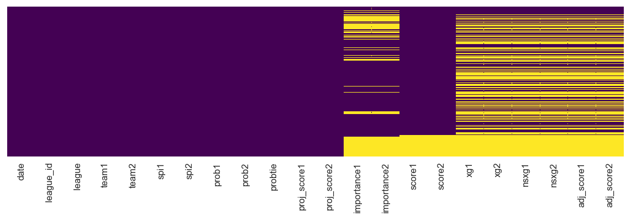

We can see alot of missing values(yellow entries in the data). Since we are going to use linear regression so its better to remove all the null values as situation gets pretty messed up otherwise. Even if we manage to some how fill the data.Most of those will be treated as outliers and going away anyways

Below we will look at the data with respect to some ordinal variables like leagues and teams for EDA.

In [359]:

df=df.dropna().reset_index(drop=**True**) fig, ax = plt.subplots(figsize=(20,5))

sns.heatmap(df.isnull(),yticklabels=**False**,cbar=**False**,cmap='viridis',)

Out[359]: <matplotlib.axes._subplots.AxesSubplot at 0x24e6240aa20>

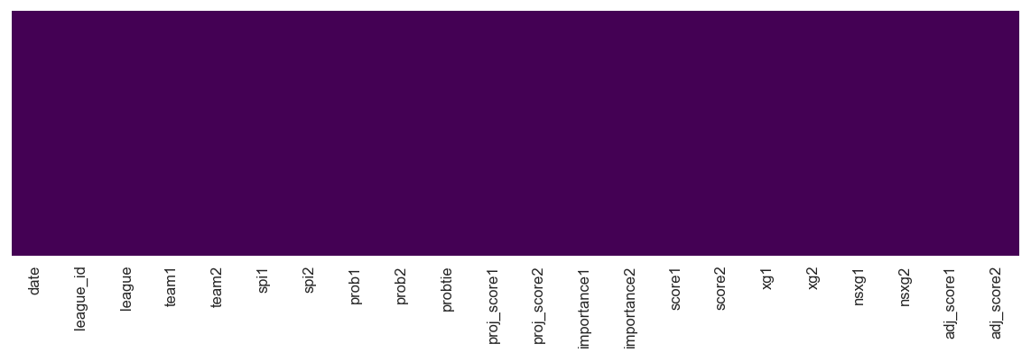

# Feature Engineering & EDA:

In [360]:

plt.figure(figsize=(40,10)) plt.xticks(size='30',rotation='vertical') plt.yticks(size='30')

sns.boxplot(x='league',y='importance1',data=df,palette='winter',)

Out[360]: <matplotlib.axes._subplots.AxesSubplot at 0x24e62436c18>

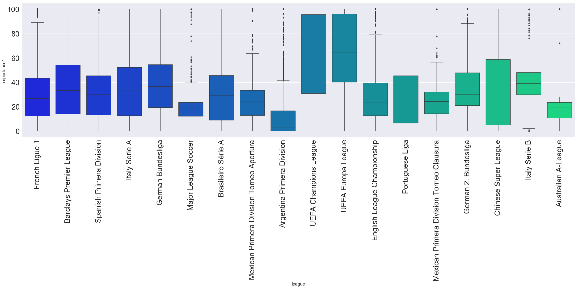

This box plot shows that each match in UEFA champions league and Europa League is highly important as their median valus is alot higher compared to the rest. While in other leagues, some games are considered very important.

In [361]:

plt.figure(figsize=(40,10)) plt.xticks(size='30',rotation='vertical') plt.yticks(size='30') sns.boxplot(x='league',y='spi1',data=df,palette='winter',)

Out[361]: <matplotlib.axes._subplots.AxesSubplot at 0x24e626feb38>

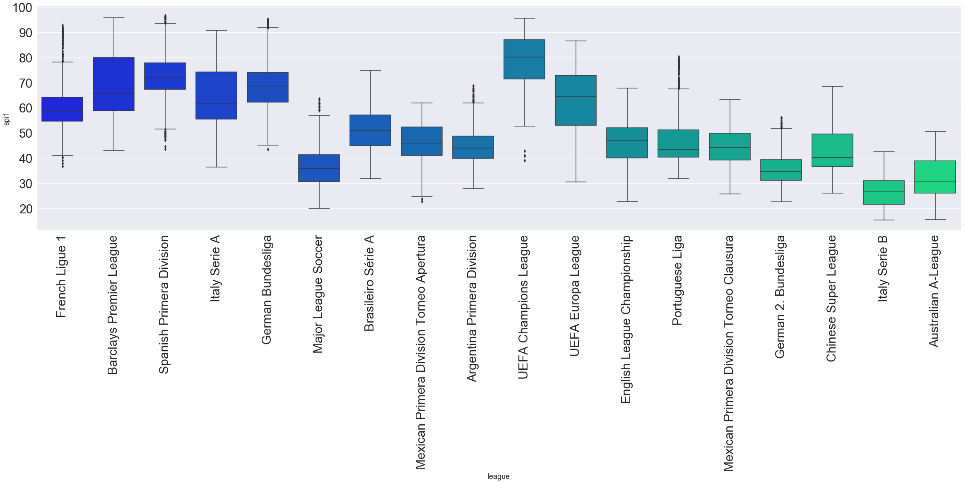

Here we are looking at the SPi1 ratings of each league. As we can see that Leagues from Weatern Europe, UEFA Champions league and UEFA Europa League have teams with very high spi1 ratings and also teams in A or first class divisions while others are not that high

Distributions of each Numerical Features is shown below where we can clearly see some variables following normalized variations with less skew meaning that variation in the data is very low

In [362]:

df.hist(figsize=(20,20),bins=50,xlabelsize=20,ylabelsize=20)

ut[362]: array([[<matplotlib.axes._subplots.AxesSubplot object at 0x0000024E6350E0F0>,

<matplotlib.axes._subplots.AxesSubplot object at 0x0000024E635046A0>,

<matplotlib.axes._subplots.AxesSubplot object at 0x0000024E63538048>,

<matplotlib.axes._subplots.AxesSubplot object at 0x0000024E6355C9B0>], [<matplotlib.axes._subplots.AxesSubplot object at 0x0000024E63589358>,

<matplotlib.axes._subplots.AxesSubplot object at 0x0000024E635B0CC0>,

<matplotlib.axes._subplots.AxesSubplot object at 0x0000024E635DC668>,

<matplotlib.axes._subplots.AxesSubplot object at 0x0000024E63603FD0>], [<matplotlib.axes._subplots.AxesSubplot object at 0x0000024E6360B080>,

<matplotlib.axes._subplots.AxesSubplot object at 0x0000024E6365F320>,

<matplotlib.axes._subplots.AxesSubplot object at 0x0000024E68371C88>,

<matplotlib.axes._subplots.AxesSubplot object at 0x0000024E6839F630>], [<matplotlib.axes._subplots.AxesSubplot object at 0x0000024E683C8F98>,

<matplotlib.axes._subplots.AxesSubplot object at 0x0000024E683F3940>,

<matplotlib.axes._subplots.AxesSubplot object at 0x0000024E684222E8>,

<matplotlib.axes._subplots.AxesSubplot object at 0x0000024E68447C50>], [<matplotlib.axes._subplots.AxesSubplot object at 0x0000024E684765F8>,

<matplotlib.axes._subplots.AxesSubplot object at 0x0000024E6849CF60>,

<matplotlib.axes._subplots.AxesSubplot object at 0x0000024E684C8908>,

<matplotlib.axes._subplots.AxesSubplot object at 0x0000024E684F82B0>]], dtype=object)

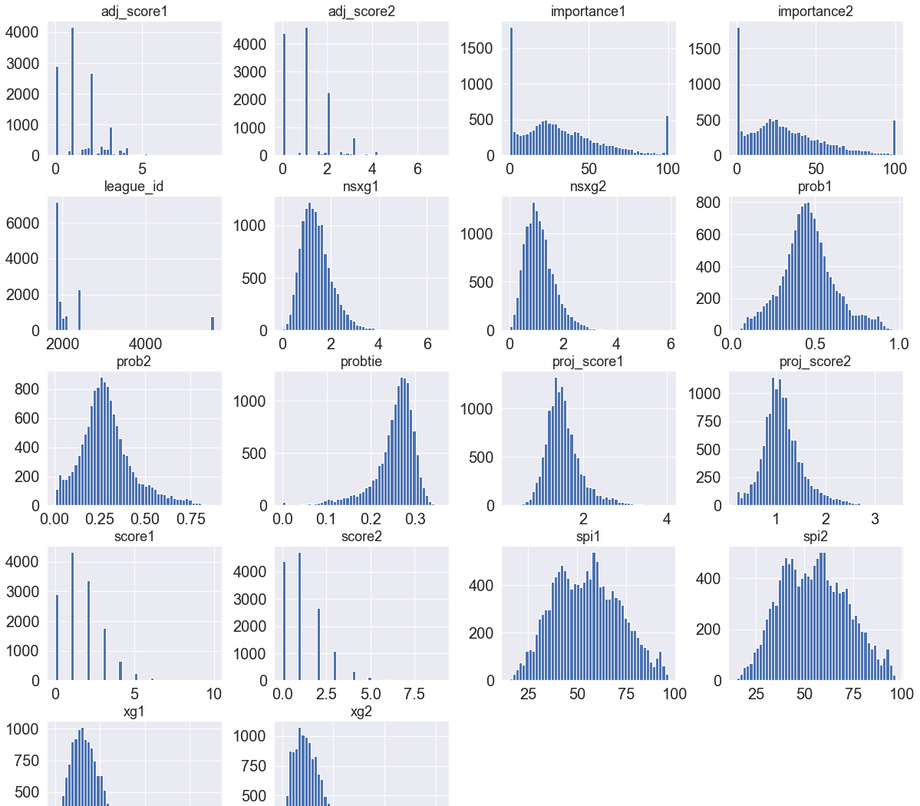



Now Lets plot the correlation matrix to check the dependencies of the features on each other and how variation in one changes the other.

In [363]:

plt.figure(figsize=(15,15)) c= df.corr()

sns.heatmap(c,cmap='BrBG',annot=**True**,)

Out[363]: <matplotlib.axes._subplots.AxesSubplot at 0x24e6bdaa940>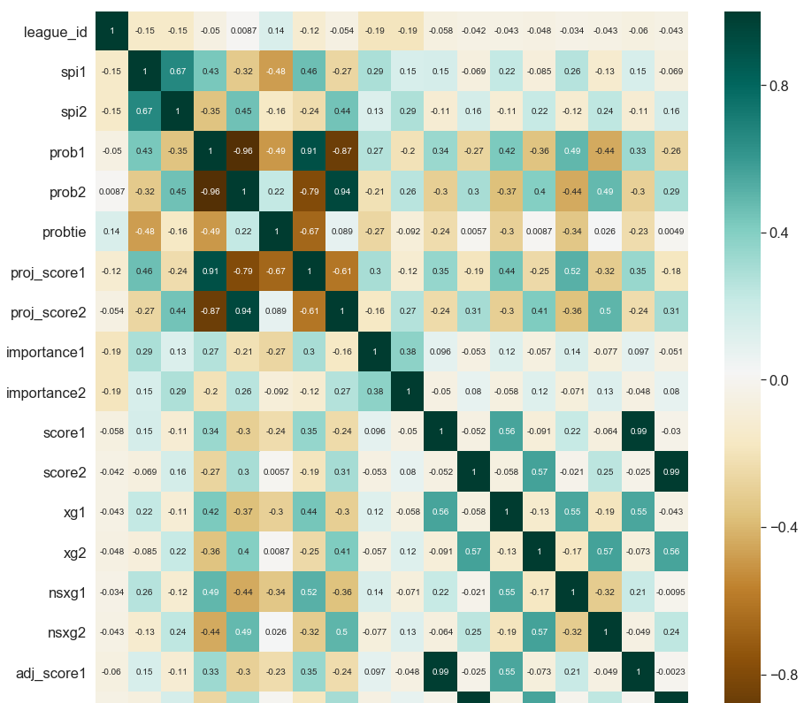

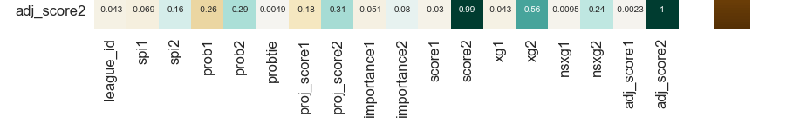

We can see that variables like Spi1, spi2, prob1, prob2 are closely related with scores and one another. Clearly if you have a high spi1 ratings it gives you more chance to score a goal.

Now Lets plot the pair plots of the most important features found above to have a look at their distribution.

In [364]:

sns.set(font_scale=1.5) sns.pairplot(df[['spi1','spi2','prob1','prob2','importance1','importance2','score1','score2']])

Out[364]: <seaborn.axisgrid.PairGrid at 0x24e718075f8>

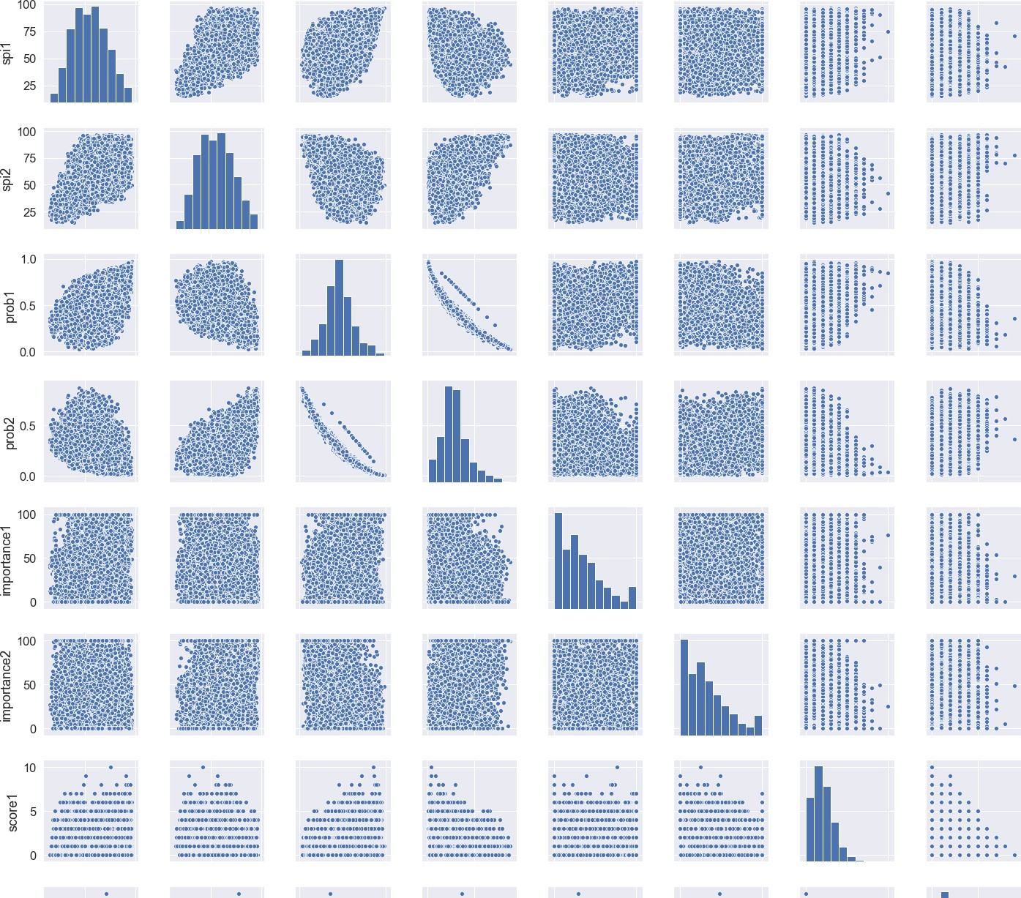

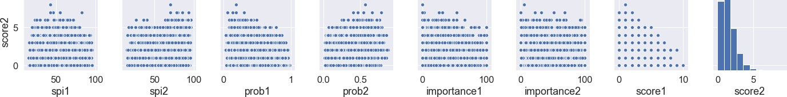

This graph shows that higher the probability, higher chance of scoring more than 1 goals. Higher the spi1 rating gives them the higher probabilities.

# Data Preprocessing

In [365]:

df.head(2)

Out[365]:

|  |  |  |  |  |  |  |  |  |  |  |  |  |  |
| --- | --- | --- | --- | --- | --- | --- | --- | --- | --- | --- | --- | --- | --- |
| **date league_id** | **league** | **team1** | **team2** | **spi1** | **spi2** | **prob1** | **prob2** | **probtie** | **...** | **importance1** | **importance2** | **score1** | **score2** |
| **0** 2016- 1843  08-12 | French Ligue | Bastia | Paris Saint- | 51.16 | 85.68 | 0.0463 | 0.8380 | 0.1157 | ... | 32.4 | 67.7 | 0.0 | 1.0 0 |
|  | 1 |  | Germain |  |  |  |  |  |  |  |  |  |  |

**1** 2016- 1843

08-12

French Ligue

1

AS Guingamp 68.85 56.48 0.5714 0.1669 0.2617 ... 53.7 22.9 2.0 2.0 2

Monaco

2 rows × 22 columns

Now we are going to create dummy variables for all the ordinal & categorical variables so that we have all the data available for our model in the required format.

In [366]:

league_n=pd.get_dummies(df['league'],drop_first=**True**) team1_n=pd.get_dummies(df['team1'],drop_first=**True**) team1_columns=['team1_'+str(i) **for** i **in** team1_n.columns] team1_n.columns=team1_columns team2_n=pd.get_dummies(df['team2'],drop_first=**True**) team2_columns=['team2_'+str(i) **for** i **in** team2_n.columns] team2_n.columns=team2_columns df1=pd.concat([df,league_n,team1_n,team2_n],axis=1)

Its good to have your data shffled so that all the data gets properly distributed between training and testing datasets.

In [367]:

**from sklearn.utils import** shuffle df2=shuffle(df1).reset_index(drop=**True**)

In [368]:

X=df2.drop(['date','score1','league','team1','team2'],axis=1) Y1=np.array(df2[['score1']])

Y2=np.array(df2['score2'])

We are going to normalize our data so that our model is able to work on it which is otherwise not possible

In [369]:

**from sklearn import** preprocessing x=preprocessing.scale(X)

C:\ProgramData\Anaconda3\lib\site-packages\ipykernel_launcher.py:2: DataConversionWarning: Data with input dt ype uint8, int64, float64 were all converted to float64 by the scale function.

We are going to split our training and testing data.

In [370]:

**from sklearn import** metrics

**from sklearn.model_selection import** train_test_split

X_train, X_test,Y_train, Y_test=train_test_split(x,Y1,test_size=0.1)

# Linear Regression Model Design and Testing

In [371]:

**from sklearn.linear_model import** LinearRegression model=LinearRegression() model.fit(X_train,Y_train) y_pred=model.predict(X_test)

print('Linear Regression model Accuracy is: '+str(model.score(X_test,Y_test)*100))

Linear Regression model Accuracy is: 98.16361120773463

In [372]:

**from sklearn.metrics import** mean_absolute_error,mean_squared_error print('mean_absolute_error: '+str(mean_absolute_error(y_pred,Y_test))) print('mean_squared_error: '+str(mean_squared_error(y_pred,Y_test))) print('RMSE: '+str(np.sqrt(mean_squared_error(y_pred,Y_test))))

mean_absolute_error: 0.11743347439146046

mean_squared_error: 0.03299389176466845

RMSE: 0.1816422081033713

# RandomForest Regressor to check Prediction

In [373]:

**from sklearn.ensemble import** RandomForestRegressor RM=RandomForestRegressor(random_state=4) RM.fit(X_train,Y_train)

y_pred=RM.predict(X_test) RM.score(X_test,Y_test)

print('Random Forest Regressor model Accuracy is: '+str(RM.score(X_test,Y_test)*100))

C:\ProgramData\Anaconda3\lib\site-packages\sklearn\ensemble\forest.py:246: FutureWarning: The default value o f n_estimators will change from 10 in version 0.20 to 100 in 0.22.

"10 in version 0.20 to 100 in 0.22.", FutureWarning)

C:\ProgramData\Anaconda3\lib\site-packages\ipykernel_launcher.py:3: DataConversionWarning: A column-vector y was passed when a 1d array was expected. Please change the shape of y to (n_samples,), for example using rave l().

This is separate from the ipykernel package so we can avoid doing imports until Random Forest Regressor model Accuracy is: 99.38679960245057

In [374]:

print('mean_absolute_error: '+str(mean_absolute_error(y_pred,Y_test))) print('mean_squared_error: '+str(mean_squared_error(y_pred,Y_test))) print('RMSE: '+str(np.sqrt(mean_squared_error(y_pred,Y_test))))

mean_absolute_error: 0.016529543754674646

mean_squared_error: 0.011017202692595363

RMSE: 0.10496286339746722

# Conclusion:

Accuracy, MAE, MSE and RMSE clearly indicates the model to be good one. Values are very low which tells us that difference between predicted and actual values is very low for both models.