Part 1

Q1 Thermal velocity

Q2 Mean free path

Q3 2D plot of particle trajectories and temperature plot

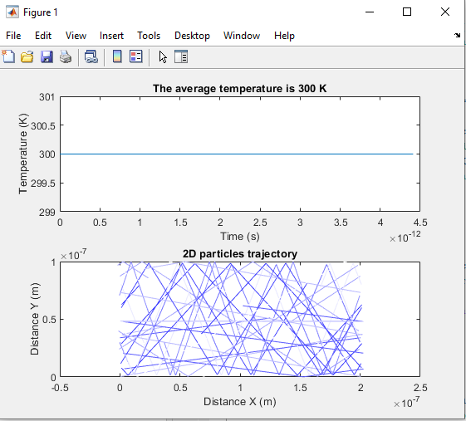

Part2

Q1 Histogram

[Q2,Q3] Plot of trajectory and temperature

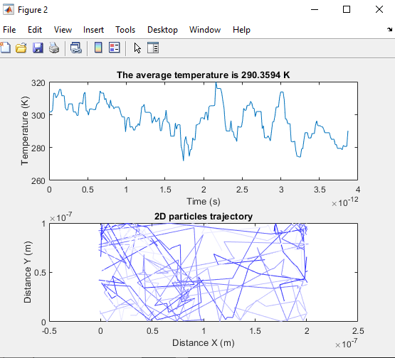

Q4