We’re using ARCADE to run ACDC analysis

1. Start the VM
2. Run Eclipse
3. Open up the “arcade” project, click src, and then right-click on “edu.usc.softarch.arcade.frontend”. Select “Run As” -> “Java Application”. 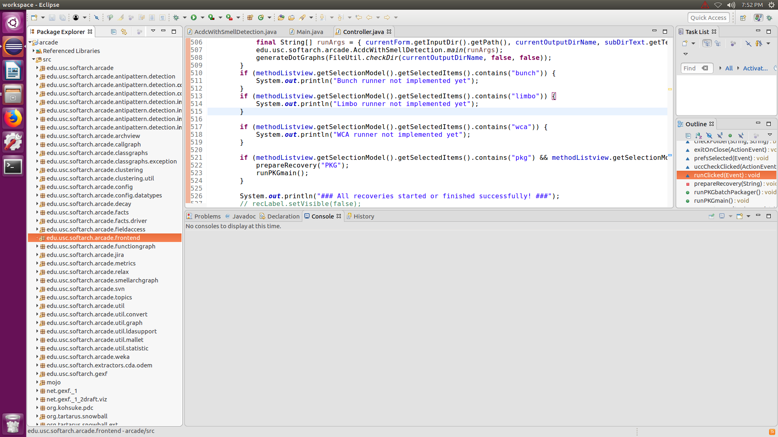
4. This should bring up the ARCADE Runner dialog and look like this:
5. 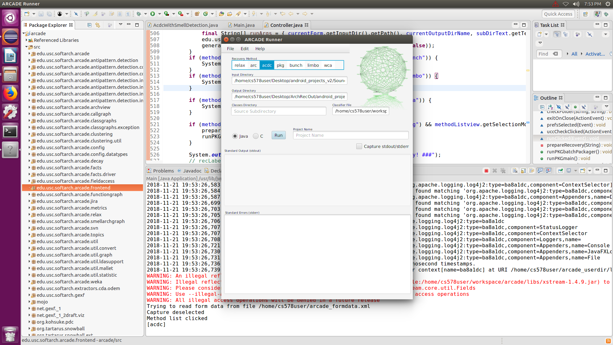
6. We can config the recovery method. In our case, select acdc
7. Config the input directory
8. Config the output directory
9. We can add the prefix to the output directory by filled up the “Project Name” field
10. Select the programing language
11. Click Run

Reference: http://sunset.usc.edu/classes/cs578_2018s/assignments/CSCI%20578%20S18%20HW0.5.pdf