1. Get a general understanding about Bayesian Analysis and Metropolis Hastings Algorithm.

<https://en.wikipedia.org/wiki/Bayesian_inference>

<https://en.wikipedia.org/wiki/Metropolis%E2%80%93Hastings_algorithm>

1. Try to understand our algorithm:

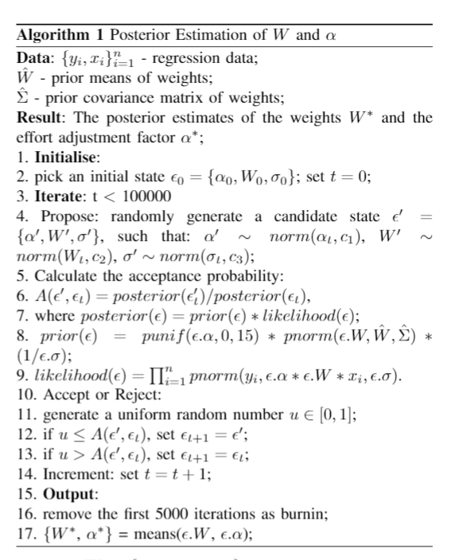

1. Find the scripts under folder:

UMLx\data\TransactionWeighting

1. transaction_weights_calibration_visualizations.Rmd
2. transaction_weights_calibration4.R

Specifically find this algorithm and try to understand how the algorithm is implemented.

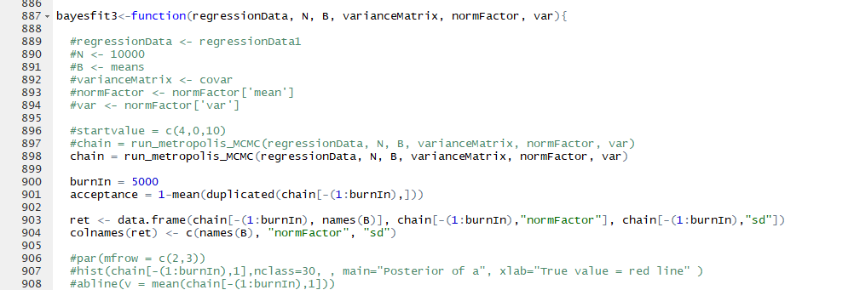

The hyperparameters are the ones in the proposal function, which are the location and variances of gaussian density functions.

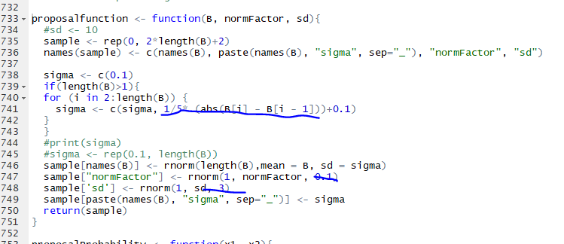

Guidelines for R studio:

Open up R studio for transaction_weights_calibration_visualizations.Rmd and transaction_weights_calibration4.R

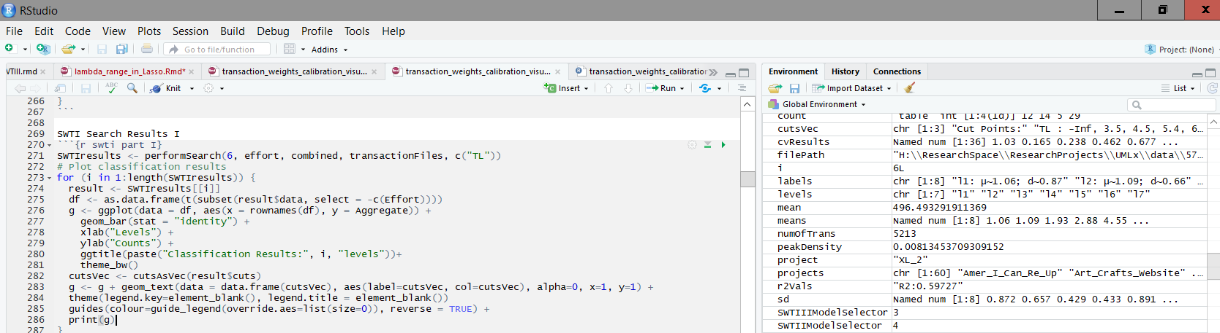

Load the data:

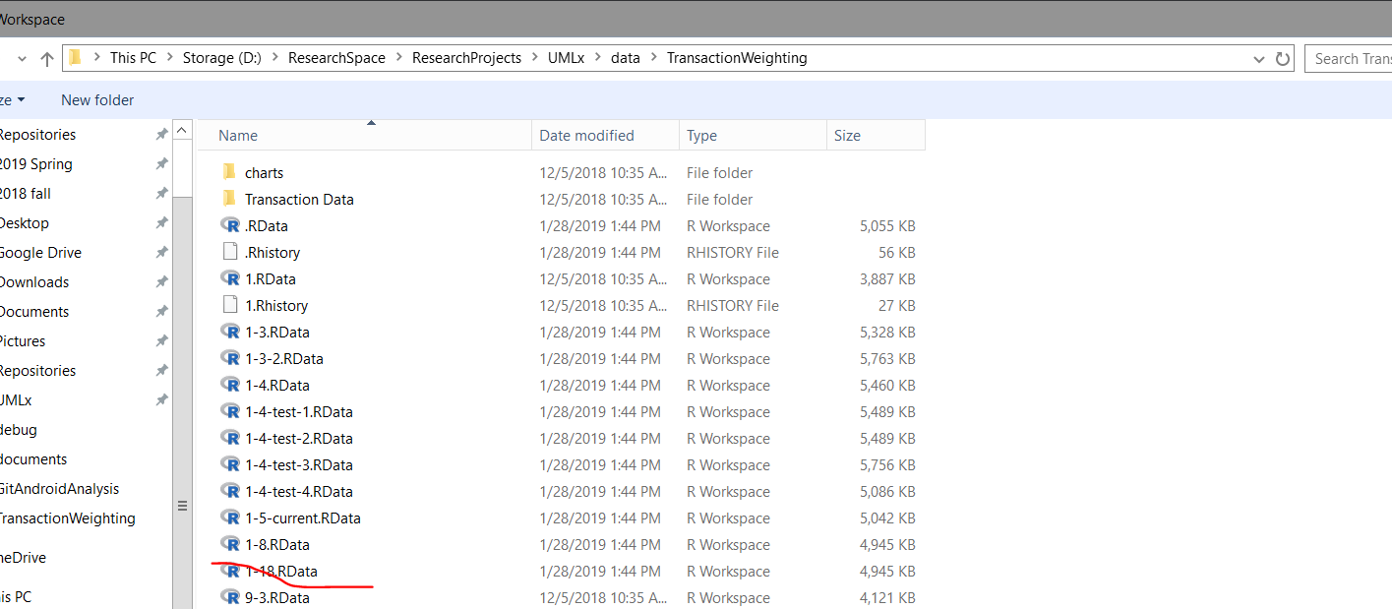

Run the first two sections to load the data:

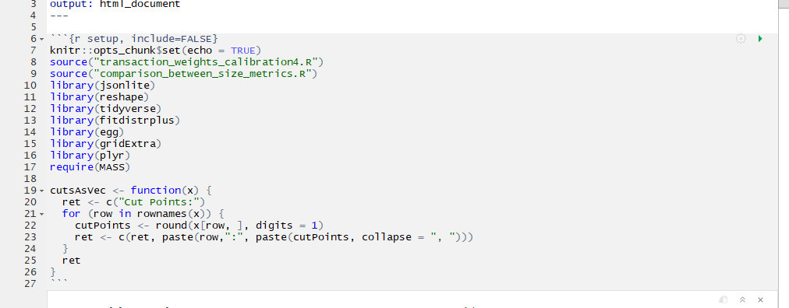

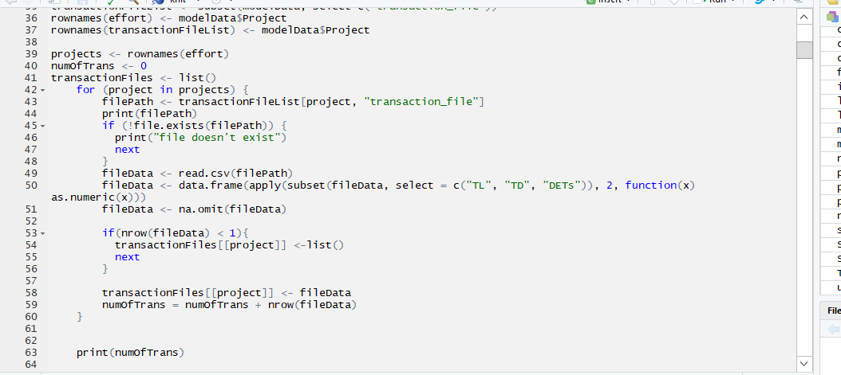

Run this function to test the Bayesian functions. Also you can follow the thread of calls to understand what functions are called to generally understand the process.

