1. Download Enterprise Architect from here: <https://drive.google.com/drive/folders/1bD77wI0-nT-j5qUkLGuM6S5DgmtG1Jb0?usp=sharing>
   1. Active the tool using the key in the document marked with 1
2. Create a new enterprise architect project

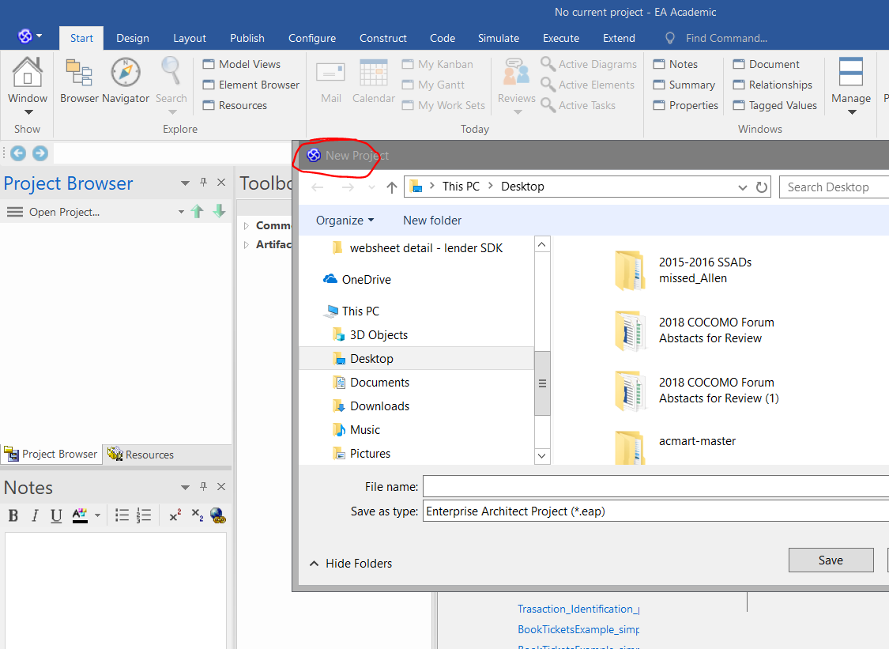

1. Create a model in the project.

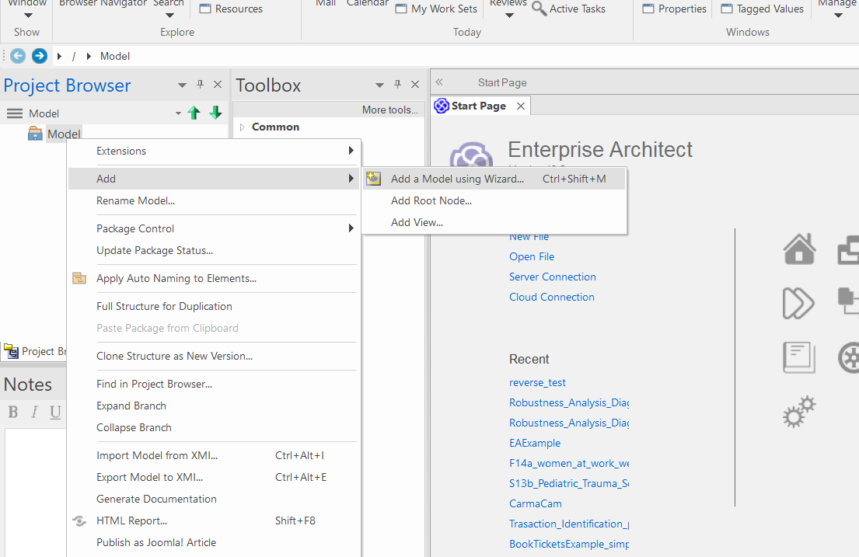

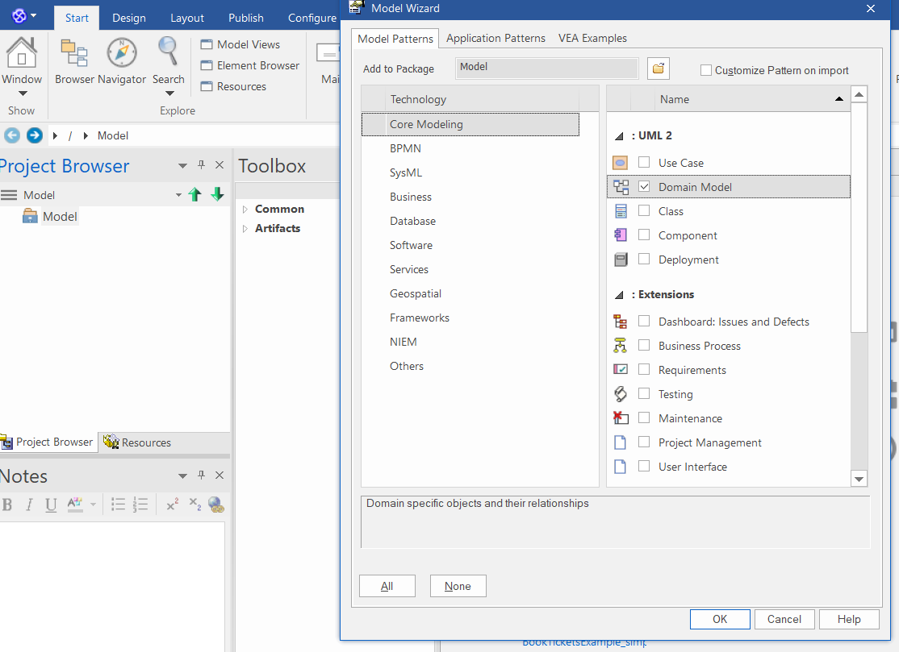

1. Import the source code directory.

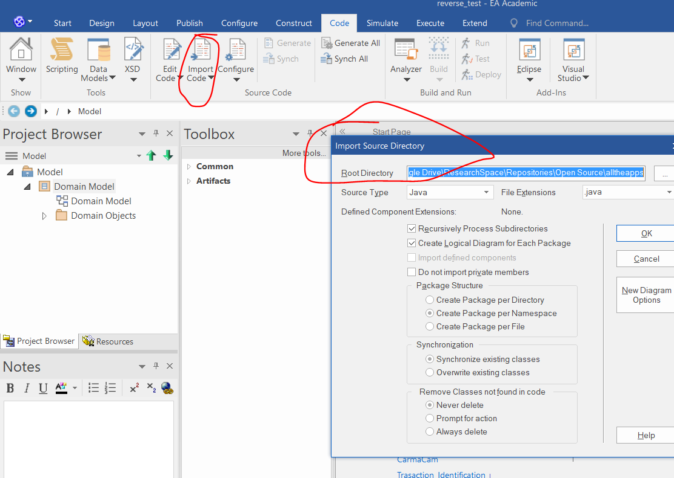

1. Export the recovered class diagram into xml file

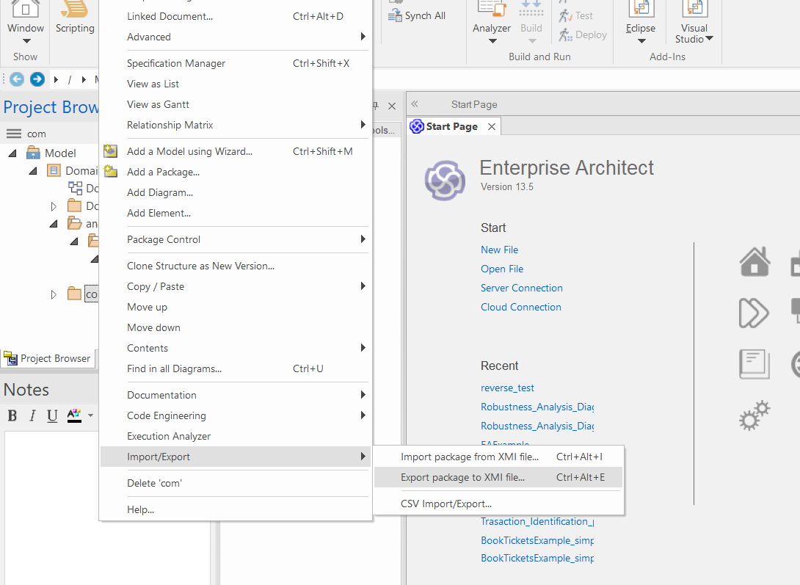

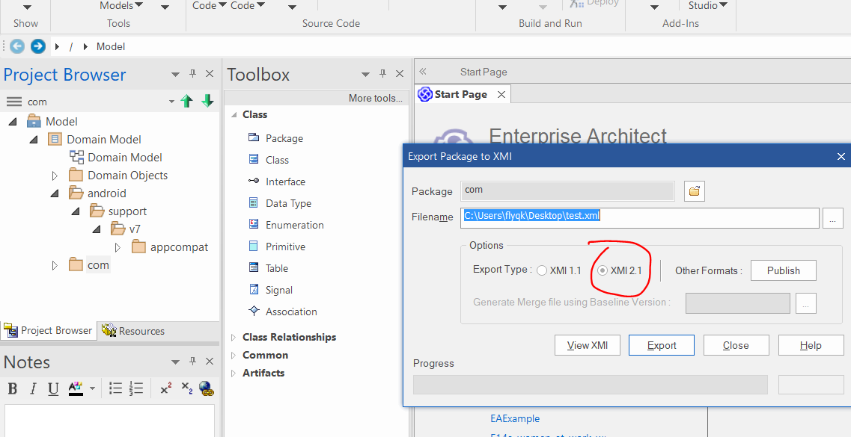

1. Run the command to derive the data.
2. Run command to generate the analysis results using the generated eclipse_dkm.xml file.

node ./UMLxAnalyticToolKit.js <input file> <output dir> <project name>

For example,

node ./UMLxAnalyticToolKit.js "./data/StandAloneToolKit/f14a_e_lock_box.xml" "./data/StandAloneToolKit/output" "f14a_e_lock_box"

1. Find the generated data sheet from the output dir.

