Here is a summary of collecting UML data from documentation

1. Find the document for the model:
   1. Open the file list.xlsx

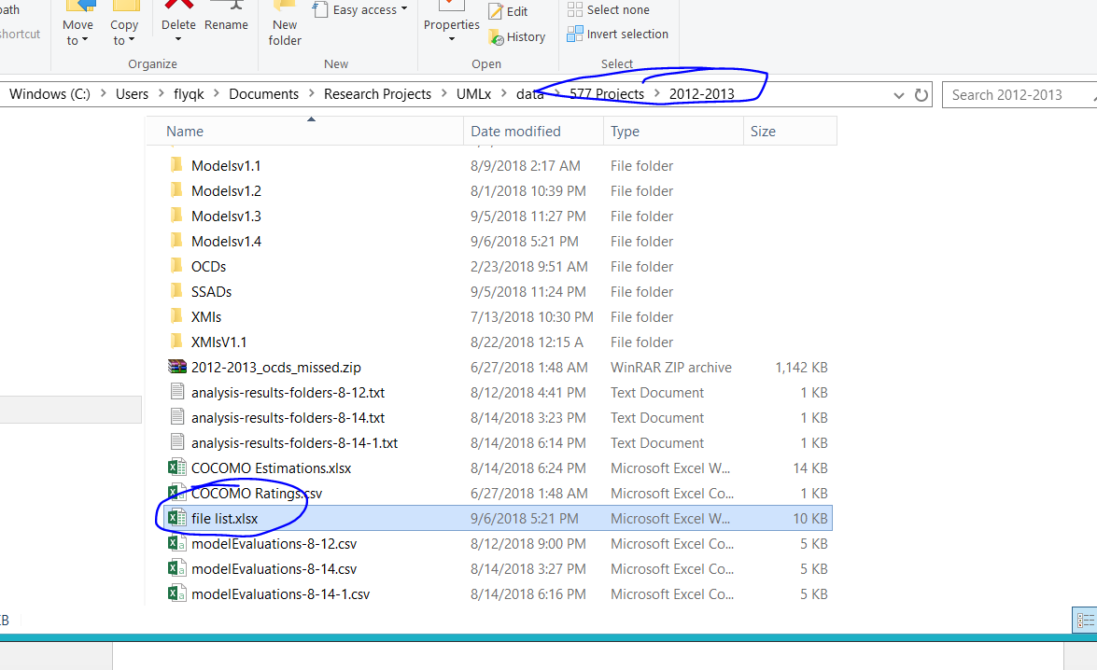

* 1. Find the semester and year that correspond to the model

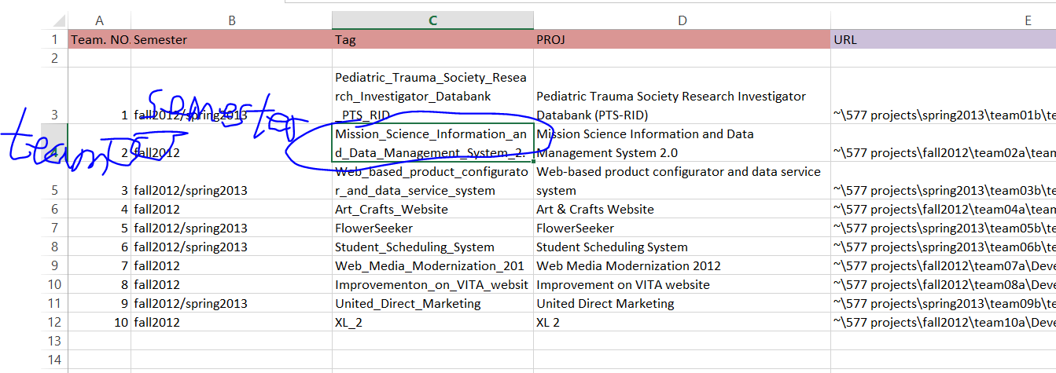

* 1. Find the document for the model using the semester and team.

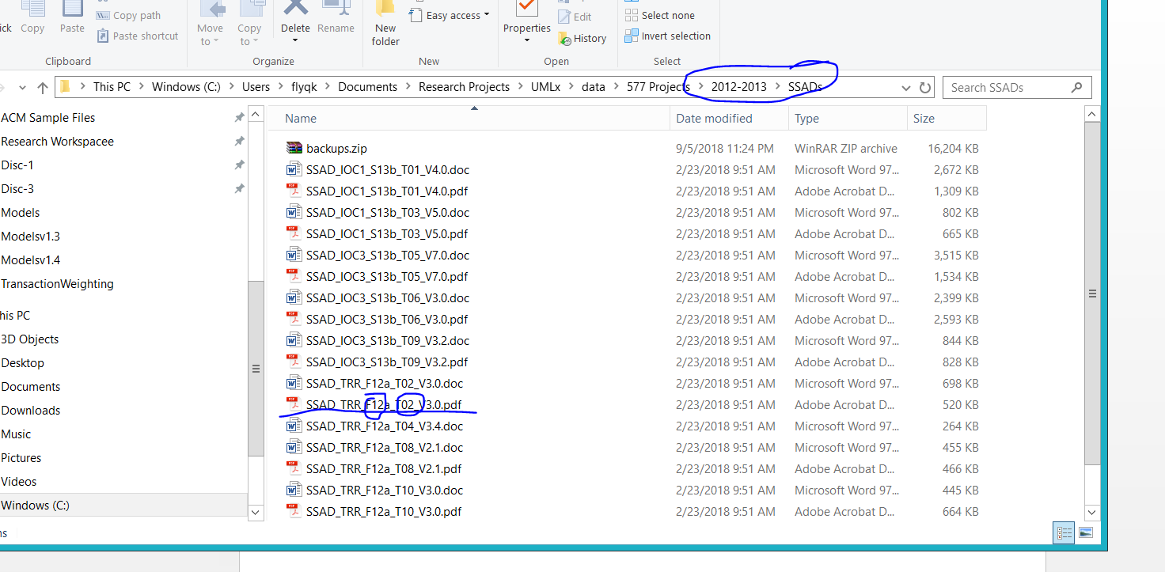

1. Completing the model.
   1. For example, for the diagrams shown in the document, create a corresponding diagram in the .eap model.

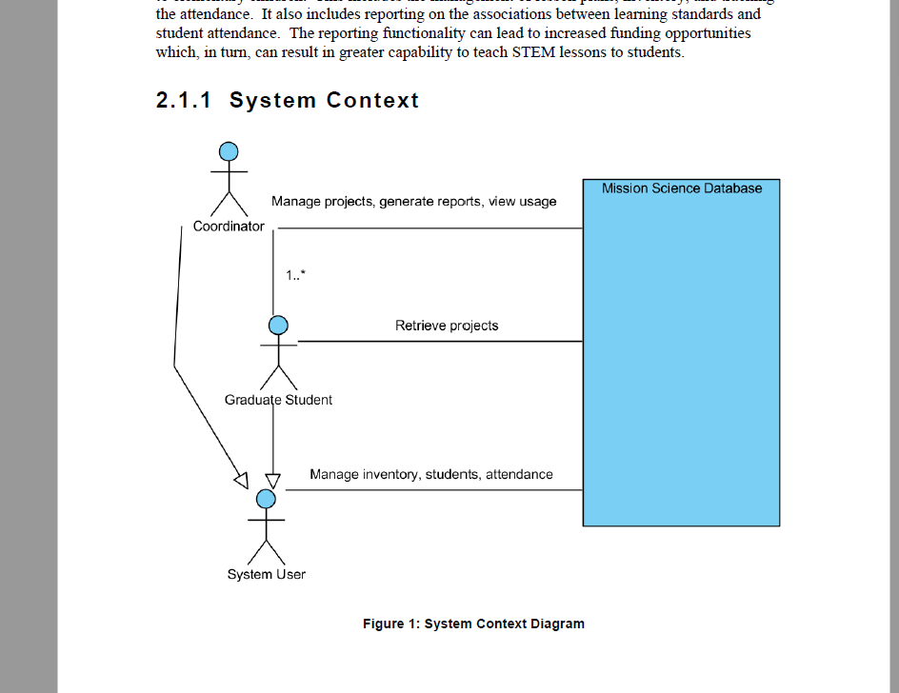

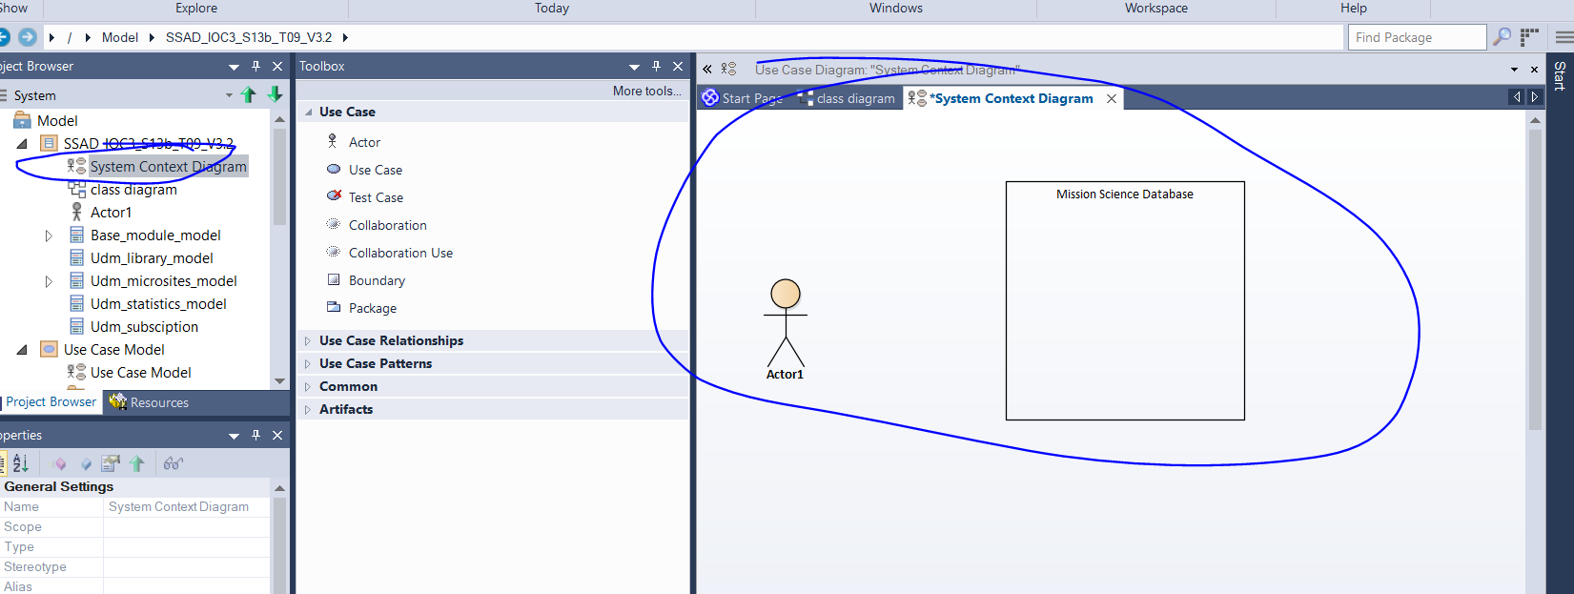

* 1. For each use case (the content shown in the table), create an analysis diagram for it.

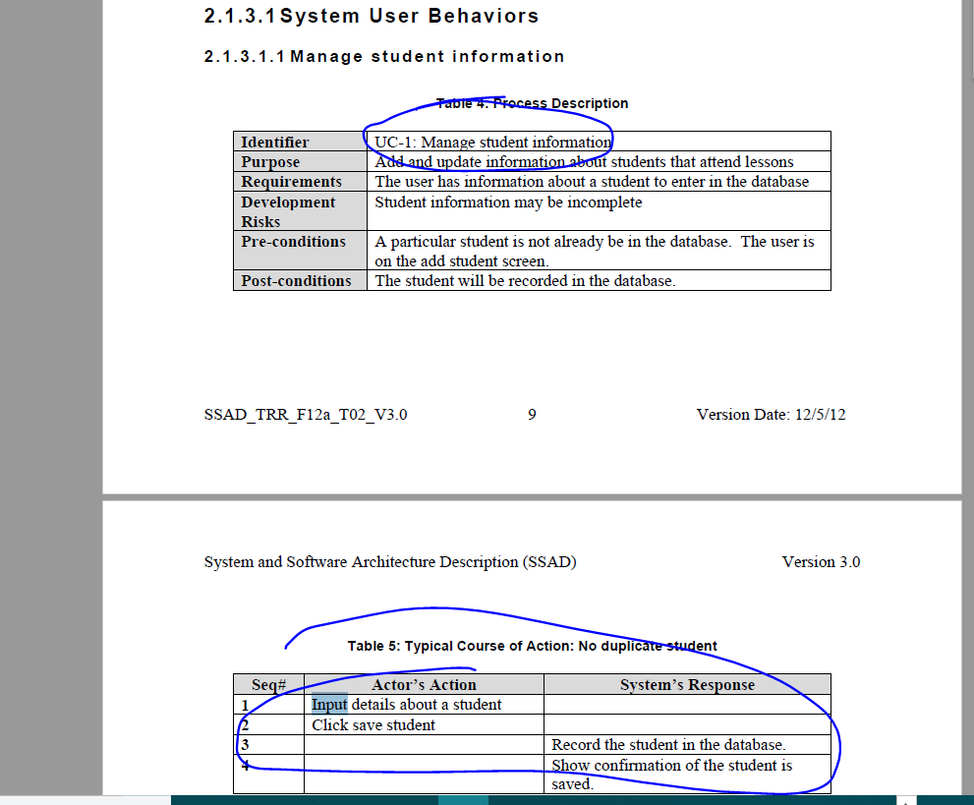

The program can be downloaded from the link:

https://drive.google.com/drive/folders/1bD77wI0-nT-j5qUkLGuM6S5DgmtG1Jb0?usp=sharing

