Model Calibration and Evaluation

1. The benchmark framework is implemented in this folder:

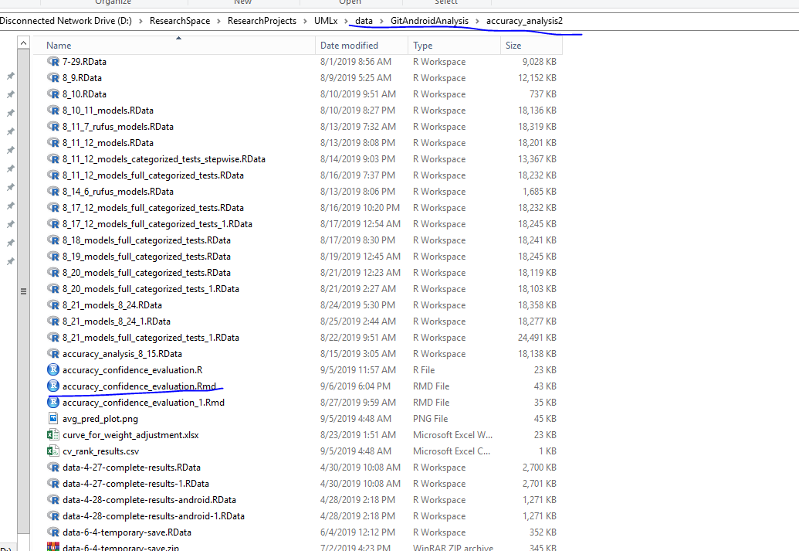

1. Install R (3.6.1) studio and open up (accuracy_confidence_evaluation.Rmd) in R studio.

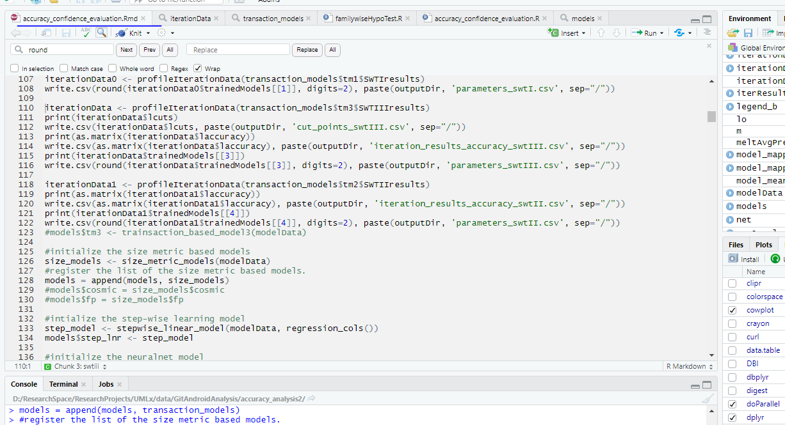

1. Load some testing data set:

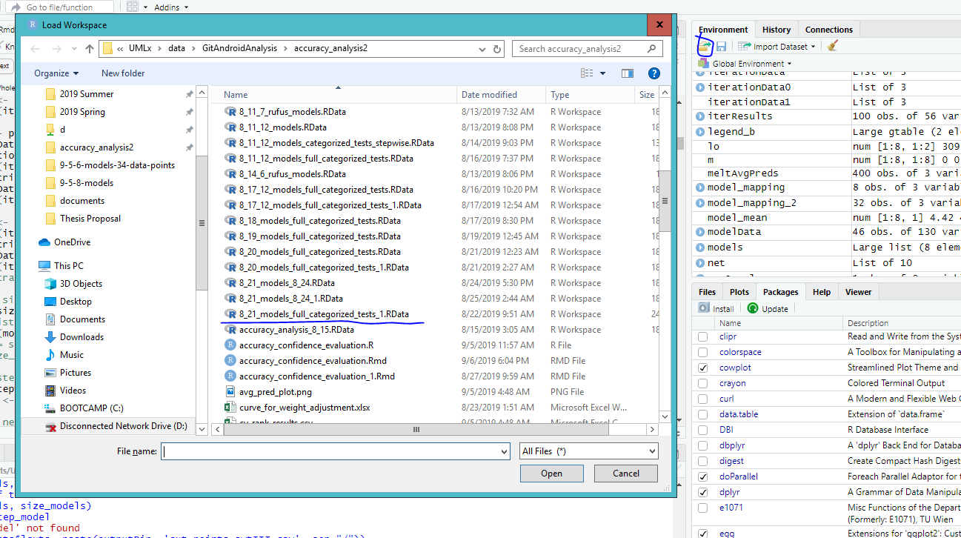

* Don’t change current data set files (delete, add, or modify).
* You can try to create yours in other folders on your pc.

1. The code is separated into chunks:

Loading datasheet and set output folder:

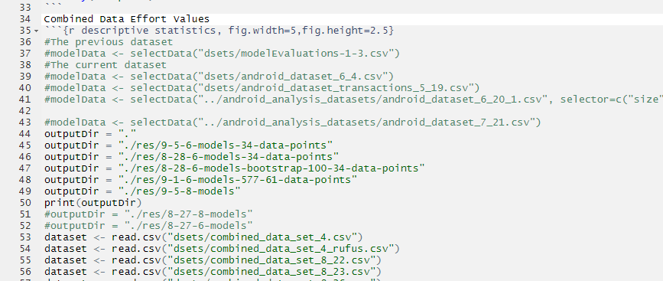

Register the models for benchmarking:

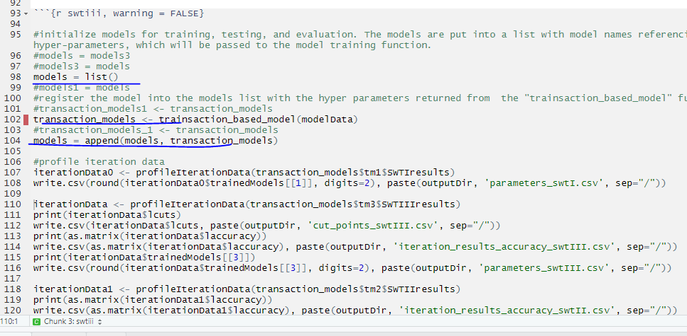

Trained the models and evaluate goodness of fit:

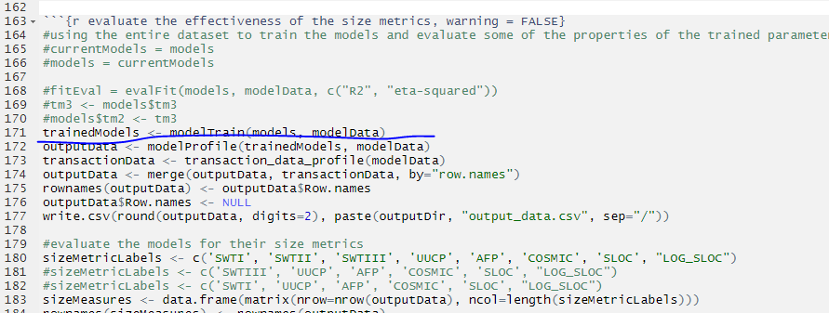

Benchmark the models for out-of-sample accuracy and statistical significance of improvements.

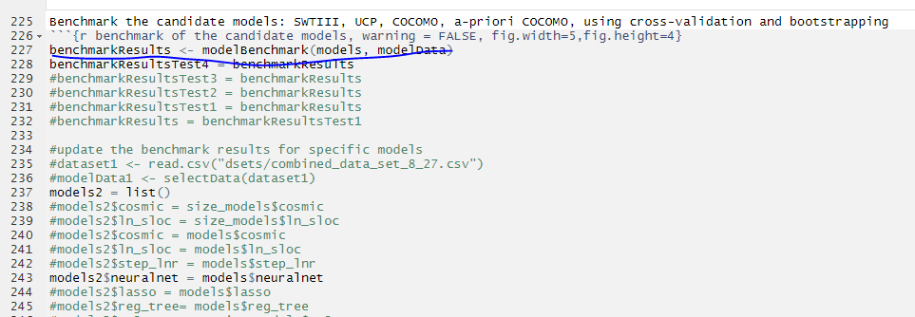

Present the results for goodness of fit evaluation:

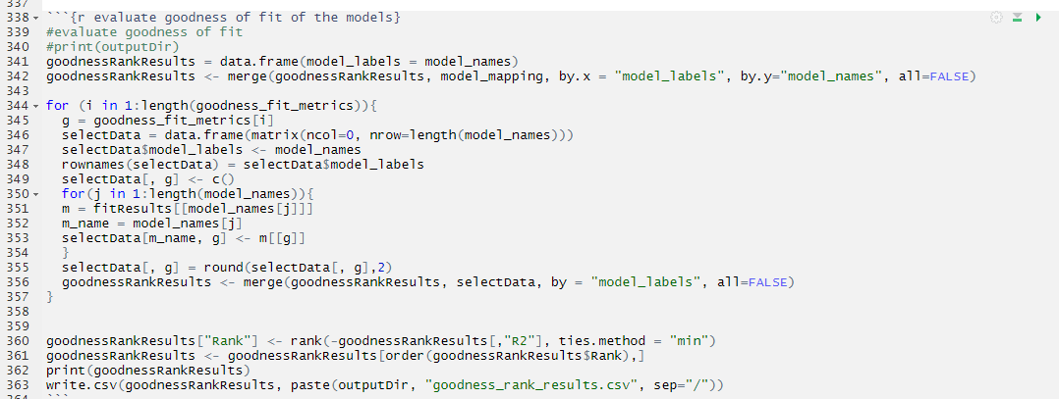

Present the out-of-sample accuracy results:

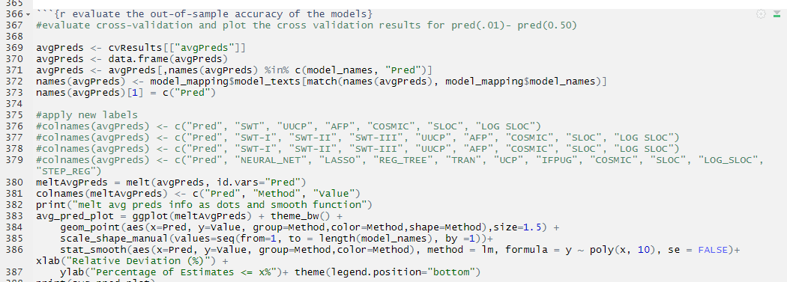

Present the results for confidence interval assessment:

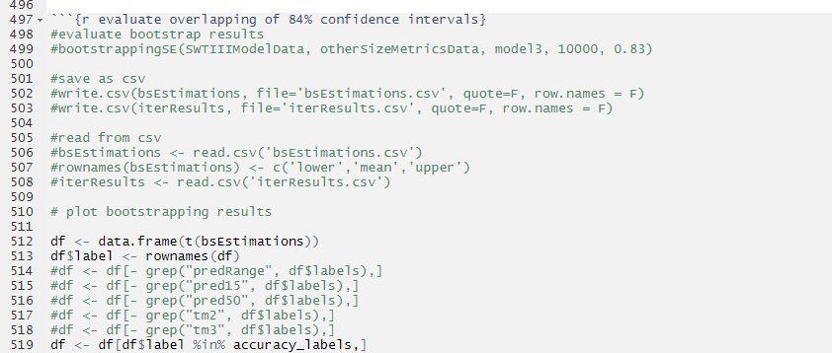

Present the results for p-value assessment:

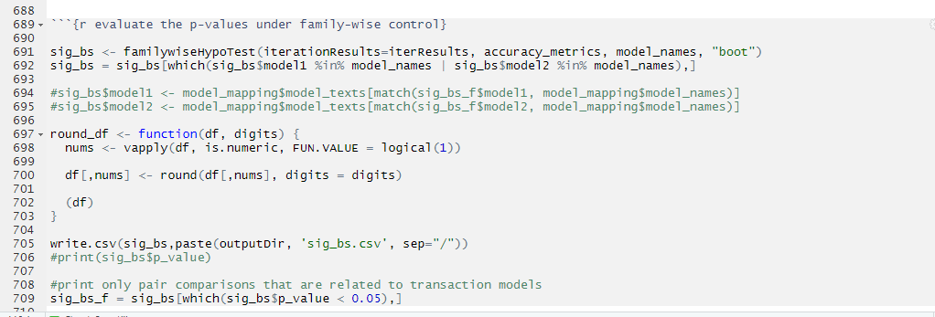

The benchmark script relies on a list of other script files:

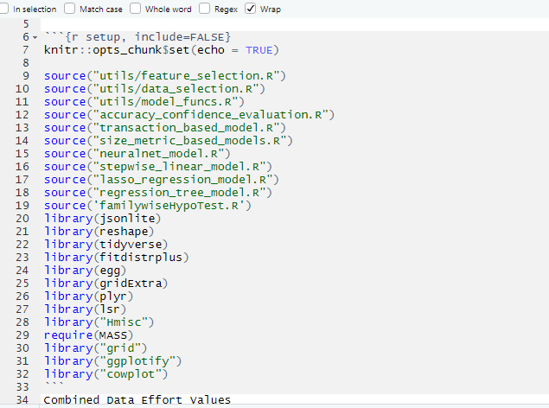* Go through them if needed or interested.