1. Create an empty project.

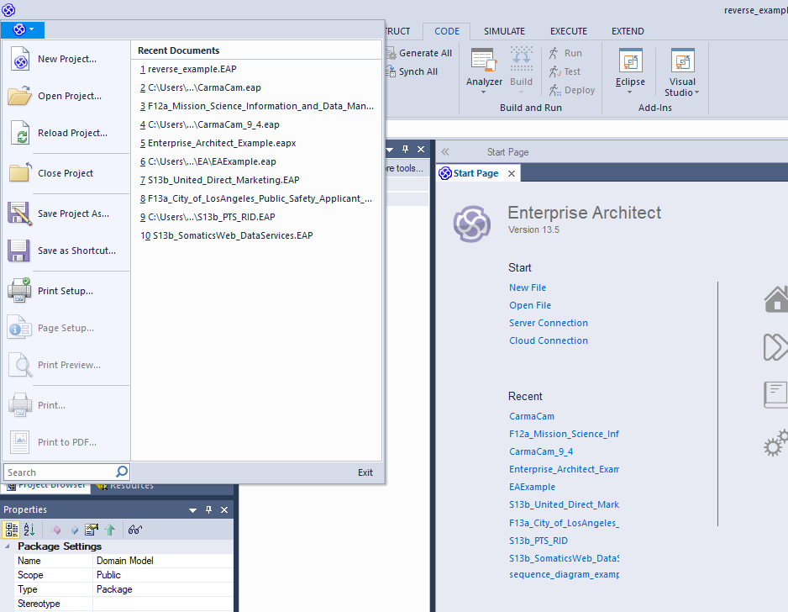

1. Create an empty domain model.

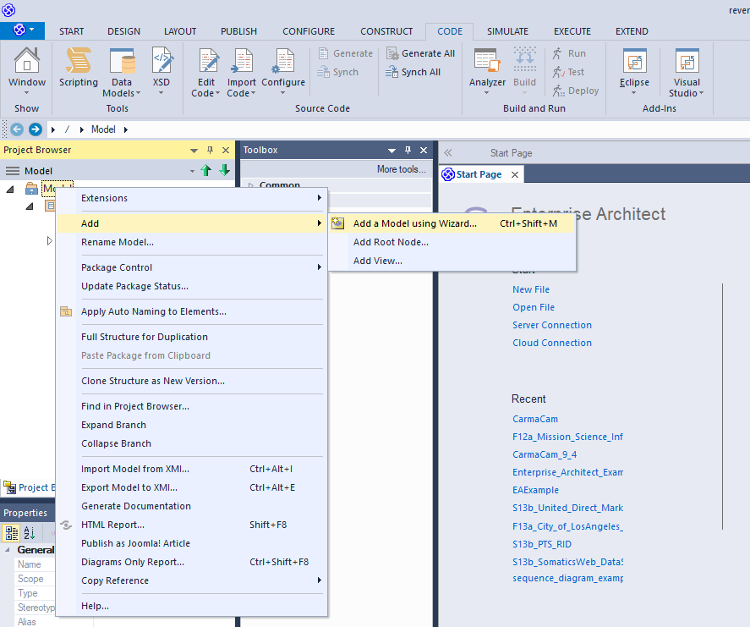

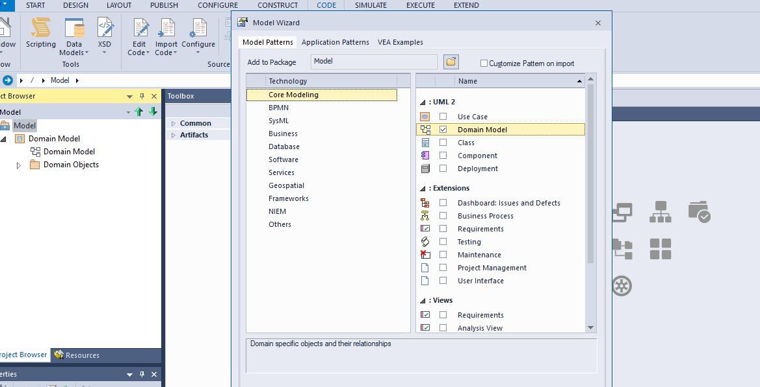

1. Import code from the directory

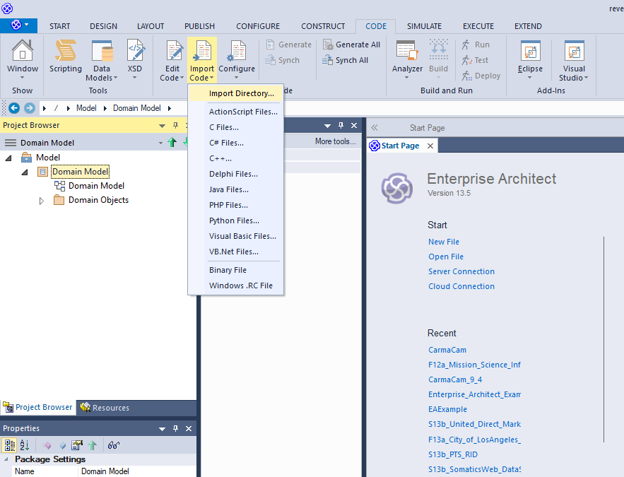

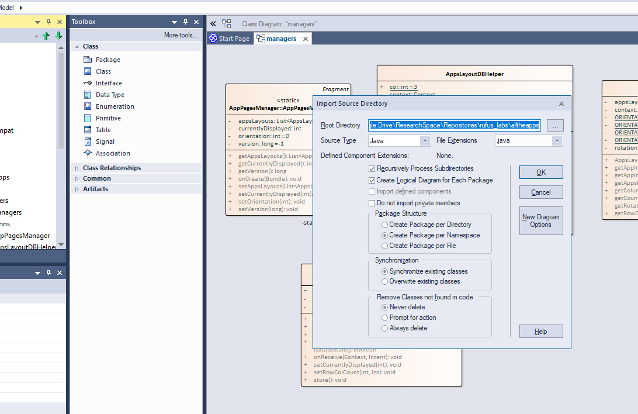

1. Export the class diagrams into xml file.

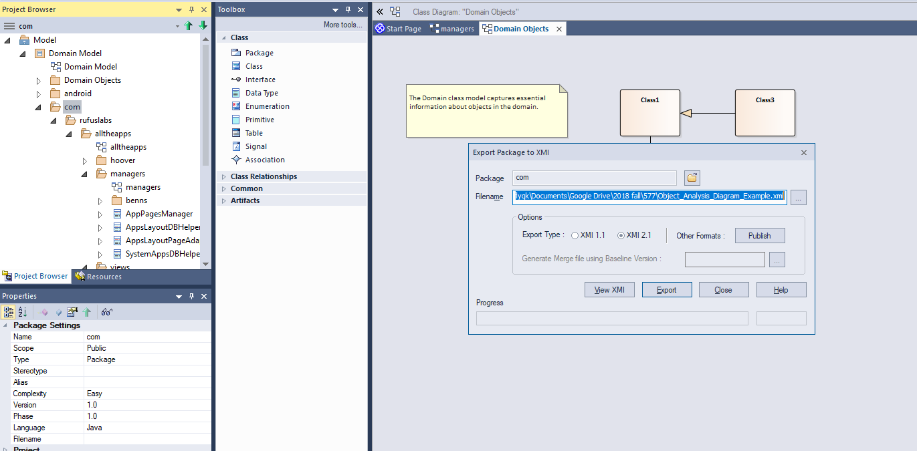

1. Use case command to analysis

node ./UMLxAnalyticToolKit.js "./data/ReverseEngineering/exported.xml" "./data/ReverseEngineering/debug/output" "export"