## environment setup

1. download related files from google drive: https://drive.google.com/drive/folders/1bD77wI0-nT-j5qUkLGuM6S5DgmtG1Jb0?usp=sharing
   1. Enterprise Architect Academic Site License - 30 USERS-1.docx
   2. easetupfull.msi
2. follow the instruction on “Enterprise Architect Academic Site License - 30 USERS-1”
   1. install easetupfull
   2. registration key: 6XQ1-LP80-SHNC-00JP

## work flow

### Searching for the related files

1. Open list.xlsx
   * ex. UMLx\data\577 Projects\2012-2013\file list.xlsx
2. Open the .eap file of the model
   * ex. UMLx\data\577 Projects\2012-2013\Modelsv1.3\ Pediatric_Trauma_Society_Research_Investigator_Databank _PTS_RID.eap
3. find the SSAD document
   * First, check the excel file for the year and the team number of the model
     1. you can see that this project is under team 1 in 2012 fall to 2013 spring

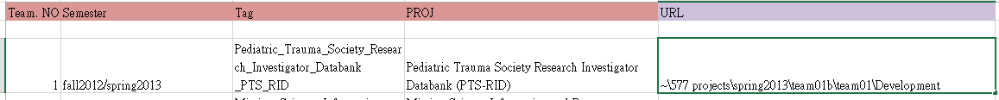

* + ex. UMLx\data\577 Projects\2013-2014\SSADs\SSAD_IOC1_S13b_T01_V4.0
    1. T01 means team 1
    2. S13b means 2013 spring
    3. If you cannot find the SSAD document in a certain year, just try to look into the next or previous year’s folder.

### Building models based on SSAD

#### For all Process in SSAD, create UseCase for that, and add Analysis Diagram underneath.

1. Under a Package with Use Case Diagram
2. Drag a UseCase into the Diagram, and give it a name

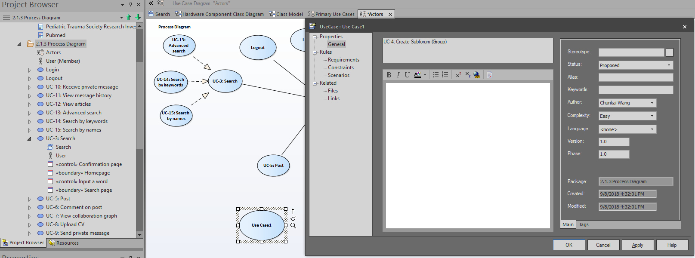

1. Create an Association between the UseCase and the Actor

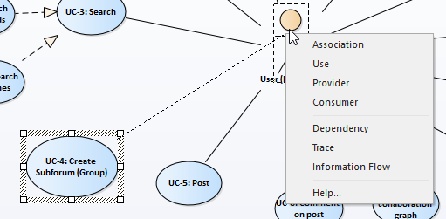

1. Right-click on UseCase, Add > Add Diagram > Type = Extended > Analysis

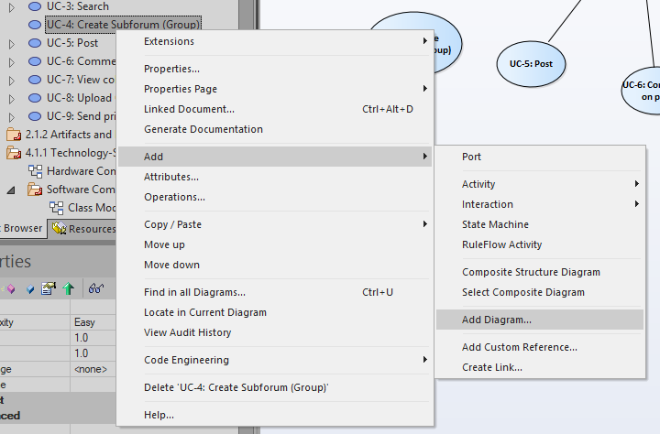

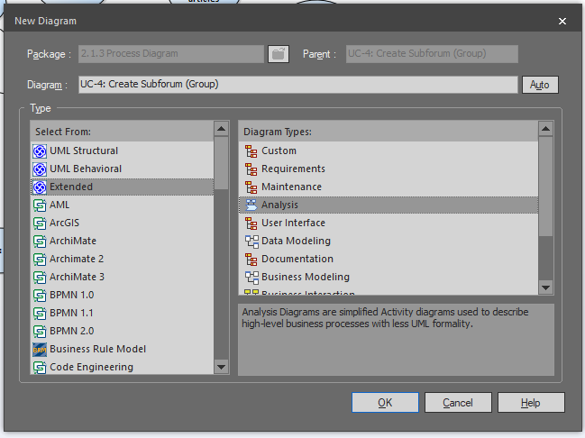

#### Constructing Analysis Diagram under UseCase

1. Follow the description on SSAD. For example, in the section “2.1.3.1.2 Process Create Subforum (Group)” of file “SSAD_IOC1_S13b_T01_V4.0.pdf”, there are three tables describe this specific process
   * Table 8: Process Description
   * Table 9: Typical Course of Action
   * Table 10: Exceptional Course of Action
2. You’ll need to build the Analysis Diagram based on the “System’s Response” column of “Typical Course of Action”. For example, on “Table 12: Typical Course of Action” of file “SSAD_IOC1_S13b_T01_V4.0.pdf”, it says that the System’s Response would be “Sends the request to PTS-RID back-end to do group creating processing, and group successfully created”, and “Show the message that the group has been successfully created, and redirect the user to the group page” after that. From this description, you’ll know that we need several elements in thie analysis diagram
   * **Actor**: User
   * **Boundary Object**: the UI element shows on the page. In this case, you can put Boundary Objects such as “Group Creating Page”, “Success Message”, and “Group Page”.
   * **Control** **Object**: the system’s behavior. In this case, you can put a Control Object “Sends the group creating request”, and “Group creation success”
3. You’ll also need to include the “Exceptional Course of Action” into the model. For example, on “Table 13: Exceptional Course of Action” of file “SSAD_IOC1_S13b_T01_V4.0.pdf”, it says that if fail to find the item, it would “Display the message that group creation fails”. From this description, you’ll know that we need to add several elements in this analysis diagram:
   * **Boundary Object**: the UI element shows on the page. In this case, you can add a Boundary Object such as “Failure message”.
   * **Control** **Object**: the system’s behavior. In this case, you can put a Control Object named “Group creation failed”
4. Drag an Actor from the Toolbox to the working area (or you can also right-click on the working area to call a drop-down menu, and then New Element or Connector > Actor) and name it “User”.

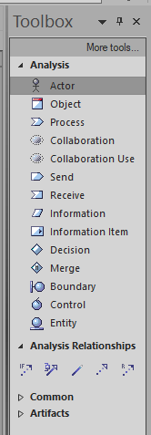 or 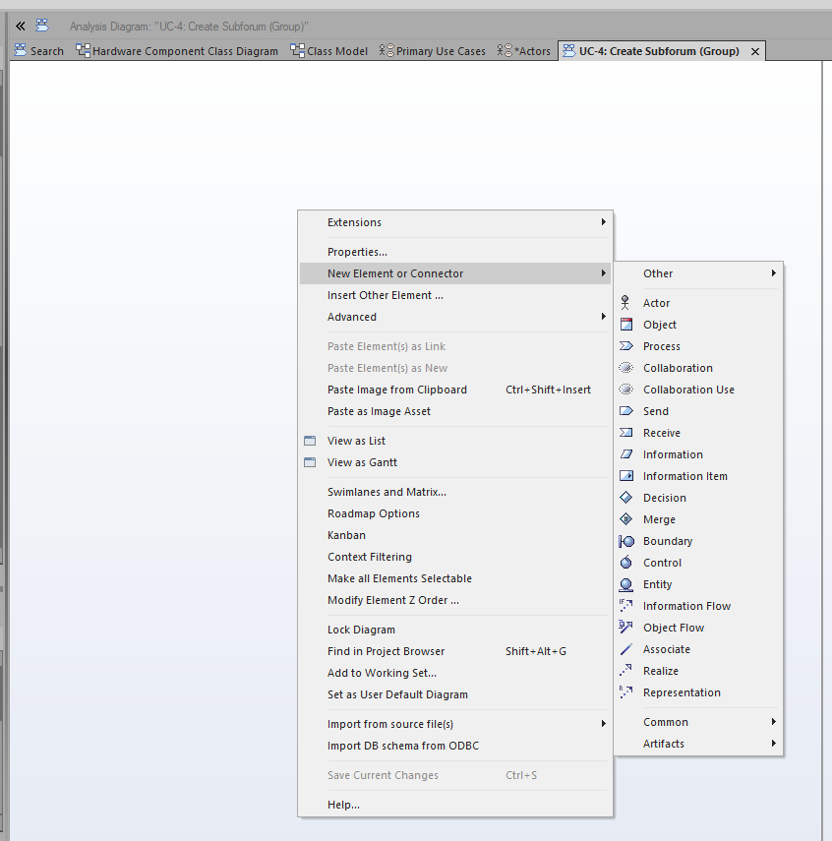

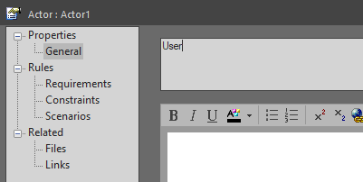

1. Create Boundary Objects and Control Objects using the same method.
2. Add Directed Link from Actor to Boundary Objects, and from Boundary Objects to Control Objects.
   * When you select an element (Actor or Object), there will be an arrow appear on the upper-right corner of the icon.

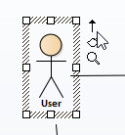

* + Drag it to the target element and drop. Select “Directed Link”.

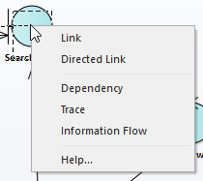

1. The finished Analysis Diagram.

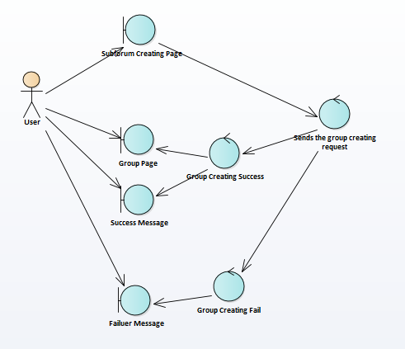

#### Process Realization Diagram

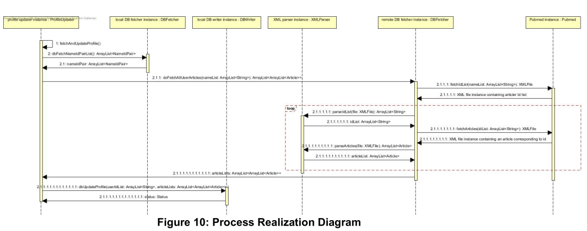

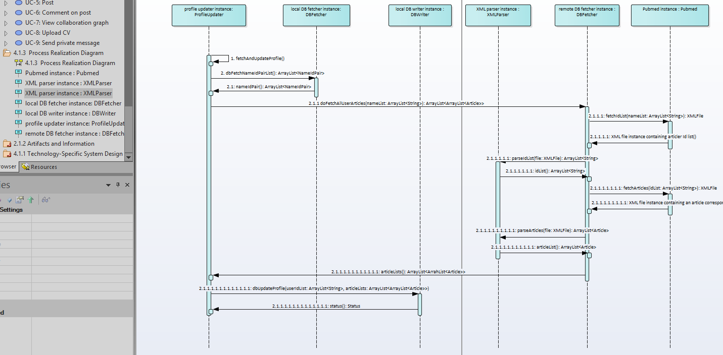

1. Add a package under the project directory (“Package Only”)

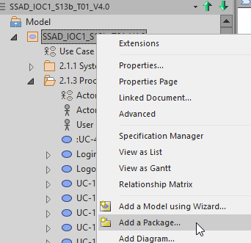 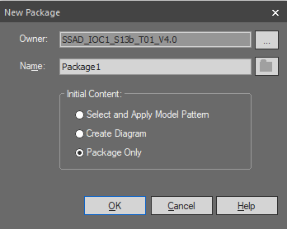

1. Add a Sequence Diagram under that package

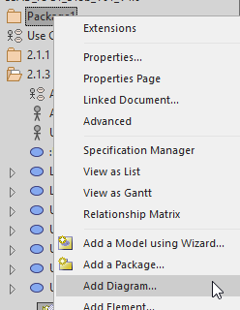 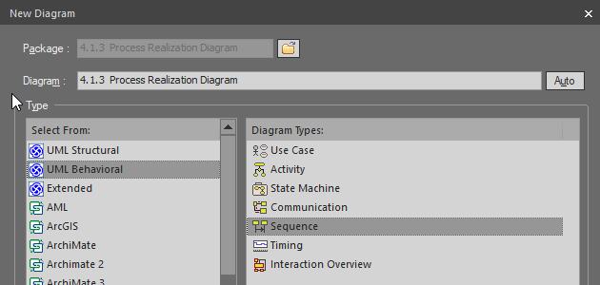

1. Drag “Lifetime” element into the workspace
2. Select one of “Interaction Relationships” and then click on the dash line under the Lifetime element to create an interaction

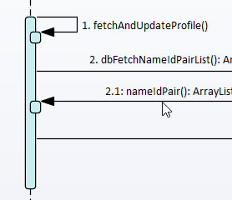

1. Drag the arrowhead to the endpoint element as shown on the SSAD diagram
2. Double-click on the arrow to edit the properties of the interaction.

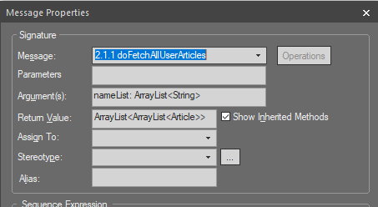



#### ER-diagram

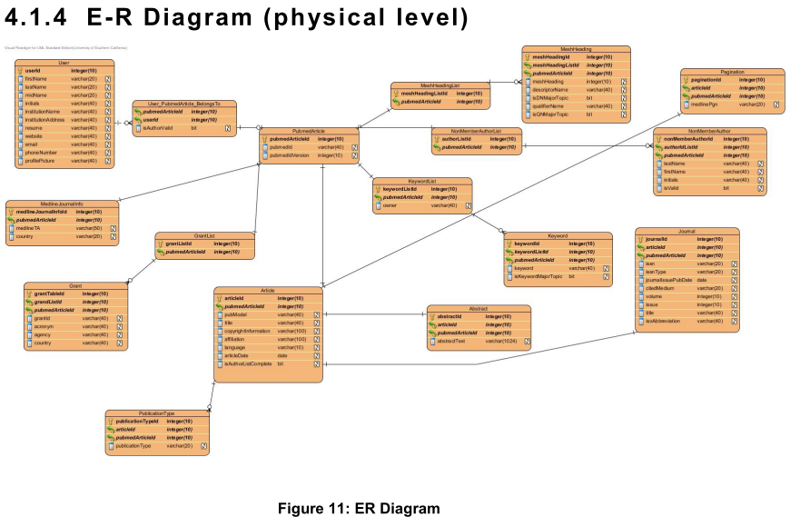

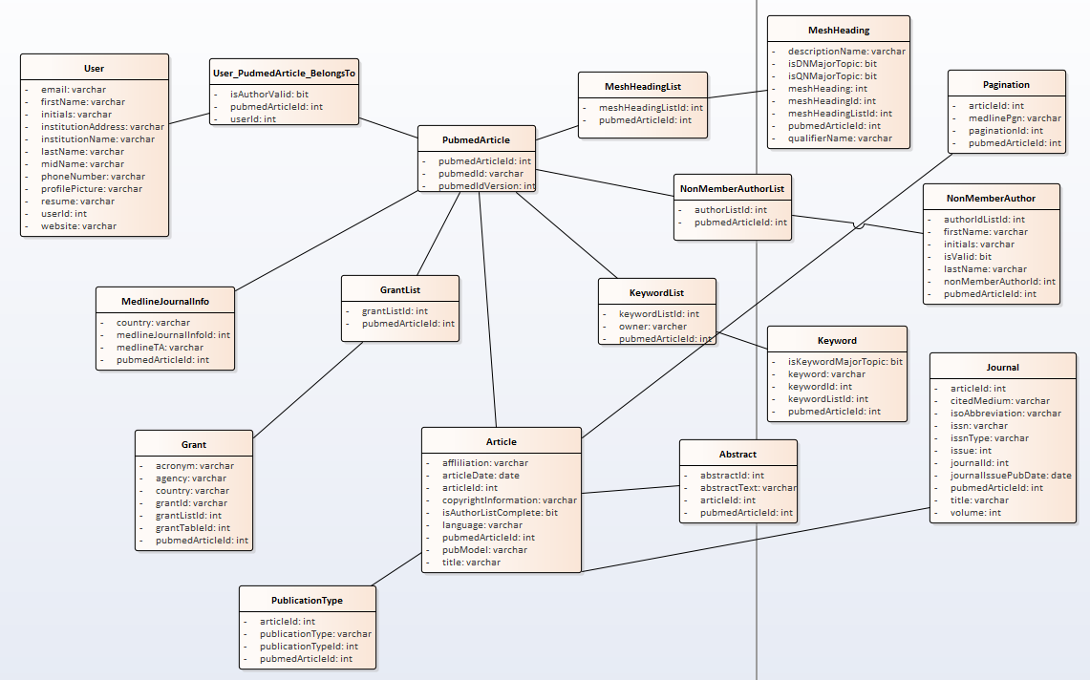

1. Create a package, and add an UML Structural – Class Diagram under it

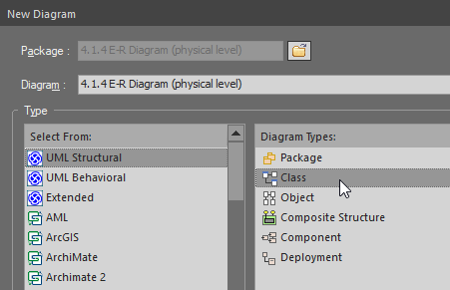

1. add Class element into it

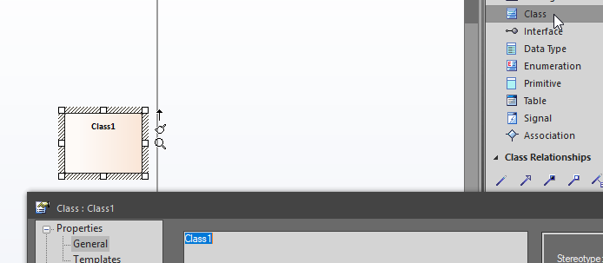

1. add Attributes to the Class

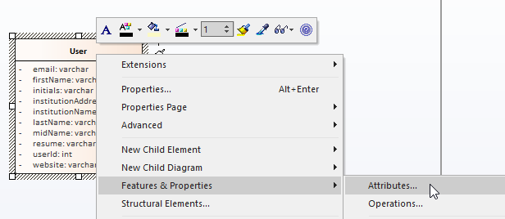

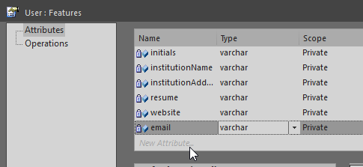

1. Create Association Connectors between Classes

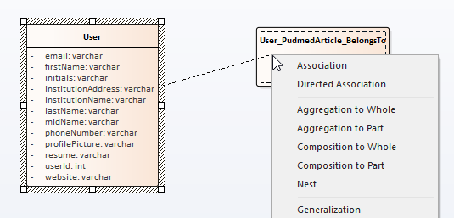

## more examples

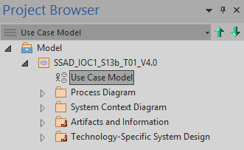

### Use Case Model

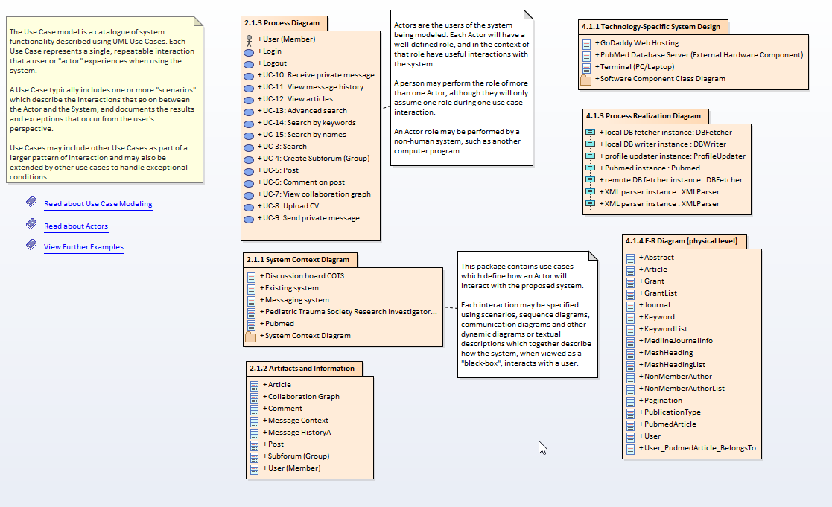

### 2.1.1 System Context Diagram

#### Primary Use Cases

This part corresponds to SSAD figure in 2.1.1 System Context

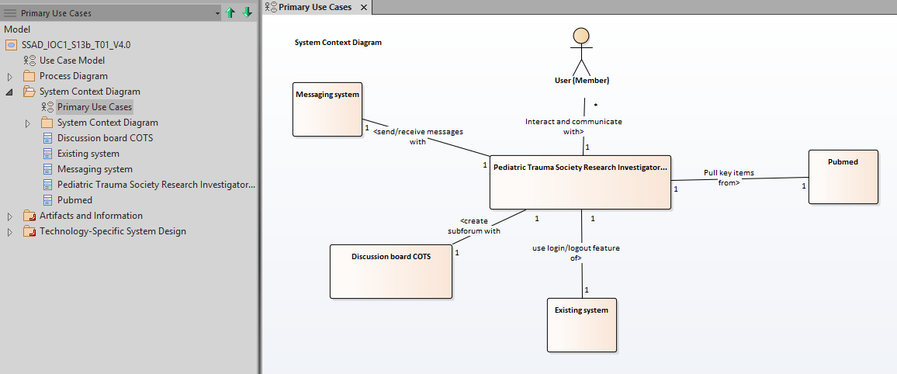

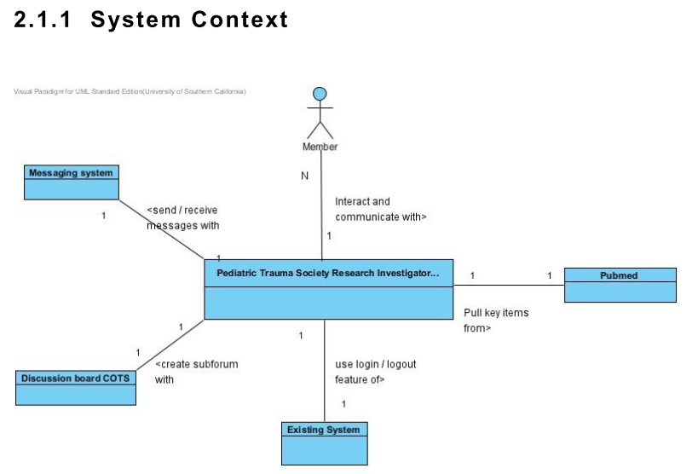

### 2.1.2 Artifacts and Information

#### Class Model

This part corresponds to SSAD figure: Process Diagram in 2.1.2 Artifacts & Information

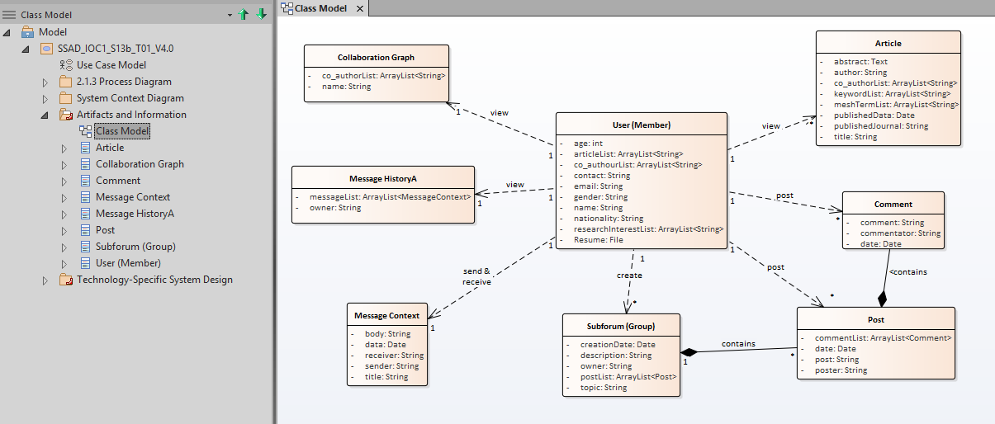

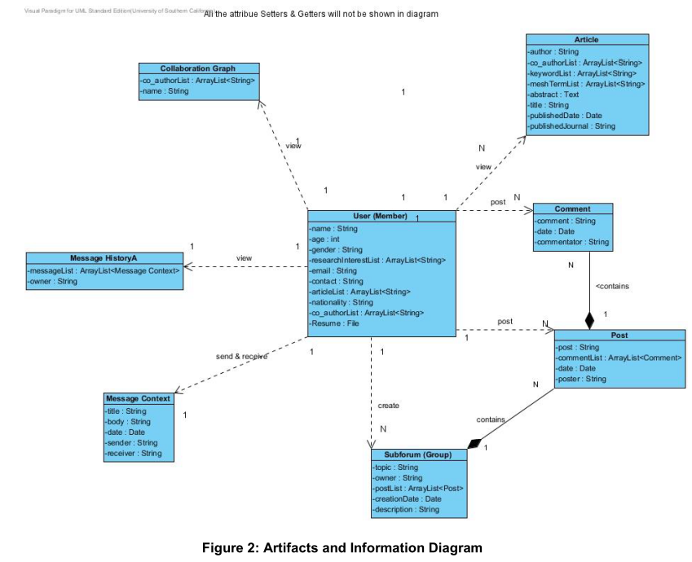

### 2.1.3 Process Diagram

This part corresponds to SSAD section: 2.1.3 Behavior

#### Use Case Diagram: Actors

This part corresponds to SSAD figure: Process Diagram in 2.1.3 Behavior

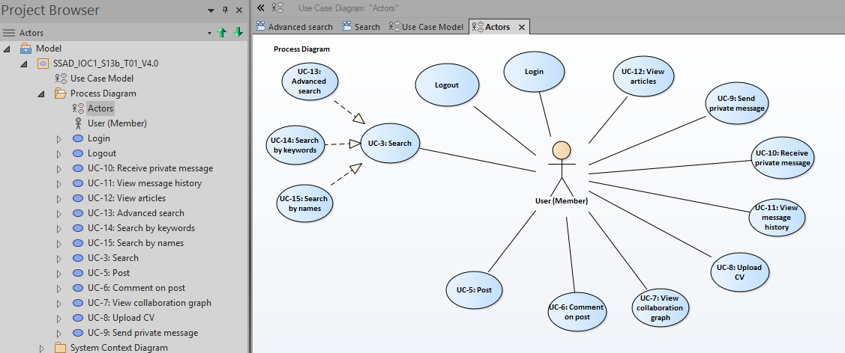

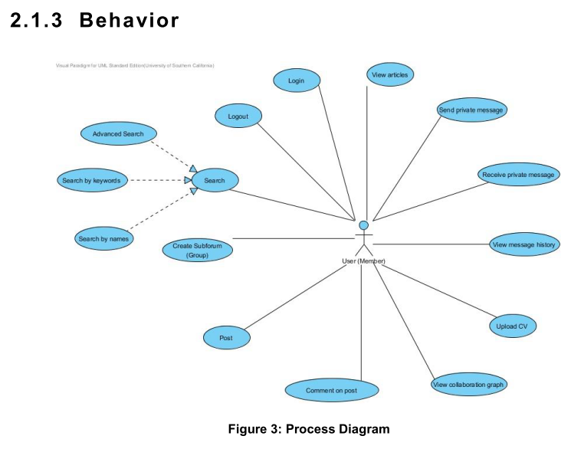

### Technology-Specific System Design

#### Hardware Component Class Diagram

This part corresponds to SSAD figure: Hardware Component Class Diagram in 4.1.1 System Structure 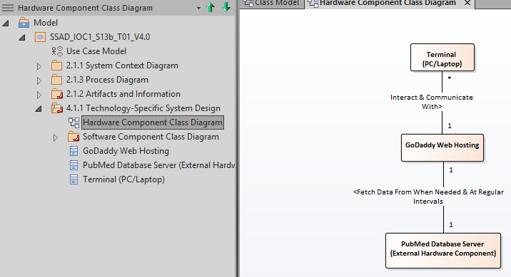

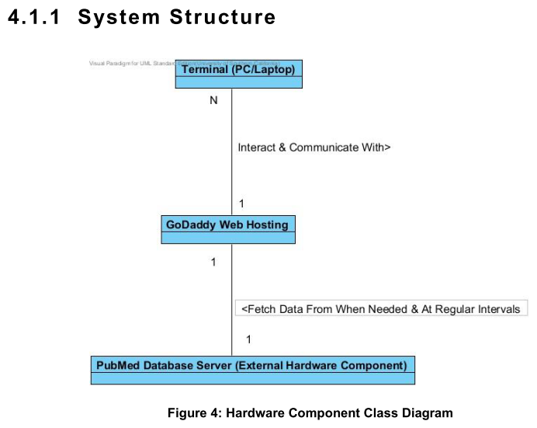

#### Software Component Class Diagram

This part corresponds to SSAD figure: Software Component Class Diagram in 4.1.1 System Structure

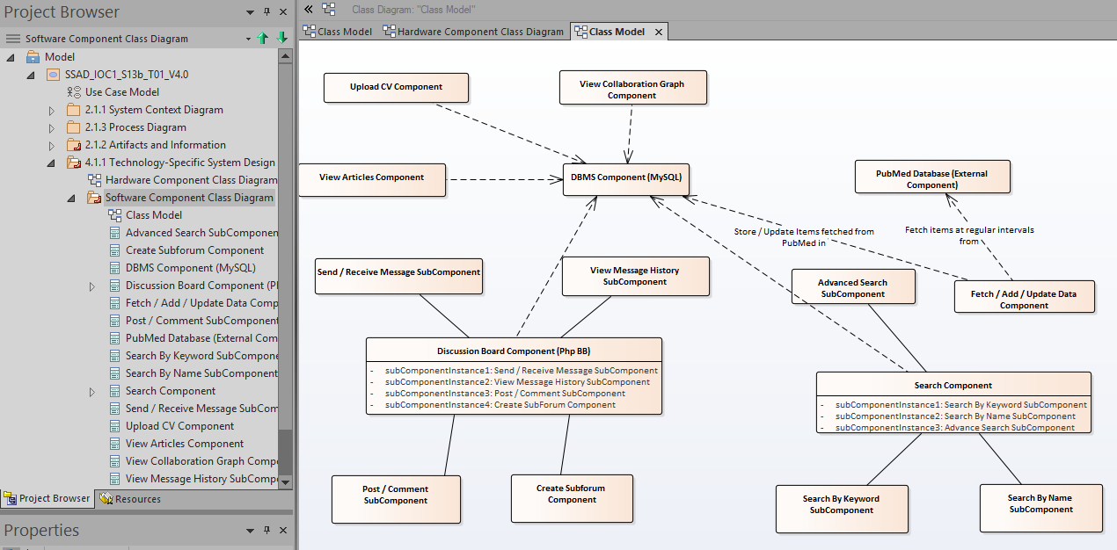

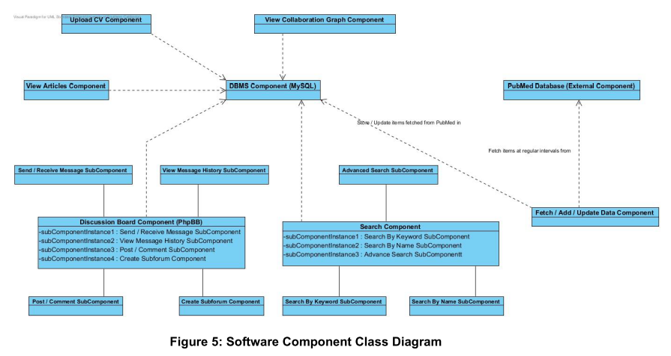

**A few examples of incorrect model patterns:**

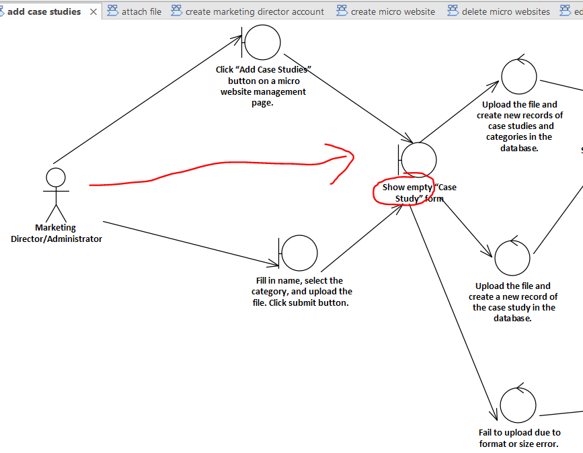

* + 1. Every boundary should be connected to an actor - human user or external system

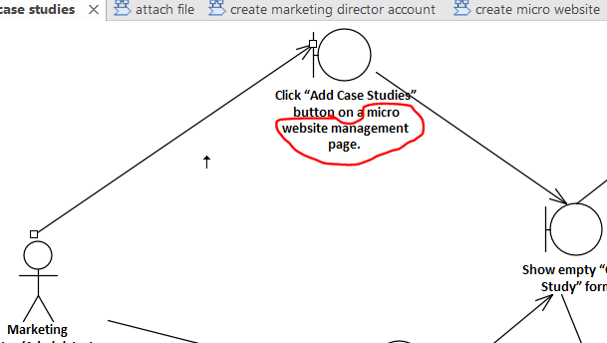

* + 1. For boundaries, they are objects, so should be named as "noun words". Verbs should be encapsulated into "control" element.

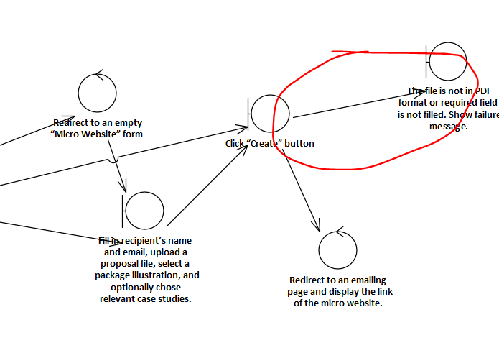

* + 1. No direct connections between boundaries. There should be control element in between.

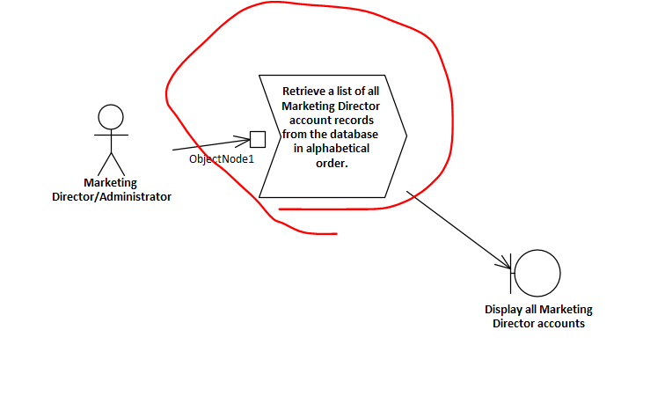

* + 1. This part needs to be expanded into control-boundary-model elements.

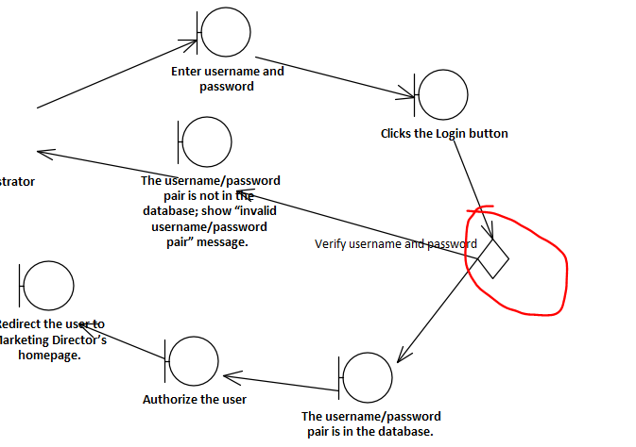

* + 1. For this decision node, use a "control" element to replace.