Use Case Analysis Tutorial

Following the steps:

1. Install the APK. It is best that you could have android phone, if not please install the emulator:

<https://www.bluestacks.com/>

If you install the APK on Android phone, you can plugin your phone and install Vysor (https://chrome.google.com/webstore/detail/vysor/gidgenkbbabolejbgbpnhbimgjbffefm?hl=en-US), which is a chrome plugin app such that you can operate your phone from your computer for better efficiency.

1. Run the Android app and identify use cases. Please see the definition of use cases here:

<https://en.wikipedia.org/wiki/Use_case>

“In software and systems engineering, a use case is a list of actions or event steps typically defining the interactions between a role (known in the Unified Modeling Language (UML) as an actor) and a system to achieve a goal. The actor can be a human or other external system. In systems engineering, use cases are used at a higher level than within software engineering, often representing missions or stakeholder goals. The detailed requirements may then be captured in the Systems Modeling Language (SysML) or as contractual statements.”

Keypoints:

1. Identify your role (unregister user, registered user, admin, etc).
2. The goal you are trying to achieve, for example, registration, login, reset password, read articles, etc. Each of the goal is a use case.

Exmaples of use cases.

1. For each of the use case, create a sheet as below in the DataCollectionForm.xlsx

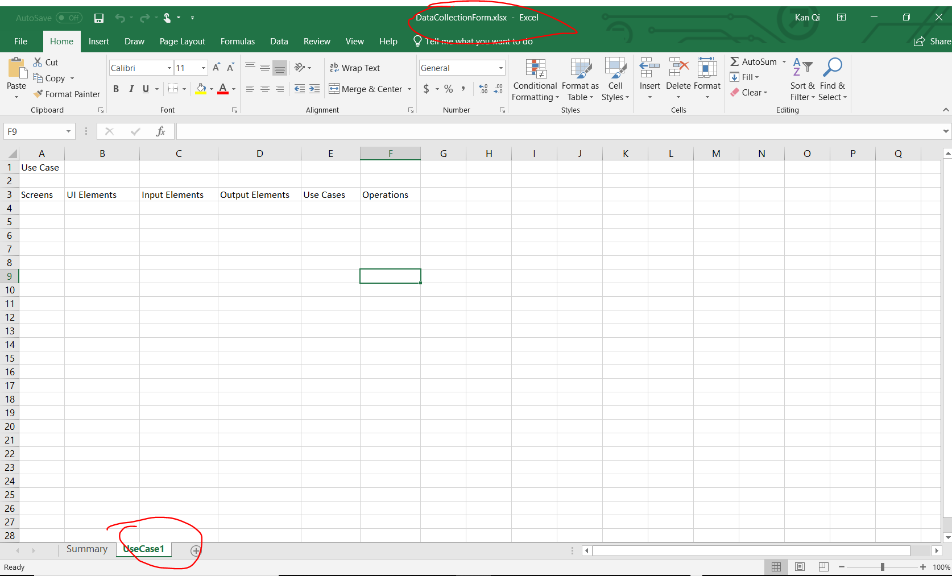

The template provides the example fields needed:

1. Screens. Take screenshot for each screen in the app to realize a use case. You can use the emulator and Vysor to capture the screenshot which should be convenient. Name the screenshot following the rule: UseCaseName-1.png. “1” represents the order you see the screen for the use case.
2. Input Elements. The number of input fields in the screen for the use case.
3. Output Elements. The number of views that display the information you need for the use case.
4. UI Elements. The total number of UI elements, which is a sum of the Input elements and output elements.
5. Operations. The number of movements on the screen for you to complete the use case.
6. Sum up the use cases to update the columns in the “summary” tab.

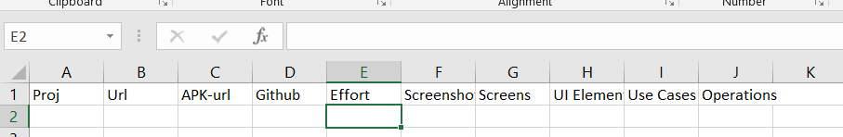

1. Run the command “” to derive data from github for the effort:

"C:/Program Files/R/R-3.2.5/bin/Rscript" ./UMLx/data/OpenSource/active_contributors_every_30.R "Github-repo-api-url" "./temp/git_effort_request_results.txt"

1. Run the command below to derive the data for lines of source code.

Command to source code of code.

1. Run the R script to understand the correlations and the stepwise model

UMLx\data\FeatureSelection\gzh_report.Rmd