Object Recognition and Weather Forecast App Documentation

Project Lead: Kanaad Madhav Limaye. (FE Comp)

1. Introduction:

Welcome to the comprehensive documentation for the Object Recognition and Weather Forecast app. This document serves as a detailed guide to understanding the features, functionality, and technical aspects of our app.

1. **Features**:

Object Recognition: Utilizing the robust capabilities of Thunkable's standard library, the app uses machine learning algorithms (ML) and Computer Vision Techniques (CV) to accurately recognize objects captured through the device's camera.

Weather Forecast: Utilizing a reliable API, our app delivers live weather data, including temperature and weather conditions, to provide users with accurate and up-to-date forecasts for their location.

1. **Technology Stack**:

* App Development Platform: Thunkable
* Object Recognition: Thunkable's standard library for object recognition
* Weather Forecast API: OpenWeatherMap API

1. **Architecture of the App**:

The client side is developed using Thunkable which efficiently integrates the object recognition libraries into the app.

The server-side utilizes OpenWeatherMap API to receive weather forecast data based on the location that the user inputs.

1. **User Guide**:

When the app is opened the user will come across two icons:

a Camera icon and a Weather icon.



Click on the Camera Icon to click a photo.

The clicked image will be visible in the space below

Below the Image, the description of the image will be visible in the given white box.



Click the Weather icon to enter the weather section.

In the provided input box, input the city of your choice.

Click the search button.

Upon clicking, the Temperature and Weather Description will be visible for the user input city/location.

This is the Home Screen This is the Weather Screen

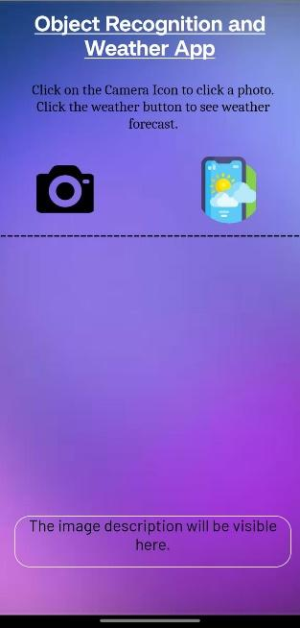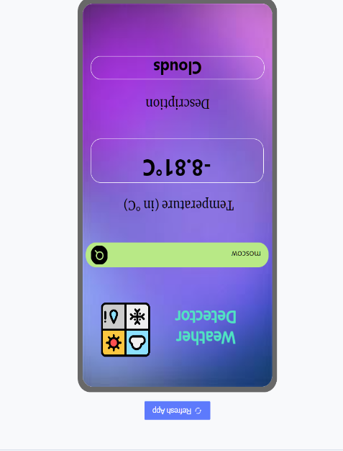

1. **Functioning of the App**:

* For the object recognition feature, the app uses the standard thunkable libraries on ML and Computer Vision (CV) to accurately identify the object.

The algorithms analyze various visual features and patterns present in the images to make predictions about the objects that the image contains.

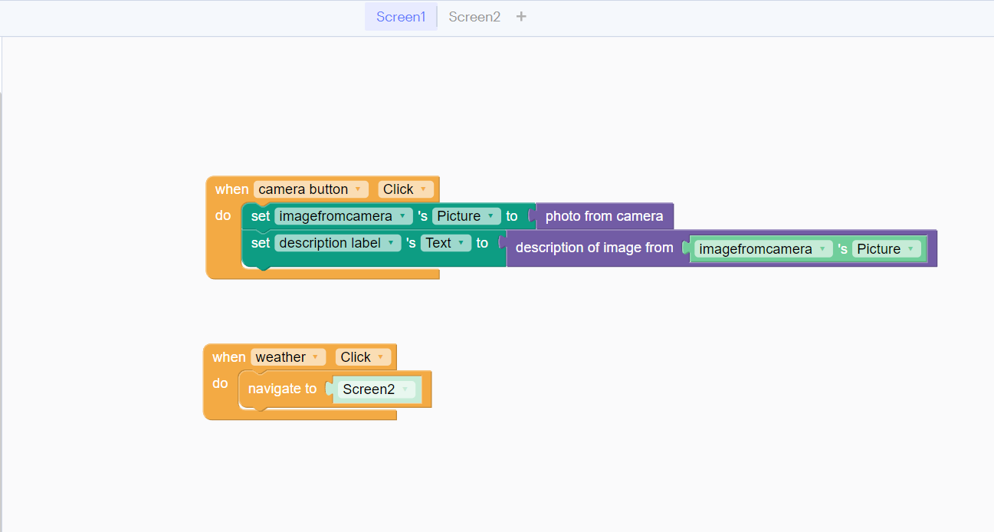

This is the code running in the backend of the application for the Home Screen.

Thunkable uses Drag-and-Drop Programming in the form of blocks, to implement various functionalities.

* For the weather forecast feature, first, the OpenWeatherMap’s API is connected to the app. After the connection, the app is ready to make the API call to the site, in order to retrieve information regarding temperature and weather about a particular location set by the user.

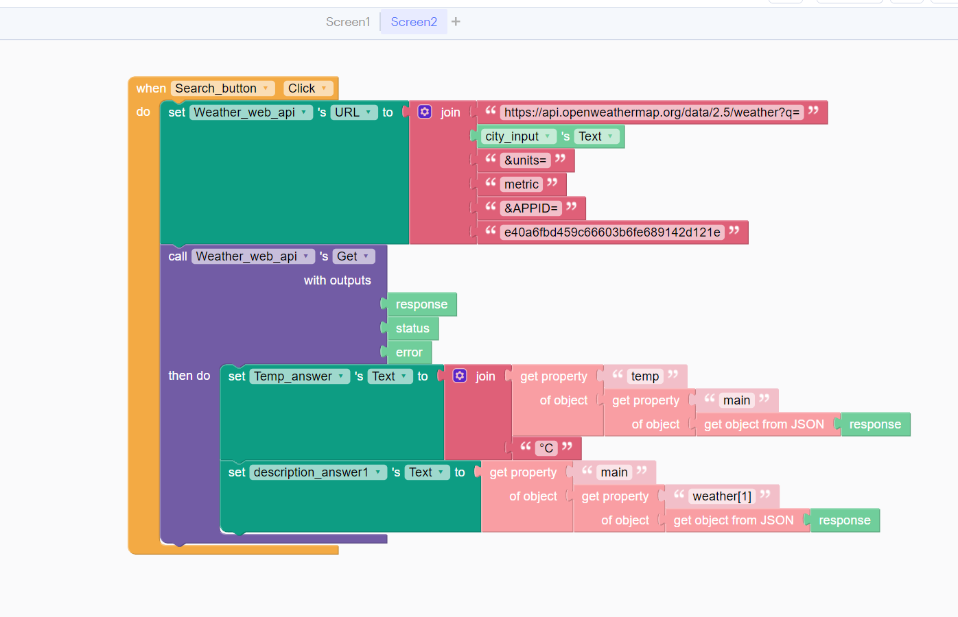

This is the code that runs in the background for the weather forecast section.

The API call is made and useful information like temperature and weather is pulled by declaring them as properties and obtaining the response from JSON.

The information regarding temperature is then displayed in the corresponding temperature block in the UI part of the app.

Similarly, the information regarding the weather is displayed in the corresponding description section/block in the UI part of the app.

1. **Testing**:

Throughout the Development process, the app has been tested multiple times with numerous inputs being given and suitable results obtained.

These tests were conducted on the Web version as well as the Android version of the app.

The above images were successfully detected and its accurate description was provided by the algorithm.

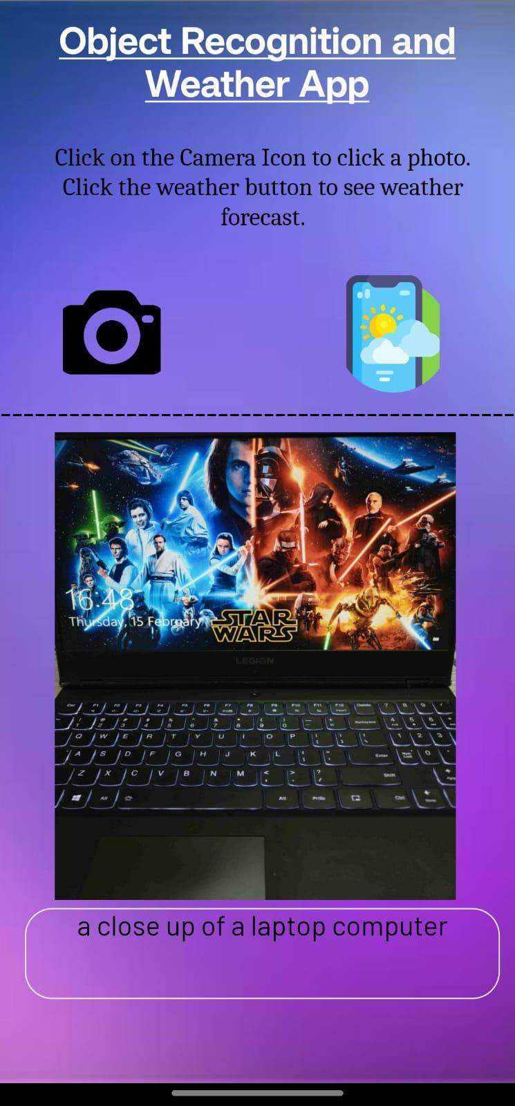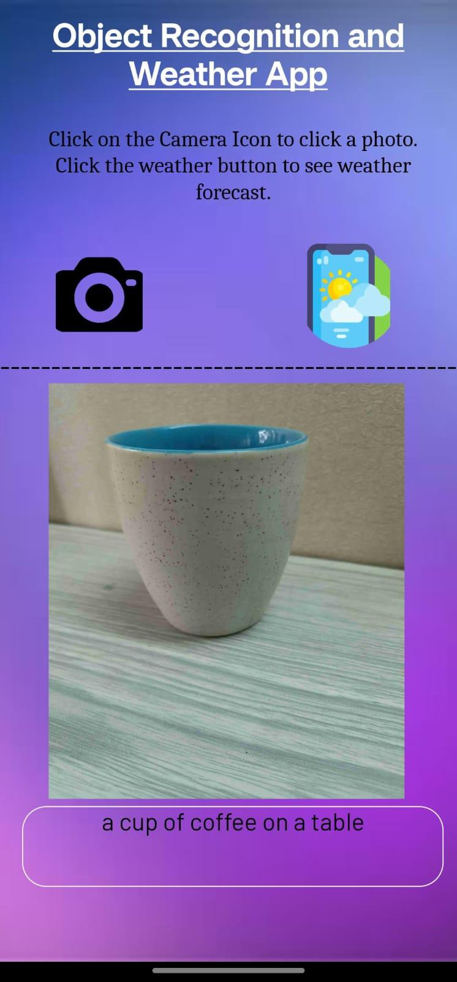

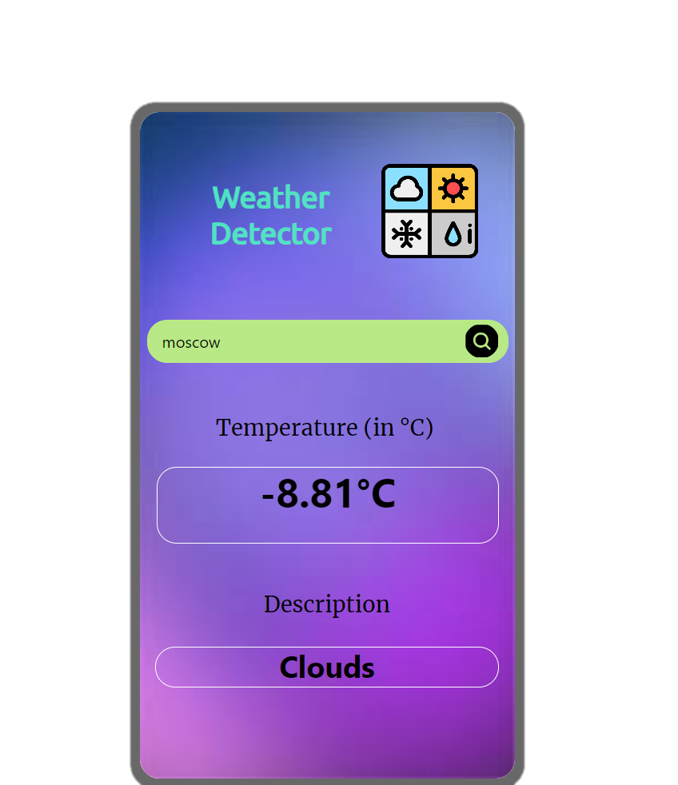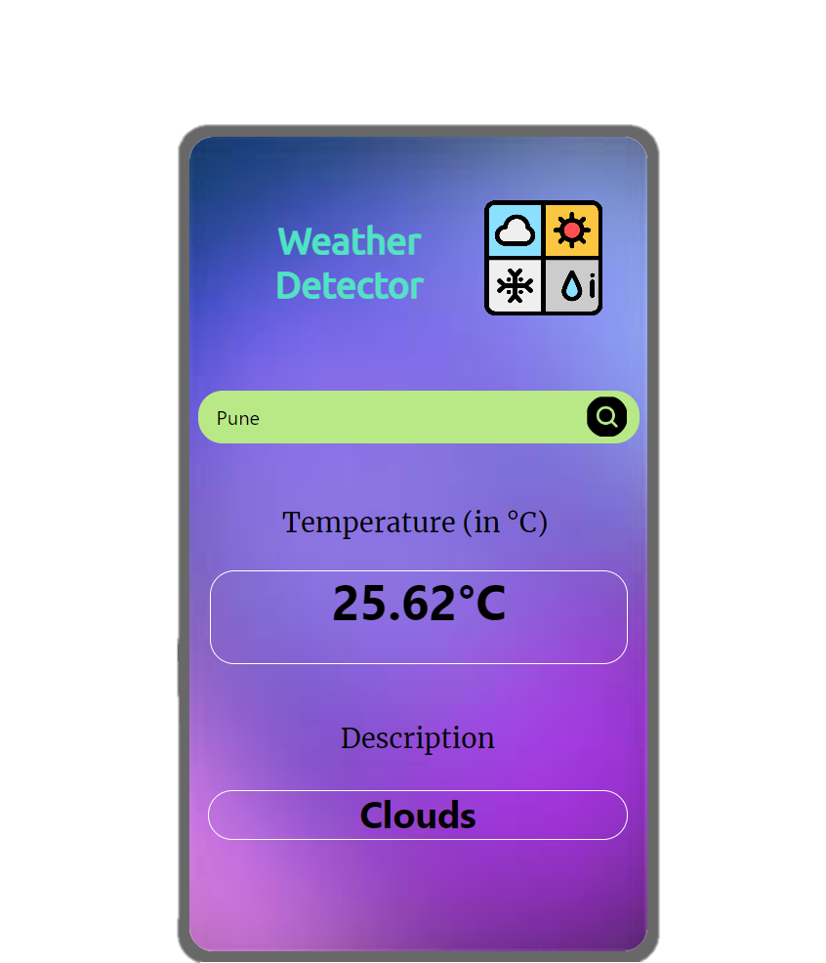

The above images show the tests run by taking inputs of 2 cities namely Pune and Moscow

It is observed that the API works and the correct information regarding the temperature and the weather is displayed in the corresponding blocks.

1. **Conclusion**:

In conclusion, our app utilizes Thunkable's object recognition component and thoughtful integration of OpenWeatherMap’s API to create a robust and efficient application.

Through careful execution and testing, the app is a great example of implementing one’s knowledge and turning ideas into reality.