Sales Insights Platform
Project Overview and Architecture - v7 FINAL (2)
Author: M. Lee Last edited: 18 February 2026 Status: Approved

1. Purpose
The Sales Insights Platform gives Northwind Outfitters one daily view of sales across every channel. It replaces four regional spreadsheets that disagreed with each other.

2. Scope
Channel | Source system | Status
Web store | Web store platform | Live
Store checkouts | Point-of-sale in 180 stores | Live
B2B orders | ERP | Phase 3
Call-center orders | CRM | Phase 3

3. Architecture
Orders are copied each night from the sales systems through FlowBridge into one warehouse in Cloud A (us-east), cleaned, combined, and shown on InsightBoard dashboards.
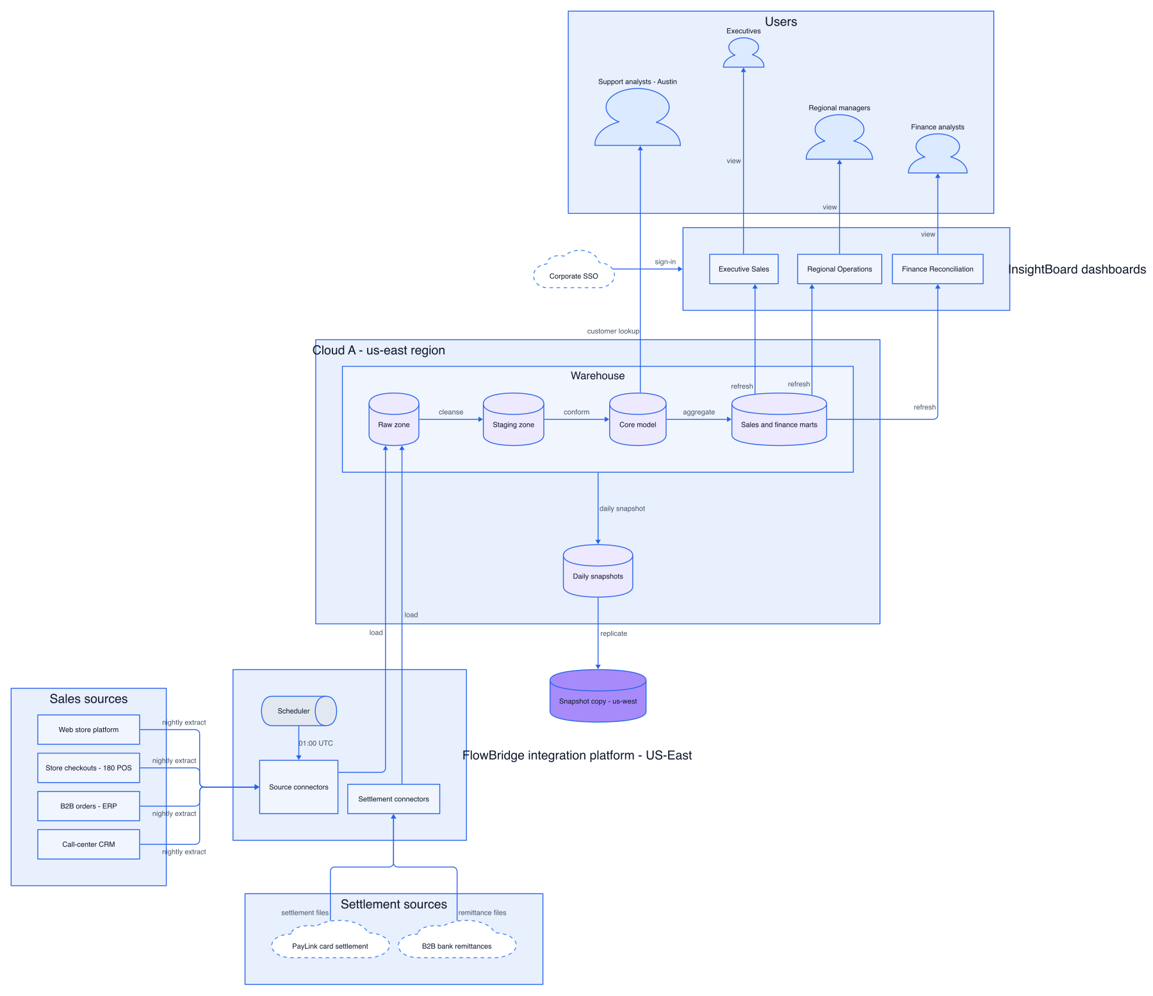
Figure 1: Architecture (exported from Visio, February 2026)

4. Hosting and security
The warehouse runs in a single region (us-east). Snapshots are copied daily to us-west. Support analysts in Austin can look up customer orders.

5. Open items
See the project tracker for risks. TODO: update diagram after Phase 3 go-live.

