Table 1: mira_documents_v2 (Ingested Content)
Stores project documents and their vector embeddings used by the Risk Assessment Agent for semantic retrieval using classical RAG.
ordinal_position | column_name | data_type | is_nullable | column_default
1 | id | bigint | NO | nextval('mira_documents_v2_id_seq'::regclass)
2 | content | text | YES | null
3 | metadata | jsonb | YES | null
4 | embedding | USER-DEFINED | YES | null

The screenshot shows the actual table with sample content.
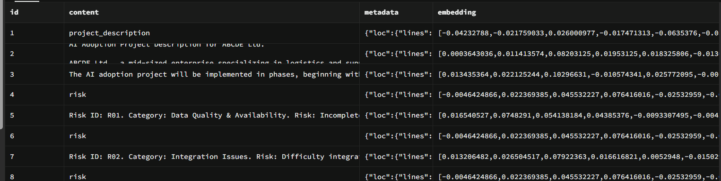

Table 2: agent_logs (Audit table)
Stores user interactions, including question, intent, confidence score, selected agent, and generated response for auditability and historical analysis.
ordinal_position | column_name | data_type | is_nullable | column_default
1 | id | bigint | NO | nextval('agent_logs_id_seq'::regclass)
2 | created_at | timestamp without time zone | YES | now()
3 | question | text | YES | null
4 | intent | character varying | YES | null
5 | confidence | numeric | YES | null
6 | selected_agent | character varying | YES | null
7 | response | text | YES | null

The screenshot shows the actual table with sample content.
