High-Level Design:

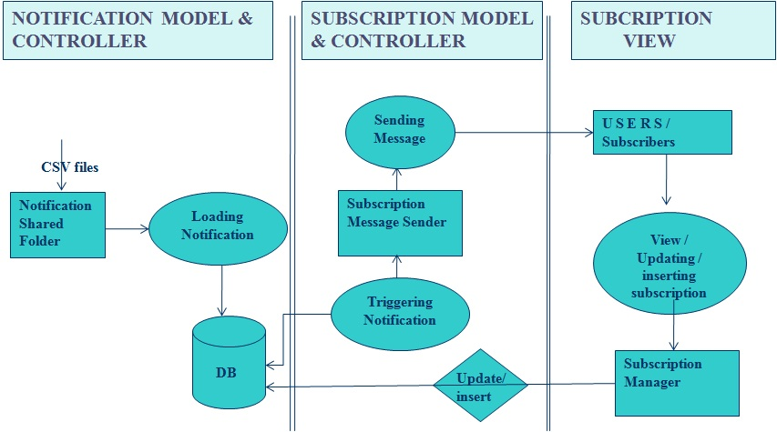

Notification Reader:

- Java watcher will be checking the Shared folder status if get update trigger will pick files
- Read the file content of newly arrived file in shared folder, And put the file content in to HeapMap.
- Heap Map data enqued to Queue whether when Heap Map size hit the threshold limit or in a particular interval.
4. DB wirter will fetch notification data from Queue and write into MY-Sql database;

Notification Trigger:
- This component will get trigged, when new notification message arrived to DB .
- Component will check that whether subscribed user available in DB .
- If it is there it will send notification to subscribed user.
- If no subscription user available , it will ignore the newly arrived notification
- Notification reader read the data from DB with help of Trigger and enqued into Queue.
- Notification sender keep on watch the Queue and send available message to client

Subscription Manager:
- It is a HTTP interface, It will accept the subscription request from client in Json format
- Store the subscription request information in DB for sending notification message to client when new notification come.

Subscription Manager Request & Response:

URL : localhost:8080/SubscriptionMng//Subscription/Updater/1.0.0
HTTP Header: Content-Type : application/json

Method : POST

Request Field:
{"usrID":"user1","emailID":"kanagaraj.20jan@gmail.com","auther":"Levitt & Dubner","publisher":"William Morrow","title":"freakonomics","price1":"9.00","price2":"0","price_cond":"EQ","date1":"2015-09-23","date2":"1970-01-01","date_cond":"EQ"}

Response:
{"status":"1","msg":"Success"}

