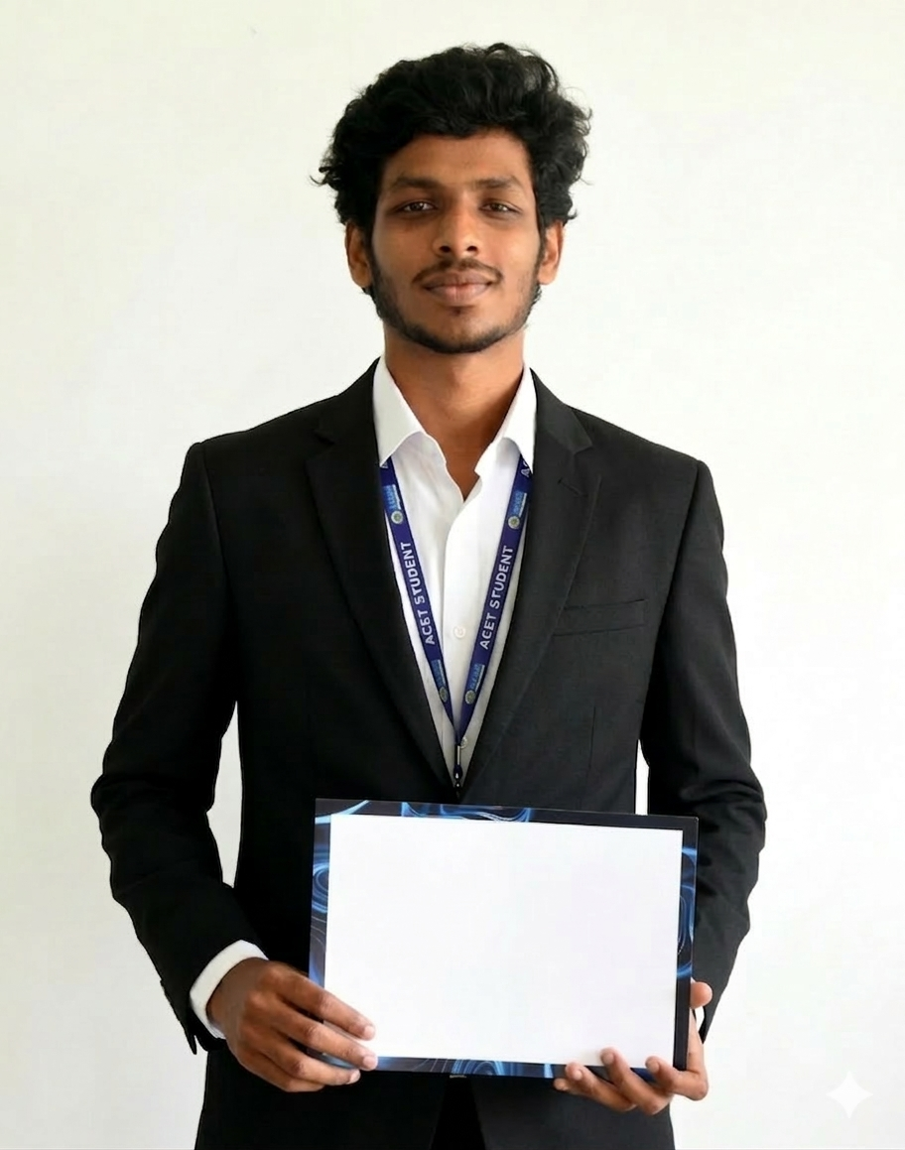
KANAGA PRASATH B
Chengalpattu, Tamil Nadu
Email id: kanagubry@gmail.com
Mobile Number: 8940293794
LinkedIn: linkedin.com/in/kanaga-prasath-balakumar
GitHub: github.com/kanaguGaming

EDUCATION
- B.E. Computer Science and Engineering, Adhi College of Engineering and Technologies (2023–2027) | CGPA: 8.1
- Higher Secondary (Computer Science), SDA Mt. Hr. Sec. School (2021–2023) | 76%
- ICSE Primary & Secondary Schooling, SDA Mt. Hr. Sec. School (2011–2021) | 82%

TECHNICAL SKILLS
- Programming Languages – Python, JavaScript, HTML, CSS, Embedded C, MySQL, Oracle
- Frameworks and Libraries – FastAPI, Flask, Pandas, Streamlit, MongoDB, Matplotlib
- Applied Skills – NLP, CNNs, RAG, LLMs, Firebase, OpenCV
- IoT and Automation – Arduino IDE, Arduino UNO R3/R4 Wi-Fi, ESP 32, ESP 8266

EXPERIENCE
- Full Stack Developer Intern – Cognifyz Technologies (Dec 2025–Jan 2026)
- Digital marketing intern – Turnip Solutions (Jan 2026- Feb 2026)
- Data Analysis Intern – Cognifyz Technologies (Feb 2026–Apr 2026)
- Data Science Intern – Thiranex (May 2026 - Jun 2026)
- Robotics and IoT Intern – Codec Technologies (Jun 2026–Aug 2026)

SELECTED PROJECTS
- ExamSeat Pro – Automated exam seating system adopted by college Examination Cell.
Python fast API, HTML, CSS, JS, Pandas, Capacitor.
- GreenPal – Award-winning smart plant and human health monitoring platform.
ESP32, Firebase, Python FastAPI, Mobile app development.
- Urbanite – Crowd sourced civic issue reporting platform with geo tagging and smart job card following features.
Python Flask, Open CV, Mobile app development.
- DraLan –Addressing the unique cultural and administrative challenges faced by Non-Resident Indian (NRI) children.
Python Flask, HTML, CSS, Voice recognition, voice synthesis, LLM, CV.
- Sidekick AI – Autonomous lab assistant/ Socratic teaching assistant using LLM-RAG.
React.js, VSC extension devs, Python, LLM & RAG.
- Evaluate.ME – Career guidance platform and technical self-evaluation/ employee evaluation platform leveraging Random Forests, NLP and RAG.
Python FastAPI, Random Forest (CB), React.js.
- Ori-Home – Cloud-based smart home automation project; CSE Expo winner.
Arduino UNO R4 Wi-Fi, Thing Speak, Embedded C, IoT& Automation.

PUBLICATIONS
- “Ai Assisted Semantic Search Based National Classification of Occupation Survey System Via Online”, Journal Paper – 2025 Dec.
- “Overview of AI Algorithms and Data Science Techniques Relevant to Education”, IGI Global Book Chapter – 2026.
- “Tech Assisted Floral Pet: Can we Give Emotion and Expression to plants?”, Conference paper - Delcon 2026.

ACHIEVEMENTS
- Winners – Innovesta’26 Project Expo CSE Winners at Adhi College
for OriHome project (2026)
- Winners – National IoT Workshop Hackathon at SRM IST (2026)
- Winners – HactriX National level 24H Live hackathon at Sairam Institute of Science and Technology for project GreenPal (2026)
- Winners – Technical Quiz Winners, National level technical symposium at VELS University (2026)
- Winner – Technical Quiz solo winner, Magnus National Level technical symposium at CIT (2026)
- #6/48 teams – Innoverse’26 National level 24H live hackathon at Sathyabama University for project Evaluate.Me (2026)
- #11/120 teams – AI Ignite National Level 36H live hackathon at Sri Manakula Vinayagar Engineering College for project DraLan (2026)
- #10/64 teams – XploitX National level Cyber security 24H live hackathon Prathyusha Engineering College (2026)

LinkedIn: Portfolio: GitHub:
