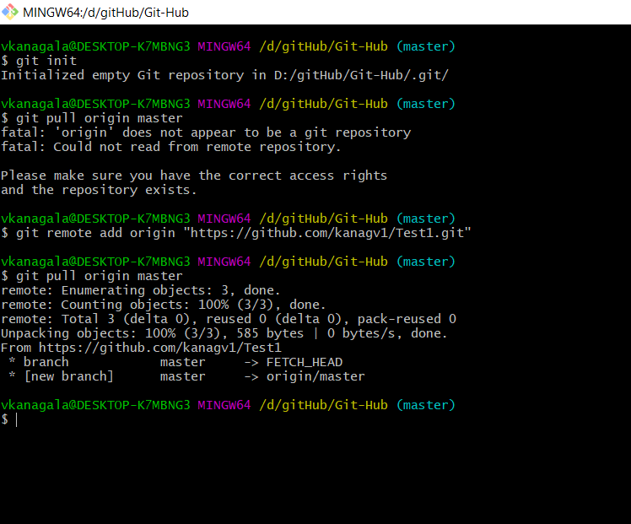

vkanagala@DESKTOP-K7MBNG3 MINGW64 /d/gitHub/Git-Hub (master)

$ git init

Initialized empty Git repository in D:/gitHub/Git-Hub/.git/

vkanagala@DESKTOP-K7MBNG3 MINGW64 /d/gitHub/Git-Hub (master)

$ git remote add origin "https://github.com/kanagv1/Test1.git"

vkanagala@DESKTOP-K7MBNG3 MINGW64 /d/gitHub/Git-Hub (master)

$ git pull origin master

remote: Enumerating objects: 3, done.

remote: Counting objects: 100% (3/3), done.

remote: Total 3 (delta 0), reused 0 (delta 0), pack-reused 0

Unpacking objects: 100% (3/3), 585 bytes | 0 bytes/s, done.

From https://github.com/kanagv1/Test1

* branch master -> FETCH_HEAD

* [new branch] master -> origin/master

vkanagala@DESKTOP-K7MBNG3 MINGW64 /d/gitHub/Git-Hub (master)

$ git commit -m "first"

*** Please tell me who you are.

Run

git config --global user.email "you@example.com"

git config --global user.name "Your Name"

to set your account's default identity.

Omit --global to set the identity only in this repository.

fatal: unable to auto-detect email address (got 'vkanagala@DESKTOP-K7MBNG3.(none)')

vkanagala@DESKTOP-K7MBNG3 MINGW64 /d/gitHub/Git-Hub (master)

$ git config --global user.name "kanagv1"

vkanagala@DESKTOP-K7MBNG3 MINGW64 /d/gitHub/Git-Hub (master)

$ git config --global user.email "venu.kanagla@gmail.com"

vkanagala@DESKTOP-K7MBNG3 MINGW64 /d/gitHub/Git-Hub (master)

$ git config --global --list

user.name=kanagv1

user.email=venu.kanagla@gmail.com

vkanagala@DESKTOP-K7MBNG3 MINGW64 /d/gitHub/Git-Hub (master)

$ git commit -m "first"

[master 520f5e1] first

1 file changed, 0 insertions(+), 0 deletions(-)

create mode 100644 sample.txt

vkanagala@DESKTOP-K7MBNG3 MINGW64 /d/gitHub/Git-Hub (master)

$ git log

commit 520f5e133dd9f0f0fc5797a0cc39cd35d0f131e8 (HEAD -> master)

Author: kanagv1 <venu.kanagla@gmail.com>

Date: Tue Sep 15 16:57:23 2020 -0400

first

commit 74fbdd23fa4ba979fceb50dbac8e0bbf15065e0e (origin/master)

Author: kanagv1 <71299004+kanagv1@users.noreply.github.com>

Date: Mon Sep 14 20:38:31 2020 -0400

Initial commit

vkanagala@DESKTOP-K7MBNG3 MINGW64 /d/gitHub/Git-Hub (master)

$ git branch samp

vkanagala@DESKTOP-K7MBNG3 MINGW64 /d/gitHub/Git-Hub (master)

$ git checkout samp

Switched to branch 'samp'

vkanagala@DESKTOP-K7MBNG3 MINGW64 /d/gitHub/Git-Hub (samp)

$ git add samp1.txt

vkanagala@DESKTOP-K7MBNG3 MINGW64 /d/gitHub/Git-Hub (samp)

$ git commit -m "first"

[samp 60573a3] first

1 file changed, 0 insertions(+), 0 deletions(-)

create mode 100644 samp1.txt

vkanagala@DESKTOP-K7MBNG3 MINGW64 /d/gitHub/Git-Hub (samp)

$ ls

README.md samp1.txt sample.txt

vkanagala@DESKTOP-K7MBNG3 MINGW64 /d/gitHub/Git-Hub (samp)

$ git checkout master

Switched to branch 'master'

vkanagala@DESKTOP-K7MBNG3 MINGW64 /d/gitHub/Git-Hub (master)

$ ls

README.md sample.txt

vkanagala@DESKTOP-K7MBNG3 MINGW64 /d/gitHub/Git-Hub (master)

$ git merge samp

Updating 520f5e1..60573a3

Fast-forward

samp1.txt | 0

1 file changed, 0 insertions(+), 0 deletions(-)

create mode 100644 samp1.txt

vkanagala@DESKTOP-K7MBNG3 MINGW64 /d/gitHub/Git-Hub (master)

$ ls

README.md samp1.txt sample.txt

vkanagala@DESKTOP-K7MBNG3 MINGW64 /d/gitHub/Git-Hub (samp)

$ git push origin samp

Logon failed, use ctrl+c to cancel basic credential prompt.

error: unable to read askpass response from 'C:/Program Files/Git/mingw64/libexec/git-core/git-gui--askpass'

Password for 'https://kanagv1@github.com':

Enumerating objects: 6, done.

Counting objects: 100% (6/6), done.

Delta compression using up to 8 threads

Compressing objects: 100% (4/4), done.

Writing objects: 100% (5/5), 440 bytes | 220.00 KiB/s, done.

Total 5 (delta 1), reused 0 (delta 0), pack-reused 0

remote: Resolving deltas: 100% (1/1), done.

remote:

remote: Create a pull request for 'samp' on GitHub by visiting:

remote: https://github.com/kanagv1/Test1/pull/new/samp

remote:

To https://github.com/kanagv1/Test1.git

* [new branch] samp -> samp

vkanagala@DESKTOP-K7MBNG3 MINGW64 /d/gitHub/Git-Hub (samp)

$ git checkout master

Switched to branch 'master'

vkanagala@DESKTOP-K7MBNG3 MINGW64 /d/gitHub/Git-Hub (master)

$ git push origin master

Total 0 (delta 0), reused 0 (delta 0), pack-reused 0

To https://github.com/kanagv1/Test1.git

74fbdd2..60573a3 master -> master

vkanagala@DESKTOP-K7MBNG3 MINGW64 /d/gitHub/Git-Hub (master)

vkanagala@DESKTOP-K7MBNG3 MINGW64 /d/gitHub/Git-Hub (master)

$ git status

On branch master

Changes not staged for commit:

(use "git add <file>..." to update what will be committed)

(use "git restore <file>..." to discard changes in working directory)

modified: samp1.txt

no changes added to commit (use "git add" and/or "git commit -a")

vkanagala@DESKTOP-K7MBNG3 MINGW64 /d/gitHub/Git-Hub (master)

$ git add samp1.txt

vkanagala@DESKTOP-K7MBNG3 MINGW64 /d/gitHub/Git-Hub (master)

$ git commit -a -m "res2"

[master 0570bd4] res2

1 file changed, 2 insertions(+), 1 deletion(-)

vkanagala@DESKTOP-K7MBNG3 MINGW64 /d/gitHub/Git-Hub (master)

$ cat samp1.txt

hi This is venu.

venus

vkanagala@DESKTOP-K7MBNG3 MINGW64 /d/gitHub/Git-Hub (master)

$ git log

commit 0570bd4b04ae3440d4bd0a48a345a9f2686ec812 (HEAD -> master)

Author: kanagv1 <venu.kanagla@gmail.com>

Date: Tue Sep 15 17:54:09 2020 -0400

res2

commit 61794927dd1b5c2e8cb2cb5a369713406cdd0356

Author: kanagv1 <venu.kanagla@gmail.com>

Date: Tue Sep 15 17:49:56 2020 -0400

res1

commit 60573a367e0e9f8e170fdf35292a8752a082c14b (origin/samp, origin/master, samp)

Author: kanagv1 <venu.kanagla@gmail.com>

Date: Tue Sep 15 17:07:42 2020 -0400

first

commit 520f5e133dd9f0f0fc5797a0cc39cd35d0f131e8

Author: kanagv1 <venu.kanagla@gmail.com>

Date: Tue Sep 15 16:57:23 2020 -0400

first

commit 74fbdd23fa4ba979fceb50dbac8e0bbf15065e0e

Author: kanagv1 <71299004+kanagv1@users.noreply.github.com>

Date: Mon Sep 14 20:38:31 2020 -0400

Initial commit

vkanagala@DESKTOP-K7MBNG3 MINGW64 /d/gitHub/Git-Hub (master)

$ ^C

vkanagala@DESKTOP-K7MBNG3 MINGW64 /d/gitHub/Git-Hub (master)

$ git checkout 61794927d samp1.txt

Updated 1 path from 3152701

vkanagala@DESKTOP-K7MBNG3 MINGW64 /d/gitHub/Git-Hub (master)

$ cat samp1.txt

hi This is venu.

vkanagala@DESKTOP-K7MBNG3 MINGW64 /d/gitHub/Git-Hub (master)

$ git push origin master

Enumerating objects: 8, done.

Counting objects: 100% (8/8), done.

Delta compression using up to 8 threads

Compressing objects: 100% (4/4), done.

Writing objects: 100% (6/6), 596 bytes | 596.00 KiB/s, done.

Total 6 (delta 0), reused 0 (delta 0), pack-reused 0

To https://github.com/kanagv1/Test1.git

60573a3..0570bd4 master -> master

vkanagala@DESKTOP-K7MBNG3 MINGW64 /d/gitHub/Git-Hub (master)

$ git checkout 61794927d samp1.txt

Updated 0 paths from 3152701

vkanagala@DESKTOP-K7MBNG3 MINGW64 /d/gitHub/Git-Hub (master)

$ git add samp1.txt

vkanagala@DESKTOP-K7MBNG3 MINGW64 /d/gitHub/Git-Hub (master)

$ git commit -a -m "res3"

[master 040ba43] res3

1 file changed, 1 insertion(+), 2 deletions(-)

vkanagala@DESKTOP-K7MBNG3 MINGW64 /d/gitHub/Git-Hub (master)

$ git push origin master

Enumerating objects: 5, done.

Counting objects: 100% (5/5), done.

Delta compression using up to 8 threads

Compressing objects: 100% (2/2), done.

Writing objects: 100% (3/3), 310 bytes | 310.00 KiB/s, done.

Total 3 (delta 0), reused 0 (delta 0), pack-reused 0

To https://github.com/kanagv1/Test1.git

0570bd4..040ba43 master -> master

vkanagala@DESKTOP-K7MBNG3 MINGW64 /d/gitHub/Git-Hub (master)

$ ^C