Employee Login - Create OverTime Request:

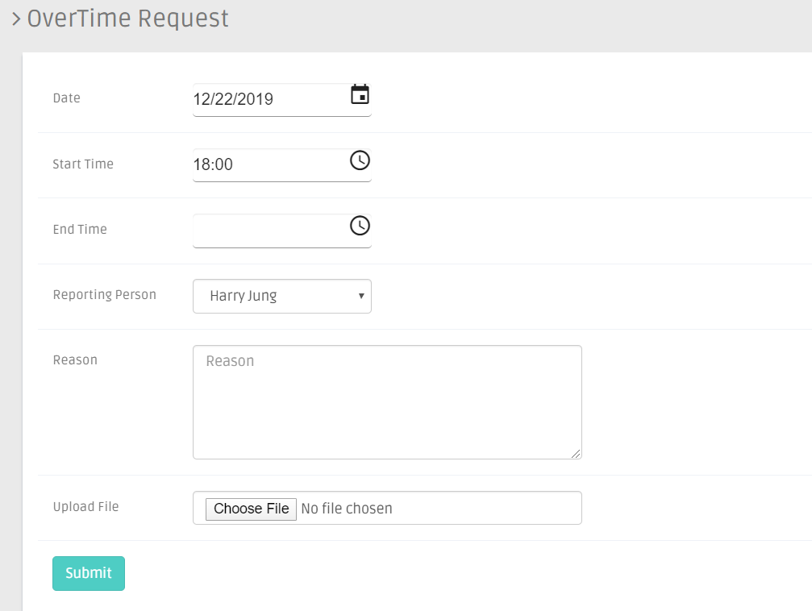

OverTime Request List in Employee:
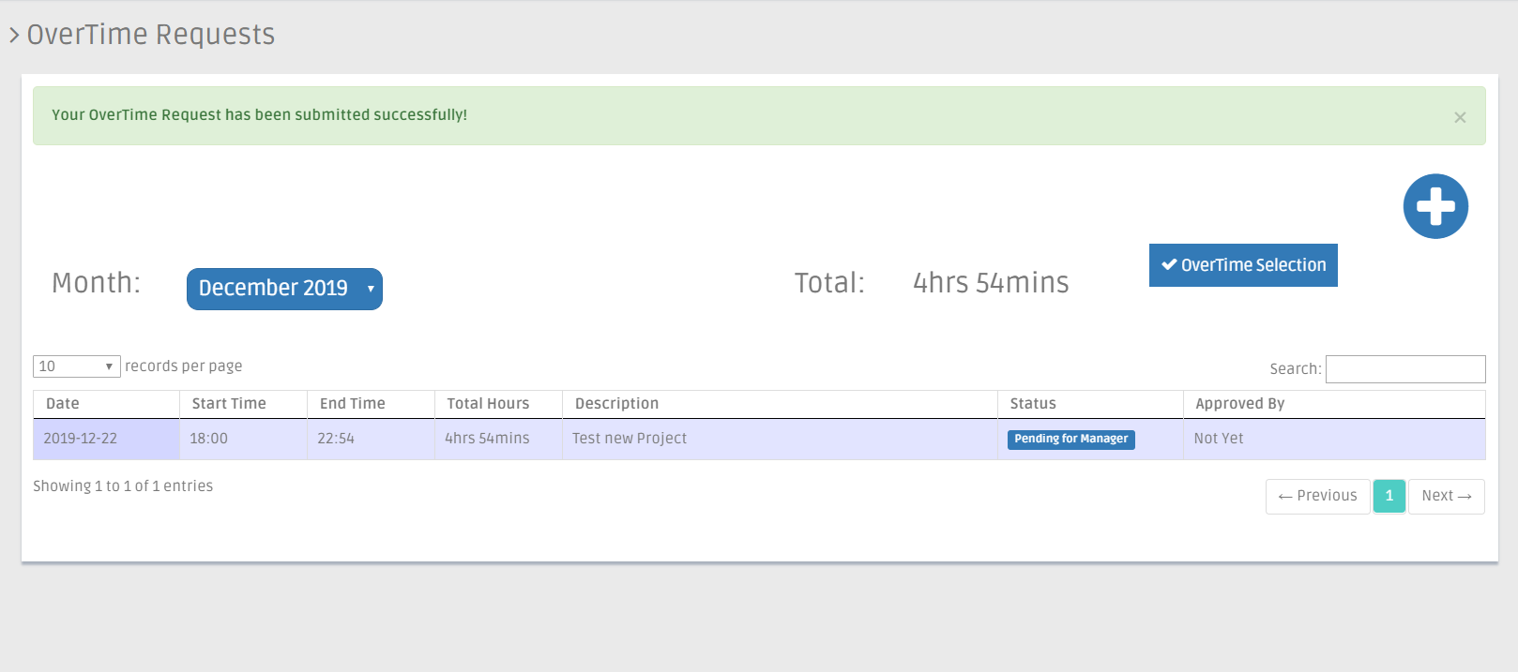

Manager will get notification about New OverTime Request:

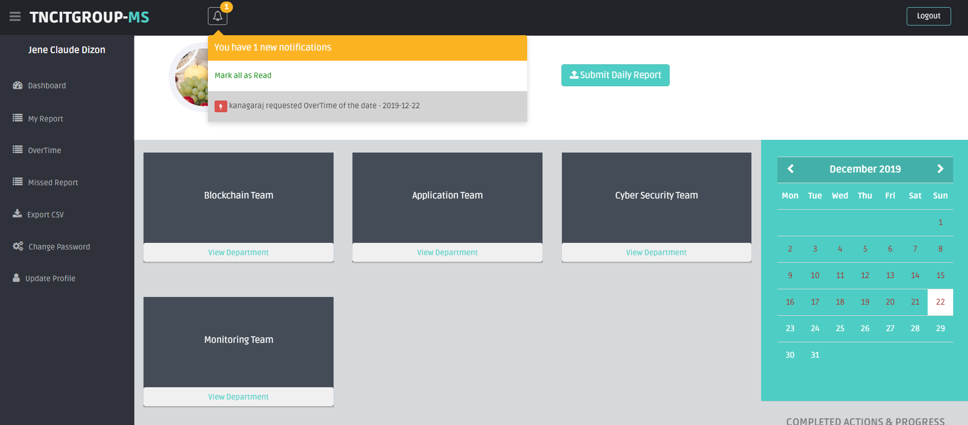

Manager will Approve/DisApprove:

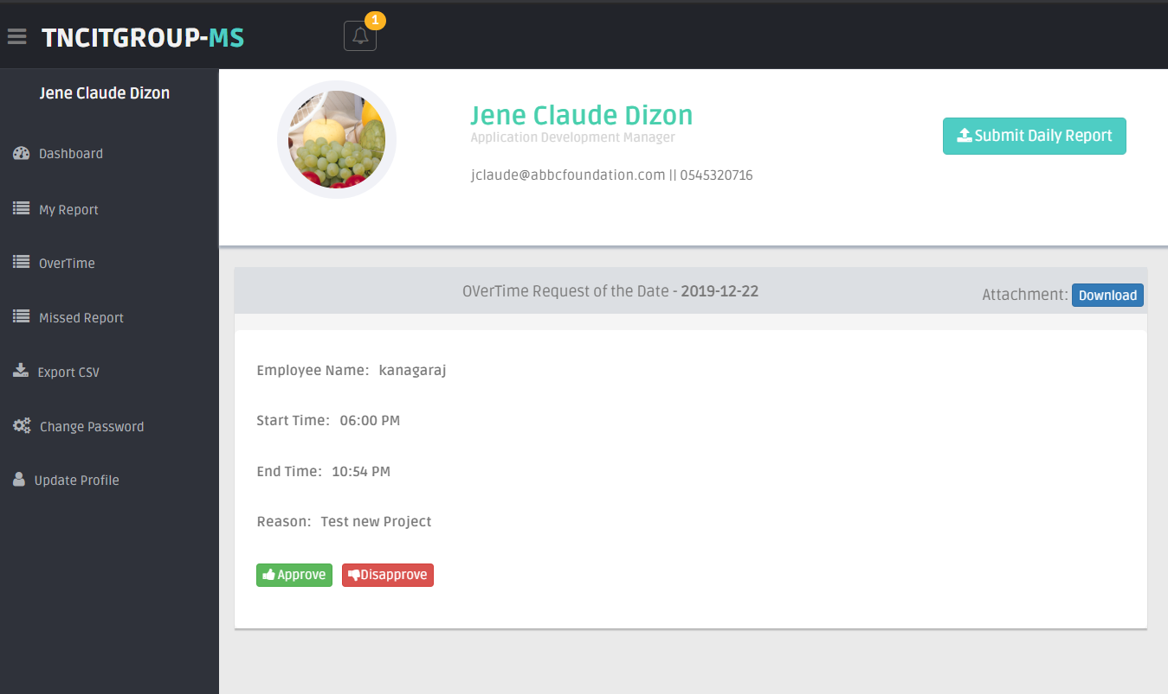

After Manager Approval, List of OverTime shown:

