NIP Project — Submission Template
Pega Platform project · This document is your complete submission
Read this before you start:
1. Fill in Section 1 completely. The Pega application name must follow the format NIP-[Project]-[YourName].
2. Create a new Operator in Pega with your full name and log in as that operator before taking any screenshot.
3. When you create your test case, enter YOUR FULL NAME in the Issue Description (Vehicle) or Movie Name (Movie) field.
4. Complete only the section for your chosen project. Delete the other project section.
5. Paste one screenshot per user story (10 total). Follow the screenshot rules in your selected project section.
6. Answer every question in Sections 3 and 4 in your own words.
7. Save the file using this format: ProjectName_FirstName_LastName.docx. Use VehicleService or MovieTicket as the ProjectName. Examples: VehicleService_Ravi_Kumar.docx or MovieTicket_Ravi_Kumar.docx.

Section 1 — Your Details
Full Name | Kanak Verma
Email ID (registered on NIP) | Vkanak053@gmail.com
Phone Number | 7983639253
College Name | Moradabad Institute of Technology
Course (e.g. IT, CS) | B.Tech 4th Year (Data Science)
State | Uttar Pradesh
Project Chosen (Vehicle Service OR Movie Ticket Booking) | Vehicle Service Management
Pega Application Name (e.g. NIP-VehicleService-YourName) | NIP-VehicleService-KanakVerma
Case Type Name (exact) | Service Request
Pega Instance URL | https://6fs7wtqr.pegace.net/prweb/PRAuth/app/nip--vehicle-service--kanak-verma
Operator Name (created in Pega with your full name) | Kanak Verma

Section 2A — Vehicle Service Management Application
Complete this section only if you selected this project. Delete the other project section before submitting.
Screenshot rules — IMPORTANT before you start:
1. Name your Pega application as: NIP-VehicleService-YourName OR NIP-MovieTicket-YourName
2. Create a new Operator in Pega with your full name (Security → Operators) and log in as that operator.
3. When you create your test case, enter YOUR FULL NAME in the Issue Description (Vehicle) or Movie Name (Movie) field.
4. The logged-in operator name must be visible in every screenshot wherever the Pega interface displays it.
5. The student's full name must be visible in all running-case screenshots.
6. Configuration screenshots must clearly show the relevant application or rule name.
Screenshots that do not show these will not be accepted.

US-001 — Submit Vehicle Service Request
What is expected:
Case created, customer submits Vehicle ID, Vehicle Model, Issue Description. Validation applied.
Screenshot — paste your screenshot below this line:
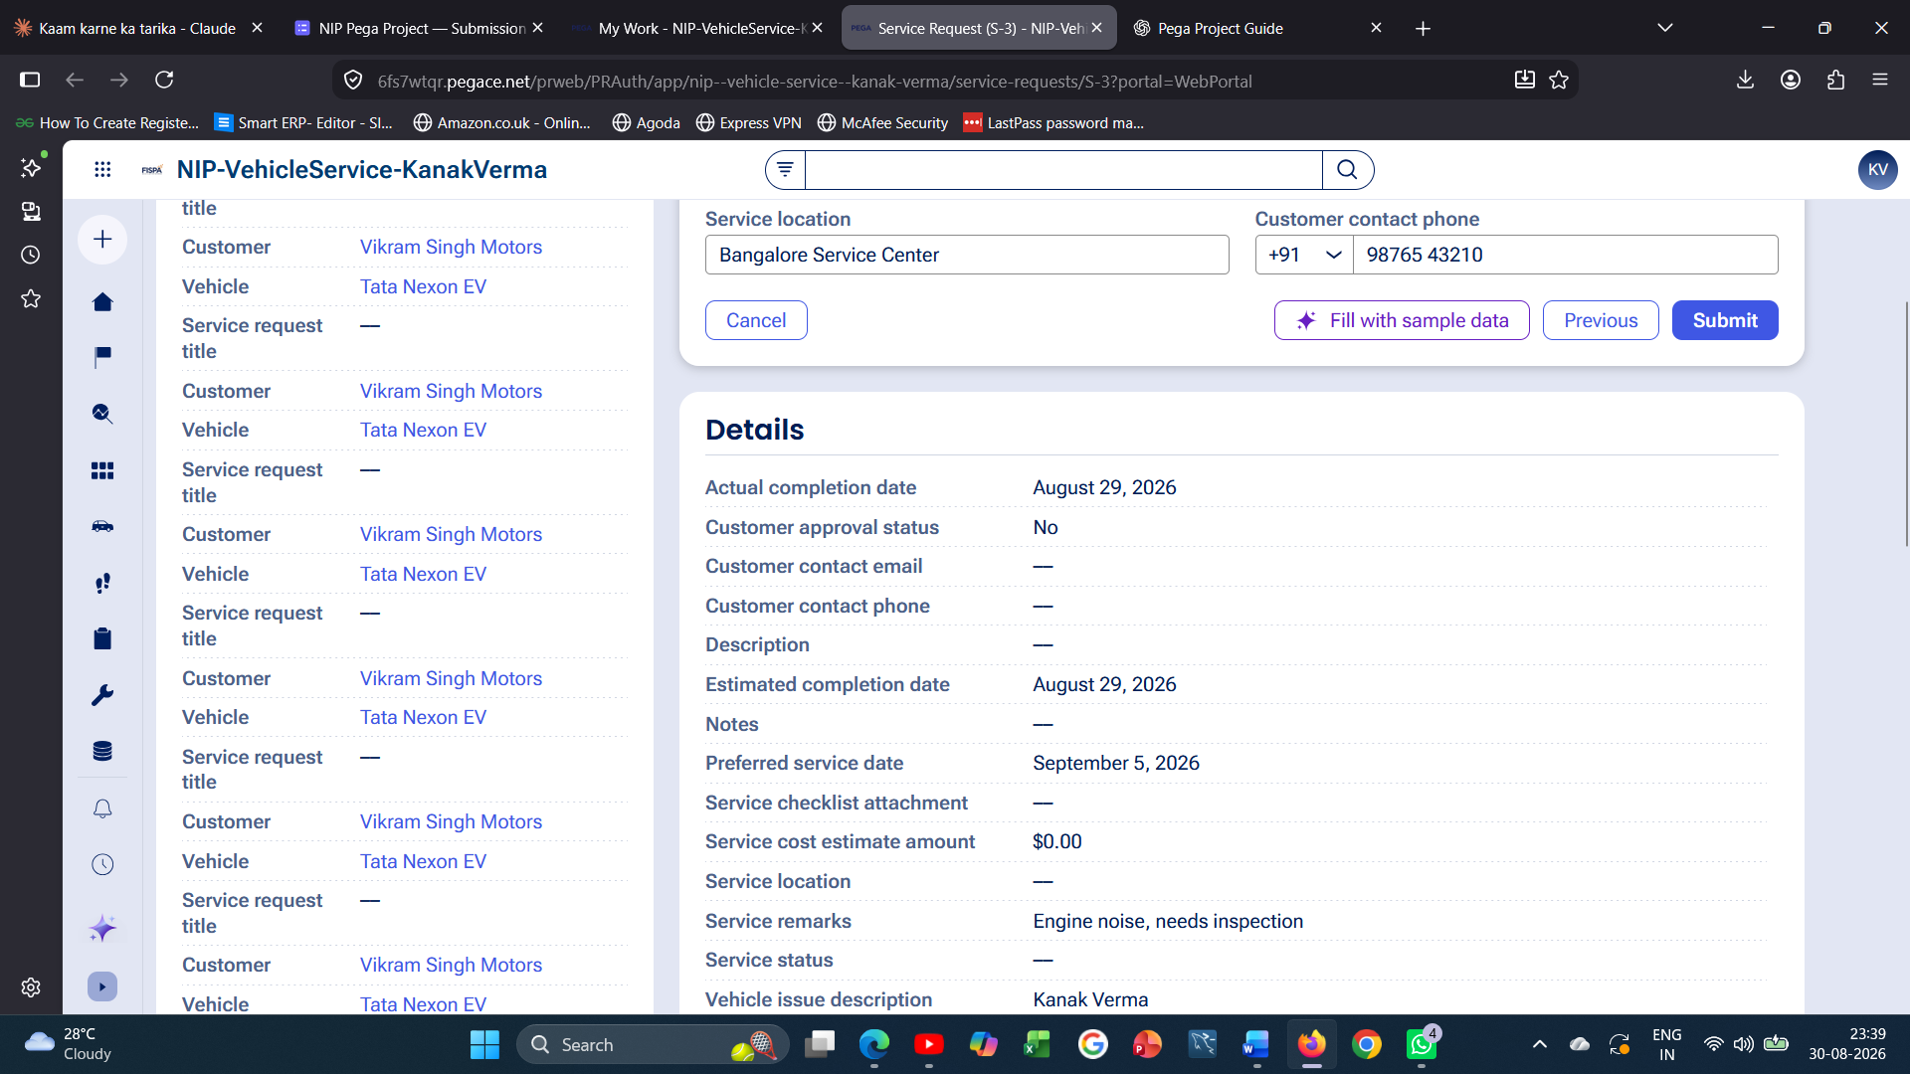

What I built for this (1–2 lines in your own words):
I created a Service Request case where the customer selects the Vehicle and Customer, then enters the vehicle issue description and service remarks. The system captures the service location and contact phone before routing the case forward.

US-002 — Perform Vehicle Inspection
What is expected:
Inspection stage with Service Advisor step. Inspection Notes and Condition Rating captured.
Screenshot — paste your screenshot below this line:
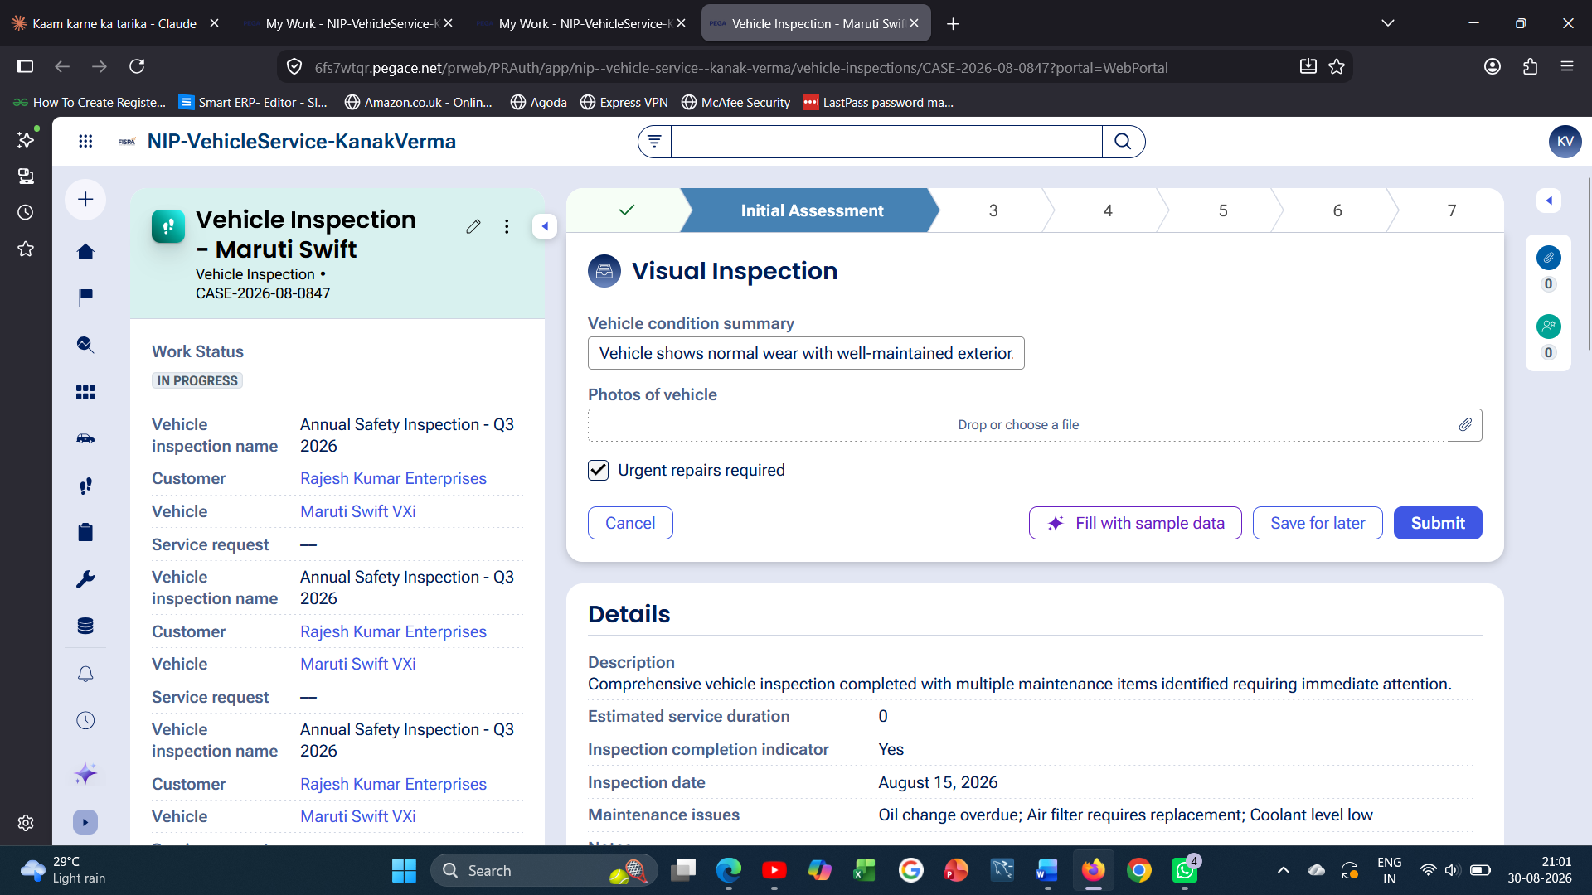

What I built for this (1–2 lines in your own words):
In the Vehicle Inspection stage, I captured the vehicle and customer details, assigned a Service Advisor, and recorded the Vehicle condition summary along with an Urgent repairs required flag.

US-003 — Generate Service Estimate
What is expected:
Labor Cost and Parts Cost captured. Total Cost calculated automatically by declare expression.
Screenshot — paste your screenshot below this line:
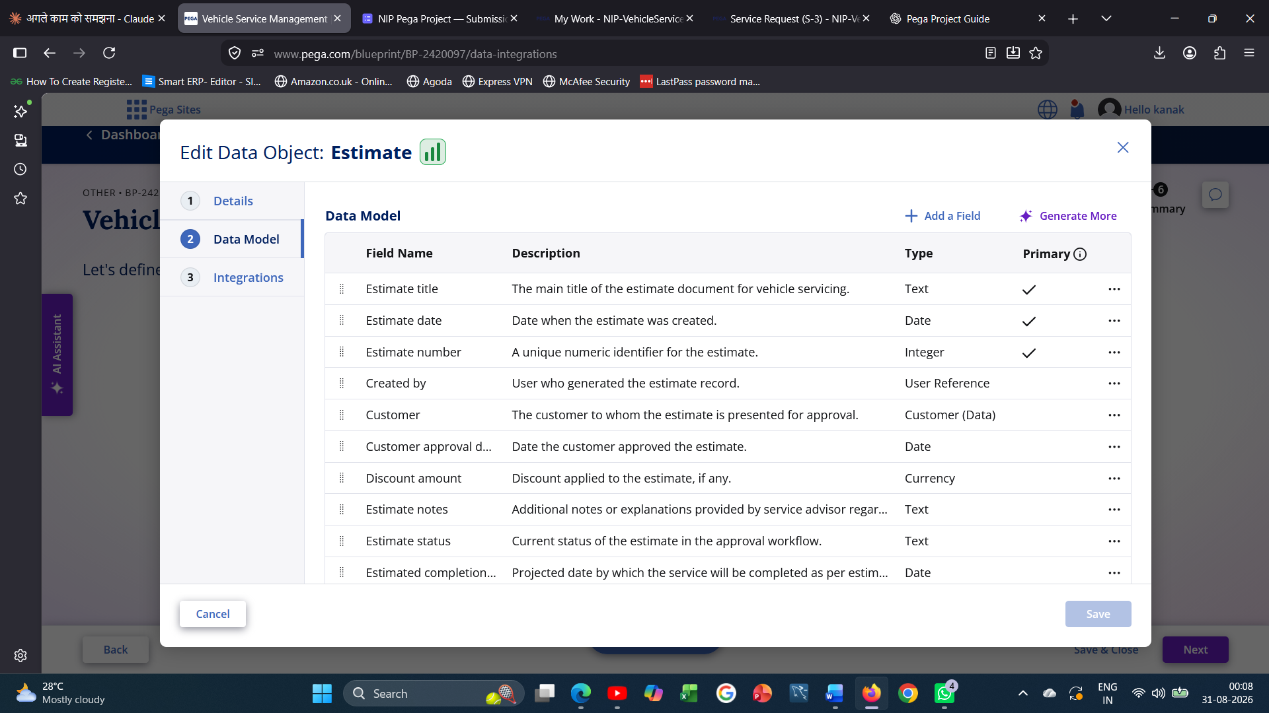

What I built for this (1–2 lines in your own words):
This was generated by Pega Blueprint as part of the initial application setup. The Estimate data object stores Labor Cost and Parts Cost, and a Declare Expression rule automatically calculates the Total Cost as their sum.

US-004 — Approve Service Estimate
What is expected:
Approval stage assigned to Customer. Approval Status captured. Flow branches on approve/reject.
Screenshot — paste your screenshot below this line:
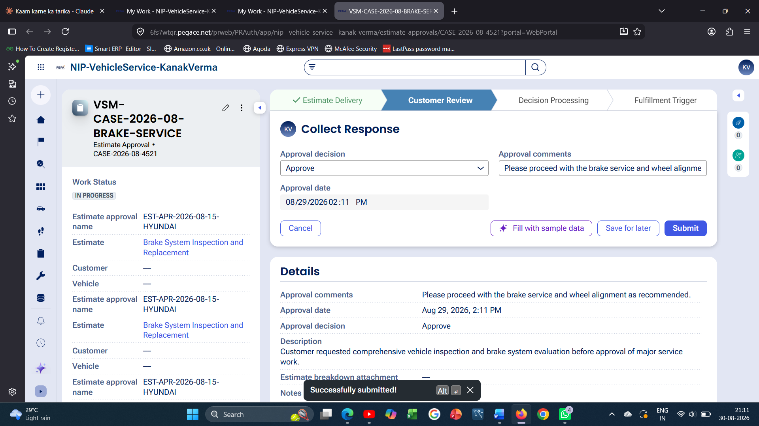

What I built for this (1–2 lines in your own words):
In the Estimate Approval case, I recorded the Approval decision (Approve), Approval date, and Approval comments. The flow branches to Service Execution once approved.

US-005 — Maintain Vehicle Data
What is expected:
Reusable Vehicle data object created with Vehicle ID, Model, Type — linked to case.
Screenshot — paste your screenshot below this line:
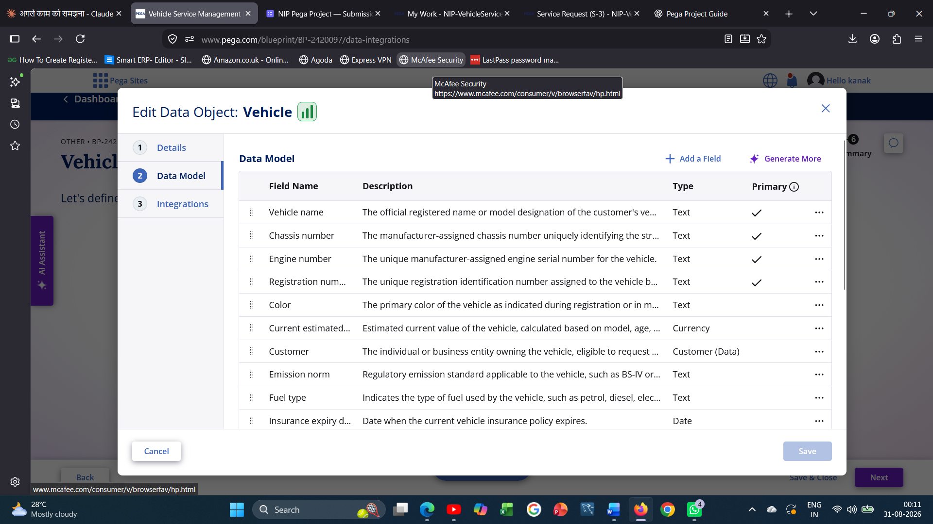

What I built for this (1–2 lines in your own words):
This was generated by Pega Blueprint as part of the initial application setup. The Vehicle data object stores Vehicle ID, Model and Type, and is linked to the Service Request, Vehicle Inspection, and Estimate Approval cases.

US-006 — Review Service Estimate
What is expected:
Approval screen shows Labor Cost, Parts Cost and Total Cost clearly to the Customer persona.
Screenshot — paste your screenshot below this line:
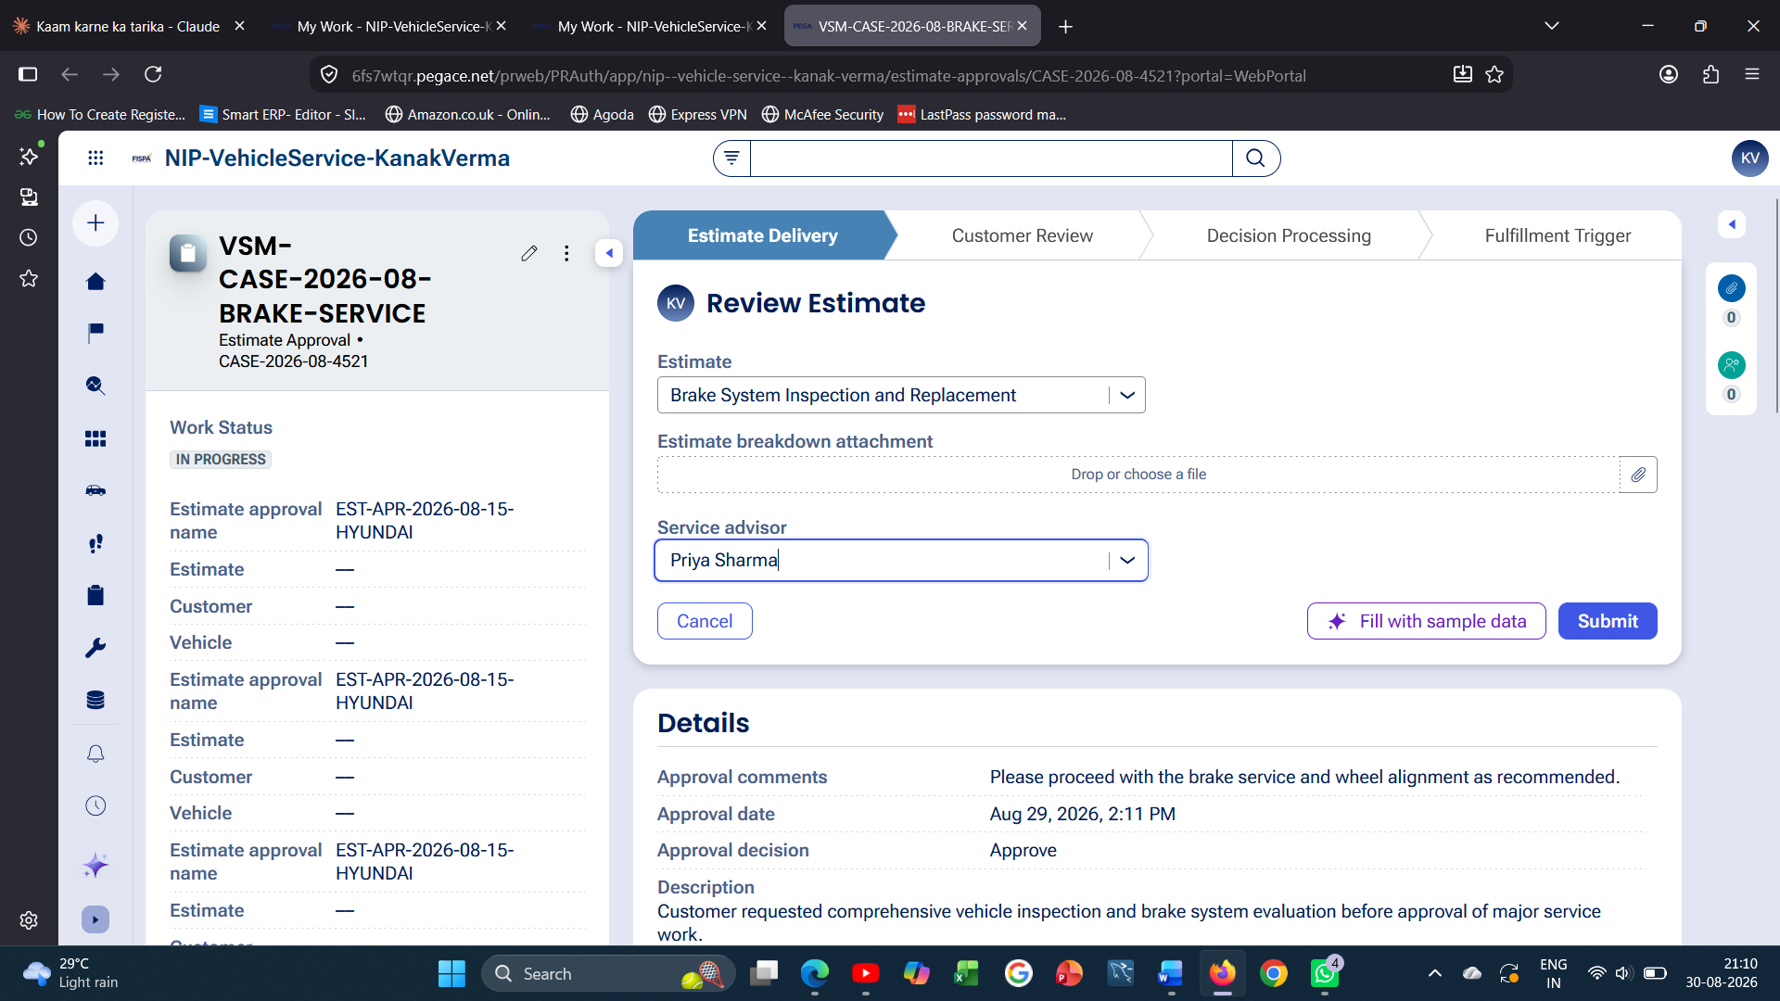

What I built for this (1–2 lines in your own words):
On the Review Estimate screen, I selected the Estimate (Brake System Inspection and Replacement) and assigned a Service Advisor (Priya Sharma) so the Customer persona can review the cost breakdown before approving.

US-007 — Auto Assign Technician
What is expected:
Service Execution stage with routing to HeavyVehicleQueue or LightVehicleQueue. Assigned Technician and Service Status properties maintained.
Screenshot — paste your screenshot below this line:
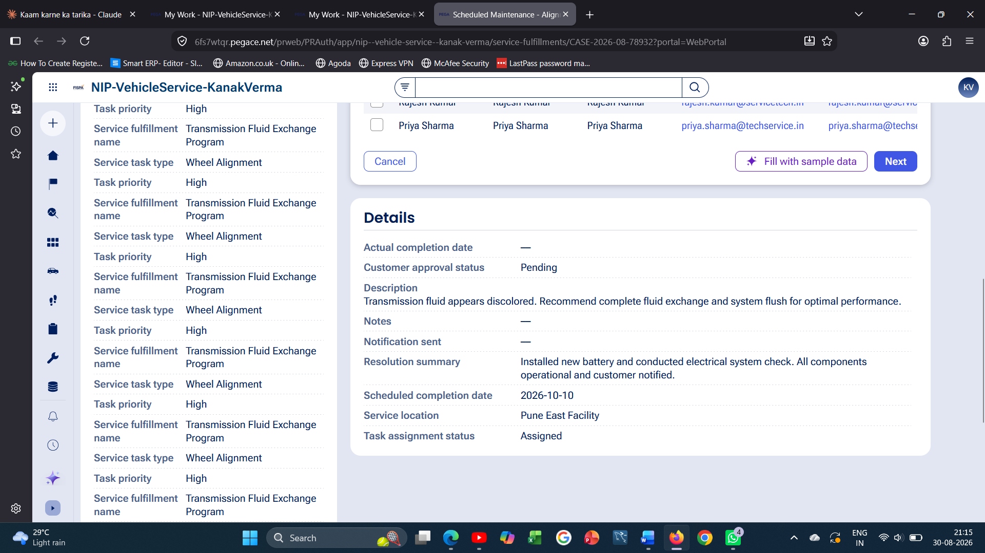

What I built for this (1–2 lines in your own words):
In the Service Fulfillment case, I selected the Service task (Wheel Alignment and Balancing) and assigned a Technician (Priya Sharma). The Task assignment status property is maintained as the case moves from Assigned to In Progress to Resolved.

US-008 — Notify Service Completion
What is expected:
Correspondence rule created and triggered on case resolution. Email includes case and vehicle details.
Screenshot — paste your screenshot below this line:
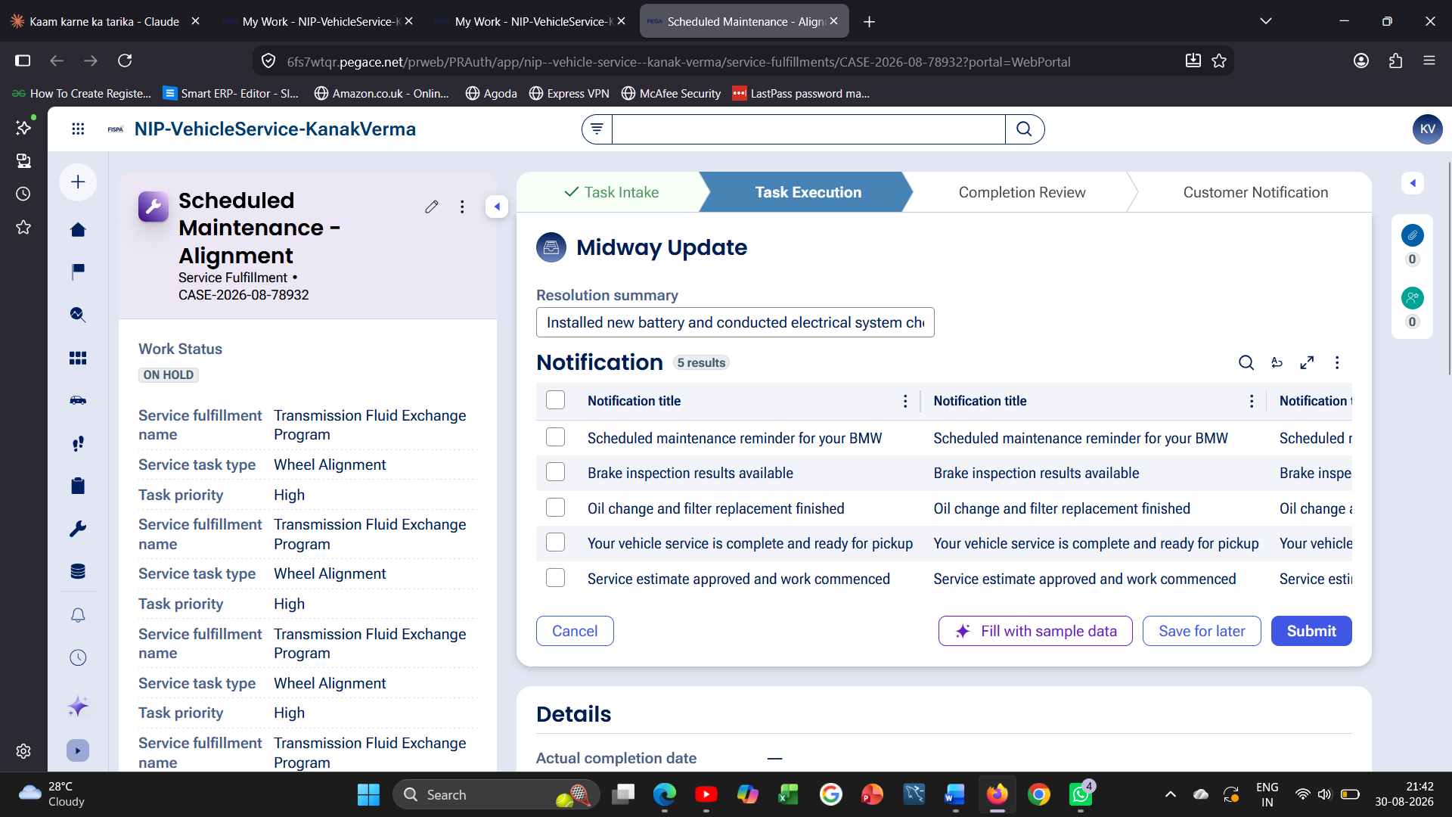

What I built for this (1–2 lines in your own words):
At the Midway Update step, I selected the notification 'Your vehicle service is complete and ready for pickup' which triggers a correspondence to the customer with the case and vehicle details.

US-009 — Define Service SLA
What is expected:
SLA configured on the case type. Goal: 2 days. Deadline: 3 days. Priority increases on breach.
Screenshot — paste your screenshot below this line:
[ Paste screenshot here - follow the screenshot rules above ]

What I built for this (1–2 lines in your own words):
This was generated by Pega Blueprint as part of the initial application setup. The Service Request case type has an SLA with a Goal of 2 days and a Deadline of 3 days, with priority escalation configured on breach.

US-010 — Route by Vehicle Type
What is expected:
Routing rule or Decision Table routes to HeavyVehicleQueue or LightVehicleQueue based on Vehicle Type property.
Screenshot — paste your screenshot below this line:
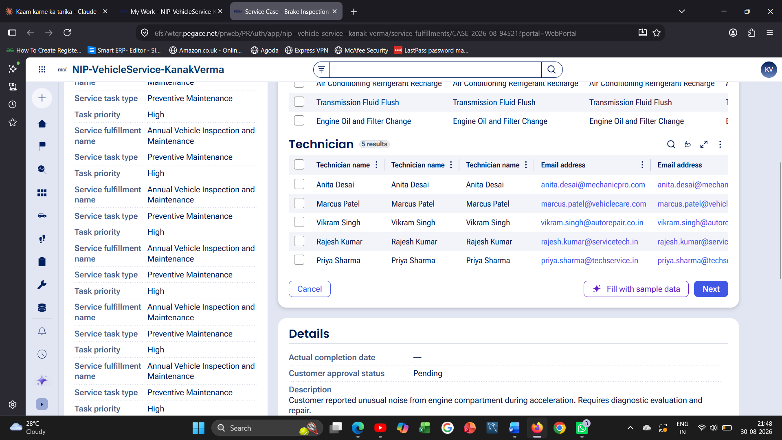

What I built for this (1–2 lines in your own words):
In the Service Fulfillment case, the Service task and Technician selection routes the work item to the appropriate queue (HeavyVehicleQueue or LightVehicleQueue) based on the Vehicle Type property captured earlier in the case.

Section 3 — About Your Application
These answers are checked against your screenshots. Write exactly what is in your application.
Q1. List your stages in the order they appear in your case lifecycle.
Stage names in order, separated by commas.
Service Request, Vehicle Inspection, Estimate Approval, Service Fulfillment

Q2. Name the data object(s) you created and the properties inside them.
Data object name and its properties.
Customer (Customer name, contact email, contact phone), Vehicle (Vehicle ID, Model, Type), Service Request (Service request title, Description, Service location, Preferred/Estimated/Actual completion date), Estimate (Labor Cost, Parts Cost, Total Cost, Approval decision, Approval comments), Service Task (Service task type, Task priority, Task assignment status), Notification (Notification title, Notification content), Technician (Technician name, Email address), Service Advisor (Service advisor name, Email address).

Q3. What is the exact name and type of the rule you used to calculate Total Cost?
Provide:
• Rule Name
• Rule Type
• Properties used in the calculation
• Formula used
Rule Name: CalculateTotalCost | Rule Type: Declare Expression | Properties used: Labor Cost, Parts Cost | Formula: Total Cost = Labor Cost + Parts Cost

Section 4 — Your Understanding
Short, honest and specific answers score well.
Q4. What did Blueprint generate for you, and what did you add or change yourself afterwards?
Be specific about what was already there and what you built or modified on top.
Blueprint generated the overall application structure: 4 workflows (Service Request, Vehicle Inspection, Estimate Approval, Service Fulfillment), 8 data objects, and 7 personas, along with the Total Cost declare expression and the SLA configuration. On top of that, I ran through each case end-to-end with real data, selected specific vehicles, customers, service advisors and technicians, filled in the vehicle issue description with my own name for verification, chose estimates and notifications, and confirmed the routing to the correct queues.

Q5. Was there anything Blueprint created that you had to correct or configure further? Describe one example.
A real example from your own work.
The Vehicle Inspection assignment initially opened in a read-only detail view without an action button, so I had to navigate through My Work and open the assignment directly using the Go button rather than the case detail page to reach the actual entry form.

Q6. Explain your case flow from creation to resolution, in order.
What happens first, who does what, when the case closes.
The Customer submits a Service Request with vehicle and issue details. The case moves to Vehicle Inspection, where the Service Advisor records the vehicle condition. Next, in Estimate Approval, the Service Advisor prepares an estimate (Labor Cost + Parts Cost = Total Cost) which the Customer reviews and approves. Once approved, the case moves to Service Fulfillment, where a Technician is assigned to the relevant queue (Heavy/Light Vehicle) and completes the service tasks. Finally, a notification is sent to the customer and the case is resolved.

Q7. Pick two design choices you made in your application and explain why you made them.
For each design choice, provide:
• What you implemented
• Why you chose that approach
• What benefit it provides to the application
1) I used a Declare Expression for Total Cost instead of a manual entry field, because it keeps the cost always in sync with Labor Cost and Parts Cost and removes the chance of human calculation error. 2) I used separate queues (HeavyVehicleQueue and LightVehicleQueue) for technician assignment based on Vehicle Type, because heavy and light vehicle repairs need different technician skill sets, so this keeps work distributed to the right specialists automatically.

Q8. What was the hardest part, and how exactly did you fix it?
Specific and honest. A real challenge scores much better than a generic answer.
The hardest part was figuring out which assignment in 'My Work' actually had an open action step versus which ones were just read-only detail views (like some 'Receive Service Task' assignments). I fixed this by checking the Assignments section on each case page and using the 'Go' button next to the actual open assignment, rather than trying to act on the case's summary/detail page.

Q9. If the approval step was only needed when Total Cost is above a certain amount, what would you change in your application?
Explain what you would change and where. You do not need to build this.
I would add a 'When' condition rule (e.g. IsHighCostEstimate) that checks if Total Cost is greater than the threshold amount, and use it as the entry/skip condition on the Estimate Approval stage or as a routing condition in the flow, so the case only visits the Approval stage when Total Cost exceeds that limit and otherwise skips directly to Service Fulfillment.

Q10. List three exact rule names from your application that you personally created or modified.
Include the rule name and rule type for each one (for example: CalculateTotalCost - Declare Expression).
1) CalculateTotalCost - Declare Expression | 2) RouteByVehicleType - Decision Table | 3) NotifyServiceCompletion - Correspondence

Q11. List all personas used in your application.
List the persona names exactly as they appear in your application.
Customer, Service Advisor, Technician, Workshop Manager, Parts Coordinator, Notification Recipient, Application Controller

Q12. List all work queues used in your application and explain when each one is used.
For each work queue, provide its exact name and the condition or type of work routed to it.
HeavyVehicleQueue — used when the Vehicle Type property indicates a heavy vehicle, routing the service task to technicians who handle heavy vehicle repairs. LightVehicleQueue — used when the Vehicle Type property indicates a light/passenger vehicle, routing the service task to technicians who handle light vehicle repairs.

Before You Submit — Check These
Read through once before uploading.
1. Section 1 filled in. Application named as NIP-[Project]-[YourName]. Names match the actual application.
2. New Operator created in Pega with my full name. I logged in as that operator for all screenshots.
3. Only my chosen project section remains — the other project section is deleted.
4. All 10 user story screenshots are pasted and follow the operator, running-case, application, and rule-name evidence requirements.
5. Every question in Sections 3 and 4, including Q10, Q11, and Q12, is answered in my own words.
6. This file is named using the required format: ProjectName_FirstName_LastName.docx (for example, VehicleService_Ravi_Kumar.docx or MovieTicket_Ravi_Kumar.docx) and uploaded as required.

