Vision-Based Detection and Classification
of Machining Chips in CNC Turning
A Computer-Vision Pipeline for Automatic Chip Shape Recognition
Project Report

What This Project Is About
When metal is cut on a lathe, it does not come off as dust or powder — it curls away as a continuous piece called a “chip.” The shape of this chip (a long ribbon, a tight spiral, or a small broken arc) tells an engineer a lot about how the cutting is going: whether the tool is sharp, whether the speed is right, and whether the process is safe and efficient. Normally, judging chip shape is done by eye, which is slow and inconsistent.
This project builds an automatic system that watches high-speed video of a lathe while it is cutting, finds the chip in every frame, and classifies its shape — without a human having to look at the footage. The end goal is a tool that can run in real time on the shop floor and flag chip shape automatically.
Three materials were tested: Aluminium, Copper, and Mild Steel, since each produces a very different kind of chip.

Data Used
The project uses 27 high-speed videos (60 frames per second) of real turning operations, giving a total of 62,301 individual frames.
Material | Videos | Total Frames
Aluminium | 7 | 18,089
Copper | 5 | 12,316
Mild Steel | 15 | 31,896
Total | 27 | 62,301

To make sure the results are trustworthy, the videos were split into training, validation, and test groups by whole video, not by individual frame. This matters because two frames next to each other in the same video look almost identical — if both ended up on different sides of the split, the system would effectively be “tested” on something it had already seen. Splitting by whole video avoids this and gives an honest measure of how well the system generalizes to a cutting run it has never watched before.
Split | Videos | Frames | Share
Training | 19 | 43,974 | 70.6%
Validation | 4 | 9,194 | 14.8%
Test (unseen) | 4 | 9,133 | 14.7%

How the System Works
The system processes each video in three broad stages, described below in plain terms.

Stage 1 — Following the Tool Tip
Because the cutting tool moves sideways as the workpiece turns, a fixed camera frame will not keep the actual cutting point centred for long. A tracking algorithm (OpenCV's CSRT tracker) locks onto the tool tip at the start of each video and follows it automatically, frame by frame. A small 300×300 pixel window is then cropped around the tip in every frame, so the system always looks at the same relative spot: the cutting zone.

Stage 2 — Keeping Only the Useful Frames
Not every frame shows the tool actually cutting — some show it retracted or idle between passes. Those frames are automatically filtered out. The remaining frames are also thinned out (one frame kept out of every 15) since consecutive frames barely differ from each other, and a simple sharpness check discards blurry frames. Out of 4,165 sampled crops, 3,820 (about 92%) were kept as clean, active cutting frames.

Stage 3 — Finding and Tracing the Chip
This is the core image-processing stage. Each cropped frame is cleaned up and simplified in a sequence of steps until only the chip's outline is left. In short, the pipeline:
- Balances out harsh glare and shadows in the image, and smooths out surface grain without losing fine detail.
- Detects all the edges in the frame (outlines of the tool, workpiece, and chip).
- Blanks out regions of the image that can never contain a chip (like the machine bed and tool holder), so the search area is smaller and cleaner.
- Compares each frame with the last few frames to remove anything that isn't moving — since the workpiece and tool holder stay still, only the moving chip is left behind.
- Removes bright straight-line glare reflections coming off the spinning, polished workpiece, while keeping the curved chip edges untouched.
- Starts from the exact point where cutting happens and “grows” outward along connected edges, so stray specks elsewhere in the image are ignored.
- Bridges any small gaps (caused by glare) and thins the final chip outline down to a single clean line — its skeleton — that traces the chip's path and curl.
Once this clean skeleton is available, simple geometric measurements are taken from it — area, perimeter, how round or elongated the shape is, and how many times it curls. These measurements are enough to sort each chip into standard categories used in industry (ISO 3685): continuous ribbon, helical spring, C-shaped, or short arc.

Visual Walkthrough of One Frame
The figures below follow a single Aluminium cutting frame through the pipeline, from the raw camera image to the final traced chip.
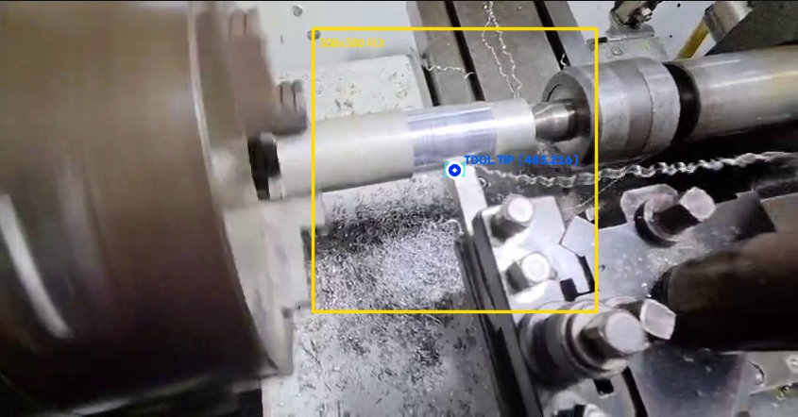
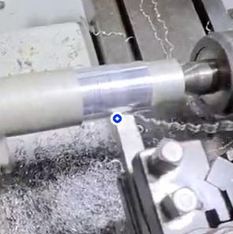
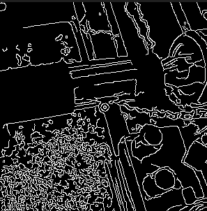

Figure 1. Top: the tool tip being tracked (yellow box) in the raw frame. Middle: the cropped 300×300 px cutting zone. Bottom: edges detected in that crop.





Figure 2. Top: the same edges after blanking out impossible chip locations (sector masking). Bottom: the result after removing everything that isn't moving (background subtraction) — only the tool holder outline and moving chip edges remain.

Figure 3. Top: straight glare-line reflections removed, leaving the true chip edges. Bottom: the final chip contour after tracing outward from the cutting point.
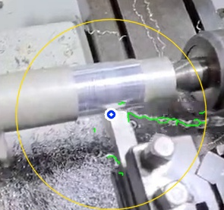
Figure 4:. The skeleton overlaid (in green) back onto the original frame, showing the chip's real flow path as it leaves the tool tip.
.

