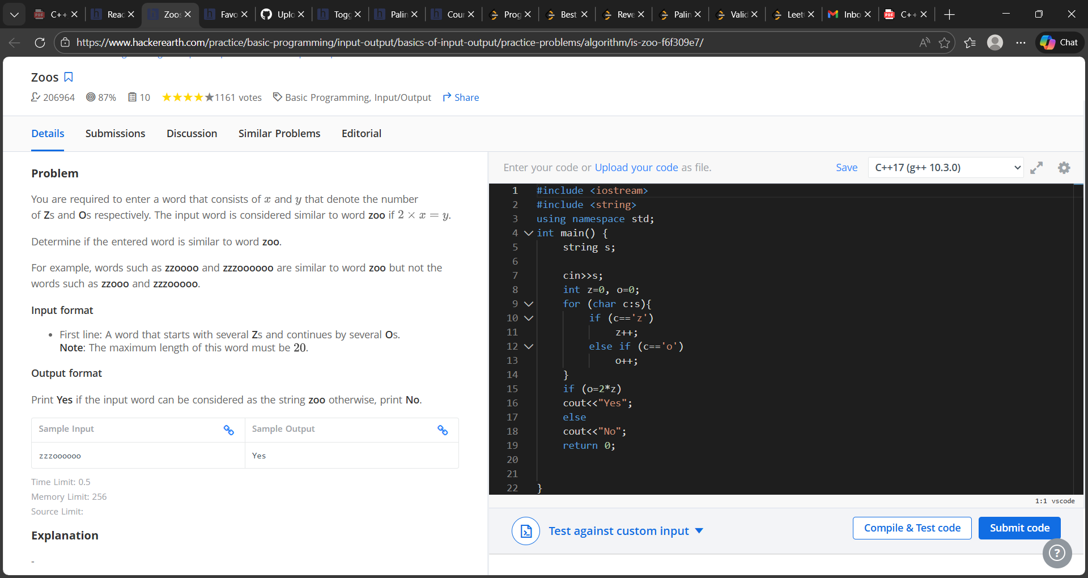

#include <iostream>
#include <string>
using namespace std;
int main() {
string s;
cin>>s;
int z=0, o=0;
for (char c:s){
if (c=='z')
z++;
else if (c=='o')
o++;
}
if (o=2*z)
cout<<"Yes";
else
cout<<"No";
return 0;
}

