Experiment No. : 1

Experiment Title: Demonstrate inline, internal, and external JavaScript; use console methods; create a webpage showing user info and a welcome message.
Software/Tools Required:
- Any text editor / VS Code
- Web Browser (Chrome/Edge) with Developer Console

Experiment Program Code
Code 1: InHead.html (Internal JS in Head Section)
<!DOCTYPE html>
<html lang="en">
<head>
<meta charset="UTF-8">
<meta name="viewport" content="width=device-width, initial-scale=1.0">
<title>JavaScript in Head</title>
<script>
function myFunction() {
document.getElementById("heading2").innerHTML = "Heading changed.";
}
</script>
</head>
<body>
<h2 id="heading2">Demo JavaScript in Head</h2>
<p id="demo">A paragraph.</p>
<button type="button" onclick="myFunction()">Try it!</button>
</body>
</html>
Code 2: InBodySection.html (Internal JS in Head Section)
<!DOCTYPE html>
<html lang="en">
<head>
<meta charset="UTF-8">
<meta name="viewport" content="width=<device-width>, initial-scale=1.0">
<title>Document</title>
</head>
<body>
<h2>Javascript in Body</h2>
<p id = "demo"></p>

<script>
document.getElementById("demo").innerHTML = "My First JavaScript Program.";
</script>
</body>
</html>

Code 3: Windows1.html (window alert() )
<!DOCTYPE html>
<html lang="en">
<head>
<meta charset="UTF-8">
<meta name="viewport" content="width=device-width, initial-scale=1.0">
<title>Document</title>
</head>
<body>
<script>
window.alert(5 + 6);
</script>
</body>
</html>
Code 4: WindowsPrint.html (window.print() )
<!DOCTYPE html>
<html lang="en">
<head>
<meta charset="UTF-8">
<meta name="viewport" content="width=device-width, initial-scale=1.0">
<title>Document</title>
</head>
<body>
<h2>The window.print() Method</h2>
<p>Click the button to print the current page.</p>
<button onclick="window.print()">Print Page</button>
</body>
</html>
Code 5: DocumentsWrite.html (document.write() )
<!DOCTYPE html>
<html lang="en">
<head>
<meta charset="UTF-8">
<meta name="viewport" content="width=<device-width>, initial-scale=1.0">
<title>Document</title>
</head>
<body>
<h1>My First Web Page</h1>
<p>My first paragraph</p>
<script>
document.write(5 + 6);
</script>
</body>
</html>
Code 6: INLINE_JS.html (Inline JavaScript)
<!DOCTYPE html>
<html lang="en">
<head>
<meta charset="UTF-8">
<meta name="viewport" content="width=device-width, initial-scale=1.0">
<title>Inline JS Demo</title>
</head>
<body>
<h2>Inline JavaScript Example</h2>
<button onclick="alert('Welcome to JavaScript !!')">Click Me !!</button>
</body>
</html>
Code 7: INTERNAL_JS.html (Internal Javascript)
<!DOCTYPE html>
<html lang="en">
<head>
<meta charset="UTF-8">
<meta name="viewport" content="width=<device-width>, initial-scale=1.0">
<title>Document</title>
</head>
<body>
<h2>Internal JavaScript Example</h2>
<p>This is a paragraph.</p>
<script>
document.write(5 + 6);
</script>
</body>
</html>
Code 8a: EXTERNAL_JS.html (External JS : HTML file)
<!DOCTYPE html>
<html lang="en">
<head>
<meta charset="UTF-8">
<meta name="viewport" content="width=device-width, initial-scale=1.0">
<title>External JS Demo</title>
</head>
<body>
<h2>External Javascript Demo</h2>
<p id="demo">Welcome !!</p>
<button onclick="changeText()">Click Me !!</button>
<script src="script.js"></script>
</body>
</html>
Code 8b: script.js (External JS : JavaScript file)
function changeText() {
document.getElementById("demo").innerHTML = "Hello ! This text is generated by javascript";
}
Code 9: Console.html (console.log)
<!DOCTYPE html>
<html lang="en">
<head>
<meta charset="UTF-8">
<meta name="viewport" content="width=device-width, initial-scale=1.0">
<title>Console Log Demo</title>
</head>
<body>
<script>
console.log(5 + 6);
</script>
</body>
</html>
Code 10: ConsoleTable.html (console.table)
<!DOCTYPE html>
<html lang="en">
<head>
<meta charset="UTF-8">
<meta name="viewport" content="width=device-width, initial-scale=1.0">
<title>Console Table Demo</title>
</head>
<body>
<h2>Javascript console.table() Demo</h2>
<script>
let students = [
{ RollNo: 201, Name: "Rahul", Course: "BTech" },
{ RollNo: 202, Name: "Priya", Course: "MTech" },
{ RollNo: 203, Name: "Amit", Course: "BArch" }
];
console.table(students);
</script>
</body>
</html>
Code 11: ConsoleTrace.html (console.trace)
<!DOCTYPE html>
<html lang="en">
<head>
<meta charset="UTF-8">
<meta name="viewport" content="width=device-width, initial-scale=1.0">
<title>Console Trace Demo</title>
</head>
<body>
<button onclick="startProgram()">Click Here !!</button>
<script>
function startProgram() {
displayMessage();
}
function displayMessage() {
console.log("Welcome to JavaScript !!");
console.trace("Function Call Trace");
}
</script>
</body>
</html>

4. Output
Code 1: InHead.html (Internal JS in Head Section)

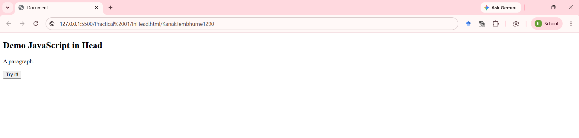
Code 2: InBodySection.html (Internal JS in Head Section)

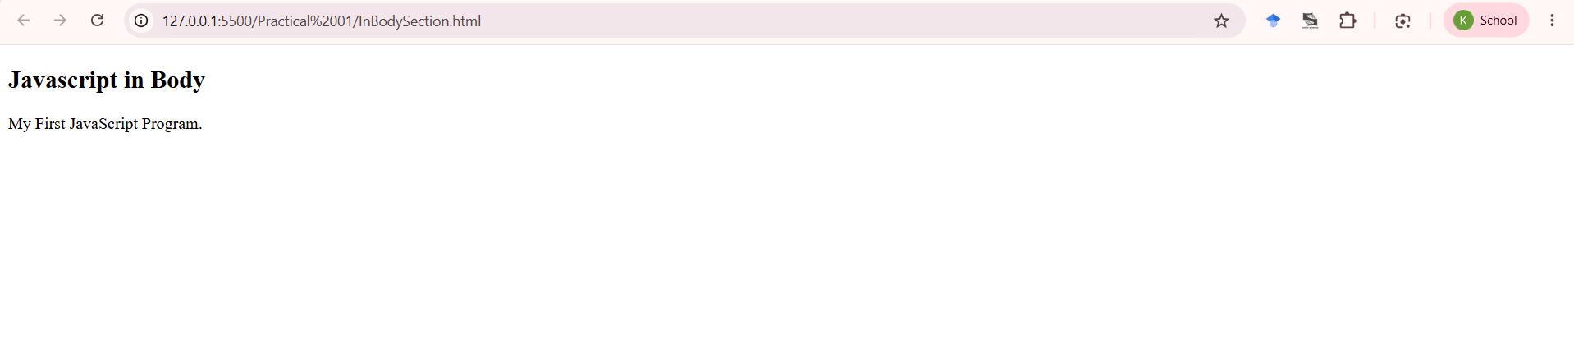
Code 3: Windows1.html (window alert() )

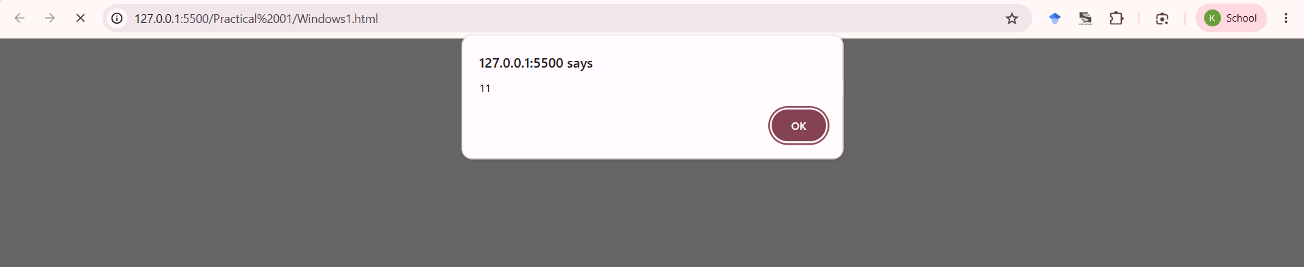
Code 4: WindowsPrint.html (window.print() )

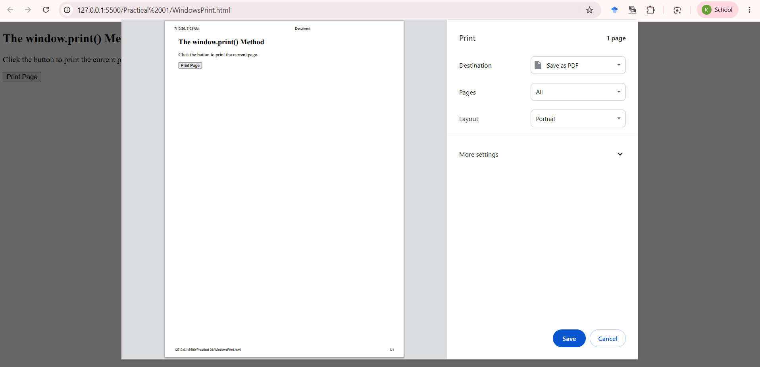
Code 5: DocumentsWrite.html (document.write() )

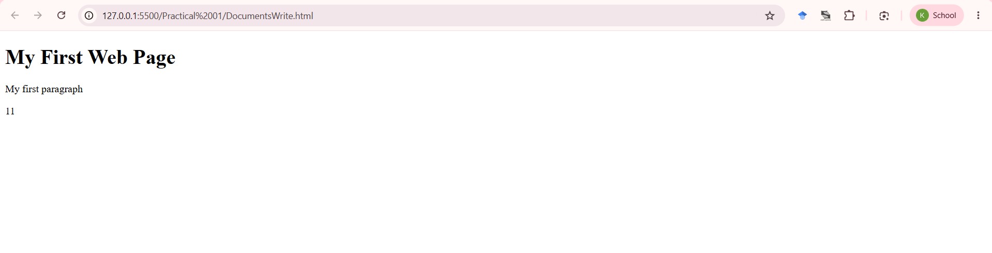
Code 6: INLINE_JS.html (Inline JavaScript)

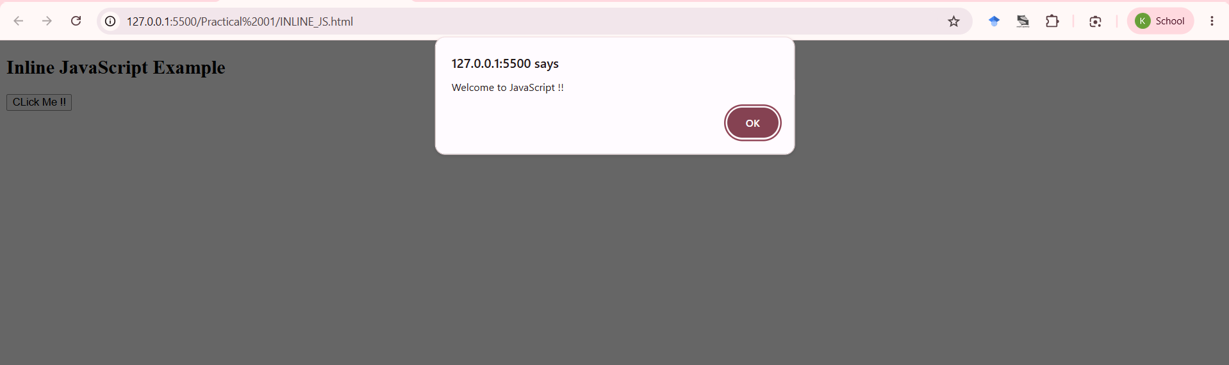
Code 7: INTERNAL_JS.html (Internal Javascript)

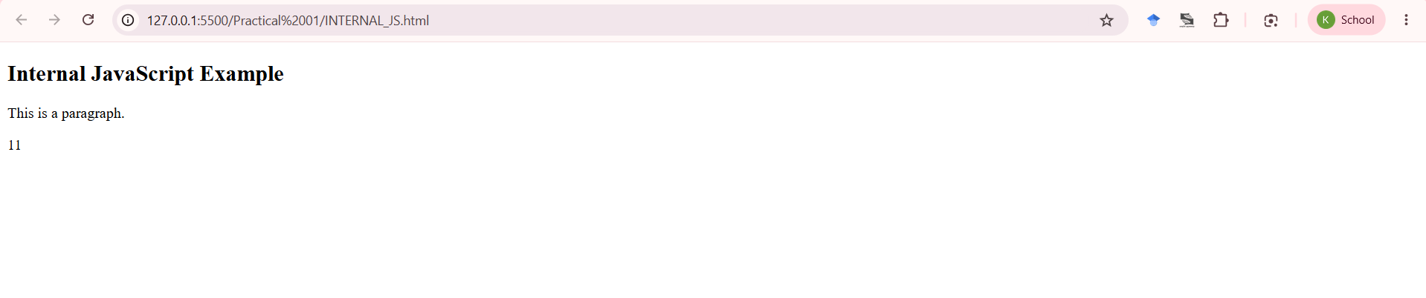
Code 8: EXTERNAL_JS.html (External JS : HTML file) and script.js (Javascript file)

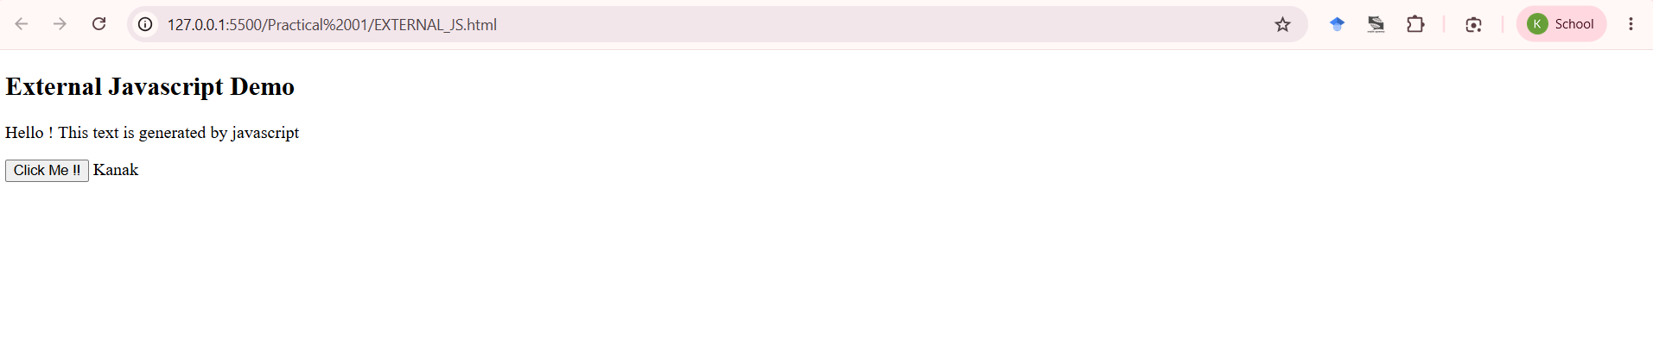
Code 9: Console.html (console.log)

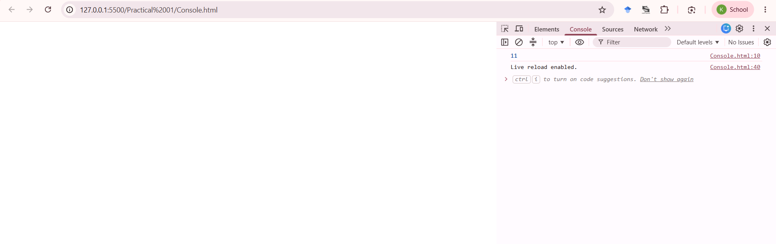
Code 10: ConsoleTable.html (console.table)

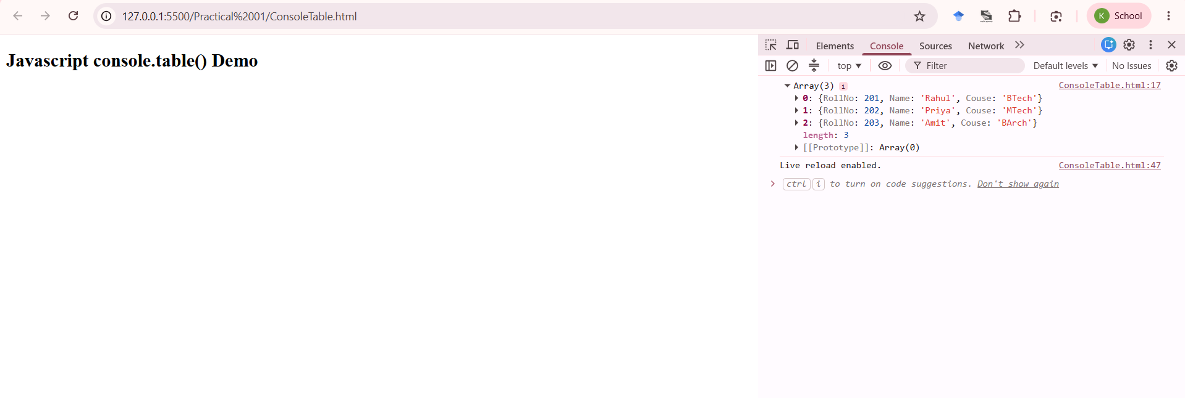
Code 11: ConsoleTrace.html (console.trace)

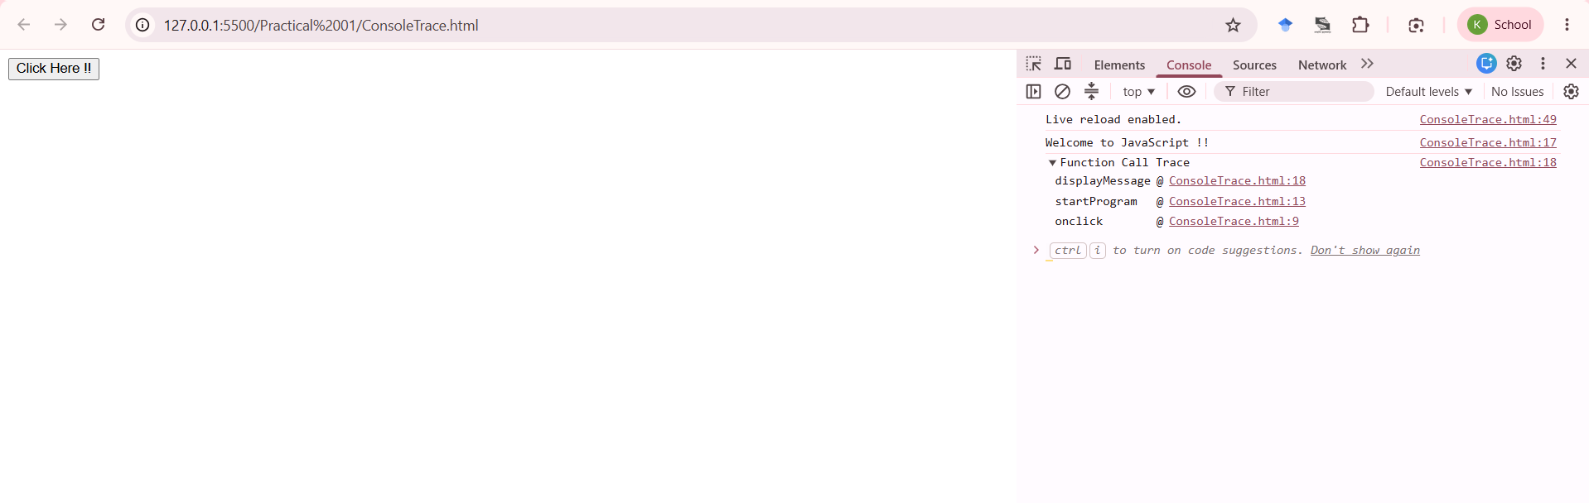

5. Case Study Title
SIT Nagpur Institute Webpage : Home Page Case Study (Using Inline, Internal JavaScript, window.alert() and DOM Styling)

6. Case Study Program Code
Casestudy_01_Kanak_Tembhurne_1290.html
<!DOCTYPE html>
<html lang="en">
<head>
<meta charset="UTF-8">
<meta name="viewport" content="width=device-width, initial-scale=1.0">
<title>PRN: 24070521290 | Name: Kanak Tembhurne | File: c:\Users\KANAK\OneDrive\Desktop\เอกสาร\Symbiosis\Sem 5\JavaScript\Practical 01\Casestudy_01.html</title>
<style>
:root {
--red: #c62828;
--red-dark: #8c0000;
--blue: #113c5f;
--light: #f7f7f7;
--text: #333;
}

* { box-sizing: border-box; margin: 0; padding: 0; }
body { font-family: Arial, sans-serif; color: var(--text); background: white; line-height: 1.6; }
img { max-width: 100%; display: block; }
a { text-decoration: none; color: inherit; }
ul { list-style: none; }
.container { width: 90%; max-width: 1100px; margin: auto; }

.topbar { background: var(--red-dark); color: white; padding: 8px 0; font-size: 13px; }
.topbar .container { display: flex; justify-content: space-between; flex-wrap: wrap; gap: 8px; }

.navbar { background: white; padding: 12px 0; border-bottom: 3px solid var(--red); }
.navbar .container { display: flex; justify-content: space-between; align-items: center; }
.logo { display: flex; align-items: center; gap: 10px; }
.logo-badge { background: var(--red); color: white; padding: 10px; border-radius: 50%; font-weight: bold; }
.logo-text h1 { font-size: 18px; color: var(--blue); }
.logo-text span { font-size: 12px; color: var(--red); }

nav ul { display: flex; gap: 20px; }
nav a { color: var(--blue); font-weight: bold; }
nav a:hover { color: var(--red); }

.btn { display: inline-block; padding: 10px 16px; background: var(--red); color: white; border-radius: 5px; }
.btn:hover { background: var(--red-dark); }

.hero {
background: linear-gradient(90deg, rgba(140, 0, 0, 0.95), rgba(17, 60, 95, 0.75)), url('campus.jpg') center/cover;
color: white;
padding: 70px 0;
text-align: center;
}
.hero h1 { font-size: 24px; margin-bottom: 10px; letter-spacing: 1px; }
.hero h2 { font-size: 32px; margin-bottom: 15px; }
.hero p { margin-bottom: 15px; }

.image-grid { display: flex; gap: 20px; flex-wrap: wrap; margin-top: 30px; }
.image-grid div { flex: 1 1 300px; }
.image-grid img { width: 100%; border-radius: 10px; box-shadow: 0 6px 16px rgba(0,0,0,0.18); }

.stats { display: flex; flex-wrap: wrap; gap: 15px; margin-top: -25px; position: relative; }
.stats div { flex: 1; min-width: 160px; background: white; padding: 20px; border: 1px solid #eee; box-shadow: 0 2px 8px rgba(0,0,0,0.08); text-align: center; }
.stats h3 { color: var(--red); }

.section { padding: 60px 0; }
.about-grid { display: flex; gap: 30px; align-items: center; flex-wrap: wrap; }
.img-block {
flex: 1; min-width: 280px; padding: 120px 20px;
background: linear-gradient(90deg, rgba(140, 0, 0, 0.75), rgba(17, 60, 95, 0.55)), url('about.jpg') center/cover;
color: white; border-radius: 10px;
}
.text-block { flex: 1; min-width: 280px; }

.card-grid { display: grid; grid-template-columns: repeat(auto-fit, minmax(220px, 1fr)); gap: 20px; }
.card { background: var(--light); padding: 20px; border-top: 4px solid var(--red); border-radius: 8px; }
.card .icon { background: var(--blue); color: white; width: 42px; height: 42px; display: flex; align-items: center; justify-content: center; margin-bottom: 10px; border-radius: 5px; }

.why-grid { display: grid; grid-template-columns: repeat(auto-fit, minmax(200px, 1fr)); gap: 20px; }
.why-item { background: var(--light); padding: 20px; border-left: 4px solid var(--red); }

.cta { background: var(--blue); color: white; padding: 35px 20px; text-align: center; margin-top: 30px; border-radius: 10px; }

footer { background: #111; color: #ddd; padding: 40px 0 20px; margin-top: 40px; }
.footer-grid { display: grid; grid-template-columns: repeat(auto-fit, minmax(220px, 1fr)); gap: 20px; }

.nav-toggle { display: none; flex-direction: column; gap: 4px; cursor: pointer; }
.nav-toggle span { width: 24px; height: 3px; background: var(--blue); }

@media (max-width: 780px) {
nav ul { display: none; }
.nav-toggle { display: flex; }
.navbar .container { position: relative; }
nav ul {
position: absolute;
top: 60px;
right: 0;
background: white;
flex-direction: column;
padding: 15px;
border: 1px solid #ddd;
}
}
</style>
</head>
<body>

<div class="topbar">
<div class="container">
<span>Wathoda, Nagpur - 440008</span>
<span>Constituent of Symbiosis International (Deemed University), Pune</span>
</div>
</div>

<header class="navbar">
<div class="container">
<div class="logo">
<div class="logo-badge">SIT</div>
<div class="logo-text">
<h1>SIT NAGPUR</h1>
<span>SYMBIOSIS INSTITUTE OF TECHNOLOGY</span>
</div>
</div>
<nav>
<ul>
<li><a href="#about">About</a></li>
<li><a href="#academics">Academics</a></li>
<li><a href="#why">Why SIT</a></li>
<li><a href="#contact">Contact</a></li>
</ul>
</nav>
<a href="#contact" class="btn btn-orange" style="display:none;" id="applyBtn">Apply Now</a>
<div class="nav-toggle" id="navToggle"><span></span><span></span><span></span></div>
</div>
</header>

<section class="hero">
<div class="container">
<h1>Symbiosis Institute of Technology, Nagpur</h1>
<p class="eyebrow">ENGINEERING • RESEARCH • INNOVATION</p>
<h2>Shaping Future-Ready Engineers Through Experiential Learning</h2>
<p class="tagline">A constituent of Symbiosis International (Deemed University), Pune : nurturing innovation, research and holistic growth on the principle of Vasudhaiva Kutumbakam.</p>
<div class="btn-row">
<a href="#academics" class="btn btn-orange">Explore Programs</a>
<a href="#about" class="btn btn-outline-light">About the Institute</a>
</div>
<div class="image-grid">
<div><img src="campus.jpg" alt="SIT Nagpur campus"></div>
<div><img src="about.jpg" alt="SIT Nagpur campus building"></div>
</div>
</div>
</section>

<section class="section page-two">
<div class="container">
<div class="about-grid">
<div class="text-block">
<h3>About Symbiosis Institute of Technology</h3>
<p>Symbiosis Institute of Technology, Nagpur is one of the leading engineering colleges in Nagpur, nurtured by the visionary leadership of Symbiosis International (Deemed University), Pune.</p>
<p>The institute follows a Problem-Based Learning approach, encouraging students to solve real-world challenges through hands-on projects, hackathons and industry-aligned coursework, supported by state-of-the-art labs and a fully residential campus.</p>
<p class="highlight">Admissions open for industry-ready B.Tech programs with a strong focus on engineering and research.</p>
</div>
<div class="image-block">
<img src="campus.jpg" alt="SIT Nagpur campus">
</div>
</div>
</div>
</section>

<footer>
<div class="container">
<div class="footer-grid">
<div>
<h4>SIT Nagpur</h4>
<p>Symbiosis Institute of Technology, Wathoda, Nagpur - 440008, Maharashtra, India</p>
</div>
<div>
<h4>Contact</h4>
<li>Phone: +91 90750 89800</li>
<li>Email: info@sitnagpur.siu.edu.in</li>
</div>
</div>
<div class="footer-bottom">
&copy; 2026 Symbiosis Institute of Technology, Nagpur. Demo page created as a JavaScript case study project.
</div>
</div>
</footer>

<script>
window.alert('Welcome to SIT');

var toggle = document.getElementById('navToggle');
var navUl = document.querySelector('nav ul');

toggle.addEventListener('click', function () {
if (navUl.style.display === 'block') {
navUl.style.display = 'none';
} else {
navUl.style.display = 'block';
}
});
</script>

</body>
</html>

7. Output of the case study :



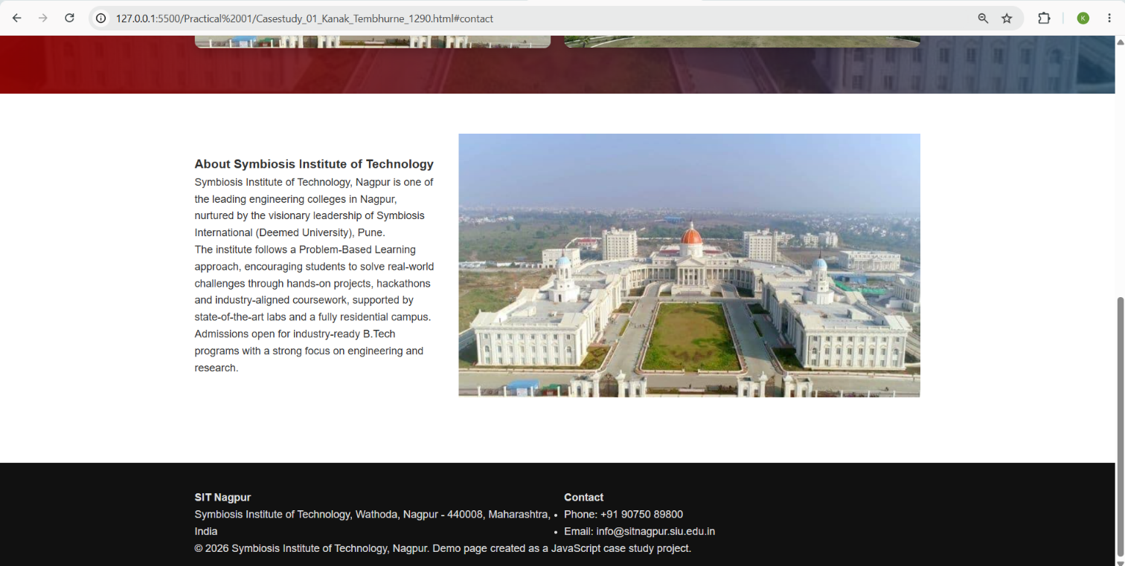

8. Result/Conclusion
Thus, the different ways of integrating JavaScript into a webpage: inline, internal, and external, along with console methods (console.log, console.table, console.trace) were successfully demonstrated. A case study webpage modeled on the SIT Nagpur institute home page was also implemented, using window.alert() to display a welcome message on page load and internal JavaScript (DOM manipulation via addEventListener) to build a responsive navigation menu toggle, thereby demonstrating practical, real-world usage of JavaScript for dynamic and interactive web pages.

